Name ___________ Date Pd

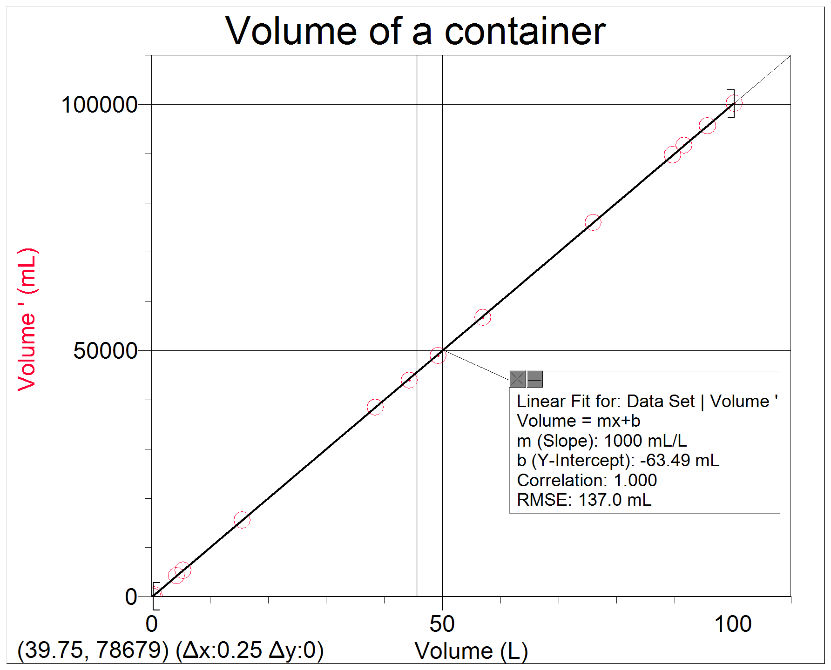
Unit 1: “For Every ….. there is….”

- Write a mathematical equation for the relationship in the form y = mx + b. Include a value for the slope.

- What are the units of the slope?

- Write a “For Every” statement that describes the meaning of the slope.

- What is the volume of the container in Liters when we measure it to be 624 mL? Show some work.
- What is the dependent variable________________?
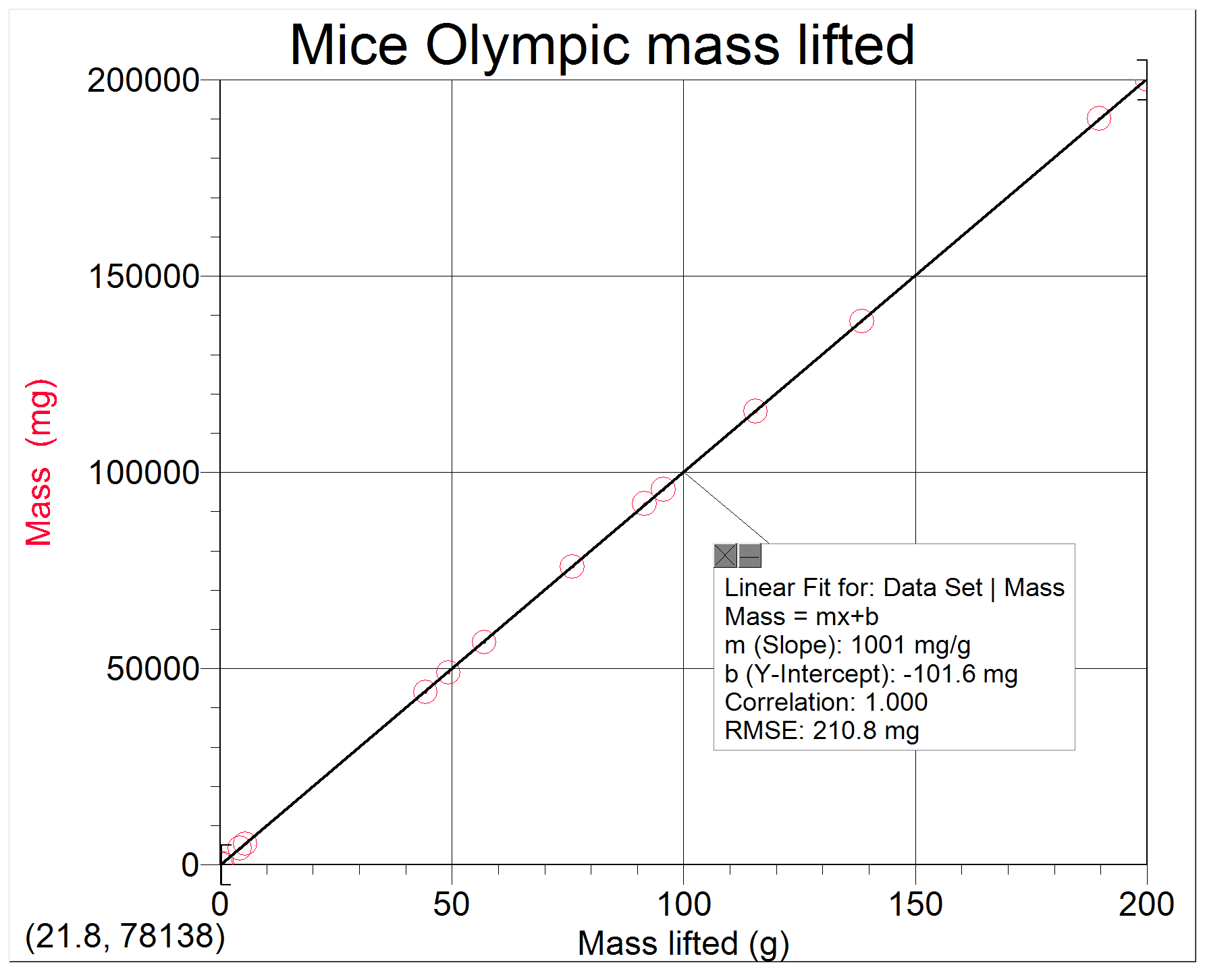
What is the independent variable______________?

- What is the value of the y-intercept________________?
What is the meaning of the y-intercept for this particular data set?

- Write a mathematical equation for the relationship in the form y = mx + b. Just write “m” for the slope.

- What is the slope of the line? Show some work. (Include Units)

- Write a “For Every” statement that describes the meaning of the slope.

