Chemistry Name ________________________
Unit 3 Period ___ Date _______________

Unit #3 Review

Kinetic Molecular Theory
This theory describes all matter as being composed of tiny particles in endless random motion. In a solid, the particles vibrate, but are locked into an orderly array. In a liquid, the particles are still touching but are free to move around past one another. In a gas, the particles are moving very rapidly and are widely separated.
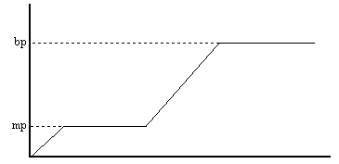
When energy is transferred to a sample of matter, either the particles speed up (temperature increases) or they get pulled apart (phase change), but not both at the same time. This helps account for the shape of the warming curve you got in the Icy Hot lab.

- Label which phases are present in each portion of the curve above.

- A) Label the sections (above) in which the thermal energy (Eth) of the sample is changing. Label the sections where the phase energy (Eph) is changing.

B) Describe what is happening to the movement and arrangement of the particles during a change in thermal energy (Eth).

c) Describe what is happening to the movement and arrangement of the particles during a change in phase energy (Eph).

- Matter has three phases (or states) – what are they and how are they different?

- Define the following:

Energy

Heat

Phase Energy

Thermal Energy

Temperature

Joule

Specific Heat

Heat of fusion

Heat of vaporization

- You walk past a puddle of water on the street and decide to take the temperature of the water. It currently has a temperature of 100 ˚C. A few hours later you walk back by the puddle and notice the puddle is now much smaller.
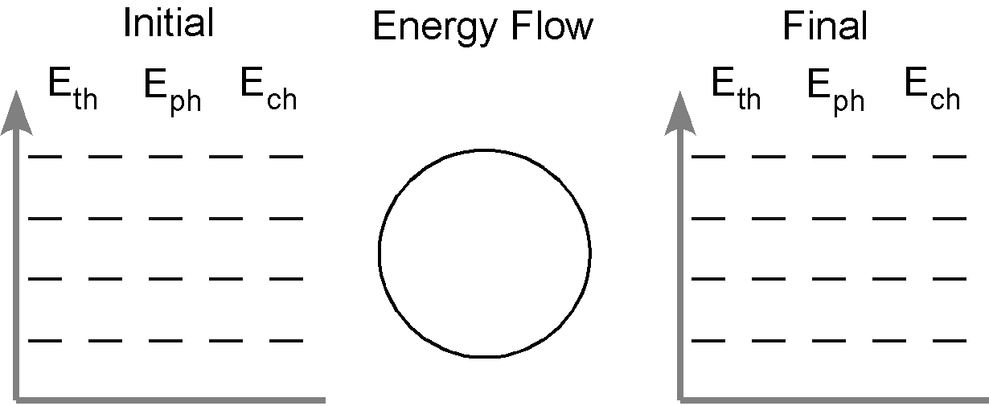

- A pan of water (25˚C) is heated to the boiling point.

- A tray of water (20 ˚C) is placed in the freezer and turns into ice cubes (- 8 ˚C).

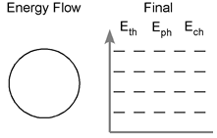

- Water is put in a pan on your stove and heated from 30ºC to 100ºC and then half of the water boils away.

For each problem below, show your work on a separate sheet of paper. Be sure to show which part(s) of a heating/cooling curve the problem focuses on (ex: only the melting plateau; melting plateau and heating water). Do the starred (**) problems. The remaining problems are optional (extra practice).
Q = m c ΔT Q = H_{f} m Q = H_{v} m

Energy constants (H2O)
334 J/g Heat of fusion (melting or freezing) Hf
2260 J/g Heat of vaporization (evaporating or condensing) Hv
2.1 J/g˚C Heat capacity (c) of solid water
4.18 J/g˚C Heat capacity (c) of liquid water
2.00 J/g˚C Heat capacity (c) of gas water
9. ** Find the change in heat energy while the water in #8 is heating. Find the change in heat energy while it is boiling. The initial mass is 1000 g. What is the total energy needed?
- **A 12 oz. can of soda (basically water) weighs about 450 grams. How many joules are released when a can of soda is cooled from 25 degrees Celsius (room temperature) to 4 degrees Celsius (the temperature of a refrigerator).
- **How many joules are required to heat 250 grams of liquid water from 0⁰ to 100⁰ C ?
- **How many joules are required to melt 100 grams of ice?
- How many joules are required to heat 200 grams of water from 25 ⁰C to 125 ⁰C? The heat capacity of steam is 2.0 J / g. ⁰C
- How many joules are given off when 120 grams of water are cooled from 25 ⁰C to -25⁰C?
- How much heat is required to completely vaporize 4.8g of ice which is at -30°C?
- ** How much heat, in kilojoules, must be added to 178 g of water to increase the temperature of the water by 5.00°C?
- ** A certain mass of water was heated with 41,840 Joules, raising its temperature from 22.0°C to 28.5°C. Find the mass of the water.
- **How much energy must be absorbed by a 50g sample of ice at 0°C that melts and then warms to 90°C?
- 50 kilojoules of energy are added to 100g of ice at 0°C. What is the final temperature of the water?
- ** An ice cube (30g) is at -15°C. How much energy is required to completely melt it?
- Using the information from problem 20, how much energy would be required to completely vaporize the ice?
After you complete one of the problems (9-21) and have shown all of your work, check your answer below. A reminder- the non-starred problems are challenging and represent our above and beyond expectations of what you need to accomplish on the exam.

**9. 1422.6 kJ  **10. -39501 J  **11. 104500 J  **12. 33400 J  13. 524700 J | 14. -58920 J  15. 14760 J  **16. 3.7 kJ  **17. 1539.9 g | **18. 35510 J  19. 39.7 ºC  **20. 10965 J  21. 301,200 J

After you complete one of the problems (9-21) and have shown all of your work, check your answer below. A reminder- the non-starred problems are challenging and represent our above and beyond expectations of what you need to accomplish on the exam.

**9. 1422.6 kJ  **10. -39501 J  **11. 104500 J  **12. 33400 J  13. 524700 J | 14. -58920 J  15. 14760 J  **16. 3.7 kJ  **17. 1539.9 g | **18. 35510 J  19. 39.7 ºC  **20. 10965 J  21. 301,200 J

After you complete one of the problems (9-21) and have shown all of your work, check your answer below. A reminder- the non-starred problems are challenging and represent our above and beyond expectations of what you need to accomplish on the exam.

**9. 1422.6 kJ  **10. -39501 J  **11. 104500 J  **12. 33400 J  13. 524700 J | 14. -58920 J  15. 14760 J  **16. 3.7 kJ  **17. 1539.9 g | **18. 35510 J  19. 39.7 ºC  **20. 10965 J  21. 301,200 J

After you complete one of the problems (9-21) and have shown all of your work, check your answer below. A reminder- the non-starred problems are challenging and represent our above and beyond expectations of what you need to accomplish on the exam.

**9. 1422.6 kJ  **10. -39501 J  **11. 104500 J  **12. 33400 J  13. 524700 J | 14. -58920 J  15. 14760 J  **16. 3.7 kJ  **17. 1539.9 g | **18. 35510 J  19. 39.7 ºC  **20. 10965 J  21. 301,200 J

