Name___________________________Period____

**Earth Science**

**Semester 1 Final Exam Study Guide**

* The final exam will be all multiple-choice/matching.
* The exam is worth 15% of your final semester grade.
* Do not bring electronic devices to the exam. This includes cell phones and iPods/iPads. If seen, they will be taken.
* If you finish your review packet (meet ***ALL*** due dates) AND are focused during the review days, then you may use a 3x5” HANDWRITTEN note card (both sides) on the final. The card will be turned in with your final.
* There will be no rest room passes until you are done with the test.
* BRING a PENCIL.
* BRING a book or something to do (NOT ELECTRONIC) to use when you are done with your final.

Keys to success:

* + Complete this study guide.
  + Don’t wait until just a day or two before finals to get help.
  + Start studying early. Remember, you have all winter break to relax.
  + Use your chapter outlines in addition to this study guide for help and extra practice. Be sure to focus on what this study guide covers, but your chapter note outlines help a lot.
  + Make flash cards for definitions and key concepts.
  + Other resources include: Quizlet, textbook, textbook website for practice quizzes, my webpage with videos, etc.

Final exam main **topics**:

* + Chapter 2: Latitude, Longitude, and Contour Mapping
  + Chapter 11: Layers of the Atmosphere, Methods of Heating & Cloud Formation
  + Chapter 12: Air Masses, Fronts, Pressure Systems
  + Chapter 13: Thunderstorms, Severe Storms, Hurricanes
  + Global Winds Mini-Unit
  + Chapter 15: Oceanography
  + Chapter 14: Climate

**Final Exam Schedule**: Find your class period and time. Be on time.

* Do NOT be late. School policy is that tardy students will not be admitted to the classroom to take the final. Instead, tardy students must return Friday during 8th period to take the exam.
* Only need to be here for periods that have a final. (Buses run on their regular schedule.)
* If here during resource/lunch, will be in the cafeteria (open study hall), library (quiet), or gym.

|  |  |  |  |  |  |  |  |
| --- | --- | --- | --- | --- | --- | --- | --- |
| **Wednesday, January 11th** | |  | **Thursday, January 12th** | |  | **Friday, January 13th** | |
| 8:10-9:40 | Resource | 8:10-9:40 | Resource | 8:10-8:45 | Resource |
| 9:50-11:20 | 5th Period | 9:50-11:20 | 1st Period | 8:50-10:20 | 3rd Period |
| 12:20-1:50 | 6th Period | 12:20-1:50 | 2nd Period | 10:30-12:00 | 4th Period |
| 2:00-3:30 | 7th Period | 2:00-3:30 | Resource | 12:30-3:30 | 8th Period (Make-ups) |

**Chapter 2 Mapping**

1. **Latitude:**
   1. What direction do the lines run?
   2. Are the lines labeled N/S or E/W?
   3. What is 0 degrees latitude?
   4. What is the latitude of the North Pole?
   5. What is the latitude of the South Pole?
2. **Longitude:**
3. What direction do the lines run?
4. Are the lines labeled N/S or E/W?
5. What is 0 degrees longitude?
6. **International Date Line**:
7. Is it latitude or longitude?
8. How many degrees?
9. What is important about this line?

|  |  |  |
| --- | --- | --- |
| **City** | **Latitude** | **Longitude** |
| Minneapolis, Minnesota | 45N | 93W |
| Cairo, Egypt | 30N | 31E |
| Madrid, Spain | 40N | 4W |
| Rio de Janeiro, Brazil | 23S | 43W |

**Using the table above, answer the following:**

1. Which city is closest **in degrees** to the International Date Line? How do you know?
2. Which city is closest  **in degrees** to the Prime Meridian? Explain.
3. Which city is closest to the equator? Explain.
4. Which city is farthest from the equator? Explain.
5. Which city is closest to the North Pole? Explain.

**Section 2.2 Topographic Maps:**

1. How are the following terms related to topographic maps? Explain their use on the maps.
2. Contour line
3. Index contour
4. Contour interval
5. Hachure
6. Why can’t contour lines come together or cross?

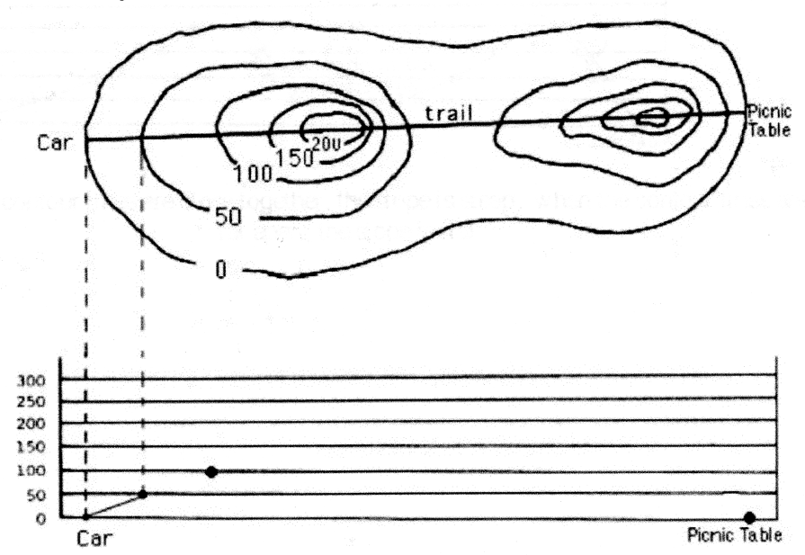

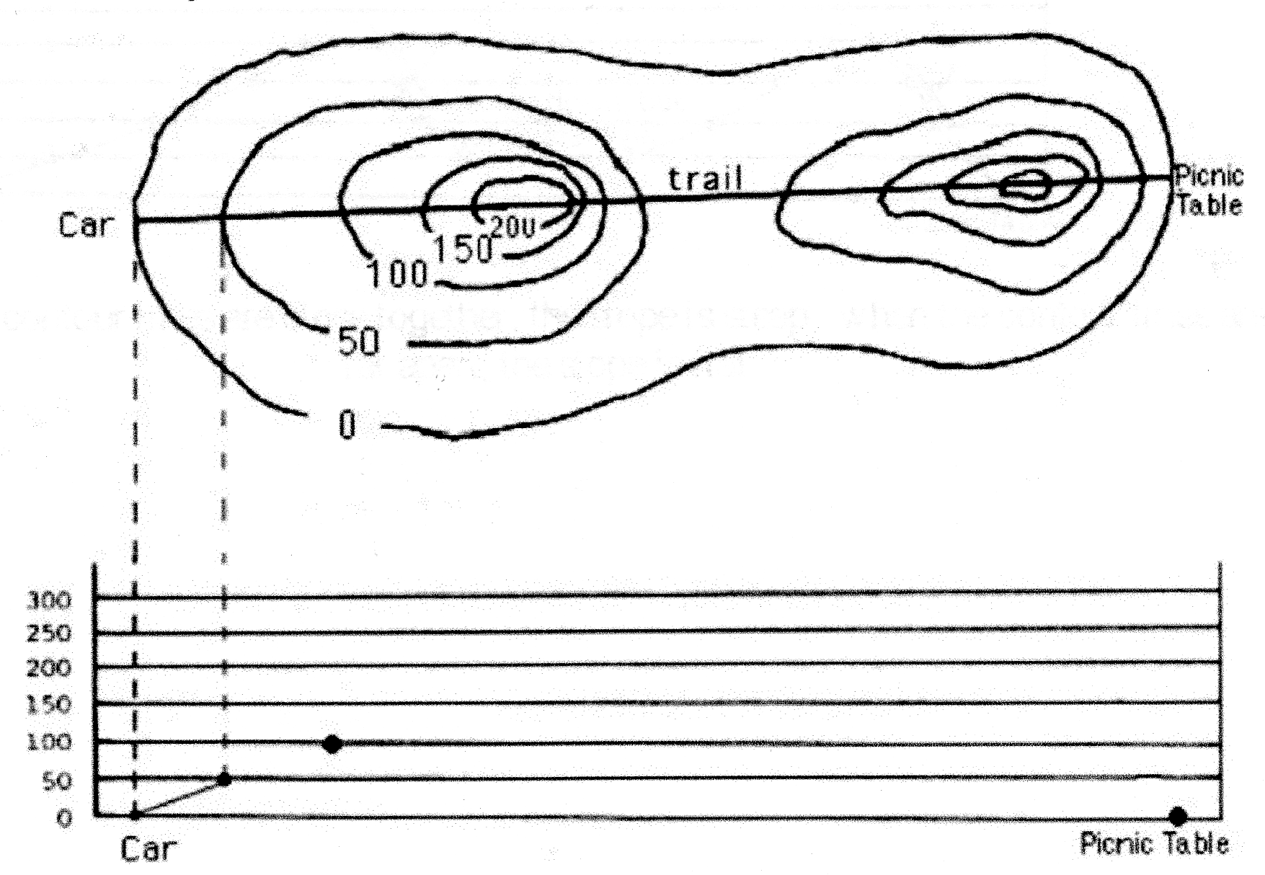**A**

**B**

**E**

**C**

**D**

**Use the topographic map above to answer the next questions**

1. At which point is it the steepest in the map above? A, B, C, D, E? How do you know?
2. At which point is it the flattest in the map above? A, B, C, D, E? How do you know?
3. What is the gradient of an area that is totally flat?
4. What is the contour interval in the map above?

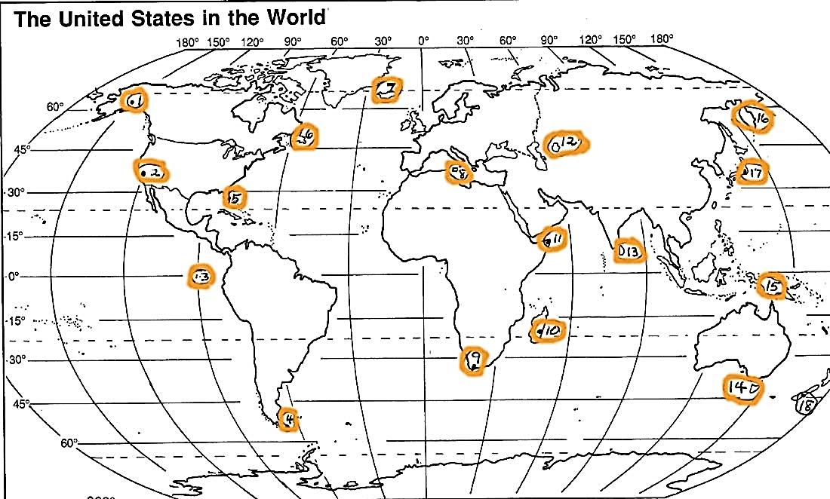

**Using the map above, answer the following questions about latitude & Longitude**

1. Which city is located at 52oS?
2. Which 2 cities are located closest to a 60o longitude line?

**Chapter 11 – Atmosphere & Cloud Formation**

**Layers of the Atmosphere**

1. Name the 4 layers of the atmosphere in order from the farthest to closest to Earth’s surface.
2. What are the 3 imaginary separation lines between layers of the atmosphere called?
3. Which layer has the largest concentration of ozone?
4. Which layer absorbs most of the Sun’s ultraviolet light?
5. Why does the temperature decreases with a higher altitude in the Troposphere?
6. Why does temperature increase with altitude in the Stratosphere?
7. What is a temperature inversion? How do they occur?

**Heat transfer**

1. What are the 3 Main Methods of Heat Transfer and explain how they work.
2. What is the Earth’s primary source of energy? Through what type of heat transfer mechanism does the Earth receive this energy?
3. Describe 2 heat transfer mechanisms by which a cup of hot coffee loses its energy.
4. How does the Earth pass on heat to the Troposphere?
5. Circle the 2 methods of heat transfer occurring in the picture below. Explain how these energy transfers work and relate them to the heating of Earth and/or the atmosphere.

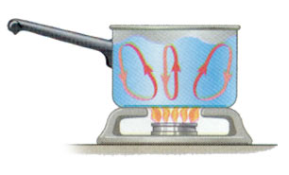

1. In the pan above, also label an area that is less dense, more dense, colder water, and warmer water.

**Temperature/Volume/Density/Pressure Relationships**

1. Explain the relationship between Temperature, Volume, and Density.
2. Explain the relationship between Temperature, Volume, and Pressure.



1. **The stars in the balloon to the right represent air molecules. The balloon

pictured is at room temperature.

* 1. Based on your knowledge about temperature and volume, draw what would happen if the balloon is put into an ice bath.
  2. How would this affect the density of the air in the balloon? **Explain why**.
  3. Based on your knowledge about density, do you think the balloon you drew would float higher or sink lower than the 1st balloon? Explain.

**Cloud Formation & Humidity**

1. What are the 3 main ingredients required for cloud formation?
2. List 2 examples of cloud nuclei.
3. What is the relationship between air temperature and the amount of water vapor it can hold?
4. If air at 80oF has a relative humidity of 65%, what happens to the relative humidity if:
   1. The air is warmed to 98oF?
   2. The air is cooled to 60oF?
5. What happens to the water vapor in the air at the dew point temperature?
6. If air contains 18g/kg of water vapor and the water vapor capacity of the air is 62g/kg, calculate the relative humidity of the air. Show your work and circle your answer.
7. If air could hold 20g/kg of water vapor, and the air contains 20g/kg, what is its relative humidity?

|  |  |
| --- | --- |
|  | **Water Vapor Capacity**  **(Maximum it can hold)**  g/kg  (grams water vapor/kg or air) |
| **30oF** | 2 |
| **40oF** | 4 |
| **50oF** | 12 |

1. Based on the table to the right, if air at 50oF contains 8g of water vapor, calculate its relative humidity. SHOW YOUR WORK. Label your answer with %.
2. Based on the table to the right, if a sample of air contains 4g of water vapor, what is its dew point?
3. List 3 forms of precipitation:
4. Complete the following table:

|  |  |  |
| --- | --- | --- |
|  | **Evaporation** | **Condensation** |
| Definition |  |  |
| To complete the phase change, is latent heat energy absorbed or released? |  |  |

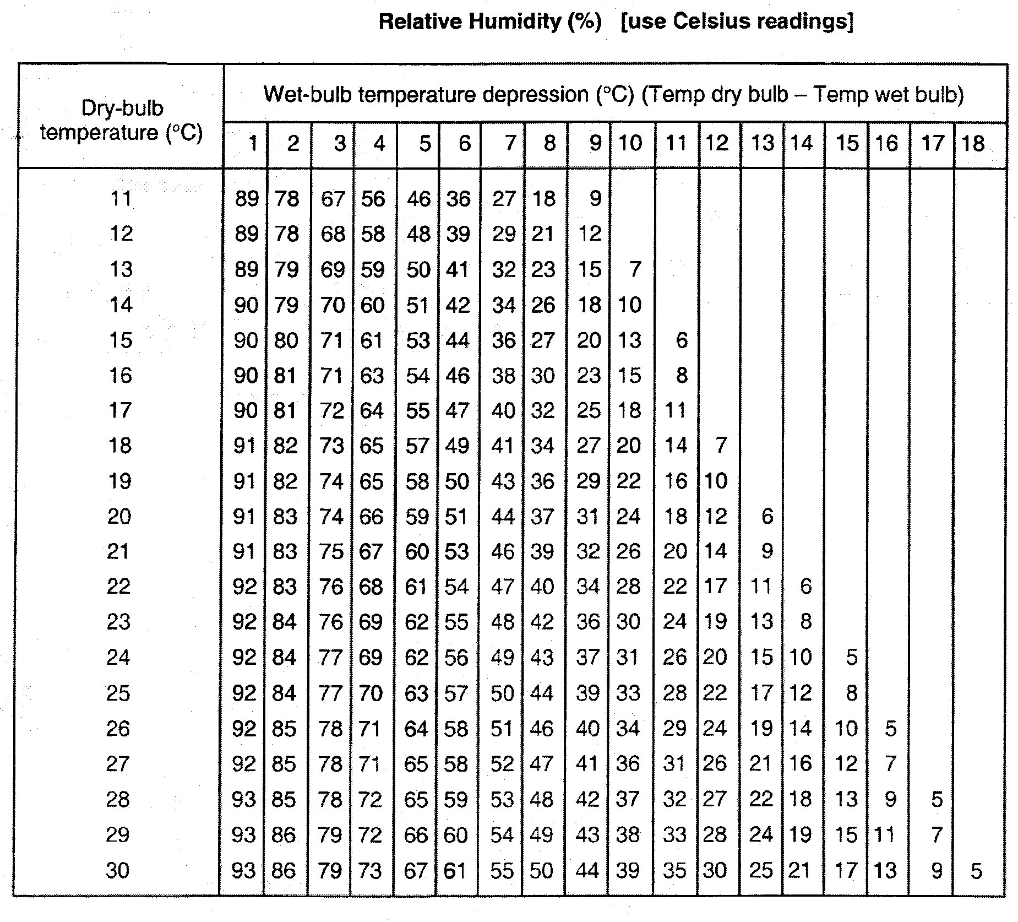

1. Use the table above. After slinging the psychrometer 50 times, the Dry-bulb temperature was 15oC and the Wet-bulb reading was 6oC. Using the table above, what is the relative humidity?
2. Compare and contrast **Orographic Lifting** and **Frontal Wedging:** You must explain similarities and differences. (You cannot say they are both a type of lift mechanism for a comparison. For differences, you must describe both terms.) You may write in sentences or use a Venn diagram. Be specific and detailed.

**Chapter 12: Meteorology (Air Masses, Fronts, Pressure Systems)**

1. Complete the “Characteristics of Air Masses” table:

|  |  |  |  |  |
| --- | --- | --- | --- | --- |
| **Symbol** | **Name** | **Relative temp** | **Relative humidity** | **Example source location (that could affect U.S. weather)** |
| mP |  |  |  |  |
| cP |  |  |  |  |
| mT |  |  |  |  |
| cT |  |  |  |  |

1. As a cT air mass that formed over Mexico moves north into the United States through New Mexico, Colorado, Nebraska, etc., what would be the major change in the air masses 2 main characteristics? Explain why.
2. What are the 2 characteristics we classify air masses by?
3. Complete the “Characteristics of Fronts” table:

|  |  |  |  |  |  |
| --- | --- | --- | --- | --- | --- |
| **Type** | **Relative Steepness**  **of Front** | **Type of Clouds** | **Strength & Length of Storms** | **Map Symbol**  **(Color, shape)** | **Description of Front**  **Use pictures and/or words**  **to describe what is happening** |
| Cold Front |  |  |  |  |  |
| Warm Front |  |  |  |  |  |
| Stationary Front | XXXXXXX  XXXXXXX | XXXXXXXX  XXXXXXXX |  |  |  |
| Occluded Front | XXXXXXX  XXXXXXX | XXXXXXXX  XXXXXXXX |  |  |  |

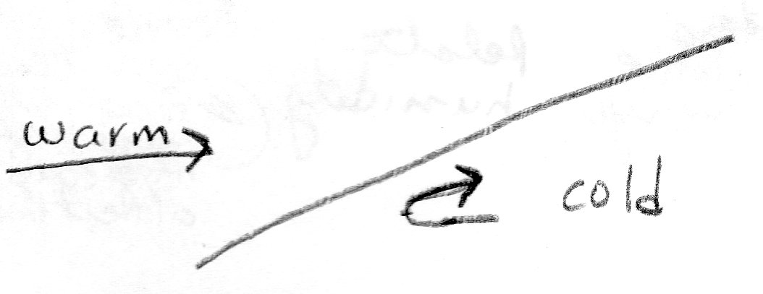

1. What type of front is shown in the diagram to the right? How do you know?
2. How many air masses are involved in
   1. Warm Front?
   2. Cold Front?
   3. Occluded Front?
3. Before the occluded front formed, what were 2 types of fronts were originally present? Explain what caused the occluded front to form.
4. Three of the fronts only involve the meeting of a warm and a cool air mass. What determines which of the three front types occurs? Explain.

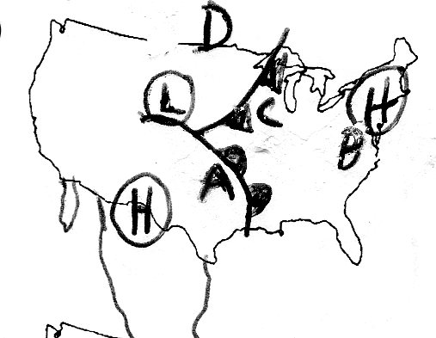**Use the diagram to the right to answer questions # 55-63:**

1. What type of front is located to the east of city A in the diagram above?
2. What direction is the front near A moving?
3. What type of air mass is A likely to be under now that the front has passed by?
4. What type of air mass is D likely to be under after the front passed by?
5. Which location (A, B, C, D) is likely to have a steady rain, but not a thunderstorm? Explain your reasoning.
6. Which location (A, B, C, D) is likely to have sunny skies? Explain your reasoning.



1. Which location on the map (A,B,C,D) is likely to have the highest temperature? Explain your reasoning.
2. Which location (A,B,C,D) is likely to have the lowest temperature of 45F? Explain your reasoning.
3. When the front passes through city C, describe how the weather is likely to change. (Explain what will happen to temperature, wind direction, precipitation, and cloud cover.
4. Complete the following table about pressure systems:

|  |  |  |  |  |
| --- | --- | --- | --- | --- |
| **System** | **Does Air Rise or Sink?** | **Usual Weather** | **Explain WHY that type of weather is found here** | **Direction of Rotation** |
| Low-Pressure |  |  |  |  |
| High-Pressure |  |  |  |  |

1. 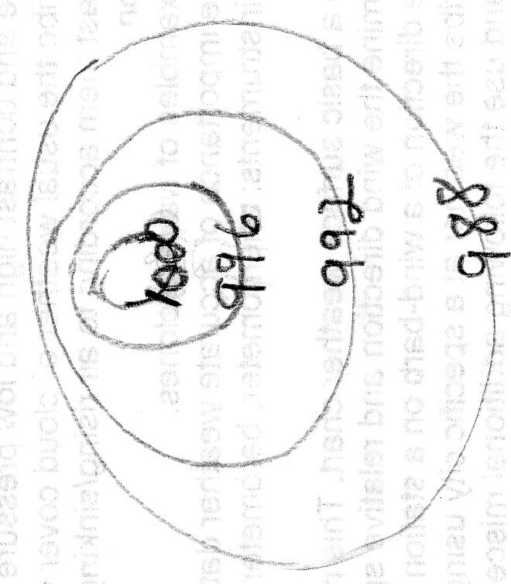On the isobar diagram to the right, circle the area with the greatest wind speed. Then explain how you know the wind speed is greatest there.
2. Is the center of the isobar diagram a high or low pressure center? Put an H or an L, as appropriate in the center.
3. In the isobar diagram, based on the isobar values, draw an arrow showing the direction the wind is blowing.

**Chapter 13: Severe Storms & Hurricanes**

1. **2 main types of thunderstorms**, air mass and frontal:
   1. They are differentiated by their lift mechanisms. Explain what causes lift in both types.
      1. Air Mass
      2. Frontal
   2. At what time of day are air mass thunderstorms most likely to occur? Why?
   3. What type of front are the most severe frontal thunderstorms associated with? Why?
2. Explain the cause of the following. Be specific.
   1. Lightning
   2. Thunder
   3. Tornado
3. Draw a **cumulonimbus cloud** to the right. Mark the location   
   of the positive and negative charges that would be found   
   there if a lightning storm was occurring.
   1. **Explain** how this would interact with the positively   
      charged surface of Earth.

+

+

(Surface of Earth)

1. Using the table below, fill in information about the **3 stages of thunderstorm development**.

|  |  |  |  |
| --- | --- | --- | --- |
|  | 1st Stage | 2nd Stage | 3rd Stage |
| Name of the Stage |  |  |  |
| Describe the type, shape, or size of the cloud. |  |  |  |
| Direction of air movement (up vs down) |  |  |  |
| Precipitation Present?  Severity of Storm?  Other weather events that might be present? |  |  |  |

1. **Tornadoes:**
   1. Is an F2 or F3 tornado stronger? What is the rating of the strongest tornadoes?
   2. During what season do most tornadoes occur? Explain why.
   3. Where is tornado alley? List 3 states in the alley. Explain what causes tornadoes to occur in this area more often than other parts of the U.S.
   4. What time of day do most tornadoes occur?
   5. How is a funnel cloud different than a tornado?
2. **Tropical Cyclones:**
   1. What sides of the continents are most often hit by hurricanes? Why?
   2. What months are hurricanes most likely to hit the U.S.? Why?
   3. Where do hurricanes typically form?
   4. What are the 3 hazards present during a hurricane?
   5. What causes the most destruction during a hurricane?
   6. List the 4 stages of hurricane development in order:

3.

4.

* 1. List 2 things that determine if a low pressure system is classified as a Tropical Storm vs. Hurricane?
  2. Where are the winds of a hurricane the strongest? __________________Calmest?___________

1. **Hurricane Andrew map & graph**:
   1. How are wind speed & air pressure related in a hurricane? (Example – if wind speed goes up, what does air pressure do? And vice versa.)
   2. If given a map of a hurricane path, what locations would result in the hurricane :
      1. Loosing strength, weakening? Why?
      2. Gaining strength? Why?
2. List the cause of the following 3 types of reoccurring weather.

|  |  |
| --- | --- |
| Reoccurring Weather | Cause – Be specific & include type of pressure system |
| Drought |  |
| Cold Wave |  |
| Heat Wave |  |

**Global Winds Mini-Unit**

1. What is the Coriolis Effect?   
     
   1. What does it do to wind in the Northern hemisphere?
   2. What does it do it wind in the Southern hemisphere?
2. How is wind named?
3. Complete the table below:

|  |  |  |  |  |
| --- | --- | --- | --- | --- |
| **Type of Wind** | **Latitude it Starts (Blows From)** | **Latitude it Ends (Blows Towards)** | ***Direction* it blows from** | ***Regions/Events* Affected** |
| Trade Winds |  |  |  |  |
| Prevailing Westerlies |  |  |  |  |
| Polar Easterlies |  |  |  |  |
| Jet Stream |  |  |  |  |

1. Fill in the globe below with the winds. Make sure to include:   
    a. convection cells

b. clouds (where they are present)

c. location of high & low pressure on the ground

d. location of high & low pressure aloft

d. names of the wind systems

e. arrows to show specific direction of wind movement   
REMEMBER: You may need to rotate your paper to take into account which way the wind is coming from!!

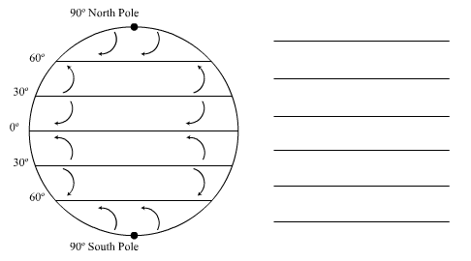

1. 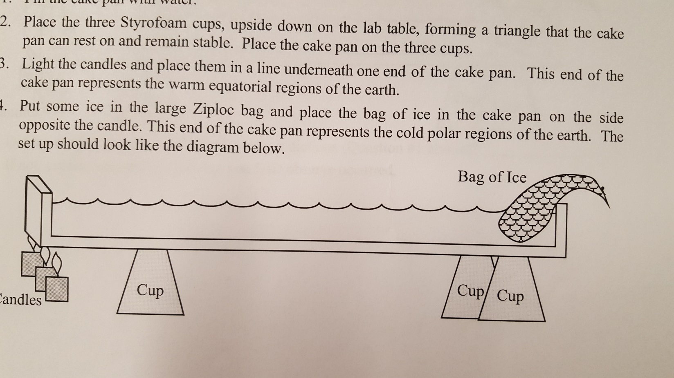In the diagram below, draw arrows to show the convection process that is occurring:
2. Complete the following chart regarding the wind patterns at the POLE and the EQUATOR:  
   (Hint: Use your arrows from question #4 to help you answer these questions.)

|  |  |  |  |  |
| --- | --- | --- | --- | --- |
| **Location** | **Pressure at Surface** | **Pressure Aloft** | **Wind felt at Surface** | **Wind felt Aloft** |
| Poles | Explain why: | Explain why: | Explain why: | Explain why: |
| Equator | Explain why: | Explain why: | Explain why: | Explain why: |

**Chapter 15: Oceanography**

1. What hemisphere are the majority of oceans found on Earth?
2. What factors cause sea level to change?
3. List 2 characteristics that cause it to be a “sea” rather than an “ocean”.
4. What does salinity measure?
5. What are 3 reasons salinity changes? Explain how these affect salinity.

1.

2.

3.

1. Explain 2 ways salts are added to the sea.

1.

2.

1. Explain 2 ways salts are removed from the sea.

1.

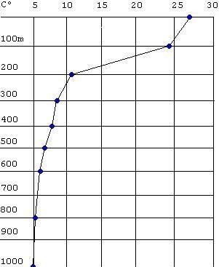

Temperature oC

Depth in meters

2.

1. What are the 3 ocean layers? Label them on the diagram to the right and

describe what is happening to temperature in each layer.

1. How is the diagram above different at the poles? How many layers would be present there?
2. What 2 characteristics affect the density of the water masses and cause them to form separate layers when they collide?
3. What is a breaker? What causes breakers to occur?
4. Label the picture below with the following words; crest, trough, wavelength, amplitude (wave height). 
5. When do high tides occur? Explain the processes that can lead to high tides.
6. When do low tides occur?
7. Spring tide:

A. What causes a spring tide?

B. How are spring high tides different from usual?

C. How are spring low tides different from usual?

D. Draw the 2 different alignments of the Sun, Earth, and Moon during a spring tide.

1. Neap tide:

A. What causes a neap tide?

B. How are neap high tides different from usual?

C. How are neap low tides different from usual?

D. Draw the 2 different alignments of the Sun, Earth, and Moon during a neap tide.

1. Currents:

|  |  |  |
| --- | --- | --- |
| Type of Current | Location/Depth of Ocean | Describe the cause |
|  |  |  |
|  |  |  |

1. Where would a gyre most likely occur? Why?
2. Circle 2 warm currents on the map below. **How do you know they are warm?**
3. Box in 2 cold currents on the map below. **How do you know they are cold?**

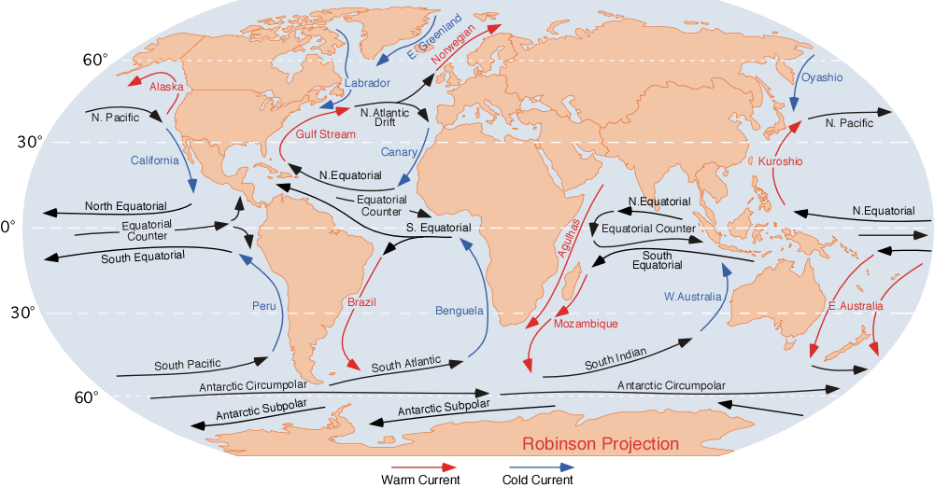

**Chapter 14: Climate**

1. What is weather? Provide two examples.
2. What is climate? Provide two examples.
3. Name the 5 factors that affect climate.
4. What location on Earth has the most direct sunlight?
5. What location on Earth has the most indirect sunlight?
6. Why do different locations receive different amounts of sunlight through the year?
7. How does the amount of insolation affect climate of a particular location?
8. What color reflects the most sunlight? Name two surface features that reflect a lot of sunlight.
9. What color absorbs the most sunlight? Name two surface features that absorb a lot of sunlight.
10. How does reflectivity affect the temperature of an area?
11. What is a positive feedback loop?
12. Explain, in detail, one example of a positive feedback loop (climate-based) and the impact that this loop may have on the current types of life on Earth.
13. What is a negative feedback loop?
14. What are two reasons that cities, at the same latitude, would have very different climates?
15. Which substance warms faster…water or land? What is the impact on a region’s climate?
16. What are the three main characteristics/variables used to determine the climate of a region?
17. Name ***and*** describe the 5 main climate zones. **Make sure to include location (latitudes) and any special facts/information about each of the zones!**
18. What causes the tropics to be much warmer than the rest of the climate zones?
19. What two factors cause the poles to be much colder than the rest of the climate zones?
20. What is the “sphere” that contains all living things, recently living things, and products of living things?
21. What is the “sphere” that contains rocks, minerals, volcanoes, and fossil fuels?
22. What is the “sphere” that contains all of the water on earth and in the atmosphere?
23. What is the “sphere” that acts like a greenhouse and keeps the Earth warm?
24. Name an interaction that moves from…
    1. Biosphere to Atmosphere
    2. Atmosphere to Biosphere
    3. Atmosphere to Hydrosphere
    4. Hydrosphere to Atmosphere
    5. Lithosphere to Atmosphere
25. What is a greenhouse gas?
    1. What are the four main greenhouse gases?
    2. What percentage of the atmosphere is made up of greenhouse gases?
    3. Which greenhouse gas is created by the burning of fossil fuels?
26. List at least 3 human activities that lead to the creation of greenhouse gases.
27. What is the “Greenhouse Effect”?
28. Is the greenhouse required for humans to live on the planet? What might happen if the greenhouse effect were completely eliminated?   
    **Think of all the factors we discussed – humans, temperature, precipitation, vegetation, etc.
29. What is global warming? What is the main cause of global warming?
30. What are the four effects of global warming? Make sure to include how each of your answers might affect current climates and/or human activities.
31. How is global warming different than the Greenhouse Effect?
32. What are some strategies (at least 3) that we, as humans, can use to reduce the amount of greenhouse gases that are released into the atmosphere?
33. El Nino:

|  |  |  |
| --- | --- | --- |
| **Describe the following characteristics:** | **Normal Year** | **El Nino Year** |
| Direction of Equatorial Winds |  |  |
| Direction of Equatorial Ocean Currents |  |  |
| Climate of NW South America |  |  |
| Climate of Australia |  |  |
| Relative number of hurricanes hitting Florida |  |  |
| **Describe** the amount of upwelling & its effect on commercial fishing |  |  |

**SEE NEXT PAGE** – for test vocabulary word lists

**1st Semester Vocabulary**

For Semester Exam

**Vocabulary on the Final Exam**: Use Quizlet, vocabulary sheets, make flashcards, be able to define and describe the relationships between the words, apply the words, etc.

**Chapter 2 Mapping**

Latitude, longitude, Prime Meridian, Equator, International Date Line, latitude of North Pole/South Pole, time zone, topographic map, contour line, index contour, contour interval, depression contour, hachure, gradient

**Chapter 11 Atmosphere & Cloud Formation**

Temperature vs. volume, temperature vs. density, temperature vs particle speed, radiation, convection, conduction, heat (heat transfer), troposphere, stratosphere, mesosphere, thermosphere, tropopause, stratopause, mesopause, ozone, direct light, indirect light, Orographic lift, frontal lifting, dew point, condensation, evaporation, condensation nuclei, cirrus, stratus, cumulus, cumulonimbus, altostratus, altocumulus, humidity, relative humidity, saturation

**Chapter 12 Meteorology (Air Masses, Fronts & Pressure Systems)**

Continental tropical (cT), continental polar (cP), maritime tropical (mT), maritime polar (mP), air mass modification, cold front, warm front, occluded front, stationary front, high pressure system, low pressure system, wind – speed & direction based on isobars, station model

**Chapter 13 Severe Storms & Hurricanes**

Frontal thunderstorm, Air mass thunderstorm, updraft, downdraft, cumulonimbus, lightning, thunder, hail, Cumulus stage, Mature stage, Dissipation stage, hail, tornado, Fujita Scale, hurricane, eye, eye wall, storm surge, Tropical disturbance, Tropical depression, Tropical storm, hurricane, Saffir-Simpson Scale, cold wave, heat wave, drought

**Global Winds Mini-Unit**

Coriolis Effect, Trade Winds, Prevailing Westerlies, Polar Easterlies, jet streams

**Chapter 15 Oceanography**

Salinity, tide, spring tide, neap tide, wave, crest, trough, wave length, wave height, sonar, surface current, density current, surface layer, thermocline, bottom layer, gyre, sea, ocean, sea level, breaker

**Chapter 14 Climate**

Climate, Weather, Radiation, Positive Feedback Loops, Volcanism, Aerosols, Temperature, Precipitation, Vegetation, Tropical Moist Climate, Dry Climate, Moist-mid Latitude Climate (mild winter) , Moist-mid Latitude Climate (cold winter), Polar Climate, Biosphere, Atmosphere, Lithosphere, Hydrosphere, Global Warming, Greenhouse Effect, Greenhouse Gas, Carbon Dioxide, Methane, Fossil Fuels