**Chapter 13: Severe Storms & Hurricanes**

1. **2 main types of thunderstorms**, air mass and frontal:
   1. They are differentiated by their lift mechanisms. Explain what causes lift in both types.
      1. Air Mass
      2. Frontal
   2. At what time of day are air mass thunderstorms most likely to occur? Why?
   3. What type of front are the most severe frontal thunderstorms associated with? Why?
2. Explain the cause of the following. Be specific.
   1. Lightning
   2. Thunder
   3. Tornado
3. Draw a **cumulonimbus cloud** to the right. Mark the location   
   of the positive and negative charges that would be found   
   there if a lightning storm was occurring.
   1. **Explain** how this would interact with the positively   
      charged surface of Earth.

+

+

(Surface of Earth)

1. Using the table below, fill in information about the **3 stages of thunderstorm development**.

|  |  |  |  |
| --- | --- | --- | --- |
|  | 1st Stage | 2nd Stage | 3rd Stage |
| Name of the Stage |  |  |  |
| Describe the type, shape, or size of the cloud. |  |  |  |
| Direction of air movement (up vs down) |  |  |  |
| Precipitation Present?  Severity of Storm?  Other weather events that might be present? |  |  |  |

1. **Tornadoes:**
   1. Is an F2 or F3 tornado stronger? What is the rating of the strongest tornadoes?
   2. During what season do most tornadoes occur? Explain why.
   3. Where is tornado alley? List 3 states in the alley. Explain what causes tornadoes to occur in this area more often than other parts of the U.S.
   4. What time of day do most tornadoes occur?
   5. How is a funnel cloud different than a tornado?
2. **Tropical Cyclones:**
   1. What sides of the continents are most often hit by hurricanes? Why?
   2. What months are hurricanes most likely to hit the U.S.? Why?
   3. Where do hurricanes typically form?
   4. What are the 3 hazards present during a hurricane?
   5. What causes the most destruction during a hurricane?
   6. List the 4 stages of hurricane development in order:

3.

4.

* 1. List 2 things that determine if a low pressure system is classified as a Tropical Storm vs. Hurricane?
  2. Where are the winds of a hurricane the strongest? __________________Calmest?___________

1. **Hurricane Andrew map & graph**:
   1. How are wind speed & air pressure related in a hurricane? (Example – if wind speed goes up, what does air pressure do? And vice versa.)
   2. If given a map of a hurricane path, what locations would result in the hurricane :
      1. Loosing strength, weakening? Why?
      2. Gaining strength? Why?
2. List the cause of the following 3 types of reoccurring weather.

|  |  |
| --- | --- |
| Reoccurring Weather | Cause – Be specific & include type of pressure system |
| Drought |  |
| Cold Wave |  |
| Heat Wave |  |

**Global Winds Mini-Unit**

1. What is the Coriolis Effect?   
     
   1. What does it do to wind in the Northern hemisphere?
   2. What does it do it wind in the Southern hemisphere?
2. How is wind named?
3. Complete the table below:

|  |  |  |  |  |
| --- | --- | --- | --- | --- |
| **Type of Wind** | **Latitude it Starts (Blows From)** | **Latitude it Ends (Blows Towards)** | ***Direction* it blows from** | ***Regions/Events* Affected** |
| Trade Winds |  |  |  |  |
| Prevailing Westerlies |  |  |  |  |
| Polar Easterlies |  |  |  |  |
| Jet Stream |  |  |  |  |

1. Fill in the globe below with the winds. Make sure to include:   
    a. convection cells

b. clouds (where they are present)

c. location of high & low pressure on the ground

d. location of high & low pressure aloft

d. names of the wind systems

e. arrows to show specific direction of wind movement   
REMEMBER: You may need to rotate your paper to take into account which way the wind is coming from!!

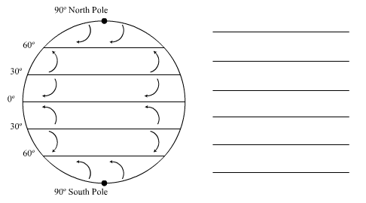

1. 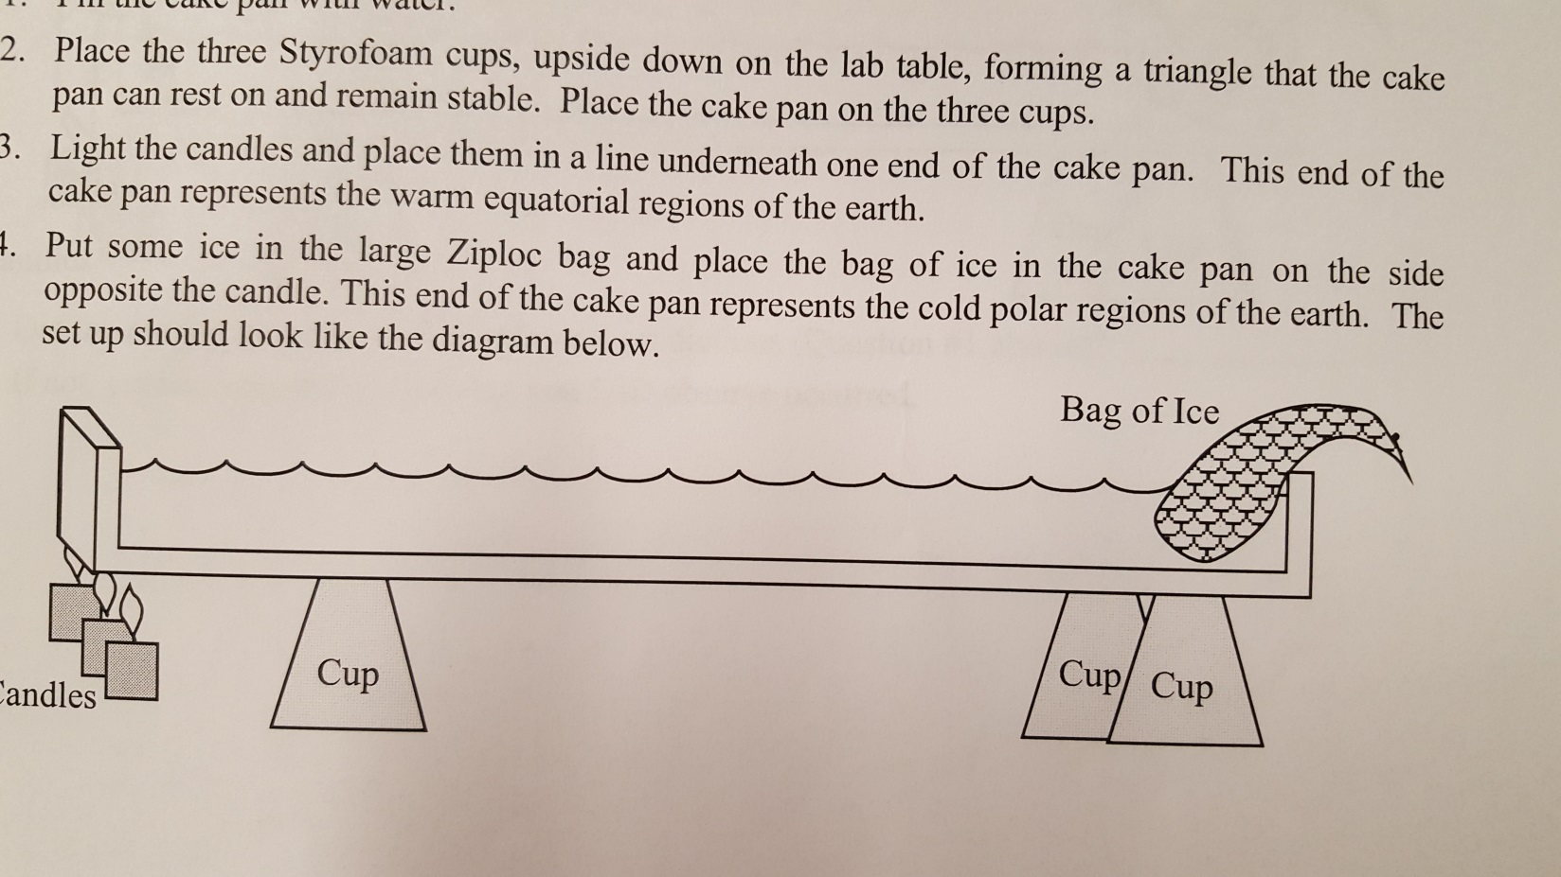In the diagram below, draw arrows to show the convection process that is occurring:
2. Complete the following chart regarding the wind patterns at the POLE and the EQUATOR:  
   (Hint: Use your arrows from question #4 to help you answer these questions.)

|  |  |  |  |  |
| --- | --- | --- | --- | --- |
| **Location** | **Pressure at Surface** | **Pressure Aloft** | **Wind felt at Surface** | **Wind felt Aloft** |
| Poles | Explain why: | Explain why: | Explain why: | Explain why: |
| Equator | Explain why: | Explain why: | Explain why: | Explain why: |

**Chapter 15: Oceanography**

1. What hemisphere are the majority of oceans found on Earth?
2. What factors cause sea level to change?
3. List 2 characteristics that cause it to be a “sea” rather than an “ocean”.
4. What does salinity measure?
5. What are 3 reasons salinity changes? Explain how these affect salinity.

1.

2.

3.

1. Explain 2 ways salts are added to the sea.

1.

2.

1. Explain 2 ways salts are removed from the sea.

1.

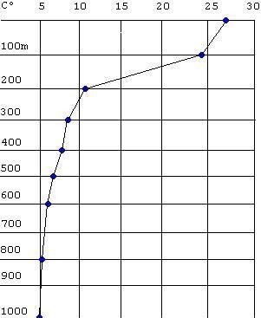

Temperature oC

Depth in meters

2.

1. What are the 3 ocean layers? Label them on the diagram to the right and

describe what is happening to temperature in each layer.

1. How is the diagram above different at the poles? How many layers would be present there?
2. What 2 characteristics affect the density of the water masses and cause them to form separate layers when they collide?
3. What is a breaker? What causes breakers to occur?
4. Label the picture below with the following words; crest, trough, wavelength, amplitude (wave height). 
5. When do high tides occur? Explain the processes that can lead to high tides.
6. When do low tides occur?
7. Spring tide:

A. What causes a spring tide?

B. How are spring high tides different from usual?

C. How are spring low tides different from usual?

D. Draw the 2 different alignments of the Sun, Earth, and Moon during a spring tide.

1. Neap tide:

A. What causes a neap tide?

B. How are neap high tides different from usual?

C. How are neap low tides different from usual?

D. Draw the 2 different alignments of the Sun, Earth, and Moon during a neap tide.

1. Currents:

|  |  |  |
| --- | --- | --- |
| Type of Current | Location/Depth of Ocean | Describe the cause |
|  |  |  |
|  |  |  |

1. Where would a gyre most likely occur? Why?
2. Circle 2 warm currents on the map below. **How do you know they are warm?**
3. Box in 2 cold currents on the map below. **How do you know they are cold?**

