Chapter 2 Mapping

- Latitude:
  - What direction do the lines run?
  - Are the lines labeled N/S or E/W?
  - What is 0 degrees latitude?
  - What is the latitude of the North Pole?
  - What is the latitude of the South Pole?
- Longitude:
- What direction do the lines run?
- Are the lines labeled N/S or E/W?
- What is 0 degrees longitude?

- International Date Line:
- Is it latitude or longitude?
- How many degrees?
- What is important about this line?

City | Latitude | Longitude
Minneapolis, Minnesota | 45N | 93W
Cairo, Egypt | 30N | 31E
Madrid, Spain | 40N | 4W
Rio de Janeiro, Brazil | 23S | 43W

Using the table above, answer the following:
- Which city is closest in degrees to the International Date Line? How do you know?

- Which city is closest in degrees to the Prime Meridian? Explain.

- Which city is closest to the equator? Explain.

- Which city is farthest from the equator? Explain.

- Which city is closest to the North Pole? Explain.

Section 2.2 Topographic Maps:

- How are the following terms related to topographic maps? Explain their use on the maps.

- Contour line

- Index contour

- Contour interval

- Hachure

- Why can’t contour lines come together or cross?

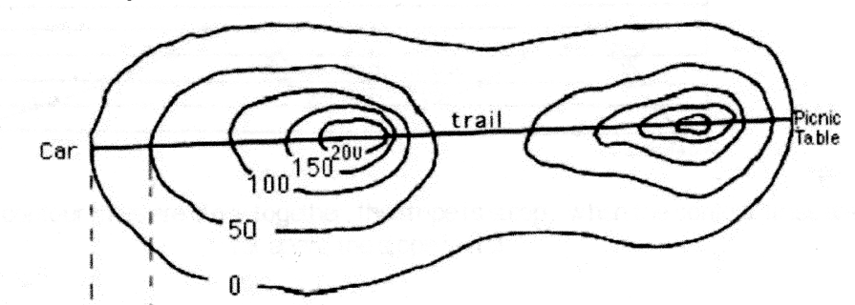
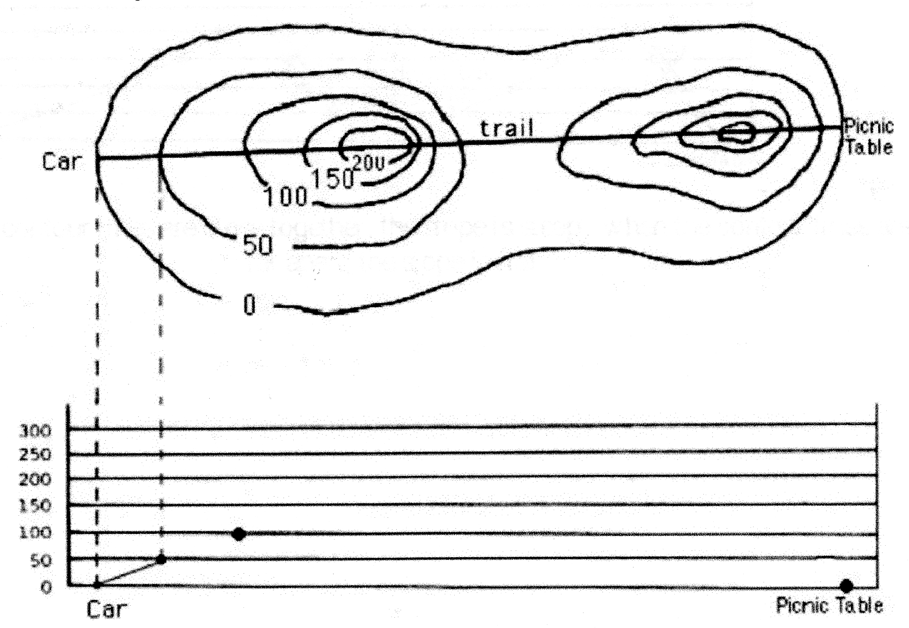A
B
E
C
D

Use the topographic map above to answer the next questions
- At which point is it the steepest in the map above? A, B, C, D, E? How do you know?

- At which point is it the flattest in the map above? A, B, C, D, E? How do you know?

- What is the gradient of an area that is totally flat?

- What is the contour interval in the map above?

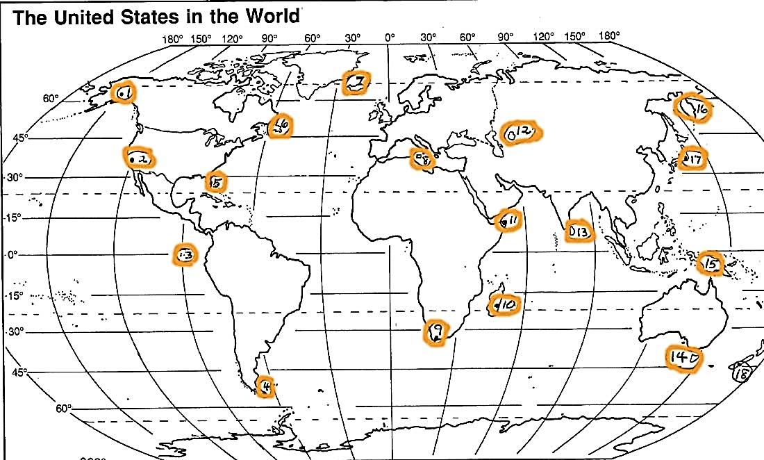
Using the map above, answer the following questions about latitude & Longitude

- Which city is located at 52ºS?

- Which 2 cities are located closest to a 60º longitude line?

Chapter 11 – Atmosphere & Cloud Formation

Layers of the Atmosphere
- Name the 4 layers of the atmosphere in order from the farthest to closest to Earth’s surface.

- What are the 3 imaginary separation lines between layers of the atmosphere called?

- Which layer has the largest concentration of ozone?

- Which layer absorbs most of the Sun’s ultraviolet light?

- Why does the temperature decreases with a higher altitude in the Troposphere?

- Why does temperature increase with altitude in the Stratosphere?

- What is a temperature inversion? How do they occur?

Heat transfer
- What are the 3 Main Methods of Heat Transfer and explain how they work.

- What is the Earth’s primary source of energy? Through what type of heat transfer mechanism does the Earth receive this energy?

- Describe 2 heat transfer mechanisms by which a cup of hot coffee loses its energy.

- How does the Earth pass on heat to the Troposphere?

- Circle the 2 methods of heat transfer occurring in the picture below. Explain how these energy transfers work and relate them to the heating of Earth and/or the atmosphere.

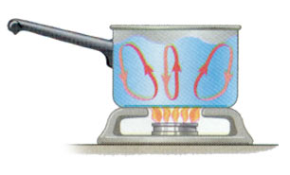

- In the pan above, also label an area that is less dense, more dense, colder water, and warmer water.

Temperature/Volume/Density/Pressure Relationships
- Explain the relationship between Temperature, Volume, and Density.

- Explain the relationship between Temperature, Volume, and Pressure.
- **The stars in the balloon to the right represent air molecules. The balloon
pictured is at room temperature.
  - Based on your knowledge about temperature and volume, draw what would happen if the balloon is put into an ice bath.

  - How would this affect the density of the air in the balloon? Explain why.

  - Based on your knowledge about density, do you think the balloon you drew would float higher or sink lower than the 1st balloon? Explain.

Cloud Formation & Humidity
- What are the 3 main ingredients required for cloud formation?

- List 2 examples of cloud nuclei.

- What is the relationship between air temperature and the amount of water vapor it can hold?

- If air at 80ºF has a relative humidity of 65%, what happens to the relative humidity if:

  - The air is warmed to 98ºF?

  - The air is cooled to 60ºF?

- What happens to the water vapor in the air at the dew point temperature?

- If air contains 18g/kg of water vapor and the water vapor capacity of the air is 62g/kg, calculate the relative humidity of the air. Show your work and circle your answer.

- If air could hold 20g/kg of water vapor, and the air contains 20g/kg, what is its relative humidity?

Water Vapor Capacity
(Maximum it can hold)
g/kg
(grams water vapor/kg or air)
30ºF | 2
40ºF | 4
50ºF | 12
- Based on the table to the right, if air at 50ºF contains 8g of water vapor, calculate its relative humidity. SHOW YOUR WORK. Label your answer with %.

- Based on the table to the right, if a sample of air contains 4g of water vapor, what is its dew point?

- List 3 forms of precipitation:

- Complete the following table:
 | Evaporation | Condensation
Definition

To complete the phase change, is latent heat energy absorbed or released?

- Use the table above. After slinging the psychrometer 50 times, the Dry-bulb temperature was 15ºC and the Wet-bulb reading was 6ºC. Using the table above, what is the relative humidity?

- Compare and contrast Orographic Lifting and Frontal Wedging: You must explain similarities and differences. (You cannot say they are both a type of lift mechanism for a comparison. For differences, you must describe both terms.) You may write in sentences or use a Venn diagram. Be specific and detailed.

Chapter 12: Meteorology (Air Masses, Fronts, Pressure Systems)

- Complete the “Characteristics of Air Masses” table:
Symbol | Name | Relative temp | Relative humidity | Example source location (that could affect U.S. weather)
mP
cP
mT
cT

- As a cT air mass that formed over Mexico moves north into the United States through New Mexico, Colorado, Nebraska, etc., what would be the major change in the air masses 2 main characteristics? Explain why.

- What are the 2 characteristics we classify air masses by?

- Complete the “Characteristics of Fronts” table:
Type | Relative Steepness  of Front | Type of Clouds | Strength & Length of Storms | Map Symbol  (Color, shape) | Description of Front  Use pictures and/or words  to describe what is happening
Cold Front
Warm Front
Stationary Front | XXXXXXX  XXXXXXX | XXXXXXXX  XXXXXXXX
Occluded Front | XXXXXXX  XXXXXXX | XXXXXXXX  XXXXXXXX
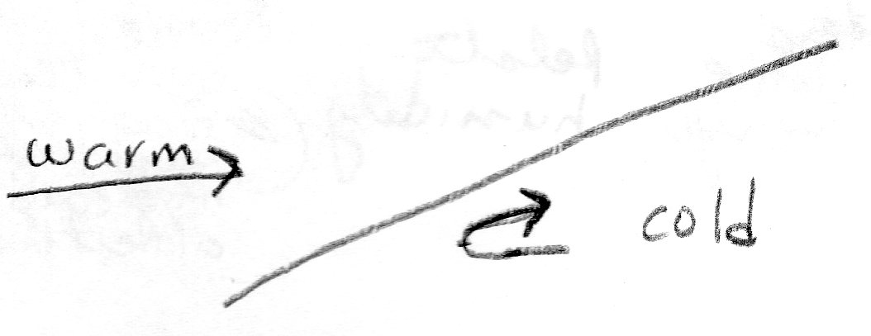
- What type of front is shown in the diagram to the right? How do you know?

- How many air masses are involved in
  - Warm Front?
  - Cold Front?
  - Occluded Front?

- Before the occluded front formed, what were 2 types of fronts were originally present? Explain what caused the occluded front to form.

- Three of the fronts only involve the meeting of a warm and a cool air mass. What determines which of the three front types occurs? Explain.

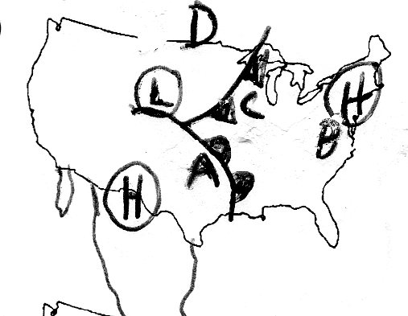
Use the diagram to the right to answer questions # 55-63:
- What type of front is located to the east of city A in the diagram above?

- What direction is the front near A moving?

- What type of air mass is A likely to be under now that the front has passed by?

- What type of air mass is D likely to be under after the front passed by?

- Which location (A, B, C, D) is likely to have a steady rain, but not a thunderstorm? Explain your reasoning.

- Which location (A, B, C, D) is likely to have sunny skies? Explain your reasoning.

- Which location on the map (A,B,C,D) is likely to have the highest temperature? Explain your reasoning.

- Which location (A,B,C,D) is likely to have the lowest temperature of 45F? Explain your reasoning.

- When the front passes through city C, describe how the weather is likely to change. (Explain what will happen to temperature, wind direction, precipitation, and cloud cover.

- Complete the following table about pressure systems:
System | Does Air Rise or Sink? | Usual Weather | Explain WHY that type of weather is found here | Direction of Rotation
Low-Pressure
High-Pressure

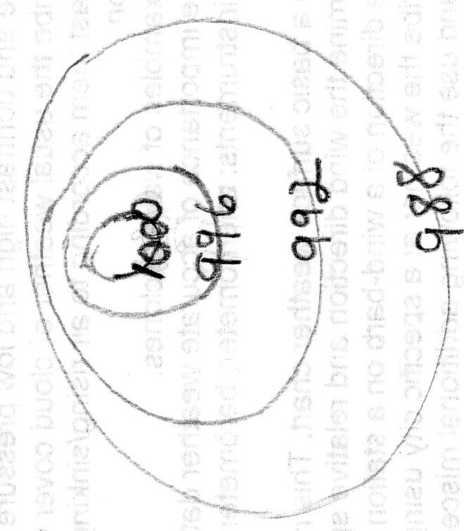
- On the isobar diagram to the right, circle the area with the greatest wind speed. Then explain how you know the wind speed is greatest there.

- Is the center of the isobar diagram a high or low pressure center? Put an H or an L, as appropriate in the center.

- In the isobar diagram, based on the isobar values, draw an arrow showing the direction the wind is blowing.

