Lab: Understanding Albedo Name________________________Period___

Purpose
This lab has TWO parts.
- In the FIRST part, you will:
  - Understand how albedo affects the temperature of the moon and other objects.
  - Formulate a hypothesis and carry out the data collection and analysis steps in an experiment.
  - Identify the variables in the experiment.
- In the SECOND part, you will:
  - Determine the albedo of the construction paper used in the lab and rocks common on the moon and on earth.
  - Describe the albedo of various solar system planets and moons.
  - Understand how changes in albedo affect the brightness of the Moon.

Background
It is common knowledge that wearing dark clothing could result in a person feeling warmer than if they wore the same clothing in a light color. This is because of a property of all materials called albedo. When the sun shines on a surface, solar radiation or solar energy is either absorbed into or reflected off of that surface. Albedo is the measurement of how much solar energy is reflected off a surface. Materials that are lighter in color have a higher albedo than the same materials with a darker color. Light color objects reflect more light than they absorb. Black jeans have a low albedo; they absorb more light than they reflect. White jeans have a high albedo; they reflect a large amount of solar energy.

Safety Concerns:
- Thermometers are glass and extremely breakable. Handle these with care and notify an instructor immediately if one is broken. Do NOT attempt to clean up the broken glass by yourself.
- The desk lamp will get extremely hot. Avoid contact with its surface.

Materials:
- 1 Desk lamp  - 1 piece of black construction paper  - 1piece of white construction paper  - 2 thermometers | - 1 pair of scissors  - 1 Ruler  - 1 Stapler  - Timer | - Rocks – Basalt, Granite, Rhyolite  - Colored pencils  - Calculator

Pre-Lab Questions:
- What is albedo?
  - Albedo is the percentage of radiant energy produced by the sun.
  - Albedo is the measure of how much radiant energy from the sun is reflected.
  - Albedo is the measure of how much radiant energy from the sun is absorbed.
- Hypothesis: Make a prediction about the temperature of each thermometer. How will the temperature of each thermometer change over time? Which will get warmer? Which will rise fastest? Explain why you think this will happen.
__________________________________________________________________________________________
__________________________________________________________________________
_________________________________________________________________________
_________________________________________________________________________
Procedure:

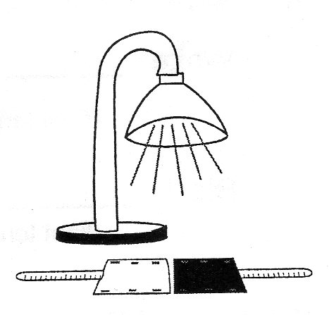
- Cut a 4 ¼ inch by 5 ½ inch square from black construction paper.
  - Or use ¼ piece construction paper by folding into fourths & cutting.
- Fold the square in half Hamburger style.
- Staple the two short sides of the square to form a wide, not long, pocket.
- Gently place the bulb end of the thermometer into the pocket.
- Repeat steps 1-4 with the white construction paper.
- Equally elevate both thermometer pockets by placing on top of a book covered with white paper. This will put the thermometers closer to the heat source to speed up the collection of data.
- The light should be pointed straight down, with the bulb area of the thermometers placed so that they receive equal amounts of light – see diagram above.
- Take a measurement of the initial temperature on the thermometers. Record these values in the data table below. NOTE: Temperature change may be small. Therefore, use .5 temperatures ( 23.5, 24.5, etc.) if appropriate.
- Every two minutes record the temperature of both thermometers in the appropriate place in the data table. Make sure to include labels for your measurements.
- During Data Collection:
  - First, go back and complete your hypothesis.
  - Second, begin graph set up by labeling axes, etc, but do not label the temperature axis with numbers until after data collection – to see how high the temperature will go.
  - Third, work on Part 2 of the Lab that begins on p.4 of the lab.

Data Table:
Temperature Measurements Taken Every 2 Minutes
Paper  Color | 0 min  (Starting Temp) | 2 min | 4 min | 6 min | 8 min | 10 min | 12 min | 14 min | 16 min | 18 min | 20 min
Black
White

Calculations: Subtract the starting temperature from the final temperature for each thermometer.

White: - =
(Final temperature) (Starting temperature) (Increase in temperature)

Black: - =
(Final temperature) (Starting temperature) (Increase in temperature)

Graphing the Data: Use the graph paper below to plot the temperature of both thermometers. Be sure to:
- Use increments that will allow the lines to use most of the graph area.
  - Label the axes with both a title and units of measurement.
    - X-axis is for the Independent Variable. In this experiment the Independent Variable is ____________________.
    - Y-axis is for the Dependent Variable. In this experiment the Dependent Variable is ____________________.
  - Do not start the temperature at 0ºC. Start at an even number a couple degrees below your starting temperature.
  - Use a different color pen or pencil for each thermometer. Make a key to show which color is which line.
  - Create a title for your graph.

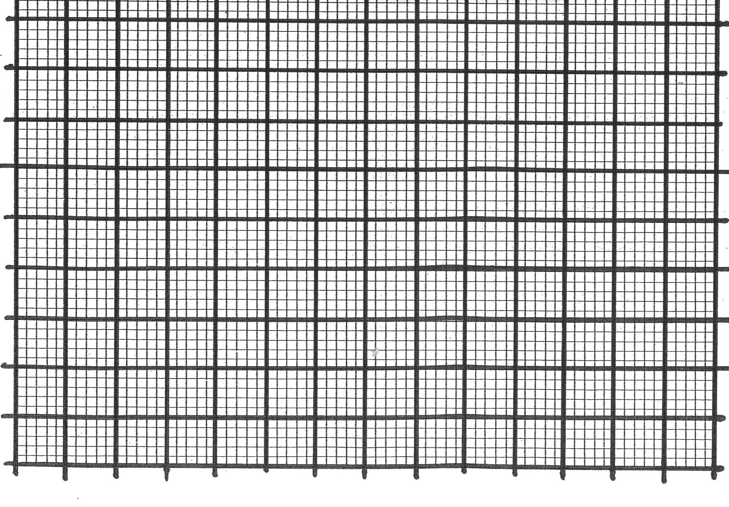

Analysis of Data:

- Which thermometer registered the warmest temperature?

- Which thermometer registered the fastest rise in temperature?

PART 2 of the Albedo Lab:
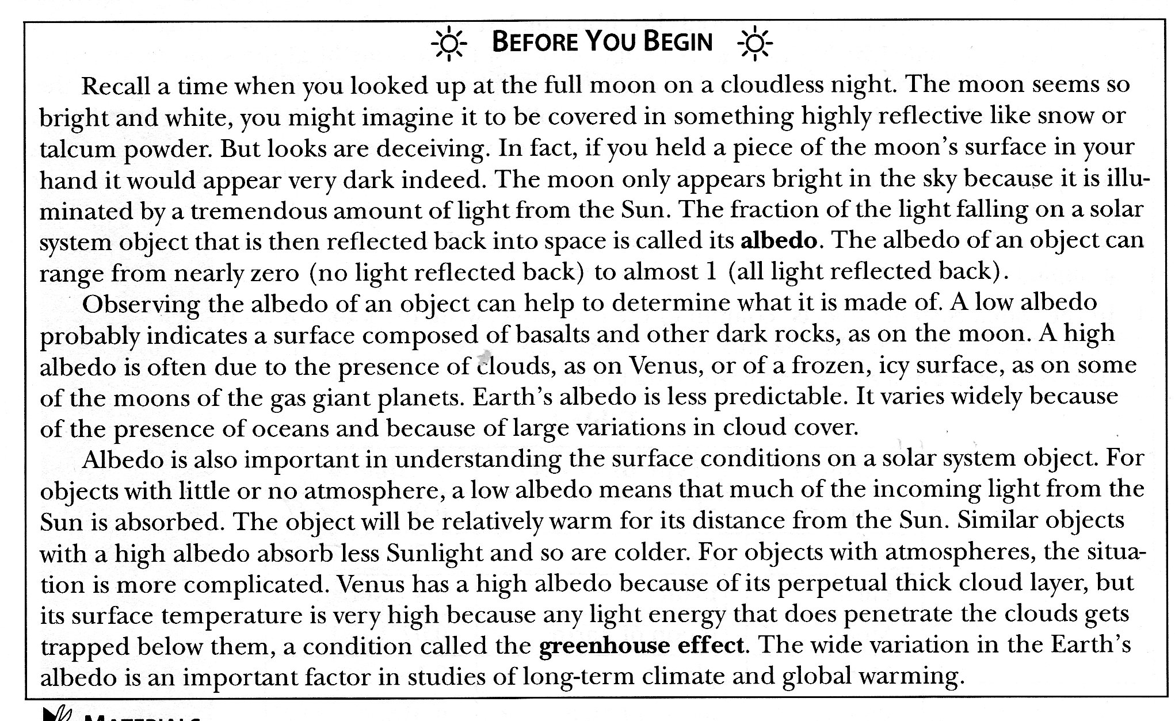
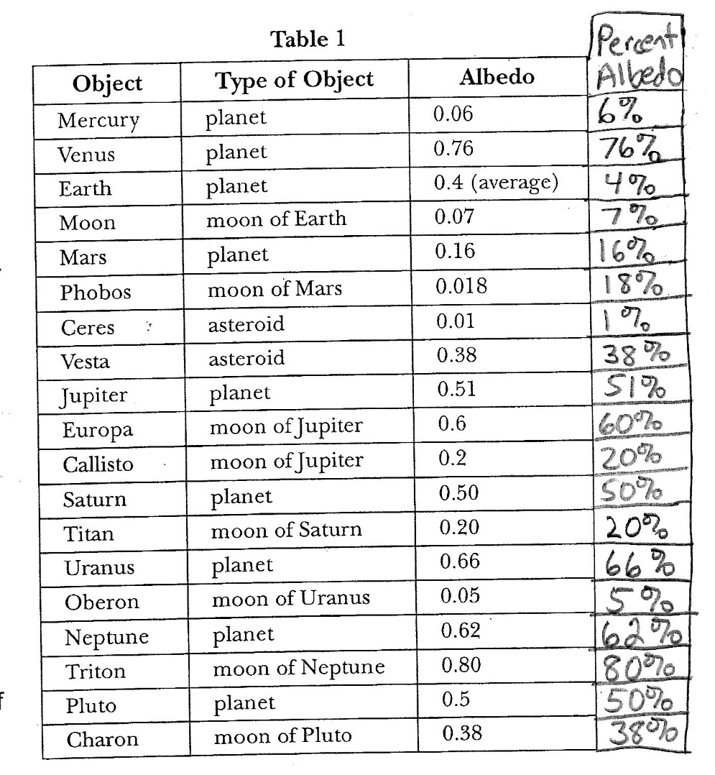
Procedure:
- Use the gray scale on the following page to determine the approximate albedo of objects listed below.
- Write the name of the object in the “Ordinary Objects” column of the Data Table.
- These objects can be compared to the albedos of various solar system objects.
Objects for Steps #1-3:
  - Black construction paper
  - White construction paper
  - Snow, if available (or frost from a freezer)
  - Basalt (rock found in maria of moon and bottom of the earth’s oceans)
  - Granite (rock found in mountains of continents)
  - Rhyolite (rock made of the same materials as granite, but the grains are so small you can’t see the individual colors.)
- In the “Solar System Objects” column of the data table, write the name of each solar system object in the row that best corresponds to its albedo. It’s OK to have more than one object in a single box in the data table.
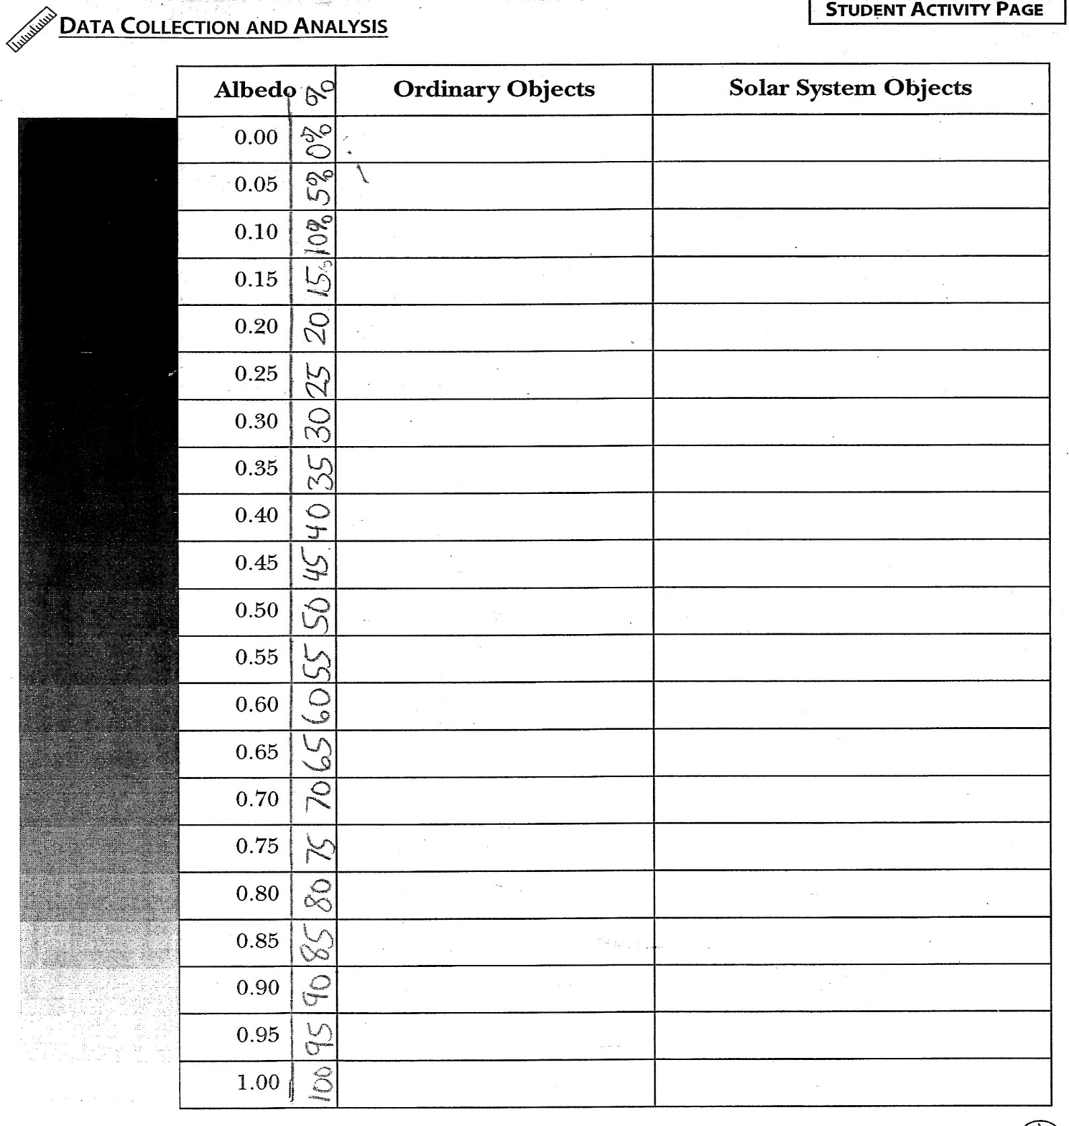

Concluding Questions

- Which solar system body in Table 1 has the

  - Highest albedo?_______________

  - Lowest?________

- Which of the common objects you measured has the ;

Highest albedo?_______________ Lowest?________

- Is the albedo of the moon more like that of

  - White construction paper or black?

  - Basalt or granite?

- Based on your knowledge of the features of the moon, which feature should have the higher albedo, highlands or maria? Explain your answer.

- Which of the features, highlands or maria, should become warmer when it is in the sunlight? Explain your answer.

:
- The moon appears very bright in our nighttime sky.
  - If you were to hold a moon rock in your hand, would you expect the rock to look light or dark in color? Explain.

  - Why does the moon look bright if it has such a low albedo? (See background reading.)

- Based on albedo, what can you infer about the composition of the surface of: (Use background reading)
  - Triton?

  - Mars?

  - Ceres?

- Examine the albedo of the Inner vs. the Outer Planets in the Albedo Table.

  - Inner Planets (Mercury, Venus, Earth, Mars). Which has the lowest & highest albedo?
    - ________________ has the lowest albedo of ____________.
    - _________________has the highest albedo of ___________.

  - Outer Planets (Jupiter, Saturn, Uranus and Neptune)
    - ________________ has the lowest albedo of ____________.
    - _________________has the highest albedo of ___________.

- If the Outer Planets are so much higher in albedo than our moon (7% albedo) , what might be some reasons we don’t see the outer planets very often? List at least 2 reasons.

Conclusion: Staple a piece of notebook paper to this lab. Write a paragraph that includes the following: ** Restate your hypothesis. ***Was the hypothesis supported or not? ***EXPLAIN your decision with data (numbers) from your lab. ***List one factor or error that COULD affect data in this lab, causing improper data – do this even if you don’t think there was an error in your lab.

