Name_______________________Period____
Chapter 17 Plate Tectonics
Review Study Guide

- Wegener used 3 major pieces of evidence to support his Theory of Continental Drift. List the types of evidence and explain how each one supports his theory.
(You will need to know this for the synthesis question on your test!!)

- Continental Drift wasn’t accepted:
  - Why wasn’t Wegener’s theory accepted when it was originally published?

  - What is the name of the process that is now used to explain what causes the plates to move and supports the Theory of Continental Drift. (The process in this question is not just convection.)

  - How does it work?

  - What evidence do we have that supports how we think it works?

- How are Continental and Oceanic Plates different?

 | Continental | Oceanic
Thickness
Density
- During the Seafloor Spreading lab (using the taped paper to represent magma coming up), an map of rock ages was made. Describe the characteristics of the map below:
  - Older/Younger rock location

  - Normal vs. reversed polarity

  - If given a map, how would you decide which color is normal polarity?

  - Compare the image on opposite sides of the ridge/map

- Fill out the table below regarding plate boundary interactions.
 | Definition | Example Location | Drawing/Illustration
Convergent
Divergent

- Choose which is happening at each of the following convergent boundary subtypes?
 | new crust is produced | Recycling old crust through subduction | Neither | Land Features Present (list multiple)
Oceanic – Oceanic

Oceanic – Continental

Continental – Continental

- Subduction:
  - Describe what happens during subduction.

  - Why does this happen?

  - What land feature is produced because of subduction?

  - What types of boundaries have subduction occurring?

- What feature forms when two pieces of ocean crust move away from each other; diverge?

- What feature forms when two pieces of continental crust move away from each other; diverge? (Hint: drawing a picture may be helpful when you are attempting to answer this question).

- Describe how convection plays a role in the Theory of Plate Tectonics. Be specific. Drawing a picture showing how convection is linked to plate movement and the different types of boundaries may help.

- What boundary type does not often have volcanoes? Why not?

- From the Seafloor Spreading lab, explain how new crust is made. Make sure to incorporate 2 ocean features into your explanation.

- Magnetic reversals:
  - How do magnetic reversals happen?

  - How do we know they occur?

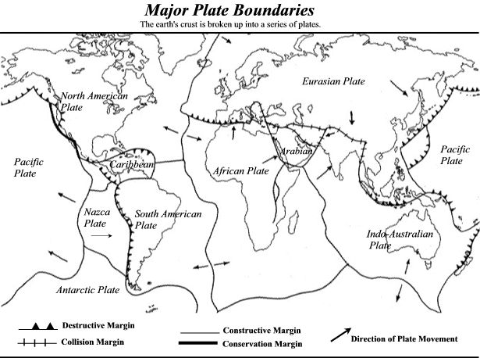

- Look at the map of the major tectonic plates of the world, and note the directions of the moving plates.
- Mark a specific location on the map where you would expect to see each of the following
- Then explain why you would expect to see those land features there:
  - A mountain range.

  - A rift valley

  - A deep sea trench.

- Look at the map above. Find the boundary between the Australian plate and the Pacific plate.
  - What type of a boundary is it?

- Doing some research, you find that that the boundary between the Australian Plate and the Antarctic Plate is a divergent boundary.

  - Draw arrows on the map indicating the direction each plate is moving.

  - What land features should be found at this boundary?

  - What process is causing those land features?

