Name_________________________ Period________

Chapter 28: Sun, Earth, and Moon Review Study Guide

Study & Prepare: Textbook reading & diagrams, objectives & notes from class, worksheets including their graphs & charts, Quizlet to print/review vocab words & their definitions, my website with links to review quizzes & videos to review the material.

- Briefly explain the most commonly accepted theory behind the formation of the moon. What does the theory say happened? Include both problems with the theory and why this theory is the one that is most commonly accepted.

- Define the following lunar surface features.
  - Highlands

  - Mare (Maria)

  - Ejecta

  - Regolith

- Compare and contrast to two main regions on the moon – the highlands and the maria. Make sure to include information about how/why each formed, their composition, their relative ages, and what you would expect them to look like today.

- Draw a picture of two moon craters that overlap. Which one would be older? How do you know?

- Both the moon and the Earth should have been hit with similar numbers of meteorites and other rocks over the years. Why are there so many craters on the moon but not really that many on Earth?

- What is albedo? Will a rock with an albedo of 20% be warmer or cooler than a rock with an albedo of 70%? Explain why.

- Why do we have seasons? Make sure to explain in detail, not just give a 1-2 word answer.

- Using the diagram below draw in where the most direct light is hitting for each of the “Earths”. Label the following important markers, adding lines to label if needed: Equator, Tropic of Cancer, Tropic of Capricorn, Winter Solstice, Summer Solstice, Fall/Autumnal Equinox, Spring/Vernal Equinox.
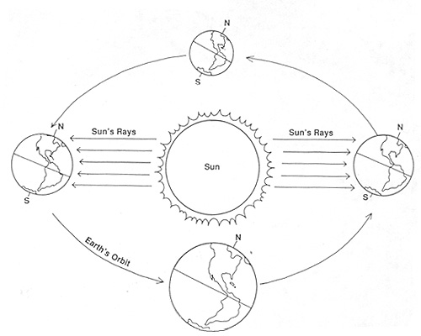

- If tilt and revolution are both required for there to be seasons, explain how the seasons would differ if:
  - First, what is the tilt of the Earth compared to its ecliptic?
  - There was no revolution:

  - There was no tilt:

  - If the Earth had a tilt of 45 degrees:

  - If the Earth had a tilt of less than 5 degrees:

- Fill in the following table.
Event | Day of the Year | Location of Direct Sunlight | Amount of  Day v. Night | Arctic Circle | Antarctic Circle
Summer Solstice
Autumnal (Fall) Equinox
Winter Solstice
Vernal (Spring) Equinox

- How long is a full moon phase cycle? Why does the shape of the moon appear to be changing over the course this many weeks – in other words, why do we see different phases?

- Draw and label a picture of each of the four different moon phases.

- Identify the umbra and penumbra in the picture below. Identify the location(s) on Earth that will be observing a total eclipse. Identify the location(s) on Earth that will be observing a partial eclipse. Is this a Solar Eclipse or a Lunar Eclipse (circle one)? How do you know?

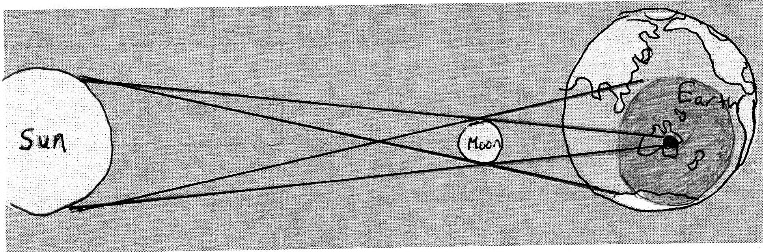

- Based on the math of number of lunar cycles and days in the year, a solar eclipse should happen 13 times a year. Why aren’t there that many solar eclipses every year?

- Explain how a lunar eclipse happens and why they are more common than solar eclipses.

- For each of the following terms, define and explain how the term is related to whether a solar eclipse is possible or not.
Term | Definition (or draw a diagram) | Relationship to whether a solar eclipse is seen or not
Ecliptic
Apogee
Perigee
- Tides:
  - What causes tides?

  - Does the sun or moon have the bigger effect on tides? Explain why.

  - At a specific location, how many high tides per day? __________ How many low tides? _____

- Spring Tides:
  - Draw the position of the Sun, Earth and Moon during a Spring Tide

  - Describe the high and low tides. Explain what causes the tides to be that way.

- Neap Tides:
  - Draw the position of the Sun, Earth and Moon during a Neap Tide

  - Describe the high and low tides. Explain what causes the tides to be that way.

- Synthesis: Use the following terms to explain why scientists believe that the highlands are older: Maria, Impact Craters, Basalt.

