Name_____________________Period____

Chapter 29 Solar System

- Draw simple pictures of what a heliocentric and what a geocentric solar system would look like.

- Who first proposed the idea of the heliocentric model of the solar system?

- Explain the discoveries or contributions of the following scientists to the field of astronomy:
  - Copernicus

  - Kepler

  - Galileo

  - Isaac Newton

- One of the problems with the geocentric model of the solar system was the fact that the planet Mars goes through retrograde motion. Describe what this means.

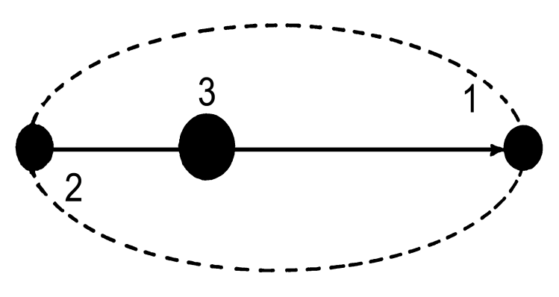
- Of choices 1, 2, or 3 in the picture to the right, where would the planet be at perihelion? Aphelion?

- Give a numerical value to the eccentricity of the orbit of the planet in the picture. Remember the values eccentricity has to be between, and identify which number this orbit would be closer to.

- What would happen to the eccentricity of the orbit pictured if the distance between the foci decreased but the length of the semi-major axis stayed the same?

- Describe the composition of a young interstellar cloud. What is it made of? (Include the main element(s) also.)

- What is the difference between asteroids, meteors, meteorites, and meteoroids?

- Comets:
  - Draw and label a diagram of the parts of a comet.

  - When do comets begin to glow? Why?

  - If you were given a picture of a comet, how would you know in what direction the sun was?

- Compare and contrast planetesimals vs. asteroids.

- What are the inner planets mostly made of? Explain why these planets are composed of these materials. Your explanation should contain the word “planetesimals.”

- Why aren’t the outer planets made of the same materials as the inner planets?

- Why do the outer planets have so many moons while the inner planets don’t?

