Name_________________________ Period________

Chapter 30: Telescopes, Stars & the Universe
Review Study Guide

- Describe a light wave’s frequency. Compare a light wave with a really high frequency to a light wave with a really low frequency. Draw a picture of each.

- Describe a light wave’s wavelength. Compare a light wave with a really long wavelength to a light wave with a really short wavelength. Draw a picture of both

- How are frequency and wavelength related? For example, if I have a light wave with a really long wavelength, what should I expect about its frequency?

- Using numbers 1 (the highest) to 7 (the lowest) rate the forms of light based on their amount of energy, level of danger, frequency, and wavelength. Use this 1 to 7 scale in each of the four columns below. **Use the EM Spectrum in your notes to help you!**

 | Energy | Level of Danger | Frequency | Wavelength
X-ray
Gamma
Infrared
Ultraviolet
Microwave
Radio
Visible Light

- Describe the composition of a young interstellar cloud. What is it made of? (Include the main element(s) also.)

- Describe nuclear fusion.

  - What is the beginning element?
  - What is the last element resulting from fusion in the core of a star?

  - There are many heavier/larger elements than those that can form in the core of a star – where does fusion occur that forms these larger elements?

- Make flow charts for the life cycles of high-mass and low-mass stars.

High Mass Stars

Low Mass Stars

- Which of the categories above (high mass or low mass) does our Sun fit into?

- How does this mean that our Sun will die?
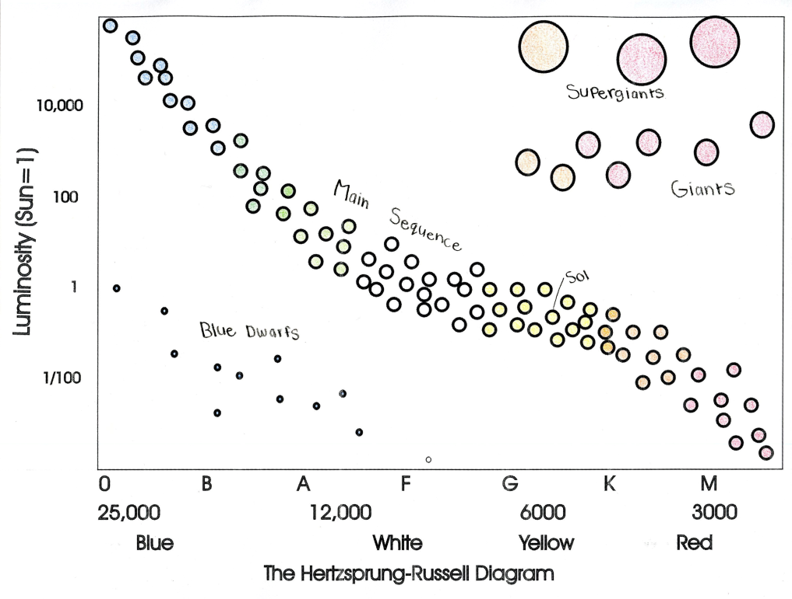

- Using the HR diagram above:
  - Circle the most luminous stars on the main sequence.

  - What color are the stars you circled in part a?

  - Put an ‘X’ next to the area with the least luminous star types on the main sequence.

  - What color are the stars in the area that you ‘X-ed’?

- What is the approximate temperature and luminosity of a “F-type” main sequence star?

- What are the 3 main characteristics that are used to determine the type of star?
1.

2.

3.

- What is the difference between absolute and apparent magnitude? Why is it important to use both of them when describing stars?

- According to the Big Bang Theory:
  - What was the size of the universe like at the beginning?

  - About how long ago did that size change?

  - How did the size change? What happened?

  - What are the two things that happened as the matter started to cool?

- What is the evidence that is currently used to explain the occurrence of the Big Bang Theory?

- One piece of evidence used for the expansion of the universe is “Red Shift”. What is a red shift? How can you determine/notice that a red shift is occurring?

- Draw two waves to represent how light would normally look and how it would look when it is going through a red shift.

