Name _________________________Period_________

Chapter 4 Minerals Review Sheet

- List the 5 characteristics that all minerals have. (NOTE – these are NOT tests like color, streak, etc.)

- Not a mineral:
  - Why isn’t sugar considered a mineral?

  - List another substance found below earth’s surface that is not a mineral. Explain why it is not a mineral. (See your notes.)

- Define each of the following tests.
  - Color

  - Luster

  - Texture

  - Streak

  - Hardness

  - Cleavage

  - Fracture

- Which of the tests above is the LEAST reliable? Why?

- What are the 2 main classifications of luster?

- Explain how you determine hardness.

- What are the 2 types of liquids that minerals can form from?

- What is the name for molten material:
  - Beneath earth’s surface?

  - On earth’s surface?

- What size of mineral crystals form if magma cools slowly?__________Cools quickly?__________

- What are the 2 main conditions needed for the formation of large crystals?

- Complete the following chart, listing the most common elements found in each of the following mineral categories.
Mineral Category | Elements Commonly Associated with the Category
Light-colored Silicates
Dark-colored Silicates
Carbonates

- What are the 2 most common elements in the crust of the earth?

- Many minerals come in a variety of colors.

  - What causes the color variation in Quartz & other minerals?

  - Does variation in color cause as difference in the geometric shape of a given mineral? (Hint- think of the Eggshell Geode Lab. What shape should both table salt, the clear Geode crystals and the colored geode minerals have been?)

- Explain in a short but thorough and detailed explanation how the 3 terms Cleavage, Hardness and Color can be used in the identification and differentiation of minerals.

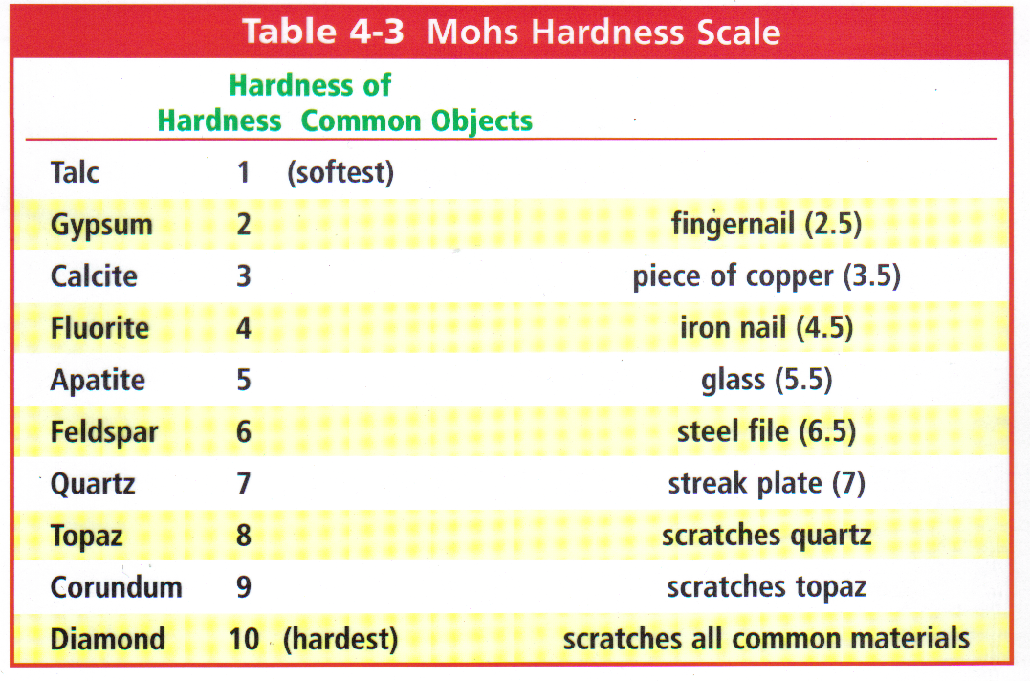
Use the Mohs Hardness Scale above to answer the next few questions:
- What does it tell you if a mineral scratches glass?

- If Gypsum is rubbed against Talc:
  - Is a scratch made, or no scratch?

  - Is a streak left behind? Why or why not?

- What happens if mineral with hardness of 3.4 is rubbed against the following. In other words, is a scratch made? Is there no scratch? A possibility of a streak?
  - Feldspar?

  - Calcite?

- A mineral scratches gypsum, but not apatite:
  - What is its possible hardness range?

  - How could you further determine its hardness? Be specific.

- Use the attached flow chart to identify the minerals with the following characteristics: (1 pt each)
  - Dark red color, fracture, non-metallic, does not scratch glass, red streak

Name of mineral is__________________

  - Black, magnetic, metallic, black streak

Name of mineral is__________________

  - Glassy, shatters when it breaks, hardness 7, scratches glass, non-metallic, pale pink color

Name of mineral is__________________ (If you’re not sure on this 1, is there something else you would look for?)

  - Breaks along a flat surface/plane, non-metallic, dark green, doesn’t scratch glass

Name of mineral is__________________
