**Chapter 21 Fossils & the Rock Record**

1. Fossils:
   1. What is a fossil?
   2. What conditions make it more likely that a fossil will form?
2. Index fossils
   1. What is an index fossil?
   2. What are the four criteria that make something an index fossil?
3. What does the Law of Superposition tell us about the relative age of rocks?

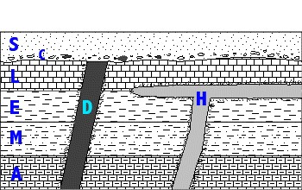

1. Star the letter of the oldest rock on the diagram to the right. Explain how you know it is the oldest
2. Circle the letter of the youngest rock on the diagram to the right. Explain how you know it is the youngest.
3. Is rock section “H” older or younger than rock section “M”? Explain.
4. 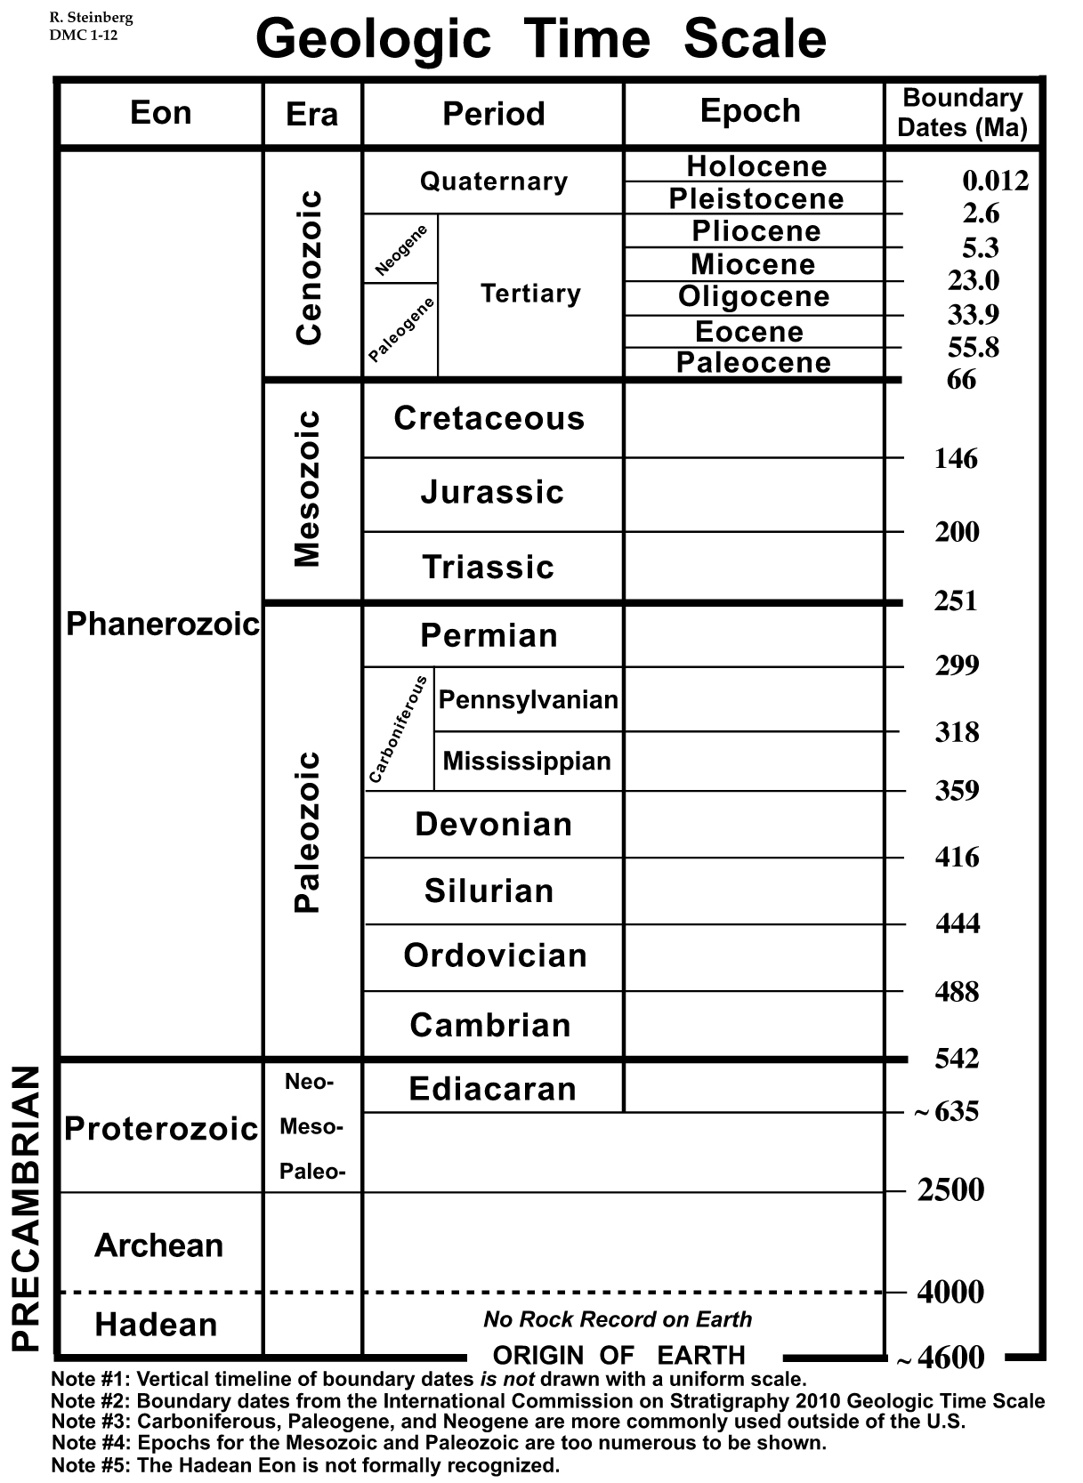Using the diagram to the right, what is the youngest period epoch in  
   in the Mesozoic Era? How do you know?
5. What are the 2 criteria that are used to divide up geologic

time (to decide when one era ends and another begins)?

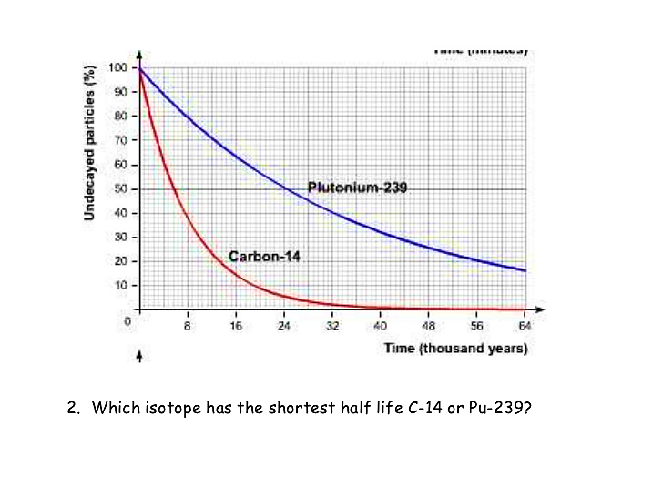

1. According to the graph to the right:
   1. What is the half-life of Carbon-14?
   2. What is the half-life of Plutonium – 239?

**Chapter 17 Plate Tectonics**

1. What indicates that the continents have moved? Describe the 3 different types of evidence that Wegener used to support the idea of plate tectonics.
2. Continental Drift wasn’t accepted:
3. Why wasn’t Wegener’s theory accepted when it was originally published?

1. What is the name of the **process** that is now used to explain what causes the plates to move and supports the Theory of Continental Drift. (The process in this question is not just convection.)

1. How does it work?

1. What evidence do we have that supports how we think it works?

1. Fill out the table below regarding plate boundary interactions.

|  |  |  |  |
| --- | --- | --- | --- |
|  | Definition | Example Location | Drawing/Illustration |
| Convergent |  |  |  |
| Divergent |  |  |  |

1. Choose which is happening at each of the following **convergent** boundary subtypes?

|  |  |  |  |  |
| --- | --- | --- | --- | --- |
|  | new crust is produced | Recycling old crust through subduction | Neither | Land Features Present (list multiple) |
| Oceanic – Oceanic |  |  |  |  |
| Oceanic – Continental |  |  |  |  |
| Continental – Continental |  |  |  |  |

1. Subduction:
2. Describe what happens during subduction.

1. Why does this happen?

1. What land feature is produced because of subduction?

1. What types of boundaries have subduction occurring?

1. What feature forms when **two pieces of ocean crust** move away from each other; diverge?

1. What feature forms when t**wo pieces of continental crust**move away from each other; diverge? (Hint: drawing a picture may be helpful when you are attempting to answer this question).

1. Describe how **convection**plays a role in the Theory of Plate Tectonics. Be specific.  Drawing a picture showing how convection **is linked to plate movement** and the **different types of boundaries**may hel
2. An Isochron map shows us the properties of the rocks around a ridge. (Remember the Seafloor Spreading Lab?)
   1. Draw an example of what an isochron map looks like – the map should include both sides of the ocean ridge.
   2. Now label the diagram you drew with the following labels: Oldest rock, Youngest rock, Normal Polarity, Reversed Polarity
   3. Now explain what causes the oldest rock and youngest rock to be located where they are.
   4. Now explain why the bands of polarity (direction the iron points) is a mirror image on both sides of the ridge.

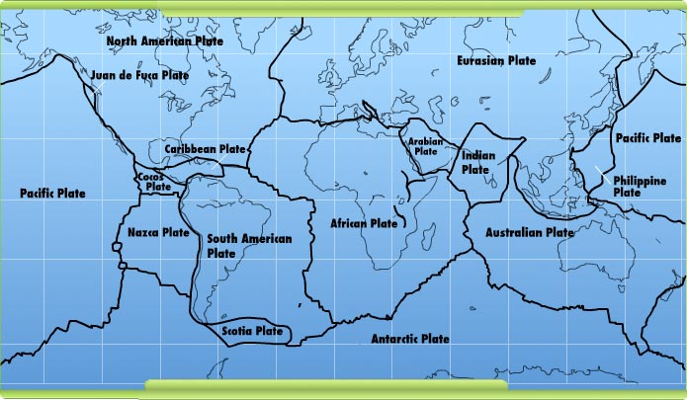

1. Look at the map of the major tectonic plates of the world, and note the directions of the moving plates.
   1. Explain where you might find a mountain range, a mid-ocean ridge, and a deep sea trench.
   2. Why would you expect to see those features there?
2. Doing some research, you find that that the boundary between the Australian Plate and the Antarctic Plate is a divergent boundary.
   1. Draw arrows on the map indicating which direction those two plates would be moving.
   2. What land feature should be found on that ridge?
   3. What process is causing that land feature?
   4. How could you figure out whether or not that process was actually occurring if you could go down there in a submarine with a magnetometer?

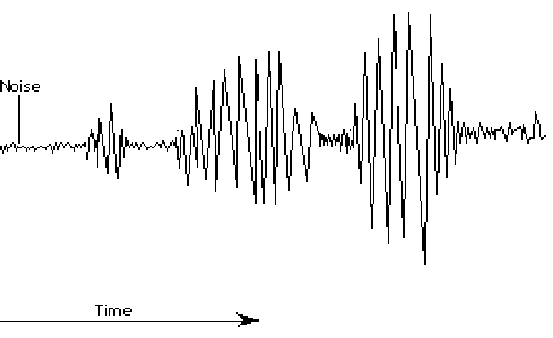**Chapter 19 Earthquakes**

1. Label the 3 wave types on the graph to the right. Explain how you know where to put the labels. Give two distinguishing characteristics of each wave type. (Characteristics might include speed, what happens to them as they hit a different type of material/layer of earth, amount of damage…)
2. 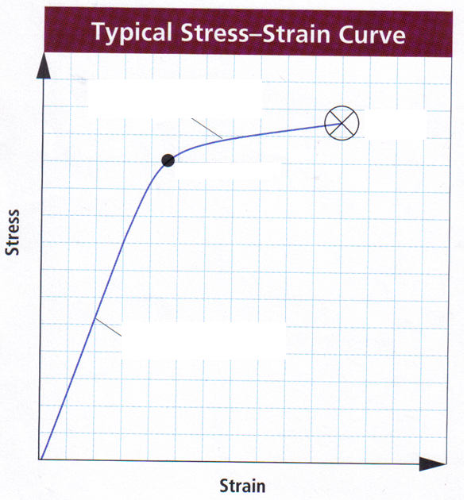Strain:
   1. Define the 3 types of strain and label them on the graph to the right.

2.________________

1.__________________:

3.________________

2.__________________:

3.__________________:

1.________________

* 1. Label the elastic limit.
  2. What happens after rocks reach their elastic limit?

1. Describe the layout of the Earth’s interior and draw a picture. Use your picture to help you to explain why we have shadow zones.
2. Compare and contrast the Richter Scale and the Mercalli Scale. Why do we use two different scales? Explain the numbering system of each scale. (NOTE – for similarities you cannot use that they are both scales or that they both deal with earthquakes.)

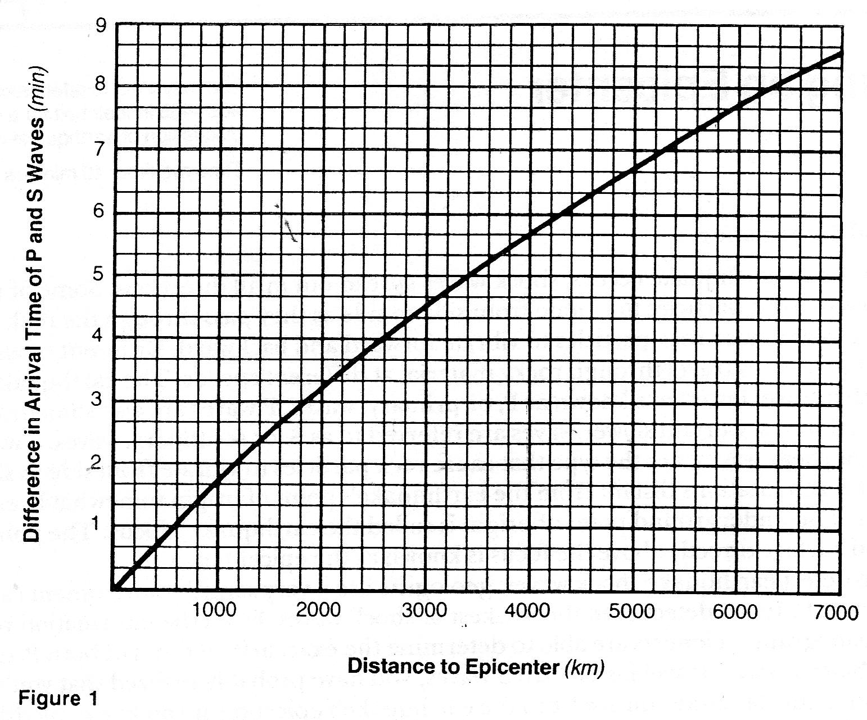

1. Figure 1 above shows the difference in arrival time of P and S waves in seconds. Use the graph to answer the following:
2. If the S-wave arrives 4minutes 30 seconds after the P-wave, how far is the seismic station from the epicenter?
3. If the seismic station is 5600 km from the epicenter, what is the difference in arrival time between the P and S waves?
4. 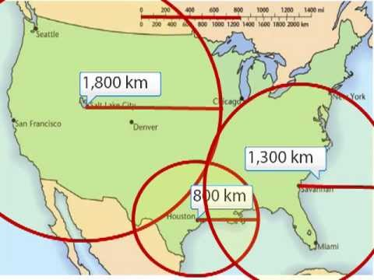Locate the epicenter of the earthquake measured by the stations in the diagram to the right. Explain why data from three stations are necessary to locate an epicenter.
5. Compare & contrast epicenter and focus. (It might be helpful to draw a picture.)