Chapter 4 Minerals

- List the 5 characteristics that all minerals have. (NOTE – these are NOT tests like color, streak, etc.)

- Define each of the following tests.
- Color

- Luster

- Streak

- Hardness

- Cleavage

- Fracture

- Which of the above is the LEAST reliable test? Why?

- What are the 2 main classifications of luster?

- Explain how you determine hardness.

- What is the name for molten material:
  - Beneath earth’s surface?
  - On earth’s surface?

- What size of mineral crystals form if magma cools slowly?__________Cools quickly?__________

- Which 2 elements are associated with the formation of dark silicates?
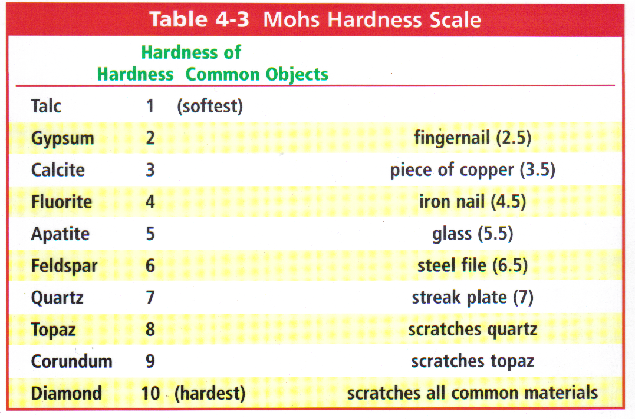

Use the Table above to answer the next few questions:
- What does it tell you if a mineral scratches glass?

- If Gypsum is rubbed against Talc:
- Is a scratch made, or no scratch?

- If a mineral with hardness of 3.4 is rubbed against feldspar:
  - Is a scratch made, or no scratch?

Chapter 5 & 6 Rocks
Igneous Rocks

- Fill in the Table below Regarding Extrusive and intrusive Rocks:
 | Where do these rocks form? | What do the rocks look like? (Describe Crystal Size) | Fine Grained or Coarse Grained
Extrusive
Intrusive

- Fill in the table below regarding igneous rocks and the magma they form from.
Types of Magma | Elements found in the magma | Viscosity of the magma | Rock Color | Type of Volcanic Hazard Produced
Light-colored

Dark-colored

- What would happen if you added water to light-colored magma?

- What affects the color of an igneous rock?

- What would you have to do to a sedimentary rock covered in fossils to produce an igneous rock?

Medium Color
Light-Colored
Dark-Colored
Really Dark
- Using the diagram above, describe the following about Rhyolite:

  - Color:

  - Texture:

  - Location where it formed:

- List and Define two processes that must be present to form an igneous rock?
1.

2.

SEDIMENTARY ROCKS:
- What is a “sediment”?

- What are the 3 subtypes of sedimentary rocks?
**For each type, tell how the subtype forms.

c.

- How is weathering different from erosion?

- Describe the 2 types of weathering that can occur in nature and provide an example of each.
**Make sure you are able to explain what your example is and how it works.
- Physical/Mechanical

- Chemical

- Define deposition:

- Lithification:
- Define lithification:

- How do you know when lithification has occurred?

- List and describe the two steps that occur as a part of lithification.

- What would need to happen to obsidian to turn it into sediments?

- After the obsidian turns to sediments, what must happen to them to produce a sedimentary rock?

METAMORPHIC ROCKS:
- What two factors are needed to form metamorphic rock?

- Fill in the table below regarding Metamorphic Rocks.
Types of Metamorphic Rocks | How was the rock formed? | Describe and/or draw the appearance of the rock.
1.

2.

Rock Cycle:
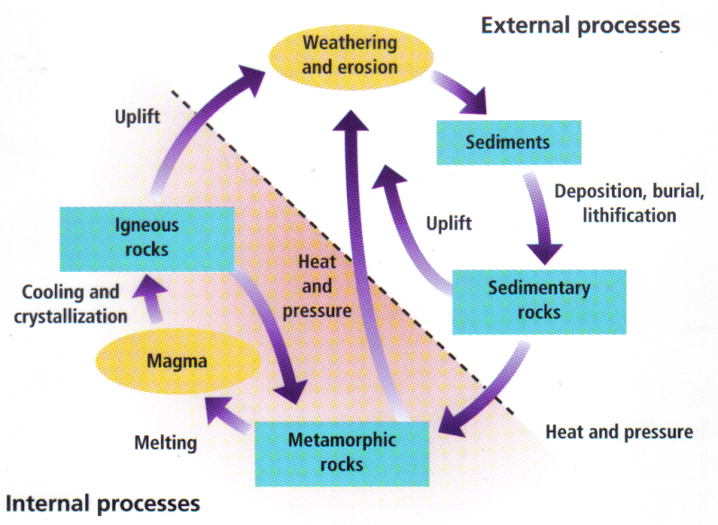
- Marble is a metamorphic rock. Using the diagram on the previous page, list ALL the processes marble must go through to become: (On the final exam, be able to define each process)
  - An igneous rock

  - A new metamorphic rock

  - A sedimentary rock

- What types of rocks can turn into sedimentary rocks?

Rock Cycle Comparison Matrix
 | Sedimentary | Igneous | Metamorphic
Environmental  Controls & Rock forming processes | Erosions and deposition  - Compaction  - Cementation  - Crystallization | Cooling of magma | Heat and pressure
Types of Rocks | - Clastic  - Chemical | - Intrusive  - Extrusive  - Felsic  - Intermediate  - Mafic | - Foliated  - Nonfoliated
Area of formation | 1. At the surface | 1. Below the surface  and  2. At the surface | 1. Below the surface

