Name________________________________Period_______
Activity: Introduction to Climate Mapping
Overview:
Understanding Earth as a system requires an exploration of the connections among various parts of the system. Environmental processes take place in and between the atmosphere, oceans, fresh water, ice soil, and living components. The processes also include energy from the Sun, and particles and gases that enter the atmosphere and oceans from both natural and human-caused sources. In this activity, you will examine connections related to weather and climate throughout the system we call Earth.

Student Goals:
- To explore the concepts of Earth as a system.
- To discover, analyze and interpret patterns in mapped data.
- To identify global climate patterns.
- To communicate observations and explanations.

Map Variable: (Note: Insolation = Incoming Solar Radiation)

- Circle YOUR Map Variable: Insolation / Temperature / Rainfall / Vegetation

- Circle YOUR Map Month: January / March / May / July / September / November

Part #1 Exploring SINGLE Images:
**Each group is examining one variable.
**Each person has a map of a DIFFERENT month.
**There will be two groups for each variable. One with Jan, May & Sept maps. Other with March, July, Nov.

- Reading the scale bars. Note: If your map has more than one scale bar, list the following for BOTH scale bars in the empty space below.
**This question can be completed together as a group.)
  - What is the title above the scale bar(s) at the bottom of your map?
  - What is the range of values shown on the scale bar(s)?
  - What unit is your variable measured in?

- Data Extremes. Where on the earth do you find the highest and lowest values (the extremes) of the data in your images?
**Each student should examine his/her OWN map and complete the following questions individually as each map is a different month.
**Include and explain, if appropriate:

- Does it vary with latitude? Explain using 0º, 22ºN, and 45ºN latitude. May use qualitative terms such as “low, medium, high amount” if appropriate to compare the latitudes.

- Are patterns different on different continents? Explain.

- Does it vary over ocean vs. over continent at the same latitude? Explain.

- As a group, list 3 similarities between all maps in your group.

- As a group, why do you think these similarities exist?

- As a group, list one difference between your maps and explain what might cause the difference.

Activity #2 Exploring Annual Changes - Procedure
- Now, arrange your maps in chronological order, beginning with January.
- Locate 45ºN 90ºW on each map and complete the appropriate column in the data table below.
- Locate 45ºN 45ºW on each map and complete the appropriate column in the data table below.
- Now, join with the “other” group that had your variable and complete the rest of the table.
- Graph the data for each location on the appropriate graph on the last page.
 | 45ºN 90ºW  Variable:_________  Units: _________ | 45ºN 45ºW  Variable:_________  Units: _________
Jan
March
May
July
September
November

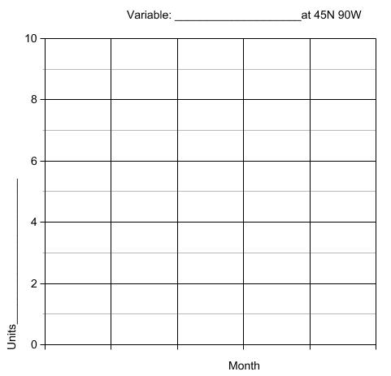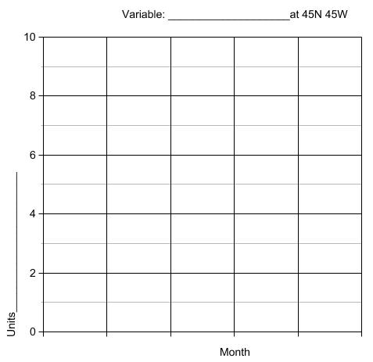
Questions
- Is 45ºN 90ºW over a continent or an ocean?

- Is 45ºN 45ºW over a continent or an ocean?
- Summarize similarities and differences between the 2 graphs. Does the presence of land vs. water appear to make a difference? EXPLAIN.

- Examine the graphs to determine changes that occur throughout the year.
  - During which months does the highest values occur?

  - During which months do the lowest values occur?

  - What explanations can you suggest for the timing of those extremes?

Correlating the Graphs as a Class:

Select different group members to:

Group #1 for each variable:
- Copy the 90W graph onto the class graph.
- Verbally summarize the answers to questions #3-6 from Activity #1

Group #2 for each variable:
- Copy the 45W graph onto the class graph.
- Verbally summarize questions #1-2 from Activity #2

Activity #2: Class Discussion
- Examine the graphs and describe apparent correlations and relationships, if any, between the variables
- Do the relationships appear to be directly or inversely proportional?
- Write the correlations the class discusses below:

  - Insolation and Temperature

  - Temperature and Vegetation:

  - Temperature and Precipitation

  - Precipitation and Vegetation:

- Project Cloud Cover Maps – any correlation between cloud cover and latitude? Explain

