Name_________________________Period_____
Note Outline: Climate & Climate Change

Objectives
- Compare & contrast weather vs. climate.
- Explain why climates vary. This means I can:
  - Explain the effect of the following natural events on climate: the sun, volcanic eruptions, latitude, elevation, mountains, large bodies of water.
  - Explain how the angle of solar radiation causes 3 main climate zones according to latitude: polar, mid-latitude (temperate), and tropical.
- Describe how tropical moist, dry, moist mid-latitude with mild winters, moist mid-latitude with cold winters and polar climates differ in temperature, precipitation, and amount of vegetation.
- Diagram the movement of Carbon through the four “spheres” of the Earth’s systems; lithosphere, hydrosphere, atmosphere and biosphere.
- Diagram the water cycle within the hydrosphere.
- Apply the terms “positive feedback” & “negative feedback” to ice ages, global warming & climate change.
- Compare and contrast the greenhouse effect and global warming. This means I can:
  - Explain why the greenhouse effect is necessary for life on earth.
  - Explain what 4 main gases are associated with the greenhouse effect and how human activities have altered their levels and contributed to global warming.
- Explain causes and effects of climate change. This means I can:
  - Differentiate natural vs. human actions that lead to climate change.
  - Explain human influence on climate and list several human activities that could be causing global warming.
- List and describe the effects of climate change on; temperature, sea level changes, severe weather events (storms, drought…), ocean acidification.
- Describe strategies to limit human impact on climate.
- Explain the cause and effects of El Nino on currents and climates of Australia and South America.

Weather vs. Climate

- Weather = Conditions of atmosphere at a ________________________________,

or a__________period of time (days).

- Climate = Long-term _______________ of weather (Averaged over 30 years)

- Example:
  - What is the current weather in Bettendorf?

  - How would you describe the climate of Bettendorf?

Factors Which Create Climate Zones

Many factors affect climate:
- Sun
  - Radiation given off by the Sun
  - Latitude affects amount radiation received
  - Solar radiation absorbed or reflected
- Volcanic eruptions
- Elevation (mountains)
- LARGE bodies of water (oceans)
  - Coastline vs. inland
  - Ocean currents
- Wind (global patterns)

- THE SUN:

Sun: #1 Radiation GIVEN OFF by the sun

  - The amount of radiation given off by the Sun varies

  - Sunspots = _________________ that erupt & send solar _____________________________ into space

  - 11-year cycle.

  - ____________ sunspots causes________________ temperatures

  - ____________ sunspots causes ________________ temperatures

    - “The Little Ice Age” from 1350- 1900 in Northern Hemisphere was due to reduced solar activity. (2ºC/4ºF lower)

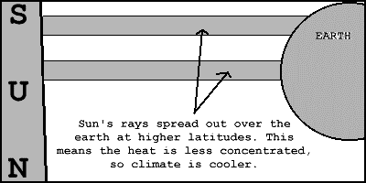
Sun: #2 Latitude affects radiation RECEIVED

- The further you travel from the equator the cooler it gets. Why?

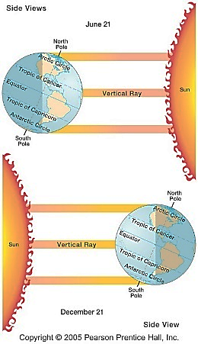
  - Because Earth is _____________ and the sun’s rays hitting at a

_________________latitude are ____________________ ,

meaning they are __________ over a greater area.

    - Equator has _____________ rays (__________ latitude numbers)

    - Poles have_______________ rays (__________ latitude numbers)

  - Because Earth is ______________ in its orbit around the sun.

- During part of the year, each pole is tilted ____________ from the

sun and receives _______ sunlight.

Sun: #3 Surface Features determine if radiation is REFLECTED or absorbed
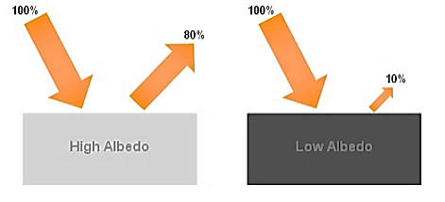

  - What color do you wear on a sunny day to stay cool? Why?

    - ______________ clothes ______________sunlight.

  - What is hotter for your feet on a sunny day; asphalt or cement? Why?

    - Instead of reflecting light, black ______________ sunlight and becomes ______________________

  - Predict the relative amount (lots, very little) of sunlight reflected for:

    - Snow, Ice? ________

    - The poles are cold not just because of their latitude and the low amount of sunlight received, but also

because their ice______________________ much of the sunlight that is received.

    - Water, soil, vegetation?______________

Positive vs. Negative Feedback Loops

- Positive Feedback Loop: ___________________ & makes changes more ___________.

- Negative Feedback Loop: Brings system ____________________________________

Ice Age Positive Feedback Loop

  - ___________sunspot activity = _______________ temperatures

  - Low temperatures = ___________________ snow & ice accumulation

  - Snow & ice _______________ more solar radiation = Earth’s temperature becomes ___________________

  - “Positive Feedback Loop” = ____________________ the change and cold temperatures become
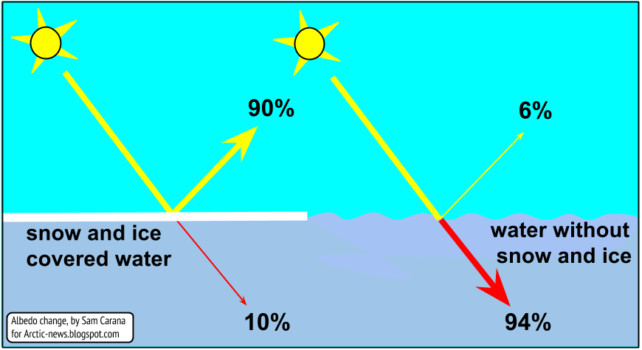
___________________ during the Ice Age

Is This Exaggerated Cooling What Is Happening Now? NO!!!

NOW, as climate is warming, the reverse is happening:

    - Warmer temperatures = __________________ in snow & ice coverage.

    - Melting =_________ & ________________ surfaces ___________________ radiation

    - Less reflection = _____________________________________ = a _________________ Earth

    - Another Positive Feedback Loop - this time causing _________________________________
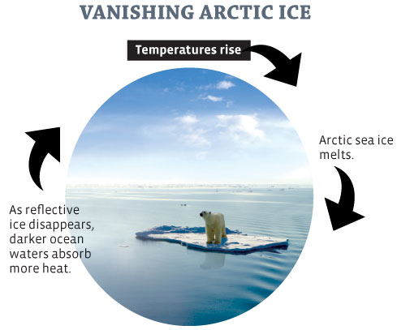
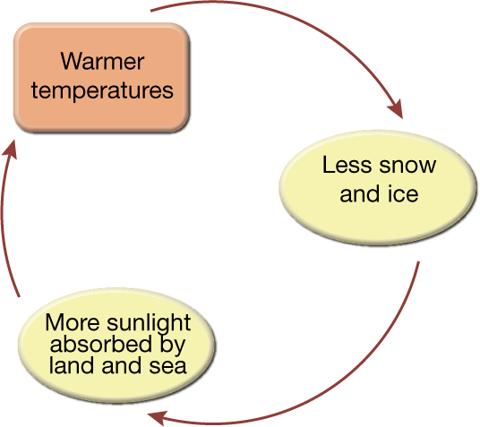

- Volcanic Eruptions

  - Large eruptions release ___________________into atmosphere.

    - Aerosols = small particles

    - Examples of volcanic aerosols: _____________________

  - Aerosols _________________solar radiation and cause ___________-term __________for only a few years.

    - Short term because the aerosols gradually settle out and don’t stay in the atmosphere.

- Elevation (Mountains)

  - Mountain climates are __________________, as atmospheric temperature ___________________with height

  - High elevations may allow______________ to form in the _________________

  - One side of the mountain is______________ than the other
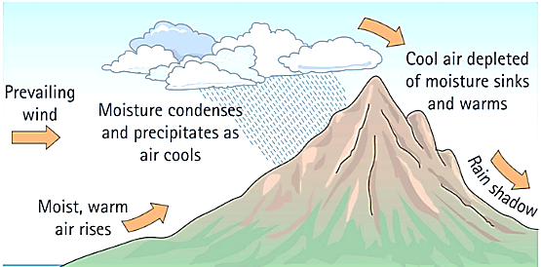

- LARGE bodies of water (oceans, seas)

The graph below shows the average monthly temperatures for two cities, A and B, which are both located at 41ºN latitude and should receive the same amount of solar radiation.

- Why is there a difference in the average yearly temperature range for the two cities?
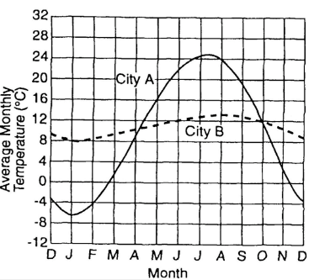

    - Because City A is located ____________________ and

    - City B is located near _______________________

  - Coastline vs. Inland Climate

    - Water heats and cools _____________________ than land, therefore it doesn’t get as cold in the winter or as warm in the summer as land does.

    - Coastline cities are _________________ by the breezes coming off the water & don’t get as hot in

the summer or as cold in the winter. They have a more ________________ climate

    - Inland cities have a ____________________ climate, both ___________ in summer and _________ in winter, than cities on the coast at the same latitude.
  - Ocean Currents
    - Ocean currents move Earth’s heat energy around

    - The effect of ocean currents on the climate depends on the direction the current _________________

      - __________ the _________________, ______________ water is moved towards the poles

      - __________ the _________________, ______________water is moved towards the equator
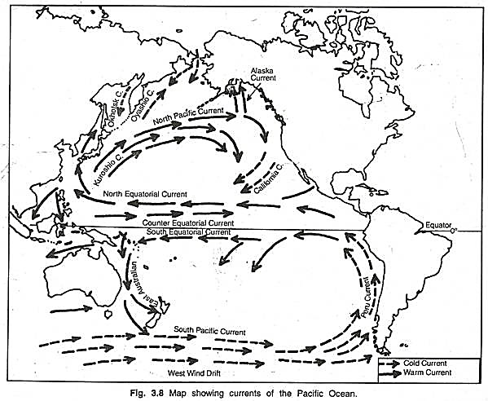

- Wind: Global Wind Patterns

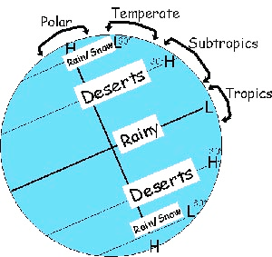
  - Global wind patterns which affect _____________________

    - _________rain & ______________ at ________latitudes (ie 0º Equator)

    - _________ rain & ______________with little vegetation at 30º Latitude

  - Mid-latitudes (ie. Iowa) – Our weather comes from the_____________

  - Tropical – Hurricanes come from the ______________

Climate Classifications

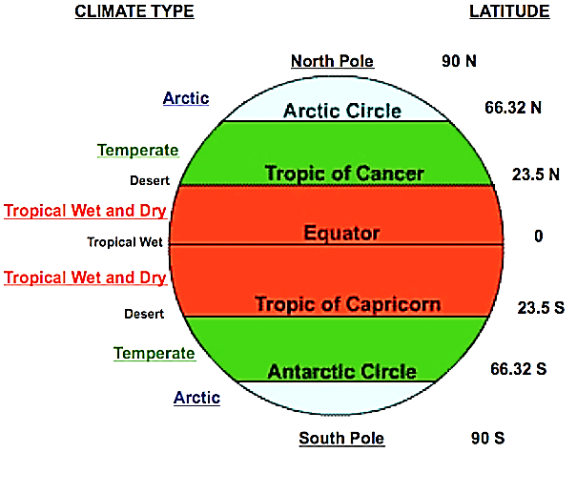
- Based on THREE main characteristics

- ______________________ – monthly and annual averages

- ______________________

- ______________________

- Tropical Moist: Year-round average temperature above 65ºF (18ºC)

  - Between what latitudes is this located? ______________

  - Cause of high temp year-round? ___________________

  - Cause of moist climate? __________________________
- Dry Climates: Low/deficient precipitation year-round

  - At what latitude do most of Earth’s deserts occur? _________

- Moist Mid-Latitude with Mild Winters

  - Latitude range? ______________________

  - Cause of Mild Winters?__________________________

- Moist Mid-Latitude with Cold Winters

  - Latitude range? ___________________

  - If the latitude range is the same as the climate with mild winters, describe how the location of the climate with cold winter is different: _______________________________

  - ONLY mid-latitudes 30-60N/S (both mild & cold winters) have _______________________.

- Polar: Extremely cold winters & summers

  - Latitude range? ________________________

  - What is the main reason it is so cold? ___________________

The Four Spheres/Systems of Earth
Earth can be divided into 4 systems that each has a specific role in keeping Earth going, the storage of carbon, and weather and climate.

The 4 systems/spheres of Earth are:
- Lithosphere
- Hydrosphere
- Biosphere
- Atmosphere

Read the last two pages of your note outline and answer the corresponding questions below for each system and for the carbon cycle.

Lithosphere
- What makes up the lithosphere? (List 4 components)

- What is the major cycle in the lithosphere?

- When fossils in sedimentary rocks are put under intense heat and pressure, what do they turn into? Be specific and detailed.

Hydrosphere

- How much of the Earth is covered by bodies of water?

- What is water in the atmosphere called?

- What happens when water vapor in the atmosphere is cooled?
Biosphere
- List 4 examples of parts of the biosphere.

- “Bio” means life. Are only living organisms included in the biosphere? Explain.

- Life cycles and food chains are important cycles found within the biosphere. What cycles from outside the biosphere are important to the biosphere? List 3.

Atmosphere
- When it is said that the atmosphere acts like a greenhouse, what does that mean?

- What are the 2 main gases, and their percentages, in the atmosphere?

- Greenhouse gases:

- What 3 gases are very good at trapping heat?

- Greenhouse gases (GHGs) make up what percent of the atmosphere?

- How much does their concentration need to change to make a difference in Earth’s climate?

Carbon Cycle

- Which “sphere” contains the most carbon, and what is it found in?

- In what are “hydrocarbons” found, and what are they formed from?

- Carbon in the hydrosphere.

  - What part of the hydrosphere contains the most carbon?

  - Describe 2 forms the carbon found in that location.

- Carbon in the biosphere:

  - How much carbon is found in the biosphere?

  - In what form is it found? List 2.

- Carbon in the atmosphere:

  - How much carbon does the atmosphere have compared to the other 3 systems/spheres?

  - In what 2 forms is most of the carbon in the atmosphere?

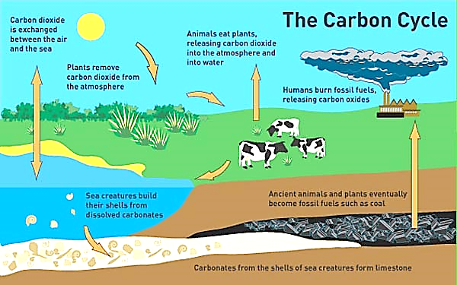
Carbon Cycle Diagram

Greenhouse Gases & Their Sources
There are 4 main greenhouse gases: CO₂, CH₄, N₂O, & water vapor

- Carbon Dioxide, CO₂

  - Today, only 5% of CO₂ in the atmosphere comes from natural processes such as animal breathing, etc.

  - 95% of ATMOSPHERIC CO₂ comes from __________________________ such as combustion (burning)

of ___________________________for electricity, transportation, industry…

  - Most abundant ________________________________ GHG

- Methane, CH₄

  - Compared to CO₂, much less CH₄ is in the atmosphere.

  - BUT it can trap ___________________ more heat than CO₂

  - YET, it has a_________________ lifespan and breaks down

  - Source of includes; livestock __________________________, waste decomposition in landfills,

______________________________________…

- Nitrous Oxide, N₂O

  - Only small amount in the atmosphere

  - BUT it can trap __________________ more heat than CO₂

  - Natural sources: Soil and oceans release N₂O into atmosphere

  - Human sources: Agriculture, _______________________________ in motor vehicles

- Water Vapor, H₂O

  - Is the _________________________ GHG in the atmosphere

  - Has the___________________ impact on temperature compared to all the other GHGs

  - Traps ____________ of all the heat trapped in the atmosphere

  - Water vapor is constantly ________________ between the hydrosphere, atmosphere, and biosphere.

  - Changes in its movement between the four systems could have big impact on the warming and cooling of the atmosphere.

    - Yet, water vapor levels have been constant throughout history, so it doesn’t appear to be responsible for the warming Earth is undergoing.

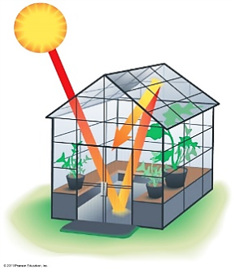
Greenhouse Effect vs. Global Warming

- Greenhouse Effect –

  - Traps _____________________heat to keep Earth at a habitable temperature

  - We ______________the Greenhouse Effect

- Global Warming

  - __________________ in Earth’s global temperatures __________________the Greenhouse Effect

  - Primarily due to ________________________ levels due to ________________________________

  - Since the Industrial Revolution, CO2 levels have _________________________

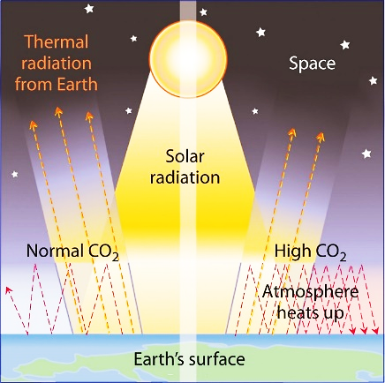

Climate Change: Positive vs. Negative Feedback Loops

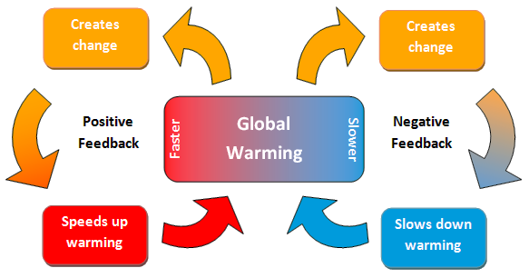
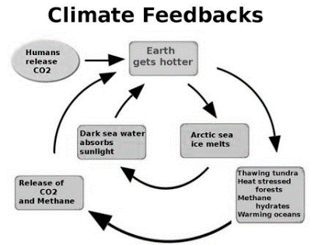
Positive Feedback – Global Warming
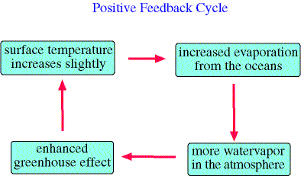

?Negative Feedback? – Global Warming

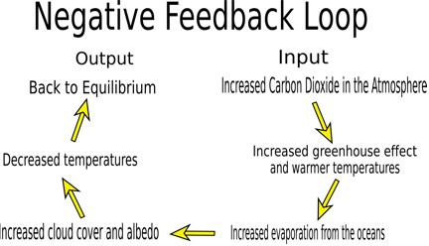

& more sunlight is ___________

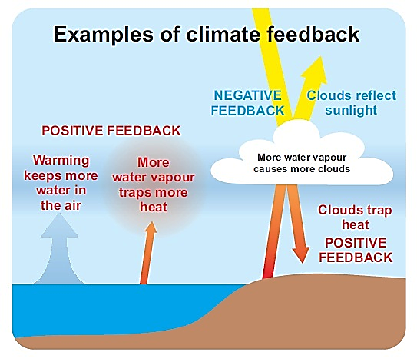
Global Warming Debate

Climate is affected by many factors. It is difficult to predict because:

- _____________to test climate in laboratory.

- Use _________________________ to predict.

- Debate – Which of the following will increasing water vapor create?

  - Positive feedback: Increasing H2O vapor will _______________________and warming will continue?

  - Negative feedback: Increasing H2O vapor will __________________________ causing temperatures to stabilize?

Effects of Climate Change

It is believed that increased levels of Greenhouse Gases is leading to the following changes:

- Temperature changes
- Sea level changes
- Weather event frequency changes
- Ocean acidification changes

Temperature Change
- Both land & ocean temperatures are __________________

- Land temperatures are increasing more than water temperatures. WHY?

  - Water can absorb more thermal (heat) energy ________________________________.

  - Water heats up ______________________ than land.

- More _________________________ are affecting the mid-latitudes (Us in Iowa!)

- Amount of sea ice, glaciers, permafrost has _____________________due to __________________.

  - As permafrost thaws it releases CO₂ & CH₄, BUT it is difficult to know how much is being released – significant or not?

Sea Level Change

- Sea level has ____________ worldwide 12-22cm.

- As oceans warm, the water particles move faster and the water’s ______________________________.

- Melting of glaciers and ice sheets ______________________________, causing sea level to ____________.

Weather Event Frequency Changes

- What is an extreme weather event?

  - Extreme weather event = ____________________________, increased frequency of _____________

- Mid-latitude U.S. changes:

  - Increased heavy precipitation

  - Winter snow sometimes now falls as rain.

- Mediterranean & Africa

  - ________________ have increased

- Other:
  - Hurricanes:
    - Increased hurricane ______________ (not number of hurricanes) due to ______ ocean waters

    - Move further towards ______________ before stopping

Ocean Acidification Changes

- Oceans, as discussed previously, are a natural reservoir for carbon

- In the past, oceans have been able to __________________________________________ as it was produced.

- As CO2 is absorbed, the ocean becomes more __________________

  - Scientists predict increased acidity will affect the formation of _____________________, crabs,

snails, clams and thereby affecting the __________________________system

- Oceans will _________________ to keep absorbing CO2 at the rates it is being added to the atmosphere.

Strategies to Limit Climate Change

Strategies are aimed at __________________________ emissions. Strategies include:

- Using energy sources that do not emit carbon; __________________________________________

- International awareness, but there is a ___________________ between developed vs. developing nations.

  - Developing nations.

    - They have ____________________ to pay for the controls needed. Money spent to limit greenhouse gas production would hurt their efforts to their citizens and country out of poverty.

    - Developing countries argue that the current climate change was caused by developed countries – developed countries should pay.

- Developed countries:

  - Think developing nations would have an economic advantage if developing countries don’t have to follow the same regulations.

- Personal awareness

  - What is YOUR “carbon footprint”? How can you decrease it?

REVIEW: Upwelling (Prior to Discussing El Nino)

Upwelling: Upward motion of ocean water
  - Cold because it originates at the bottom of the ocean
  - Usually occurs on the west coast of continents in the area of trade winds
  - Rich in nutrients, supports abundant marine life
    - Good fishing off of Peru & California

El Nino 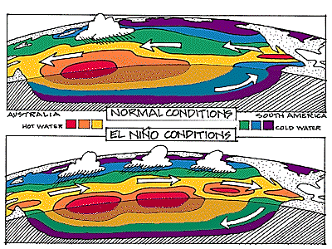

- El Nino is an unusually ___________ ocean current off the ______ coast of __________America

- Cause of El Nino:

    - Equatorial winds blow from____________ to ________________

    - This is __________________ of the normal equatorial winds

    - The winds push __________________air east towards __________________________

- Effects on climate of South America:

    - Causes the _____ coast of South America to be ___________ and __________ than normal

    - _________________. Commercial fishing __________________.
- Climate changes in United States

  - Brings ____________________________ to California & SW U.S
.
  - ____________________ winters for all of U.S., including Iowa

  - BENEFIT of El Nino: Upper winds ______________tropical disturbances from becoming

______________________, at least in the SE

- Climate changes in Australia:

  - ______________________ instead of the usual rain

- SUMMARY of all the climate changes:

  - Brings _______________________ to normally dry places

  - Brings _________________ to places that normally have lots of rain

