Name___________________Period___

LAB: 2-D CONTOUR MAP to 3-D MODEL DATA REPORT

Background/Overview: Students will explore the concept of topographic maps and contours by creating a 3-D model from a topographic map.

Objectives: Students will:
- Determine the elevation of contour lines when given an index contour and the contour interval.
- Create a 3-D model of the area represented by a 2-D Topographical Map.
- Understand how 2-D maps show 3-D elevation changes on Earth’s surface.

Prelab Questions:
- Define the following words:
  - Contour line:

  - Contour interval:

  - Index contour:

  - Depression contour:

- Tape a small copy of the map your group was given in the space below.

- Mark the elevation of each contour line on the map above using the following information:
  - The outside contour line is at 120m above sea level. Mark the outermost line as 120m
  - The contour interval is 20m. Determine the elevation of all remaining lines and mark them.

- Based on your map:
  - Mark a “F” on your map where the land is the most FLAT (or most gently sloped)
  - Mark a “S” on your map where it is the STEEPEST.
  - In the space below, explain how you know where it is flat AND where it is steep.

Day 2 – Post Lab Questions
- The teacher will show two 3-D models from different classes of the same map.
  - How are the 3-D models similar?

  - How are they different?

  - What errors might cause the differences?

  - What did the play-dough squares (or beads) between the contour layers represent?

- How might topographic maps be used? (Think of who might use them and when. Knowing elevation changes might help prepare for what type of activities? List at least 2 activities.)

- When could you use information about contour lines or maps in your own life?
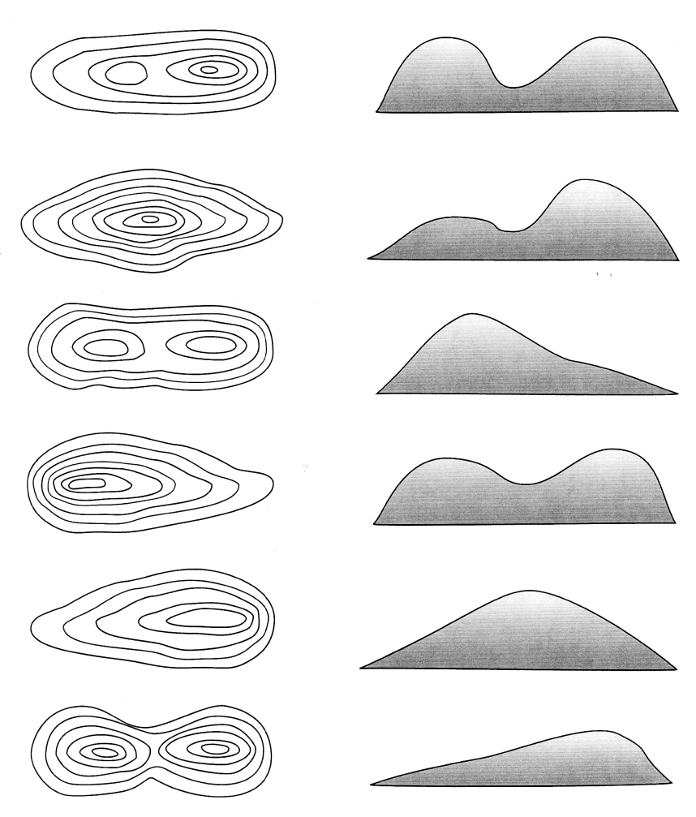

QUIZ TIME!!
- Match the topographic maps at the right with its corresponding hill silhouette by drawing a LINE between the pairs.
***BE CAREFUL!! Some hills are very similar! Ask me to check your answers when done.

- How does YOUR model compare to its silhouette at the right? List BOTH similarities & differences:

- Examine the rest of the class models. Which 3-D model seems to differ most from its hill silhouette at the right? What appears to account for the different appearance?

Write a Conclusion PARAGRAPH on a separate piece of paper and staple to this report:
*** NOTE: Use complete sentences, proper grammar and spelling. Need SEVERAL sentences.
- Restate the purpose. (Feel free to summarize and put the objectives into your own words.)
- Were the objectives met? Explain how they were or were not met in this lab.
- Relate this lab to what we are covering in class or what we will be covering.
- Did your 3-D model turn out like you’d expected based on the topographic map you were given? Were the flattest & steepest parts where you thought they would be? EXPLAIN. (Explain whether the model matches what you’d expected or not.)
- What could be one source of error in this lab? How could it affect your results?

