Name______________________Period_____

Chapter 19: Earthquakes
Review Study Guide

- List & define the 4 factors that must be considered when calculating a cost-benefit ratio for the mining process.

- What is stress?
- Strain:
  - Define the 3 types of strain and label them on the graph to the right.
1. __________________:

2. __________________:

3. __________________:

  - Label the elastic limit.
  - What happens after rocks reach their elastic limit?

- What is a transform boundary?
  - List one example location:
  - What feature is produced at a transform boundary?

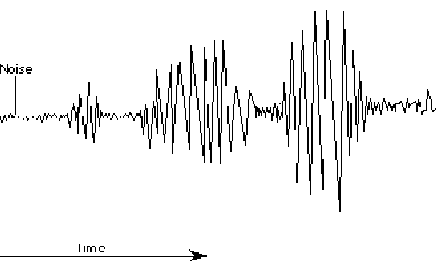
- Label the 3 wave types on the graph to the right. Explain how you know where to put the labels. Give two distinguishing features of each wave type.

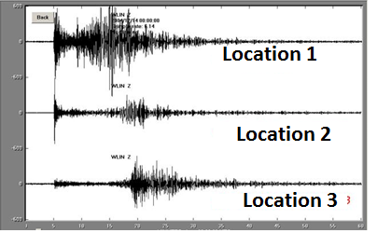
- Use the difference in arrival times of P and S waves to determine which reading was taken closest to the earthquake’s epicenter. Explain how you know.

- Describe the layout of the Earth’s interior and draw a picture. Use your picture to help you to explain why we have shadow zones.

- Compare and contrast the Richter Scale and the Mercalli Scale. Why do we use two different scales? Explain the numbering system of each scale. (NOTE – for similarities you cannot use that they are both scales or that they both deal with earthquakes.)

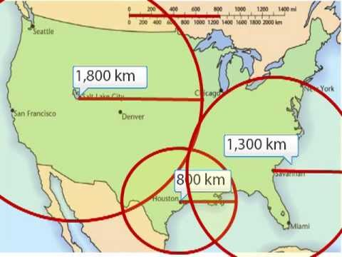

- Locate the epicenter of the earthquake measured by the stations in the diagram to the right. Explain why data from three stations are necessary to locate an epicenter.

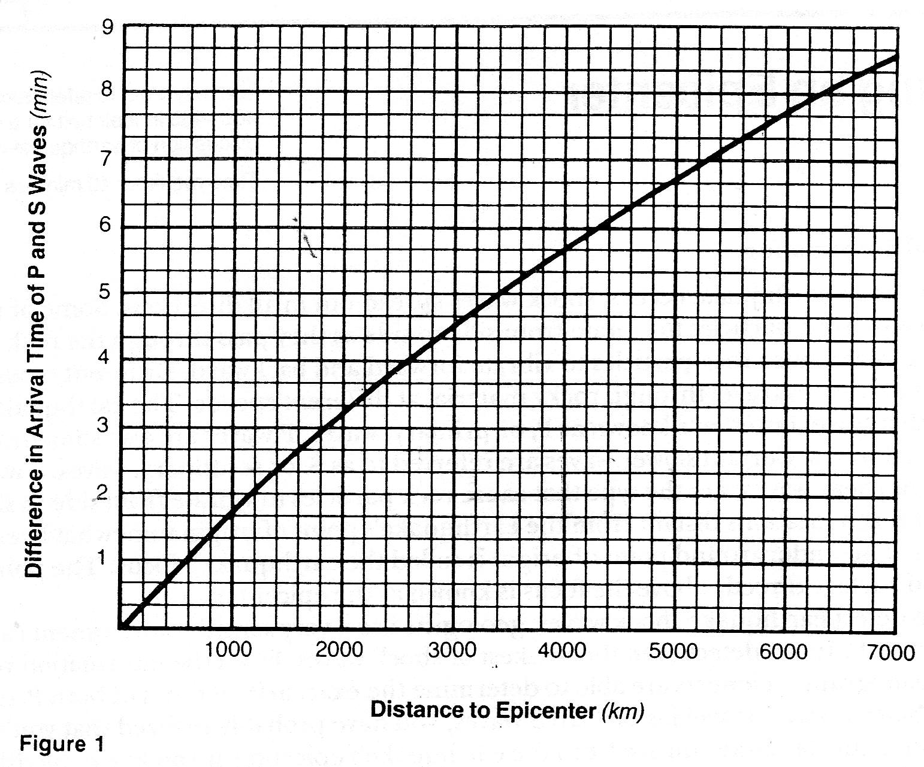

- Figure 1 above shows the difference in arrival time of P and S waves in seconds. Use the graph to answer the following:
  - If the S-wave arrives 4minutes 30 seconds after the P-wave, how far is the seismic station from the epicenter?

  - If the seismic station is 5600 km from the epicenter, what is the difference in arrival time between the P and S waves?

- Compare and contrast conventional drilling and fracking.

- What process, that is common to both conventional drilling and fracking, can lead to an increasing number of small earthquakes?

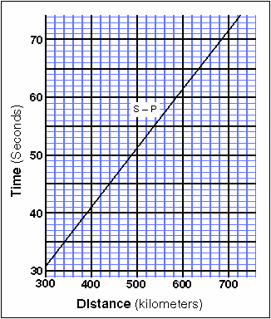
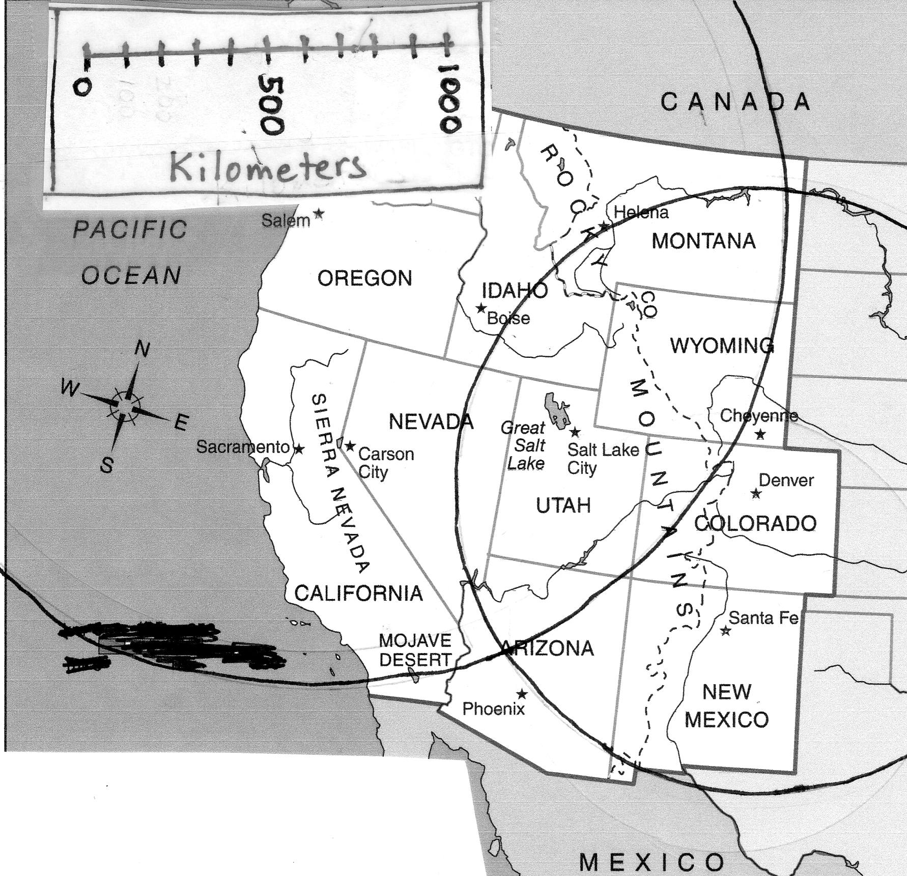

- On the map above, the seismic stations at Denver, Colorado and Olympia, Washington have both detected an earthquake. The stations have plotted their epicentral distance circles, but the location of the epicenter is still unknown. Using both the map and the Time-Distance Graph above, determine the epicenter location of the earthquake by doing the following:

  - At the seismic station at Salt Lake City, Utah, the S-wave arrived 63 seconds after the P-wave. How far is the Salt Lake City from the epicenter?

  - Using a compass, draw a circle of the epicentral distance around Salt Lake City.

  - In what state is the epicenter?

- Now, explain in a short but thorough and detailed explanation how an Earthquake that happens in Europe will be detected in the Hawaii.

**As you are explaining make sure to use and describe the relationship of these 3 terms:
    - Focus
    - P-waves
    - Outer Core

