**Activity #1 Reading Sea Surface Temperatures Using a Map**

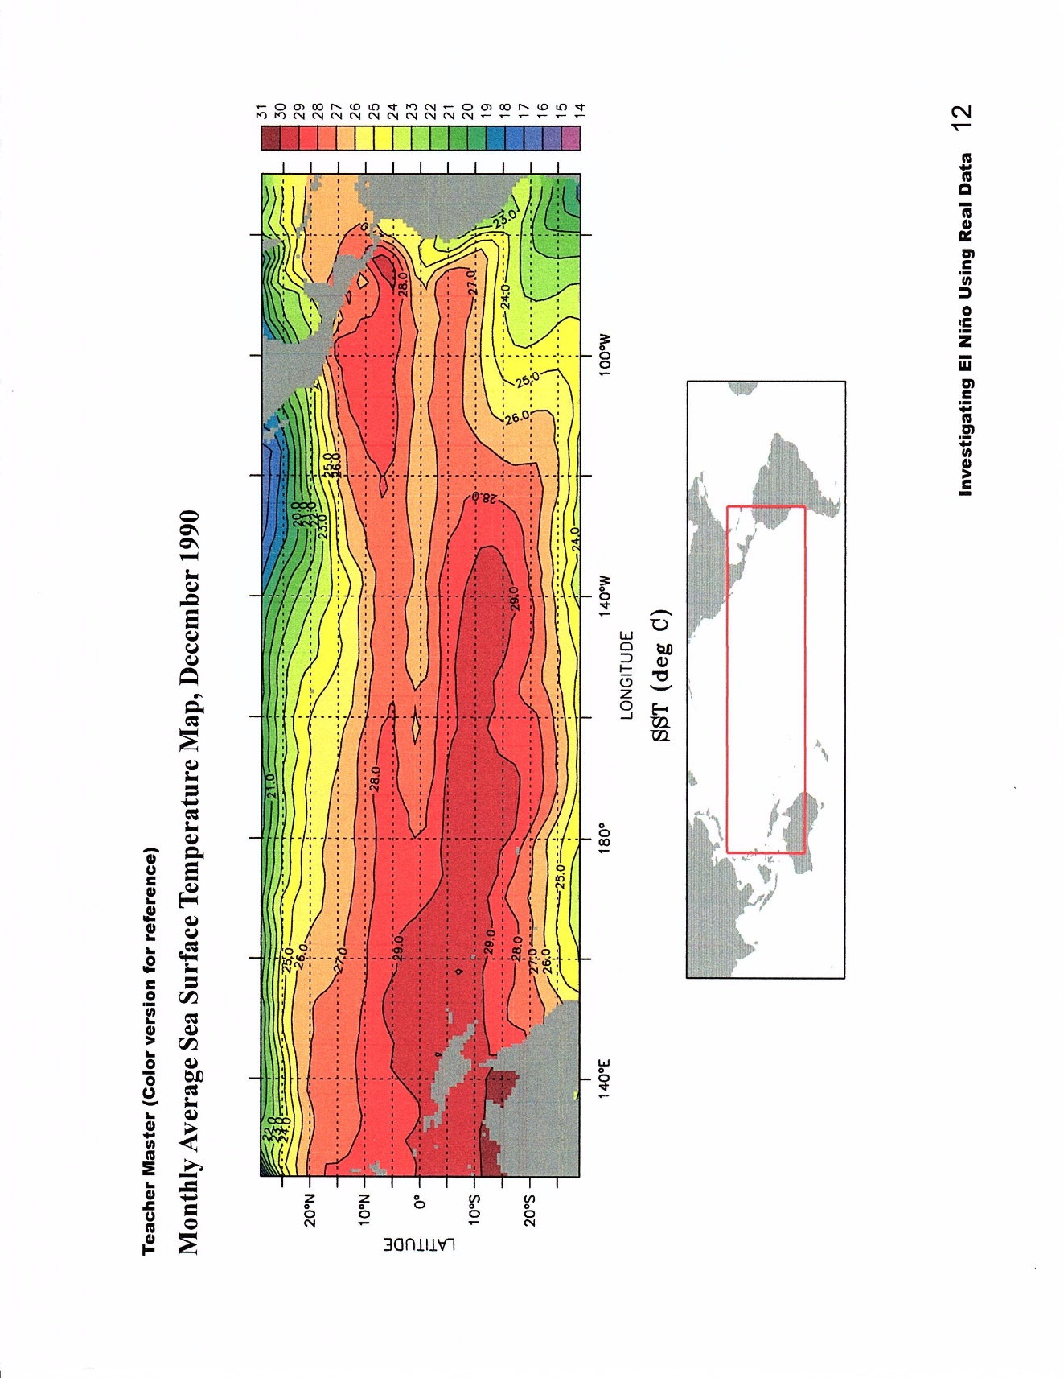

**1990 & 1991 Maps for Comparison:**

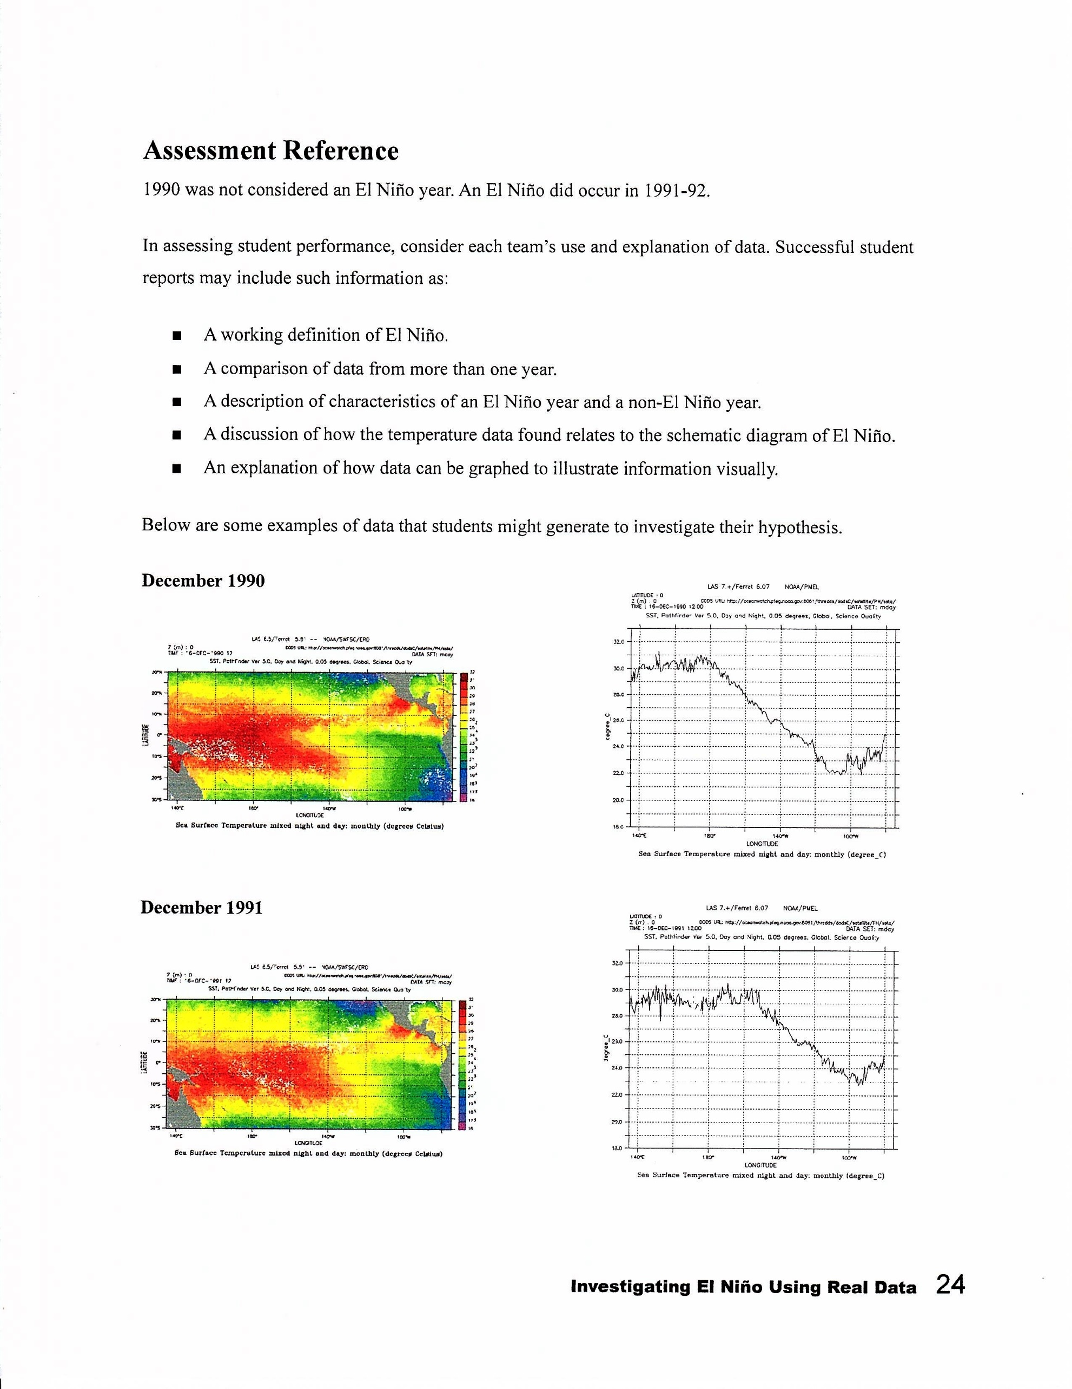

**December 1990**

**December 1991**



**Activity #2 Looking at Sea Surface Temperature (SST) Another Way**

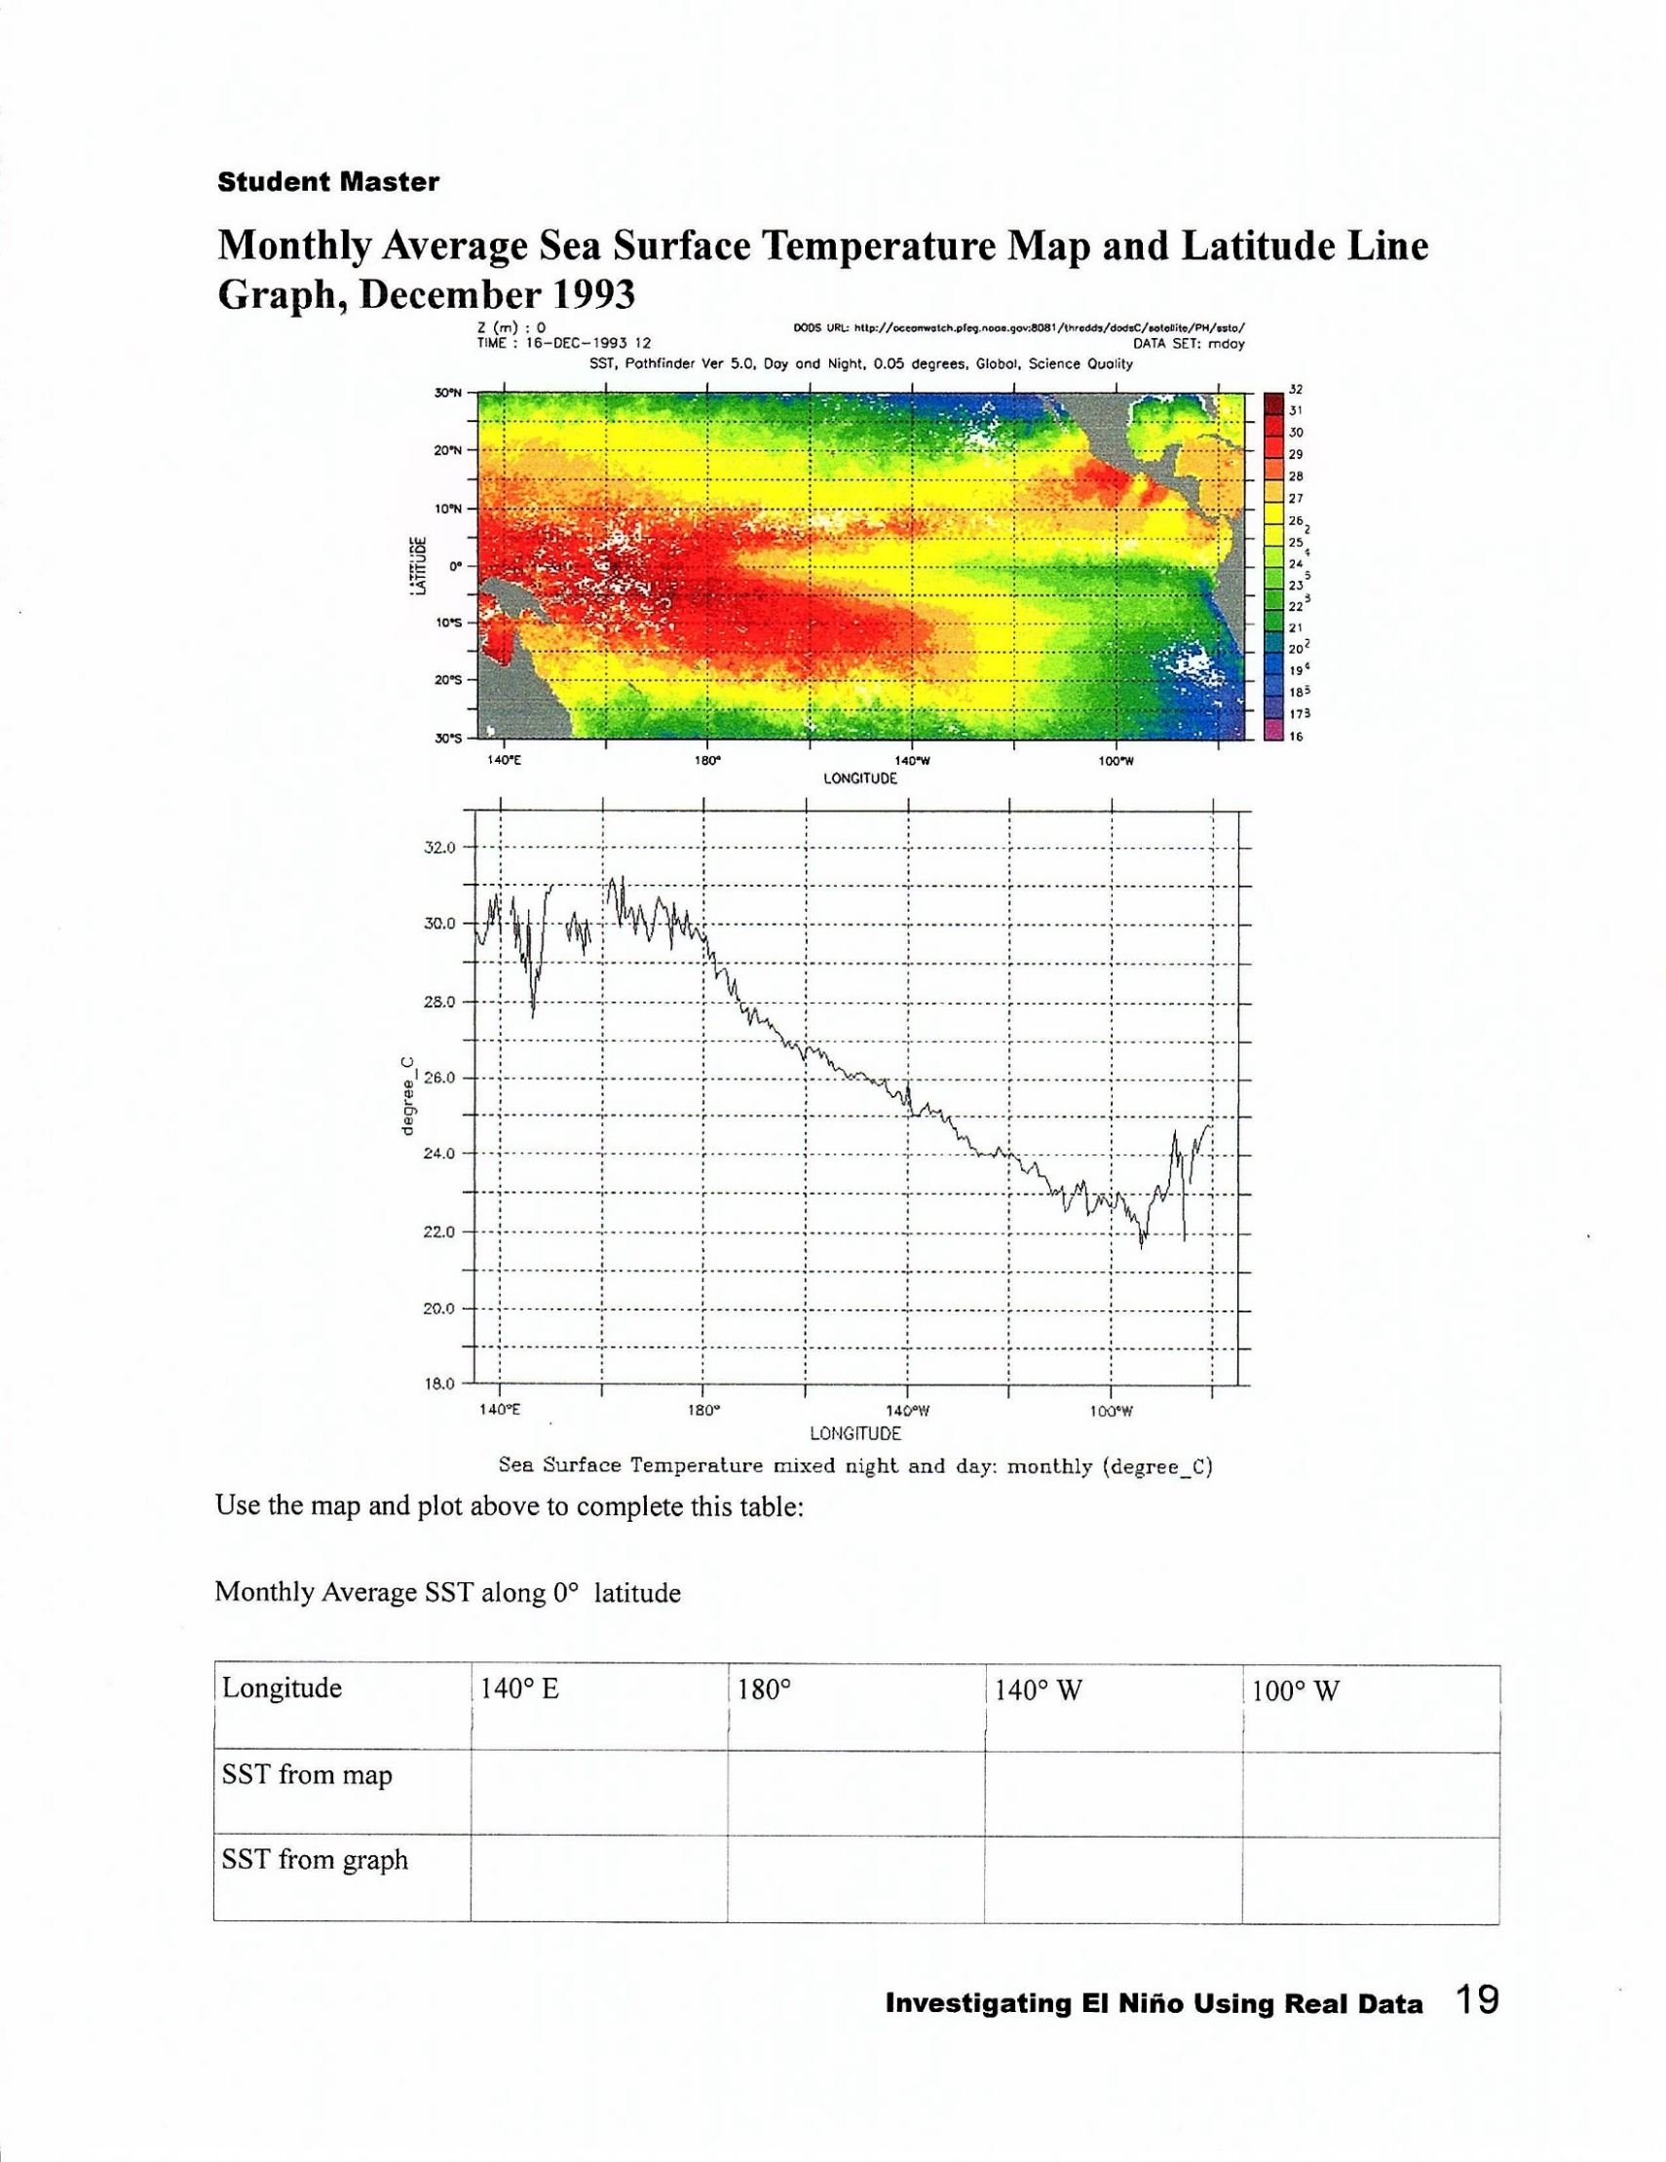



**Activity #3 Detecting El Nino**

