Name__________________________Period ____

**NOTE OUTLINE: Chapter 21 Fossils & the Rock Record**

**Objectives:**

* The Geologic Time Scale

1. I understand how Earth’s history is divided into sections of time called the geologic time scale. This means I can:
   1. Explain how major changes mark the boundaries between the sections.
   2. Discuss the general changes in organisms from the appearance of life on Earth to present day.

* Fossils

1. I can describe the characteristics Index Fossils and explain how Index Fossils are used.
2. Discuss how fossils can be used to interpret Earth’s past physical and environmental history.

* Dating of Rocks

1. I can apply the principles for determining relative age to interpret rock sequences. This means I can:
   1. Determine the oldest and youngest layers using the Law of Superposition.
   2. Determine the relative age of layers and intrusions.
   3. Match rock layers in different areas using Correlation.
2. I can apply the principles for determining absolute age using radioactive decay rates and half-lifes.

**Section 21.1 Geologic Time**

**Measuring Time:**

* According to current theories, the Earth has existed for _______________ years

**How is Time Divided?**

1. Major changes in ____________________ mark the boundaries between the sections
2. Most _______sections were divided because a major organism _______________________________

____________________. Examples:

* + Boundary between Paleozoic & Mesozoic Eras: Many _______________________________ &

_______________________________________

* + Boundary between Mesozoic Eras & Cenozoic Eras: ____________________ become extinct &

______________________ become abundant

1. Other divisions based on ______________formation. Examples:
   * North America is covered by _________________________
   * ______________________breaks up
   * _____________________________ form
   * Grand Canyon forms

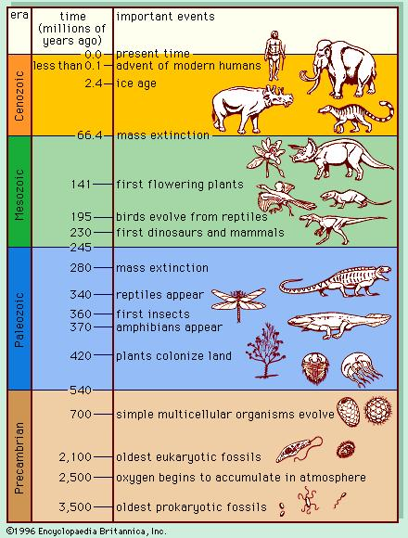

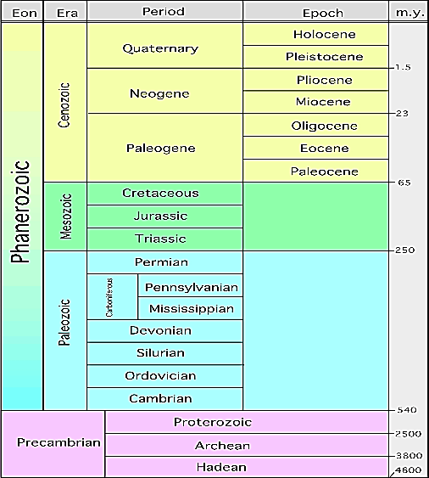

**What Units of Time are Used to Measure Earth’s History??**

The 4 Main Units:

1. Eon: ______________ amount of time
2. Era
3. Period
4. Epoch: ______________ amount of time

How Are They Listed?

1. Oldest listed at ____________________
2. Recent at ___________

**Precambrian Time**

1. Began with the ___________________of the Earth (______________ years ago)
2. At first, there was ___________________________________
3. The first organisms appeared in the ____________________ , _____ billion years ago
   * They were single-celled _______________

**Cambrian Explosion – Beginning of Paleozoic Era**

1. The _________________________________ marks the boundary between Precambrian Time & Paleozoic Era.
   * _________________________________________ life forms appeared
   * Organisms had ________________ parts (shells, exoskeletons) which left many more fossils

**Beginning of Mesozoic Era**

1. Many _________________became _________ at the boundary between Paleozoic & Mesozoic Eras.
2. _________________________ appear
3. Mesozoic Era is known as the “Age of _____________”

**End of Mesozoic Era**

1. All __________________ and many animals & plants went _______________
2. Theory:
   * Scientists think an ______________ hit Earth
   * Dust clouds blocked the _______________, causing ________________to die, then herbivores, then carnivores.

**Cenozoic Era**

1. Current era – the one we are living in
2. AKA: Age of ___________.
3. __________________ appear.
4. We know the ______________ about this Era because the fossils are in the _______ layers and are easier to find

**Remains of Organisms in Rock Record**

1. Fossil = ___________________________________________of a once-living plant or animal
2. Fossils help scientists approximate:
   1. When life began
   2. Types of animals and plants
   3. Extinction of species
3. Most organisms ___________ and don’t become fossils
4. Fossils are more likely to form if:
   1. Quick _______________occurs
      * Protects the fossil from being eaten by predators
      * Prevents it from being ___________________
   2. Organism has ______________ body parts (bones, teeth, shells)

**Index Fossils**

1. Index Fossils = Fossils used to **___________** rock layers or to ____________________ of a rock layer.
2. Characteristics needed to be an Index Fossil:
   * Easily__________________
   * Abundant (_____________ numbers) & _______________________________
   * Lived during a _____________ time to identify a specific time period
3. Examples: Trilobites, dinosaurs

**Trace Fossils**

1. Trace Fossils = INDIRECT evidence of the _____________________ of life.
2. Examples include:
   * Fossilized ___________________
   * __________________________
   * Fossilized ______________ (coprolites) – can help scientists learn about eating habits of ancient animals

***RELATIVE* - Age Dating of Rocks**

**Two Types of Dating**

1. Relative Dating simply classifies rocks or fossils as ____________or __________
2. Absolute Dating determines the _______________________________ age in ______________

**Ways to Determine Relative Age**

1. Law of Superposition can be used in rock that is ________________ (moved around by tectonic forces)
   1. Older rocks on ______________.
   2. Younger rocks on ____.
2. Uniformitarianism: Theory that states the ______________happening on Earth _________ have been

occurring since Earth ____________________

1. 2 types of processes:

* _____________everyday processes
  + take thousands of years to change the land
  + _____________________________________
* _________________________________ events
  + change the land instantly:
  + ______________________________________________

1. **Exceptions** to Law of Superposition

1. Earthquakes, faults, volcanism, flooding, weathering & erosion:
   * _______________the rock layers
   * Make it _________________ to use the Law of Superposition
2. **Intrusion**: _____________that flows _____________ of existing rocks and cools into igneous rock
   * Intrusions are always ____________________than the layers they pass through
3. Distinctive Sediment Layers
   1. **Correlation** is matching rock layers from one location to another by matching_____________

______________________________________________. Examples:

* Sandstone containing oil, ammonite fossils
* Grand Canyon (Arizona), Zion (Utah), Bryce (Utah)
  1. _________________ events such as ___________ impact or massive ____________________

form distinctive layers used to determine relative age.

Examples:

* + - Mount St. Helen’s 1980 – _______over several states makes a layer known to have

been made in_____________

* + - _______________ impact at the boundary of ______________and _______________

left a layer of space material.

* + - * Layer is age of the __________________ extinction

S

S

S

Radioactive Skittles



**Data Table:**

|  |  |  |  |
| --- | --- | --- | --- |
| Half-life period | Time passed (million years) | # of radioactive Skittles | # of decayed Skittles |
| 0 | 0 |  |  |
| 1 | 713 |  |  |
| 2 | 1426 |  |  |
| 3 | 2139 |  |  |
| 4 | 2852 |  |  |
| 5 | 3565 |  |  |

**Graphing Data**

**Use the last page of the note packet to make a ***line*** graph showing the number of radioactive Skittles vs. the time passed (million years). Make sure that you include a title for your graph and label both of the axes.

**Analysis Questions**

1. What is the half-life of Skittles (how many years does it take for ½ of the radioactive Skittles to decay)?
2. How many years did it take for the number of radioactive Skittles to reach 25? 12/13?
3. Suppose you had 40 radioactive Skittles. Using your graph determine how many years had passed.
4. After 2,000 million years had passed how many…
   1. Radioactive Skittles would be left?
   2. Skittles would have decayed?
5. Looking at the table of elements used in radioactive dating, identify which element the radioactive Skittles represent. Explain your answer.

|  |  |  |
| --- | --- | --- |
| Elements used in radioactive dating | | |
| Radioactive element | Half-life (years) | Dating range (years) |
| carbon-14 | 5,730 | 500-50,000 |
| potassium-40 | 1.3 billion | 50,000-4.6 billion |
| rubidium-87 | 47 billion | 10 million-4.6 billion |
| thorium-232 | 14.1 billion | 10 million-4.6 billion |
| uranium-235 | 713 million | 10 million-4.6 billion |
| uranium-238 | 4.5 billion | 10 million-4.6 billion |

***ABSOLUTE* - Age Dating of Rocks**

**Review:** Absolute Dating determines the ________________________________ age in _________

**Radioactive decay** of elements is used to determine the absolute age of rocks

1. Radioactive elements ______________ into a _________element
   * Example: _____________ changes into __________________
2. Original element = ________________element
3. New element = _________________element
4. Over time there is ___________parent element and ___________daughter element
5. During radioactive decay, much _______________ is given off.
   * __________ from radioactive decay___________ the inside of the earth

**Half-Life**

1. The **half-life** of an isotope is the _______________________________ of the atoms in the element to

decay into the daughter element.

1. By measuring the percent of parent isotope left, absolute age can be determined.

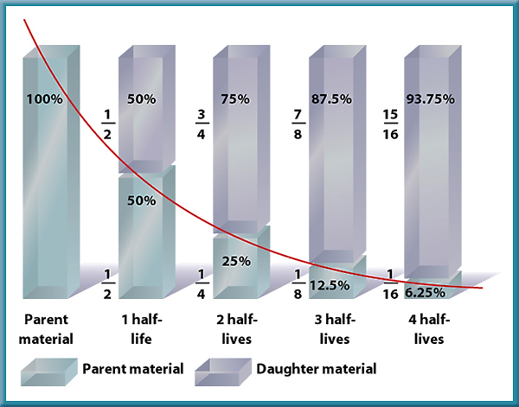

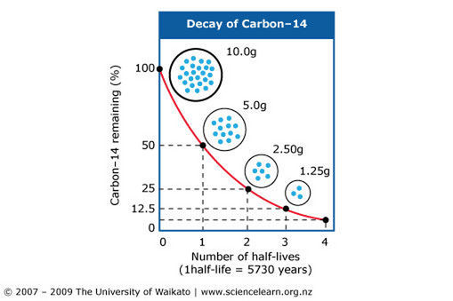

**Example: How Can You Determine Half-Life from a Graph?**

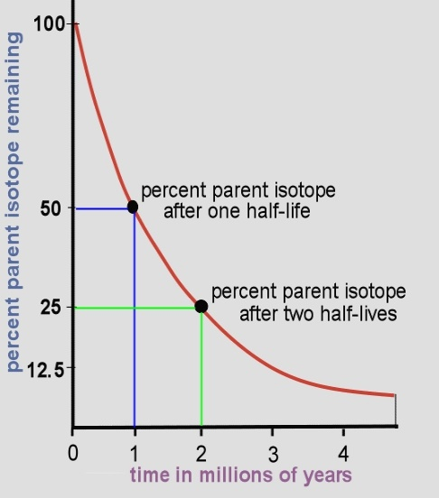

**What is the half life represented in this graph?**

**Your Turn: Half-Life Determination from Graph**

What is the half-life in the graph below?

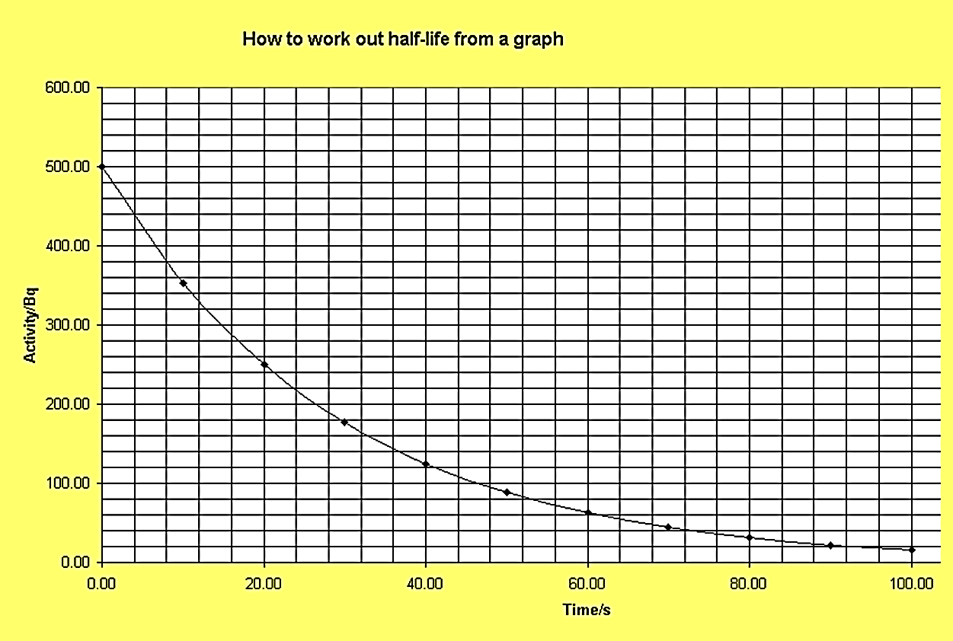

|  |  |  |  |  |  |  |  |  |  |  |  |  |  |  |  |  |  |  |  |
| --- | --- | --- | --- | --- | --- | --- | --- | --- | --- | --- | --- | --- | --- | --- | --- | --- | --- | --- | --- |
| S  S  S  Radioactive Skittles | | | | | | | | | | |  |  |  |  |  |  |  |  |  |
|  |  |  |  |  |  |  |  |  |  |  |  |  |  |  |  |  |  |  |  |
|  |  |  |  |  |  |  |  |  |  |  |  |  |  |  |  |  |  |  |  |
|  |  |  |  |  |  |  |  |  |  |  |  |  |  |  |  |  |  |  |  |
|  |  |  |  |  |  |  |  |  |  |  |  |  |  |  |  |  |  |  |  |
|  |  |  |  |  |  |  |  |  |  |  |  |  |  |  |  |  |  |  |  |
|  |  |  |  |  |  |  |  |  |  |  |  |  |  |  |  |  |  |  |  |
|  |  |  |  |  |  |  |  |  |  |  |  |  |  |  |  |  |  |  |  |
|  |  |  |  |  |  |  |  |  |  |  |  |  |  |  |  |  |  |  |  |
|  |  |  |  |  |  |  |  |  |  |  |  |  |  |  |  |  |  |  |  |
|  |  |  |  |  |  |  |  |  |  |  |  |  |  |  |  |  |  |  |  |
|  |  |  |  |  |  |  |  |  |  |  |  |  |  |  |  |  |  |  |  |
|  |  |  |  |  |  |  |  |  |  |  |  |  |  |  |  |  |  |  |  |
|  |  |  |  |  |  |  |  |  |  |  |  |  |  |  |  |  |  |  |  |
|  |  |  |  |  |  |  |  |  |  |  |  |  |  |  |  |  |  |  |  |
|  |  |  |  |  |  |  |  |  |  |  |  |  |  |  |  |  |  |  |  |
|  |  |  |  |  |  |  |  |  |  |  |  |  |  |  |  |  |  |  |  |
|  |  |  |  |  |  |  |  |  |  |  |  |  |  |  |  |  |  |  |  |
|  |  |  |  |  |  |  |  |  |  |  |  |  |  |  |  |  |  |  |  |
|  |  |  |  |  |  |  |  |  |  |  |  |  |  |  |  |  |  |  |  |
|  |  |  |  |  |  |  |  |  |  |  |  |  |  |  |  |  |  |  |  |
|  |  |  |  |  |  |  |  |  |  |  |  |  |  |  |  |  |  |  |  |
|  |  |  |  |  |  |  |  |  |  |  |  |  |  |  |  |  |  |  |  |
|  |  |  |  |  |  |  |  |  |  |  |  |  |  |  |  |  |  |  |  |
|  |  |  |  |  |  |  |  |  |  |  |  |  |  |  |  |  |  |  |  |