Name:
Global Winds Review
Earth Science Mini Unit
- What is the Coriolis Effect?
  - What does it do to wind in the Northern hemisphere?
  - What does it do it wind in the Southern hemisphere?

- Fill in the globe below with the winds. Make sure to include:
a. convection cells
b. clouds (where they are present)
c. location of high & low pressure on the ground
d. location of high & low pressure aloft
d. names of the wind systems
e. arrows to show specific direction of wind movement
REMEMBER: You may need to rotate your paper to take into account which way the wind is coming from!!
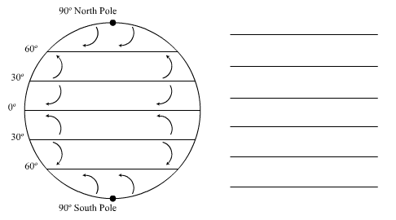

- Fill in the table below.
Type of Wind | Latitude it Starts (Blows From) | Latitude it Ends  (Blows Towards) | Direction it blows from | Regions/Events Affected
Trade Winds
Prevailing Westerlies
Polar Easterlies
Jet Stream

- In the diagram below, draw arrows to show the convection process that is occurring:

- Complete the following chart regarding the wind patterns at the POLE and the EQUATOR:
(Hint: Use your arrows from question #4 to help you answer these questions.)

Location | Pressure at Surface | Pressure Aloft | Wind felt at Surface | Wind felt Aloft
Poles | Explain why: | Explain why: | Explain why: | Explain why:
Equator | Explain why: | Explain why: | Explain why: | Explain why:

