Mount Everest
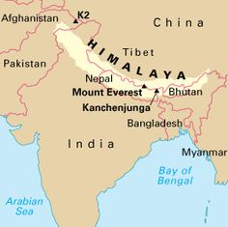
In this activity you will be graphing data related to the formation of the Mount Everest. Mount Everest is currently the tallest mountain in the world. It can be found in the Himalayan Mountain Range in Southwest Asia. These mountains formed as a result of the Indian Plate crashing into the Eurasian Plate 60 million years ago. Once you have graphed your data points, answer the analysis questions based upon patterns you observe in your model.
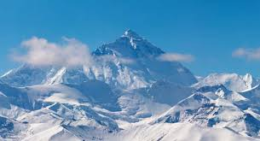

Data Table:

Years ago | Height (m)
500,000 | 6,852
200,000 | 8,050
100,000 | 8,449
50,000 | 8,636
20,000 | 8,745
10,000 | 8,806
5,000 | 8,825
2,000 | 8,839
100 | 8,847
0 (Today) | 8,848

Name _________________________
Graph: (Don’t forget to label your axes and include your scale for reference!)

Analysis Questions:
- Draw in the line of best fit for your data above.
- Determine the slope of the line of best fit you just drew. Make sure to show your calculation and label your answer with the correct units.

- Based upon the data provided, make a prediction about how Mount Everest will change over another 1 million years.

- Would you consider this process to be fast or slow? Support your answer with evidence.

- Predict whether the following changes occur faster or slower than the growth of Mount Everest:
  - Erosion of the Outer Banks (coastal North Carolina) __________________
  - Formation of a Sand Dune _________________
  - Widening of the East African Rift Valley ____________________
- Convert your rate of change (slope of the line) to cm/year. Make sure to show your work.
East African Rift Valley
In this activity you will be graphing data related to the formation of the East African Rift Valley. The East African Rift Valley is a feature that formed as two plates have been moving away from each other, as shown in the map below. Once you have graphed your data points, answer the analysis questions based upon patterns you observe in your model.
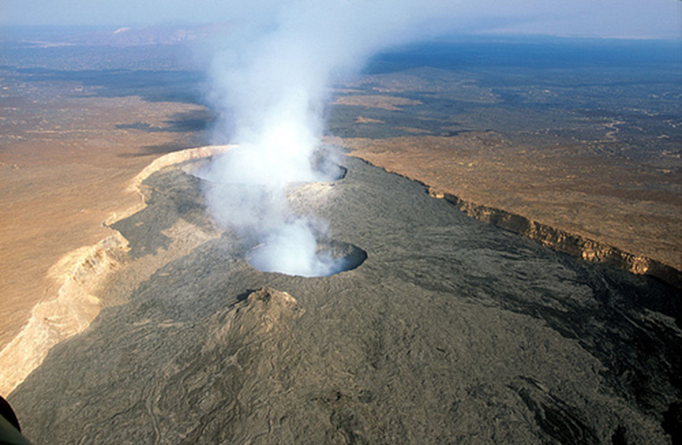
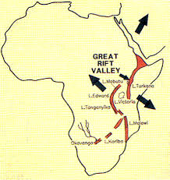

Data Table:

Years Ago | Width of Rift Valley (m)
23,000,000 | 0.0
5,000,000 | 20,526
1,000,000 | 46,535
500,000 | 49,778
100,000 | 52,383
10,000 | 52,945
5,000 | 52,998
3,000 | 53,011
1,000 | 53,023
0 (today) | 53,030

Name _________________________
Graph: (Don’t forget to label your axes and include your scale for reference!)

Analysis Questions:
- Draw in the line of best fit for your data above.
- Determine the slope of the line of best fit you just drew. Make sure to show your calculation and label your answer with the correct units.

- Based upon the data provided, make a prediction about how the East African Rift Valley will change over another 1 million years.

- Would you consider this process to be fast or slow? Support your answer with evidence.

- Predict whether the following changes occur faster or slower than the widening of the rift valley:
  - Erosion of the Outer Banks (coastal North Carolina) __________________
  - Formation of a Sand Dune _________________
  - Growth of Mount Everest ____________________
6. Convert your rate of change (slope of the line) to cm/year. Make sure to show your work.
Outer Banks
In 1870 the Cape Hatteras Lighthouse was built several 100 meters from the shoreline. By 1990 the lighthouse was moved inland because of the beach erosion. Calculate the rate of erosion from the given data.

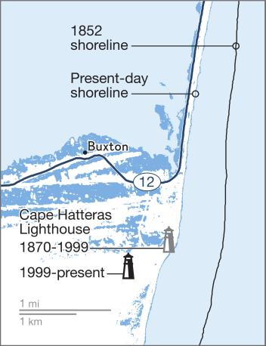

Year | Distance shoreline from lighthouse (m)
1910 | 140
1920 | 127
1930 | 111
1940 | 100
1950 | 83
1960 | 69
1970 | 54
1980 | 30
1990 | 14
2000 | 0

Name _________________________
Graph: (Don’t forget to label your axes and include your scale for reference!)

Analysis Questions:
- Draw in the line of best fit for your data above.
- Determine the slope of the line of best fit you just drew. Make sure to show your calculation and label your answer with the correct units.

- Based upon the data provided, make a prediction about how the erosion near the Outer Banks will affect the coastline of North Carolina in the next 100 years.

- Would you consider this process to be fast or slow? Support your answer with evidence.

- Predict whether the following changes occur faster or slower than the erosion of the Outer Banks:
- Movement of Hawaiian Islands on the Pacific Plate __________________
- Formation of a Sand Dune _________________
- Growth of Mount Everest ____________________
6. Convert your rate of change (slope of the line) to cm/year. Make sure to show your work.
Sand Dunes
In this activity you will be graphing data related to the movement of sand dunes in in the South-Western United States. The Dunes have been growing (due to drought) and movement (due to wind erosion). Once you have graphed your data points, answer the analysis questions based upon patterns you observe in your model.
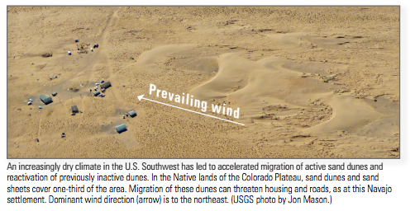

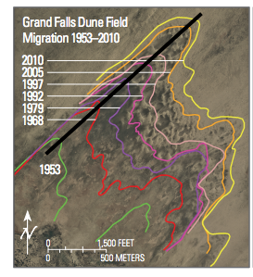

Year | Dist.(m) moved from 1953
1953 | 0
1968 | 470
1979 | 800
1992 | 1020
1997 | 1120
2005 | 1510
2010 | 1610

Name _________________________
Graph: (Don’t forget to label your axes and include your scale for reference!)

Analysis Questions:
- Draw in the line of best fit for your data above.
- Determine the slope of the line of best fit you just drew. Make sure to show your calculation and label your answer with the correct units.

- Based upon the data provided, make a prediction about how the dunes will move over the next 30 yrs.

- Would you consider this process to be fast or slow? Support your answer with evidence

- Predict whether the following changes occur faster or slower than the formation of a sand dune:
- Erosion of the Outer Banks (coastal North Carolina) __________________
- Growth of Mount Everest _________________
- Widening of the East African Rift Valley ___________________

6. Convert your rate of change (slope of the line) to cm/year. Make sure to show your work.
Pacific Plate / Hawaiian Islands

In this activity you will be graphing data to determine the average rate that the Pacific Plate has moved over the last 65 million years. We know that the ages of the islands increase as you move away from the Hawaiian hot spot. Once you have graphed your data points, answer the analysis questions based upon patterns you observe in your model.

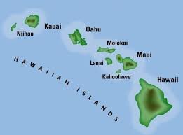

Name _________________________
Graph:

Analysis Questions:
- Draw in the line of best fit for your data above.
- Determine the slope of the line of best fit you just drew. Make sure to show your calculation and label your answer with the correct units.

- Based upon the data provided, make a prediction about how the Hawaiian Islands will move over the next 10 million years.

- Would you consider the movement to be fast or slow? Support your answer with evidence.

- Predict whether the following changes occur faster or slower than the islands move:
- Landslide (or rockslide) down a mountain __________________
- Formation of a Sand Dune _________________
- Growth of Mount Everest ____________________

6. Convert your rate of change (slope of the line) to cm/year. Make sure to show your work.

Landslide
In this activity you will be graphing data related to the movement of rocks down a sloped surface. Scientists often refer to this as a landslide. Landslides can happen at many different speeds, but you will be looking at an average of that data. Once you have graphed your data points, answer the analysis questions based upon patterns you observe in your model.
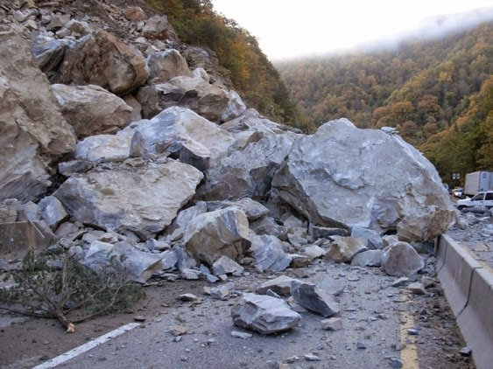
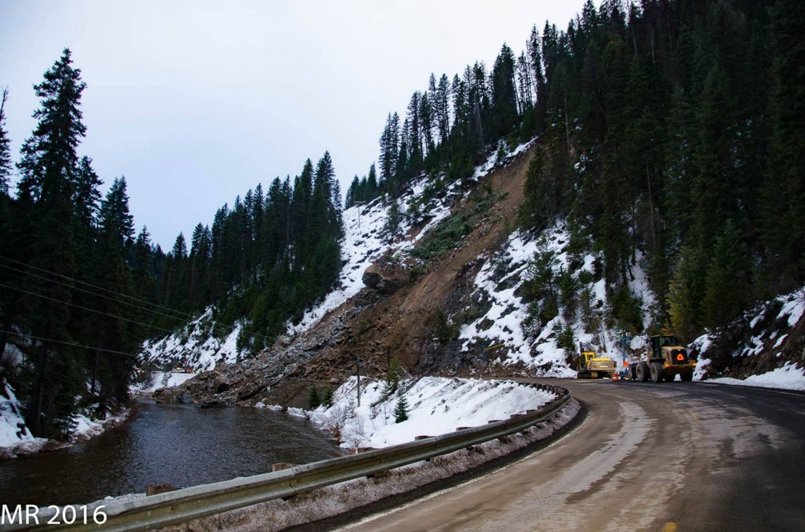

Data Table:

Amount of Time since 1st Rock Fell | Distance Moved (m)
1 hr | 1.8
2 hr | 4.2
3 hr | 5.9
4 hr | 7.7
5 hr | 9.7
6 hr | 10.1
7 hr | 12.0
8 hr | 13.8
9 hr | 15.5
10 hr | 17.3

Name _________________________
Graph: (Don’t forget to label your axes and include your scale for reference!)

Analysis Questions:
- Draw in the line of best fit for your data above.
- Determine the slope of the line of best fit you just drew. Make sure to show your calculation and label your answer with the correct units.

- Based upon the data provided, make a prediction about how a landslide would move over the next 5 hours.

- Would you consider this process to be fast or slow? Support your answer with evidence.

- Predict whether the following changes occur faster or slower than the movement of rocks in the landslide:
- Erosion of the Outer Banks (coastal North Carolina) __________________
- Formation of a Sand Dune _________________
- Growth of Mount Everest ____________________
6. Convert your rate of change (slope of the line) to cm/year. Make sure to show your work.
Summary Questions:
- Find a group whose landform had a similar rate of change (slope). Why do you think they are similar? Make sure to provide specific evidence to support your claim.

- Find a group whose landform had a very different rate of change (slope). Why do you think they are so different? Make sure to provide specific evidence to support your claim.

- Place each of the six events in order from slowest to fastest rate. Make sure to include both the name and the rate for each event.

- Do you notice any specific patterns regarding the events that had a slower rate of change vs. the events that had a faster rate of change? Give evidence to support the patterns that you have discovered.

- Will any of these events change their rate in the future? If yes, explain why the rate would change for that specific event(s).

