Lab: Hurricane Andrew Name______________________Period________

Procedure: NOTE: A good map is necessary to answer the post-lab questions. Take care to follow the directions and plot the points accurately.

- Suggestion: Draw light lines on the axes to show placement of every latitude and longitude degree to make plotting of points easier.

- Plot the points, labeling each point with the date and time in the following format, “day/time”
  - The data point for August 21, 03:00 should be labeled 21/03
  - The data point for August 21, 09:00 should be labeled 21/09

- After all points have been plotted:
  - Connect the points with a line
  - Draw 4 arrowheads, spaced evenly along the line, to show the direction that the hurricane moved.

- Wind speed vs. time:
  - Plot the data for Hurricane Andrew’s wind speed vs. time on the wind speed and pressure grid/graph located under the map.
  - Connect the points using a colored pencil with a smooth curve.
  - Circle the axis label “Wind speed km/hr” to show the color used.

- Pressure vs. time:
  - Plot the data for Hurricane Andrew’s pressure vs. time on the wind speed and pressure grid/graph located under the map.
  - Connect the points using a 2nd colored pencil with a smooth curve.
  - Circle the axis label “Air Pressure (millibars) to show the color used.

- Use the hurricane track you plotted on the MAP in Steps 2-3 to determine the landfall times for the hurricane. Landfall occurs when the hurricane first passes over land.
  - Use a 3rd colored pencil and a ruler to draw vertical lines ON THE GRID/GRAPH (not the map) corresponding to the landfall times. ***This line will be used in the post-lab questions to help you determine if change occurs in wind speed or pressure when the hurricane makes landfall.
  - Label the line with the location (state) that the landfall occurred.

- Use the hurricane track you plotted on the MAP in Steps 2-3 to determine the time that Hurricane Andrew passed back onto water after being on land.
  - Use a 4th colored pencil and a ruler to draw ONE vertical lines ON THE GRID/GRAPH (not the map) corresponding to t time. ***Note- there will be only 1 line, as Hurricane Andrew went back onto water only 1 time.
  - Label the line as “back onto water”.
Lab: Hurricane Andrew

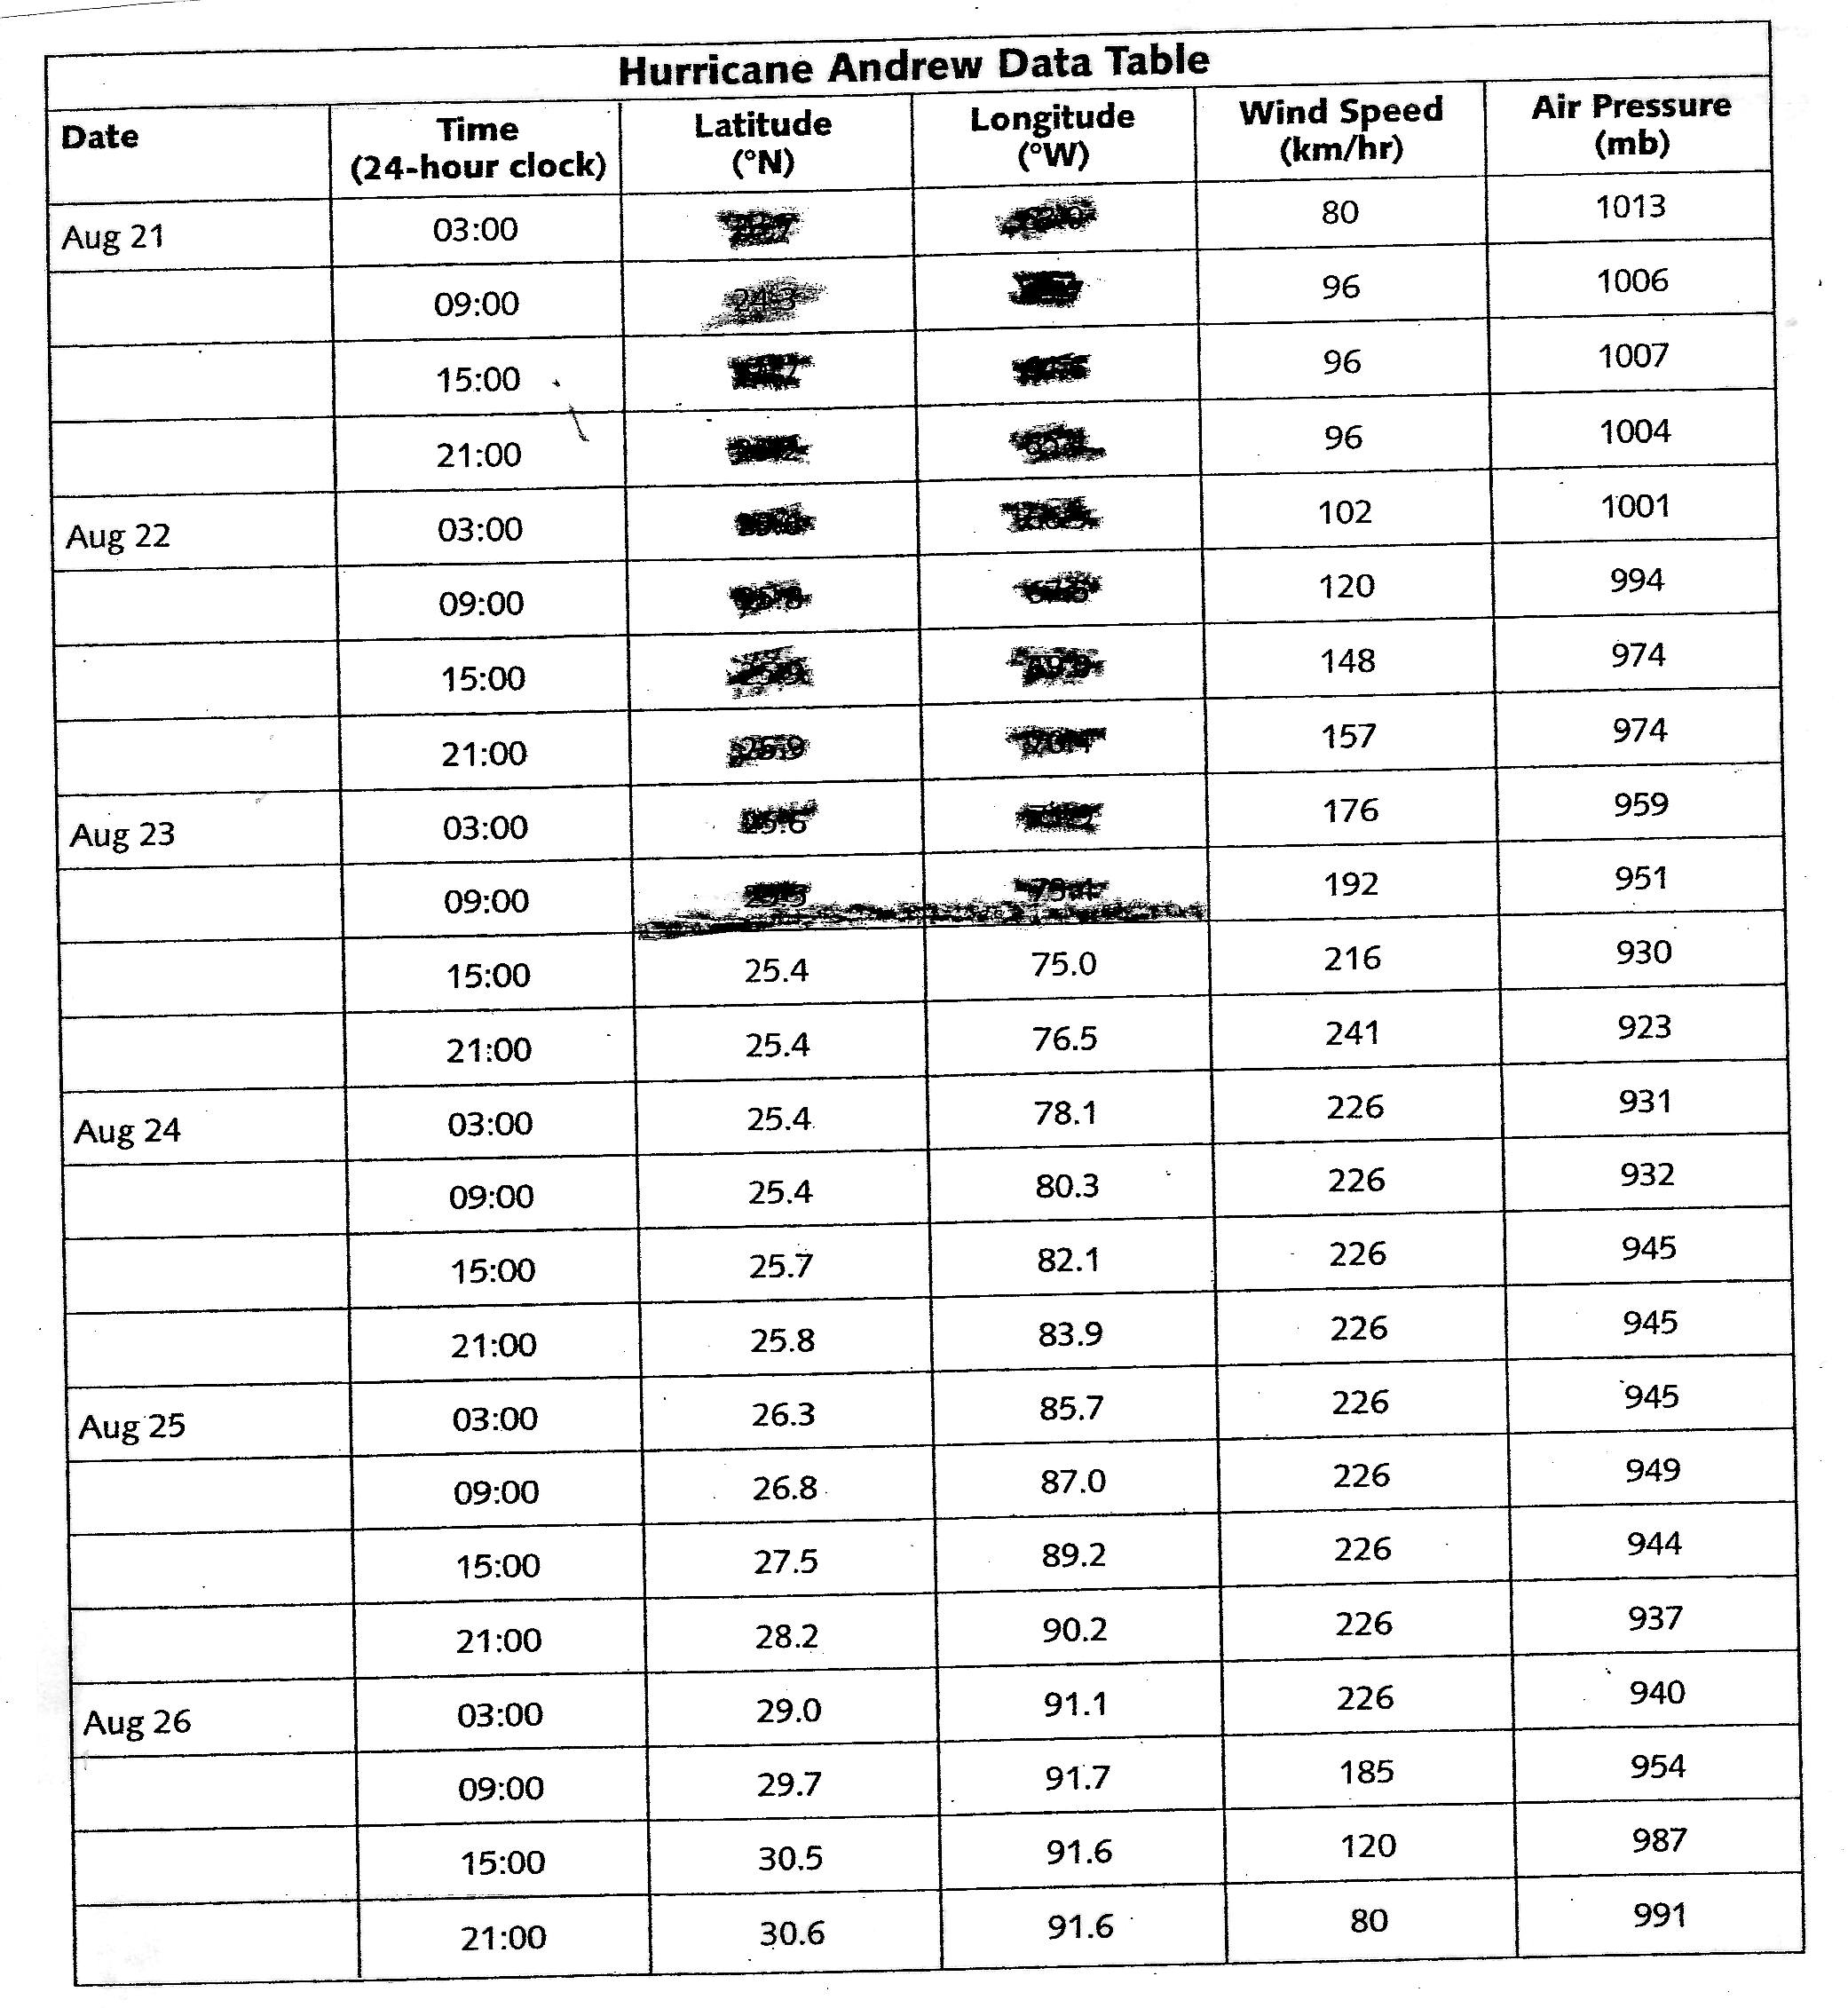

Lab: Hurricane Andrew Name______________________Period________

Background:

Prelab Questions:
- What are tropical cyclones called in the:
  - Atlantic Ocean?
  - Pacific Ocean?

- Complete the following table of the stages of hurricane formation:
 | Name of Stage | Description of Stage
1st Stage
2nd Stage
3rd Stage
4th Stage

- List 2 areas a hurricane may move, resulting in loss of energy, and explain why it loses energy.

- Measurement of the strength of a hurricane:
  - What is the name of the scale used to measure the intensity (strength) of a hurricane?

  - List 3 things the scale uses to determine the strength of a hurricane.

- Explain why hurricanes generally hit the east coast of continents.

Lab: Hurricane Andrew
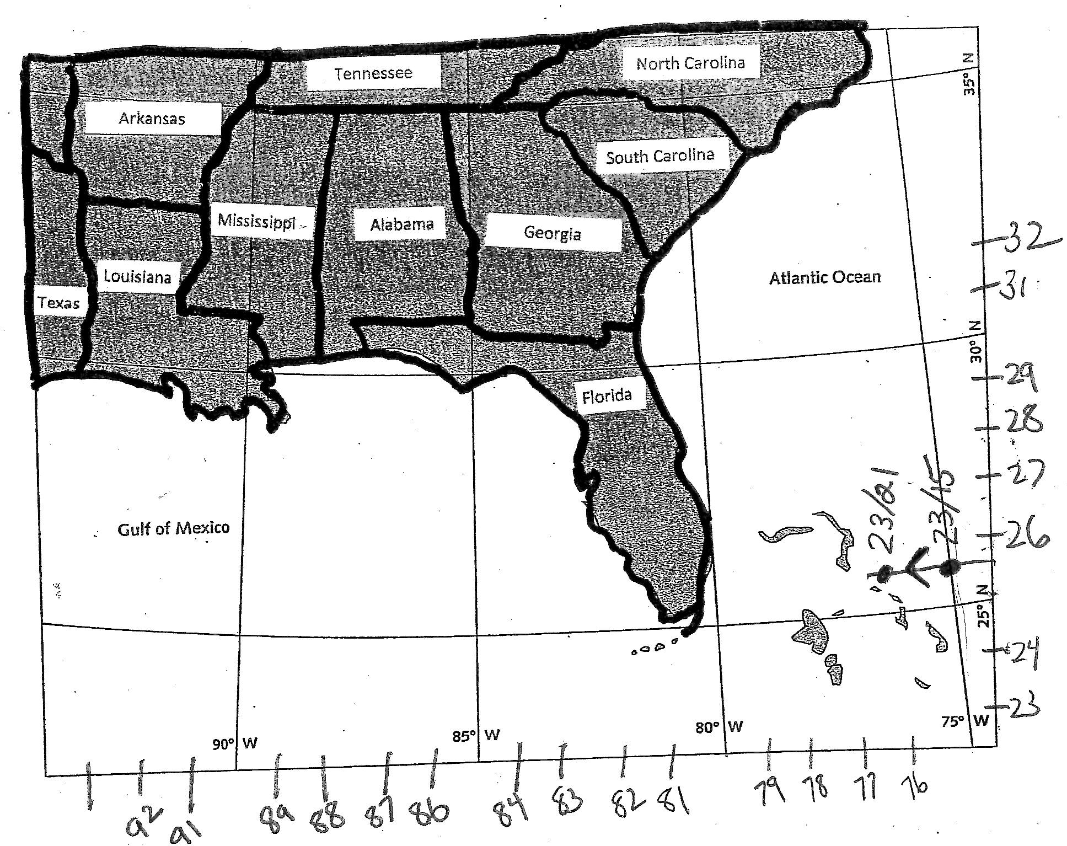

Post lab Questions

- Basic Graph Analysis:
  - Between August 24, 15:00, and August 26, 03:00, the wind speed for Hurricane Andrew remained essentially the same. Where was Hurricane Andrew located during this period of time?

  - According to your graph, what is the general relationship between air pressure and wind speed?

  - Landfalls:
    - How did Hurricane Andrew’s air pressure change around the time of both landfalls?

    - How did Hurricane Andrew’s wind speed change around the time of both landfalls?

  - Movement from land back onto water:
    - How did Hurricane Andrew’s air pressure change around the time the hurricane left the west coast of Florida and moved over water?

    - How did Hurricane Andrew’s wind speed change around the time the hurricane left the west coast of Florida and moved over water?

- Explain why air pressure and wind speed are affected by the surface over which a hurricane moves.

- Change in Pressure:
  - What is the difference (subtract) between the highest and lowest air pressure value in the data table? (Show your work.)

  - Would you expect this value to be more or less than the air pressure change of a typical mid-latitude low? EXPLAIN your choice. (Mid-latitude lows include tornados, blizzards, severe thunderstorm, etc.)

- Compare the length of the hurricane track between the points plotted from
- August 24, 15:00, and August 25, 15:00.
- August 25, 15:00, and August 26, 15:00.

  - During which 24-hour time period did the hurricane move faster? How do you know?

  - Why did the hurricane’s speed change?

- A tropical storm officially becomes a hurricane when it attains speeds greater than 119 km/hr. Using the data table, when did Hurricane Andrew:

  - Change from a tropical storm to a hurricane?

  - Change back to a tropical storm?

