Name__________________________Period____

Latent Heat Lab – Does Freezing Warm??
Objectives: I will:
- Understand how latent heat is related to phase changes; which changes absorb heat and which release energy.
- Develop a basic understanding of how latent heat is related to cloud formation, Iowa storms in the spring, the winds of a hurricane, etc.
- Conduct an investigation making careful observations, recording data, drawing conclusions and describing and communicating results.

Background:
Have you ever wondered what weather broadcasters mean when they say that a particular storm has lots of “energy," or that a hurricane is “fueled” by warm ocean water? Although these remarks may be confusing, recognizing the role that energy plays in various phase changes of water is actually an important key to understanding weather. The "energy" in a storm enters the air when water molecules absorb heat as they evaporate from the ocean. Water molecules need this heat to make the change from liquid to vapor. Storms that contain more vapor (humidity) really do have more “energy”. Eventually, as the vapor molecules condense or freeze to form clouds, this energy, called “latent heat,” is released into the surrounding air, often several days later and hundreds of miles from the nearest ocean.

Latent heat also influences barometric pressure and wind speeds. For instance, within hurricanes, “energy” (latent heat) is released as vapor changes into cloud droplets, which eventually become raindrops. This heat helps air within the storm to rise even more, decreasing the pressure, and increasing the wind speed. As hurricanes move over land they quickly weaken because they are away from their source of “fuel”; the warm water that provides vapor (with latent heat; a.k.a. “energy”).

Materials
- 400-500 ml plastic beaker or similar container  - Slush (snow/chopped ice, salt, water)  - Small thermometer | - Tic Tac container or test tube or other small container  - Distilled water  - Disposable plastic table knife
Procedure
- Teacher prep:
  - If snow is not available, crush ice – small pieces work best.
  - Soak the Tic Tac containers in rubbing alcohol to remove the labels.
  - To make the slush, use snow/crushed ice, salt, and water. Use about 100-150 ml of salt per liter of slush. Try to make the slush about the same consistency of those that would be purchased to drink. Make the slush in some sort of large container and put it in student beakers as they bring them to you.
- Fill the Tic Tac containers about 2/3 full with distilled water.
- Insert the container into the slush.
- Put a clean thermometer into the Tic Tac container.
- DO NOT DISTURB! Leave the container and thermometer alone. Moving either may trigger the crystallization process (freezing).
- Let the temperature of the water drop to about –4 C. If the water starts to freeze before it reaches, empty the container, rinse it out, and start over.
- When the temperature reaches -4C, notify the teacher.
- As the teacher drops a few snowflakes or crushed ice pieces into the Tic Tac container or test tube, watch the following. (This works best when clean, fresh snow or crushed ice is used.):
  - Consistency of the water in the TicTac container
  - The thermometer temperature.
Name__________________________Period____

Latent Heat Lab –Does Freezing Warm??

Pre-Lab Questions

- What are clouds made of?

- Which of the following molecules is moving “slowest”, “medium”, and “fastest”.

_______________water vapor molecules

_______________frozen water molecules (ice)

_______________liquid water molecules

- When sweat (mostly liquid water) evaporates from your skin, why does this help to cool your body?

- During the spring, most of the water in the clouds over Iowa comes from the Atlantic Ocean. What do water molecules absorb as they evaporate from the ocean?

- What is the freezing point of water? ________C

- Supercooled water: During the winter, we in Iowa create “supercooled” water, causing water to stay liquid below its normal freezing point. We do this to prevent the water on roads from freezing. What do we add to the winter roads to prevent the water on the roads from freezing as fast?

- Look at the diagram shown below. Name the phases changes labeled “B, C, D, E” by using the words “freezing, melting, condensation, evaporation”. Then fill in the blanks using the words “absorb, release, warmer, colder”.

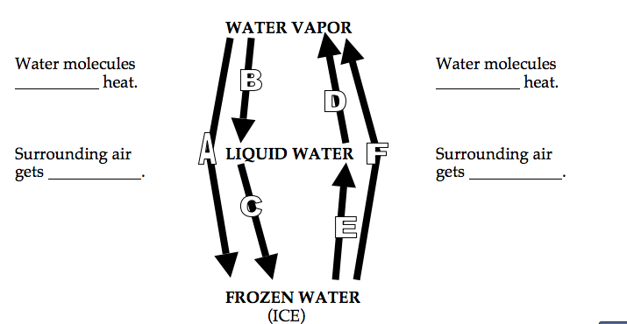
Phase Change “D” = __________
Phase Change “B” = __________

Phase Change “C” = __________
Phase Change “E” = __________

DATA:
- Lowest temperature in the Tic Tac container (test tube)get before it froze: ________C

- Temperature as the water froze in the TicTac (test tube)container: ________C

ANALYSIS:
- Did the water in the TicTac container (test tube) become “supercooled” before it froze? Explain, using quantitative data from the experiment.

- What happened to the temperature of the thermometer in the Tic Tac container as the water froze? Include quantitative data from the experiment in your data.

  - Why did this happen? Circle one.

- Water molecules absorb heat from their surroundings as they changed from liquid to solid.

- Water molecules release heat to their surroundings as they changed from liquid to solid.

APPLICATION:

- During the spring in Iowa, warm and humid air masses from the Atlantic collide with cold air masses from Canada. The warm, moist air is forced up over the cold air. The rising air cools with altitude in the troposphere, causing clouds to form. As vapor changes to solid cloud crystals, the water molecules would . . . (circle one)

  - absorb heat from their surroundings, making the air colder

  - release heat to their surroundings, making the air warmer

- If rain falls through very dry air, much (or all) of the rain may evaporate. As this falling rain evaporates the water molecules . . . (circle one)

  - Water molecules absorb heat from their surroundings as liquid changes to vapor.

  - Water molecules release heat to their surroundings as liquid changes to vapor.

- As the air described in question #4 gets colder than the surrounding air it becomes heavier than the surrounding air, causing it to accelerate toward the ground like a lead weight falling through water. As this rapidly falling air hits the ground surface winds can exceed 100 miles/hour. This is known as a “downburst”. The most intense ones, which may last only 5minutes and have wind speeds over 175 miles/hour, are called “microbursts”.
- Scientists can tell whether an area has experienced a tornado, or a microburst by surveying the damage from an airplane.
- Based on the description of a microburst above vs. your personal knowledge of tornadoes as a resident of Iowa, make an inference on how the pattern of damage caused by a microburst differ from the pattern of damage caused by a tornado:

- When a hard frost is expected, orange growers may spray their trees with water to keep the oranges from freezing. As the water on the oranges freezes, the ice provides insulation for the fruit within. Also, as the water freezes, this helps prevent the fruit from freezing because . . . (circle one)

  - Water molecules absorb heat as they change from liquid to ice.

  - Water molecules release heat as they change from liquid to ice.

- A psychrometer, which is used to measure relative humidity, consists of a wet-bulb and a dry-bulb thermometer. Fill in the blanks in the following statement.

As water molecules evaporate from the wet bulb they ____________(absorb/release) heat,

causing the wet bulb to become ________________(warmer/colder) than the dry bulb.

- TV weather broadcasters occasionally say that a storm has “lots of energy,” indicating that it has greater potential for precipitation (and wind). Why is it that storms with “lots of moisture” would also have “lots of energy”? Circle the correct answer.
  - The storm generates heat as a result of friction between water molecules and the ground.

  - The presence of water molecules in the air makes the air go faster.

  - The water molecules in the air absorbed heat in order to evaporate from the ocean.

- Circle all of the phase changes listed below that would release heat into the air.

liquid water changes to vapor ice changes to liquid

vapor changes to liquid frost changes to vapor

liquid water changes to ice vapor changes to frost

- Consider the phase change listed in question #9 above. Complete the statement below by circling the correct choice.

T he water molecules absorb heat if they change. . . (Circle one.)

  - from a phase where they are going slower to a phase where they are going faster

  - from a phase where they are going faster to a phase where they are going slower

- Look at the diagram on Question #7 of the PRE-LAB questions. Which phase change is:
  - Responsible for releasing the heat (energy) that makes the winds of a hurricane? (See background info if needed)

  - The reason a meteorologist might comment that a particular storm “has lots of energy”?

  - The reason for the temperature increase in your Tic Tac container (test tube) at the end of your experiment?

Video links: https://www.youtube.com/watch?v=1PcnCWZP7l0 for this latent heat experiment &
https://www.youtube.com/watch?v=RyOi7EiaPA8&list=UUk4TjPPc8L8RFNBgjMGdPKQ microburst

