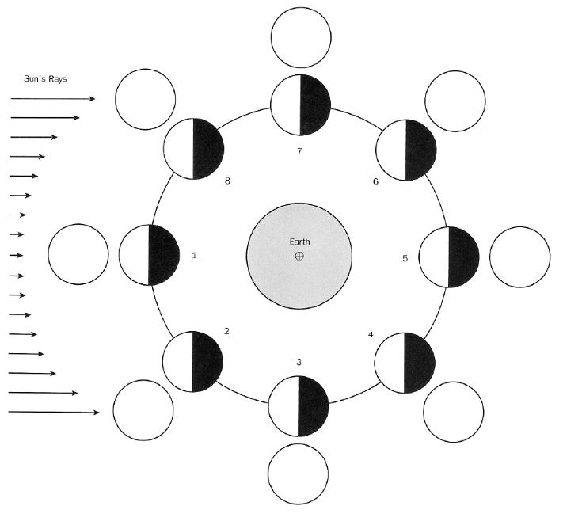
- Draw the moon phases as you would see them from Earth.
- Label each of your images with the proper phase name.

