Name________________________Period_____

**Chapter 12 Meteorology**

**Objectives:**

1. I can compare & contrast weather and climate.
2. I can analyze how imbalances in the heating of Earth’s surface create weather. This means I can:
   1. Describe the angle and effect of solar radiation hitting different areas of the earth.
   2. Explain why the temperature of the various regions of the earth remain relatively constant.
3. I can describe air masses; their source regions and how and they form. This means I can:
   1. Define air mass.
   2. Tell the relative temperature, humidity and source location of mP, mT, cP, and cT air masses.
   3. Understand which air masses are usually associated with regions of the U.S.
   4. Describe air mass modification as a given air mass moves across a given location.
4. I can identify the four main types of fronts. This means I can:
   1. Identify types of fronts and direction of front movement based on map symbols.
   2. Identify the type of front based on temperature differences between the two colliding masses.
   3. Identify the type of front based on which the temperature of the air mass which is “on the move”.
   4. Contrast the speed of air rising, type of clouds formed, severity and length of precipitation usually associated with each.
5. I can compare and contrast high and low pressure systems. This means I can:
   1. Describe the usual weather or cloud cover with each.
   2. Contrast them according to air rising/sinking, moving in/out of the center, and direction of rotation.
6. I can analyze a basic surface weather chart. This means I can:
   1. Determine the wind direction and relative speed based on isobar spacing and numbers.
   2. Describe the weather at a specific city using the station model symbols when given a key.
   3. Use the following additional miscellaneous terms: isopleths, isotherm.

**Weather vs. Climate**

1. **Meteorology** is the study of atmospheric phenomena
2. **Weather** is the ______________________________ state of the atmosphere
3. **Climate** is the _______________________________ variation in weather for a particular area

(Averaged over _____ years)

**Solar Radiation: Sun’s Angle and Earth’s Tilt**

1. The sun heats _________________________ (radiation)
2. The tropics have ___________________________ concentrated & intense rays making the tropics __________________
3. The poles have _______________ and ____________intense rays
   1. The poles receive the same amount of energy as the equator, but the energy is more spread out & it is__________

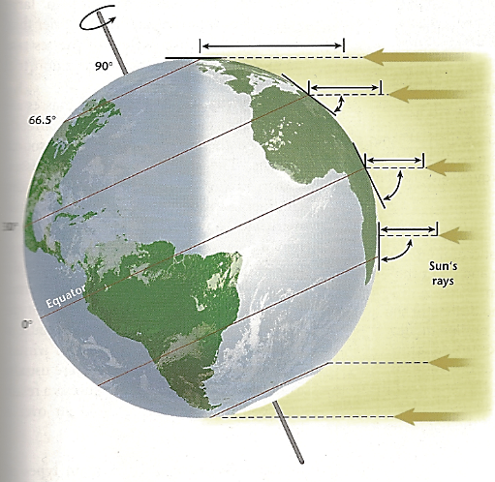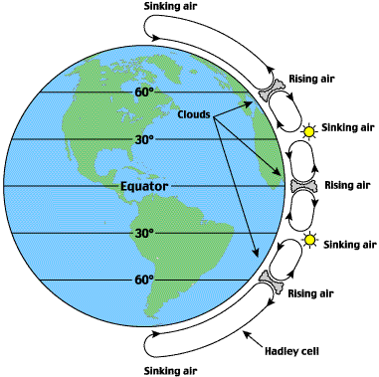

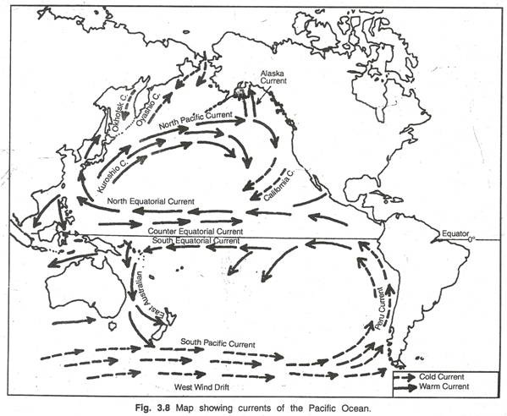

1. **Why does the earth not get too hot at the equator?**
2. Air currents and ocean ___________________currents constantly

______________________ _________________________________

**Air Mass**

1. An **Air Mass** is a ______________body of air that takes on the characteristics of the

__________________________ it forms

1. **Source Region** is the region ____________ which the air mass forms

**Air Mass Classification** Classification is designated with 2 letters. (See Fig 12-3 p. 303)

1. **Humidity** is represented by a ______________ letter

* Maritime (m) is ____________
* Continental (c) is ___________

1. **Temperature** is represented by a __________________ letter:
   * Tropical (T) is _____________
   * Polar (P) is ________________
2. **Arctic air** masses (A) represented by a single capital letter. Similar to _______ but much ________
3. Example: What would a cT air mass be like? ______________________ Source region?____

**Air Mass Modification**

1. Air masses move, change, become modified and more like the areas they move over
2. **Example:** Air masses can _____________ moisture and take on ____________characteristics if they move away from the body of water they formed over

**Example question:** A cool, wet air mass that brings cloudy, rainy weather to the Pacific NW is an example of what type of air mass?

1. Continental tropical
2. Maritime polar
3. Continental polar
4. Maritime tropical

**Fronts**

1. A **front** is a narrow region separating two air masses of ______________________________.
2. 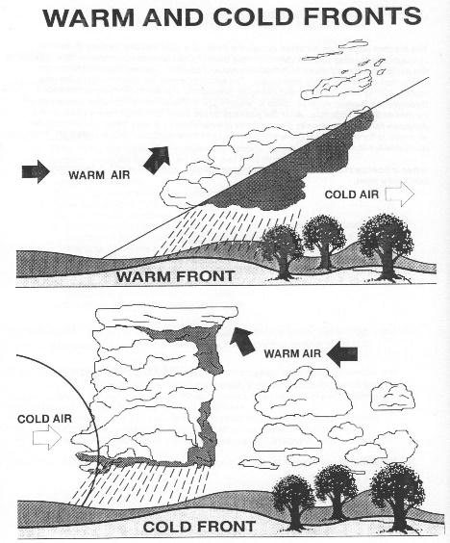**4 main types of fronts See Figure 12-7 p. 308 IMPORTANT)**
   1. ____________________fronts
   2. ____________________ fronts
   3. ____________________fronts
   4. ____________________ fronts

**Cold Fronts**: Cold air is “on the move” and doing the “pushing”

1. In cold fronts, cold, dense air is moving & forces ____________________________________
2. Very ____________ slope, air rising quickly

_

1. Wall of ___________________clouds and a ______________ line of

_____________________________________ thunderstorms

1. Temperature ______________ after the front passes
2. __________________line with _________triangles pointing in the direction the front is moving

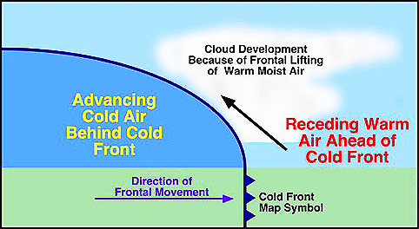

**Warm Fronts:** Warm air is “on the move” and doing the “pushing”

1. Warmer air ______________ advances ___________cooler air
2. Much _________________________ slope as air is rising slowly
3. This causes _____________ band of ____________________________________________

__________________________________________________________________________

1. _________________________________ rainfall.
2. Temperature___________ after the front passes.
3. ________ line with __________ semicircles pointing in the direction the warm front is moving.

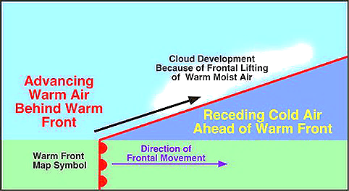

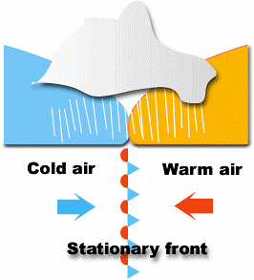**Stationary Fronts**

1. Stationary fronts occur when two air masses of similar

temperature and density collide but __________________ each

other because the temperature difference is _____________.

1. Not moving (“stationary”). AKA “Stalled Front”. The air mass that is slightly warmer rises & stalls over the cooler air mass.
2. _________weather for days. May have constant ________clouds &

________________rain depending on amount water vapor present.

1. Combo of _______________________ diagrams with short segments of

_____________blue triangles & red semicircles pointing in ________________ directions

**Occluded Fronts**

1. Occluded Fronts occur when a cold front PASSES a warm air mass & hits a cold air mass

moving in ____________________________________

* Cold fronts move faster than warm fronts….so they catch up and overtake them.

1. Forces all of the warm air _____________and then two cold air masses _________________.
2. Varied clouds & precipitation because both warm & cold fronts involved:________________ or

________________________; _________________ or _____________________

1. _____________line with ________________________ triangles and semicircles on SAME SIDE of the line.

**Occluded Front Development:**

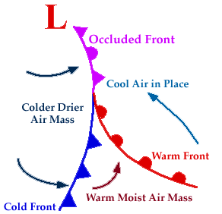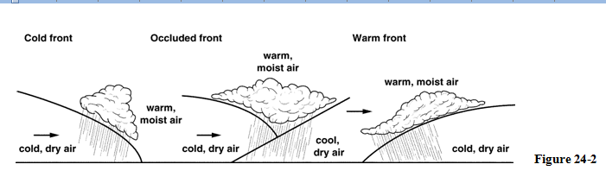

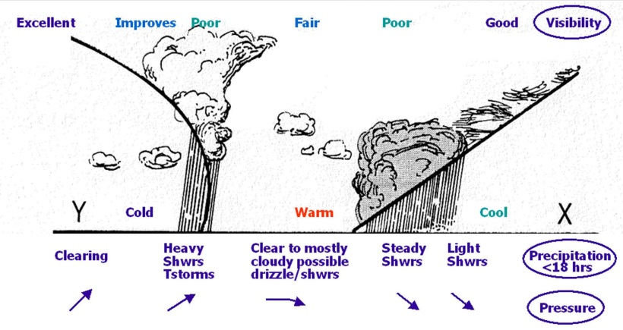

**Web Links to Animations of Fronts:**

1. Good Animation of All 4 fronts <http://www.phschool.com/atschool/phsciexp/active_art/weather_fronts/>
2. Short animation and explanation of Cold & Warm fronts: <http://www.youtube.com/watch?v=huKYKykjcm0>

**Pressure Systems**

**\*\*\*Think of hands on your back when you are lying on the ground.**

* If the hands rise off your back, do you feel pressure?
* If the hands “sink” and push onto your back, do you feel pressure?

1. High pressure is associated with ___________________ air
2. Low pressure is associated with ___________________air
3. Pressure = ____________________

**High-Pressure Systems**

1. In high-pressure systems, dense air falls to the earth’s surface and

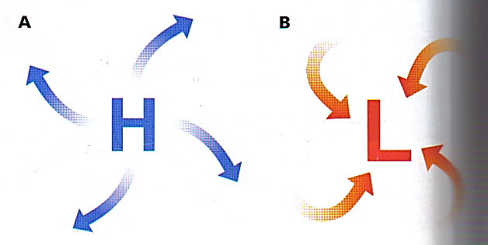

___________________________.

1. Spins (rotates) _______________________ in the Northern hemisphere
2. Air is “spun” _____________________
3. ____________ weather (______________ clouds)

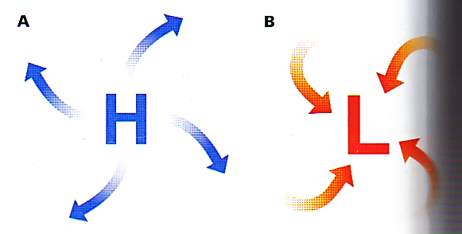**Low-Pressure Systems**

1. In low-pressure systems, less dense surface air ___________________

1. To fill in the “hole” that then forms in the center, air from around it must move inwards
2. Rotates _____________________________ in Northern Hemisphere
3. Rising air causes _______________________________
4. May form “wave cyclones”-bad weather in the mid-latitudes like us: _____________________________________________________

**Gathering Weather Data: Station Model**

1. **Station model** is a record of weather data for a _________________ at a ________________
2. FYI Windspeed: 1 knot = 1.15mph = 1.9 km
3. See Appendix E p.915 for weather `symbols

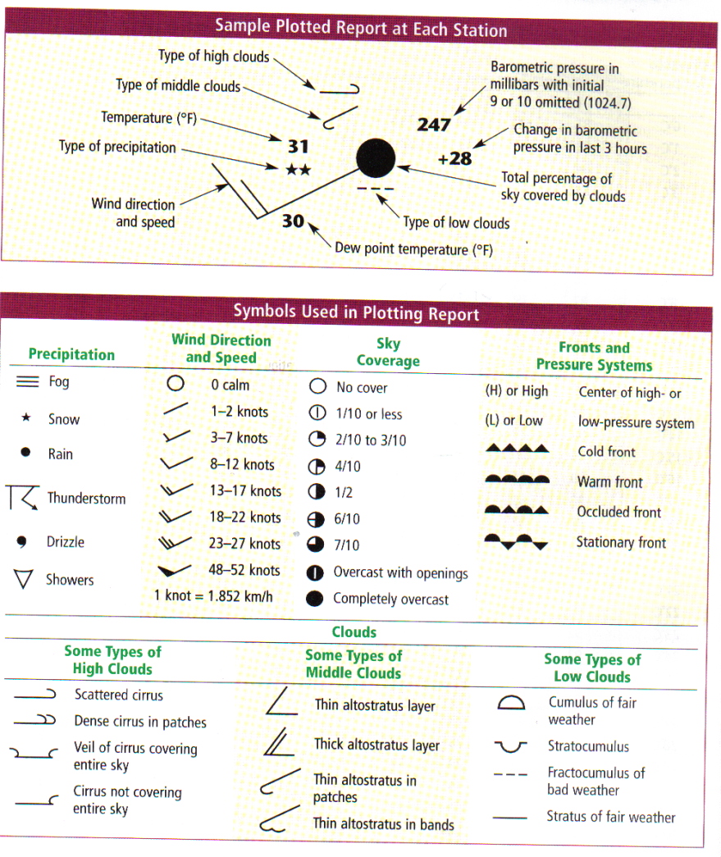

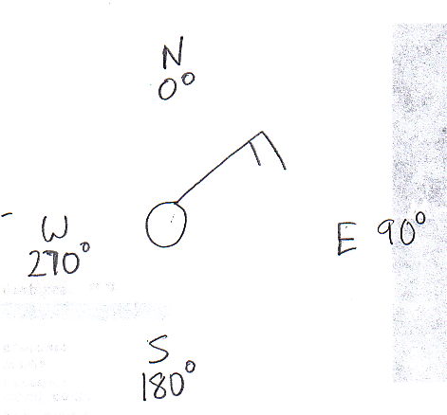

**Additional Terms Used on National Weather Maps**

1. **Isopleths** are lines that connect points of __________________________________ values
   1. **Isobars** are lines of equal _________________________
      * What do you think many isobars that are close together mean? ______________________________________________________________
      * Far apart?
      * Isobars show the locations of ______________________________ systems
      * See Fig 12-16 p.319
   2. **Isotherms** are lines of equal ____________________________
      * Shows temperature _____________________________
      * Identifies ___________________ systems (Fronts occur where isotherms are _______________________; big temp difference marking the boundary between 2 air masses)

**Bellwork #1 Prior Knowledge**

1. What is the difference between weather & climate?
2. List some terms used by meteorologists.

**Bellwork #2: Review Air Masses**

1. Write the symbols for the following AND list an location where that type of air mass would form:
   1. Cold & dry air mass
   2. Cold & humid
   3. Warm & dry
2. “It’s raining”. Is that a statement of weather or climate? Explain.

**Bellwork #3: Section 12.1 Assessment p. 304**

**Bellwork #4: Temperature & Season Causes**

1. What factors warm a particular spot on Earth?
2. What causes seasons to occur?

**Bellwork #5 Type of Front??**

|  |  |  |
| --- | --- | --- |
|  | Type of front | List 3 things seen in the diagram that support that type of front. |
| Top Picture |  |  |
| Bottom Picture |  |  |

**Bellwork #6 Miscellaneous Review**

1. Draw a symbol for both a high pressure and a low pressure system, including arrows showing the direction of wind at the surface.
2. Compare **and** contrast isobars & isotherms?
3. As an air mass moves away from where it was formed, its characteristics change. What is the vocabulary term to describe this change?