Lab: Ocean Tides & Tidal Ranges Name__________________ Period____

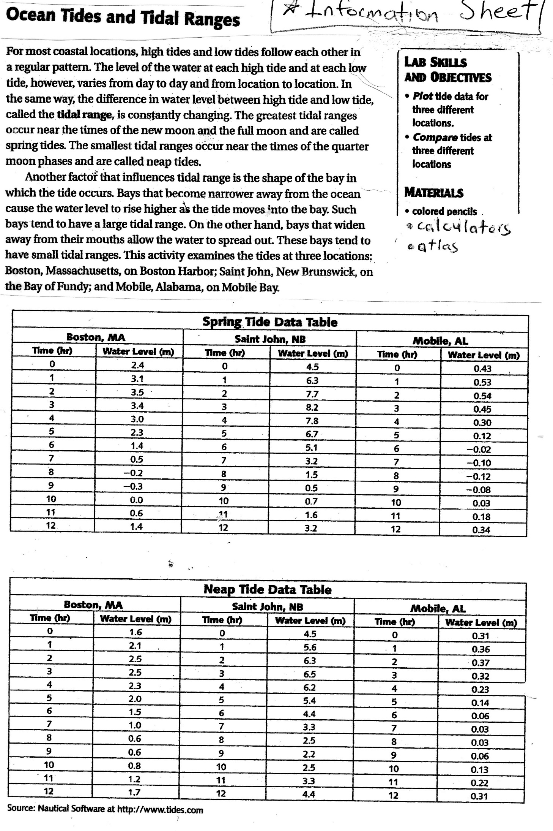
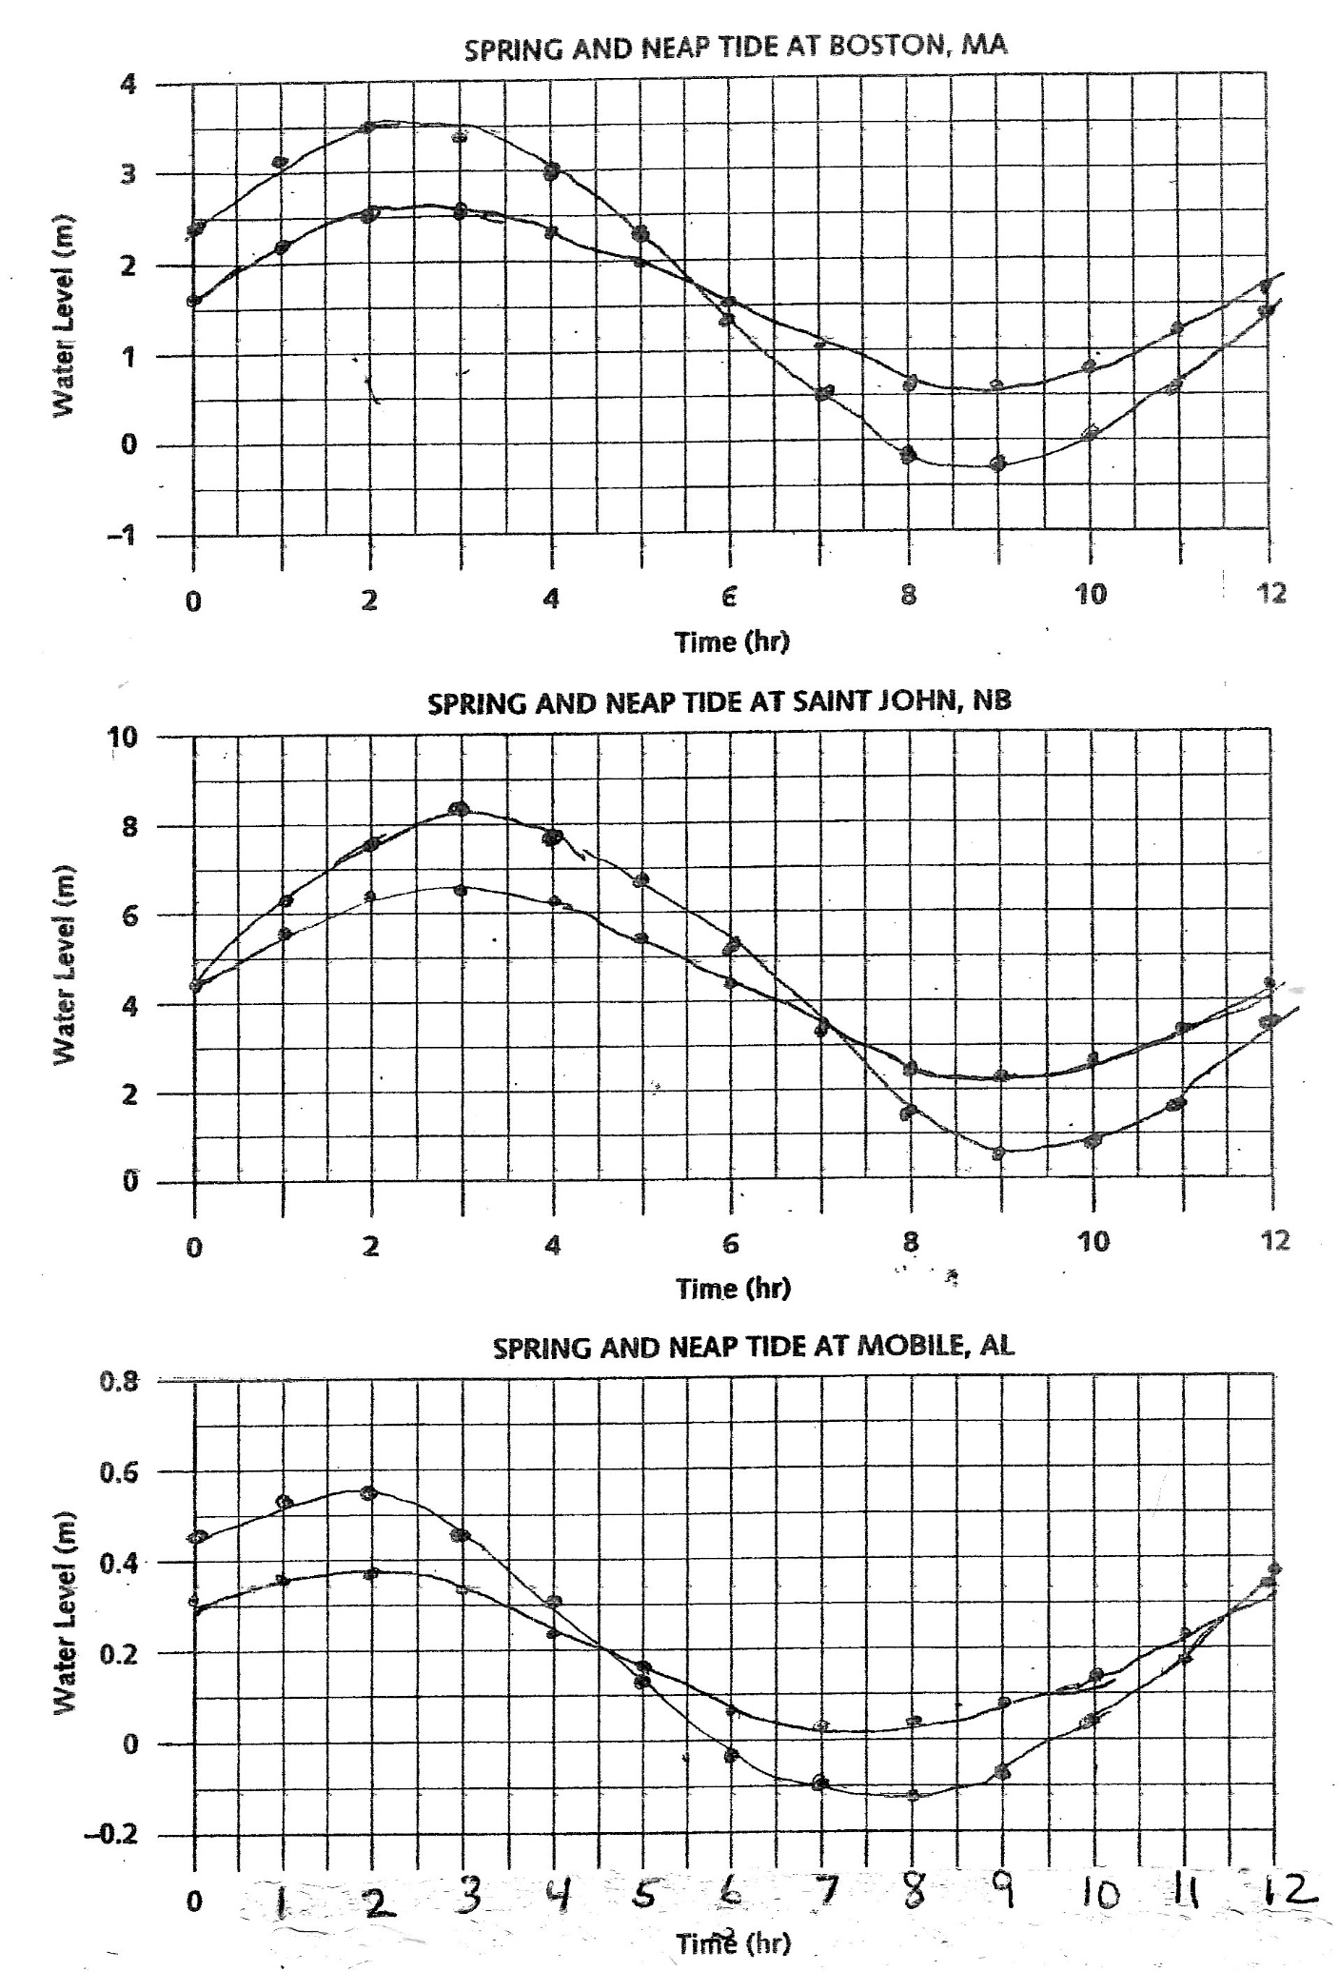

- Use the data table to determine which line for each graph is the spring tide, and which line is the neap tide.
  - Color all 3 spring tides the same color.
  - Color all 3 neap tides a second color.
  - Make a key showing which color is which type of tide.

- Use the graphs to answer the following questions:

  - Boston, MA: Which tide has the highest water level, spring or neap?

  - Saint John, NB: Which tide has the highest water level, spring or neap?

  - Mobile, AL: Which tide has the highest water level, spring or neap?

- Use the graphs to answer the following questions:

  - Boston, MA: Which tide has the lowest water level, spring or neap?

  - Saint John, NB: Which tide has the lowest water level, spring or neap?

  - Mobile, AL: Which tide has the lowest water level, spring or neap?

- Calculate the tidal range for each location’s SPRING TIDE by finding the highest water level and the lowest water level for the SPRING tide in the DATA TABLE (not the graph).

 | Boston, Massachusetts | Saint John, NB, Canada | Mobile, Alabama
Highest tide level (m)
Lowest tide level (m)
Tidal range (m) (subtract the two levels)

- Now do the same calculation for the Neap Tides. Calculate the tidal range for each location’s NEAP TIDE by finding the highest water level and the lowest water level for the NEAP tide in the DATA TABLE (not the graph).

 | Boston, Massachusetts | Saint John, NB, Canada | Mobile, Alabama
Highest tide level (m)
Lowest tide level (m)
Tidal range (m) (subtract the two levels)

- How do the tidal ranges for spring and neap tides compare?

- Explain what causes the difference in tidal ranges between spring & neap tides. Be specific. (The diagrams you draw for the next question may help.)

- Use your notes or textbook to draw the alignment of sun, earth and mood for spring and neap tides.
Type of tide | Drawing showing alignment of sun, earth & moon | What moon phases cause each type of tide?
Spring
Neap

- Based on your graph, approximately how many hours separate the high tide from the low tide?

- The graphs only show 1 high tide & 1 low tide. How many hours apart should the high tides be apart?

- Read the lab background information about how the shape of bays affect tide levels. Then find the cities in an atlas and circle which description best describes the shape of the bay at each city.

  - Boston, MA (42.2N, 71.1W). Circle bay shape:
    - Becomes narrower as bay moves away from the ocean
    - Bay widens away from the mouth (opening) of the bay, allowing water to spread out
  - Saint John, New Brunswick, Canada (45.3N, 66.1W). Circle bay shape:
    - Becomes narrower as bay moves away from the ocean
    - Bay widens away from the mouth (opening) of the bay, allowing water to spread out
  - Mobile, Alabama (30.7N, 88W). Circle bay shape:
    - Becomes narrower as bay moves away from the ocean
    - Bay widens away from the mouth (opening) of the bay, allowing water to spread out

- Using the lab background information, EXPLAIN the difference in tidal ranges for Boston and St. John:

- Based on the background reading and the shape of the bay you determined for Mobile, AL:
  - Does Mobile’s tidal range appear to follow the expectations found in the background reading? Explain

  - Mobile is located on Mobile Bay, which opens into the Gulf of Mexico. Can you determine why that fact may account for the extremely low tidal range for Mobile?

