Name_______________________________Period_____

**NOTE OUTLINE Chapters 29 & 30: Solar System & Stars**

**Objectives:**

1. **Describe early models of our solar system. This means I can:**
   1. Explain the geocentric model of the solar system and how **retrograde motion** brought change to that model.
   2. Describe the contributions and changes to solar system arrangement due to the following scientists: Nicolaus Copernicus, Kepler, Isaac Newton, Galileo.
2. **Examine the modern heliocentric model of our solar system. This means I can:**
   1. Explain Kepler’s 1st Law and its relationship to the following terms **astronomical unit, focus, major axis, semi-major axis,** the Sun, and **eccentricity.**
   2. Determine the relative shape (elongated oval, oval, circle) of an orbit when given its eccentricity value.
3. **Relate gravity to the motions of celestial bodies. This means I can:** Describe how mass, center of mass, and distance between 2 objects affects their gravitational pull on each other.
4. **Summarize the properties of the solar system that support the theory of the solar system’s formation. This means I can:**
   1. Describe how the planets formed from a disk surrounding the young Sun.
   2. Define & describe how the following terms are involved in the theory of the solar system’s formation: **interstellar cloud, planetesimal.**
   3. Explain how the theory is supported by the types of elements and density differences of the inner terrestrial vs. outer gas giants.
   4. Using distance from the sun and resulting temperature differences throughout the solar system, explain why lightweight gases such as hydrogen and helium are rare in the terrestrial planets but common in the gas giants.
5. **Explore remnants of solar system formation. This means I can:**
   1. Define **asteroid.** Identify the location of the asteroid belt on a solar system diagram.
   2. Define and describe the composition of a comet.
   3. Discuss the location of the two main clusters of comets, including how far they are from the sun in astronomical units.
6. **Compare and contrast the properties of the inner/terrestrial vs. outer/gas planets. This means I can** 
   1. Describe similarities and differences in composition, size, surface, composition (main elements), density, rings, number of moons.
   2. Explain why/how the inner and outer planets are composed of different substances.
7. **Explain the Impact Theory about the Moon’s formation, including evidence supporting the theory**.
8. **Identify features on the Moon. This means I can:**
   1. Define, draw and label the following surface features of the Moon on a diagram: highlands, maria, impact craters, regolith.
   2. Describe the history of the Moon’s surface features; contrast the age and formation of maria vs. highlands.
   3. Determine the relative age of features on the moon using the principle of superposition.
9. **Identify the relative positions and motions of Earth, Sun & Moon. This means I can:**
   1. Explain what causes earth’s day and night, seasons.
   2. Compare and contrast summer solstice, winter solstice, autumnal and vernal equinoxes.
   3. Describe the following motions and their effects: rotation, revolution, tilt of axis, synchronous rotation.
   4. Compare and contrast high & low tides as well as spring & neap tides according to sun and moon alignment, tidal range, frequency and location.

**Section 29.1 Early Astronomers**

**Research & Ideas**

* 1. Ancient astronomers could recognize the difference between stars and ______________
     1. Planets move, stars are stationary & do **NOT** move
  2. **Geocentric** Model –1st model of solar system
     1. Geocentric = ___________ is the center of the universe
        + - Believed the Sun, planets, and stars _____________a stationary _____________

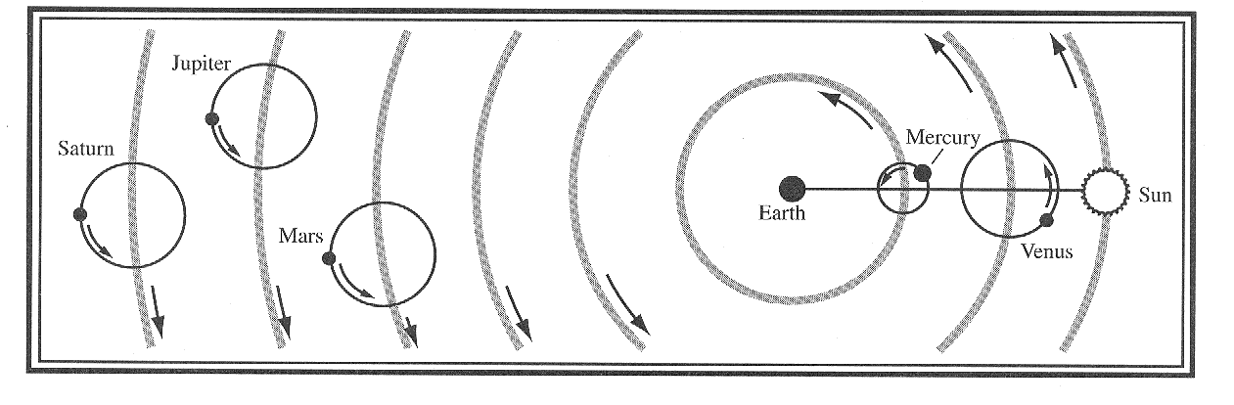

* + 1. Problem: Didn’t explain **________________ motion** 
       1. This is a sudden change in planetary motion when planets suddenly **appear** to move

_________________

* + - 1. Very hard problem to solve
      2. Scientists began looking for a better model of the universe/solar system

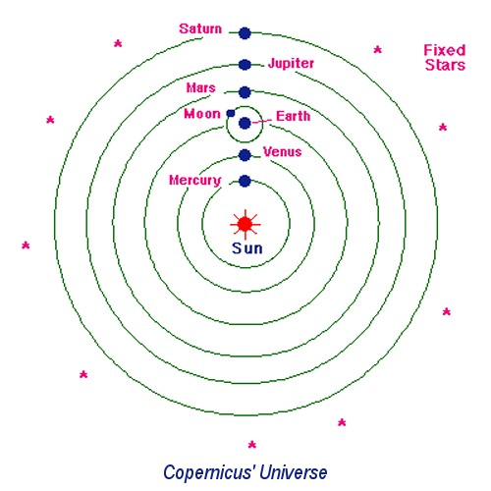 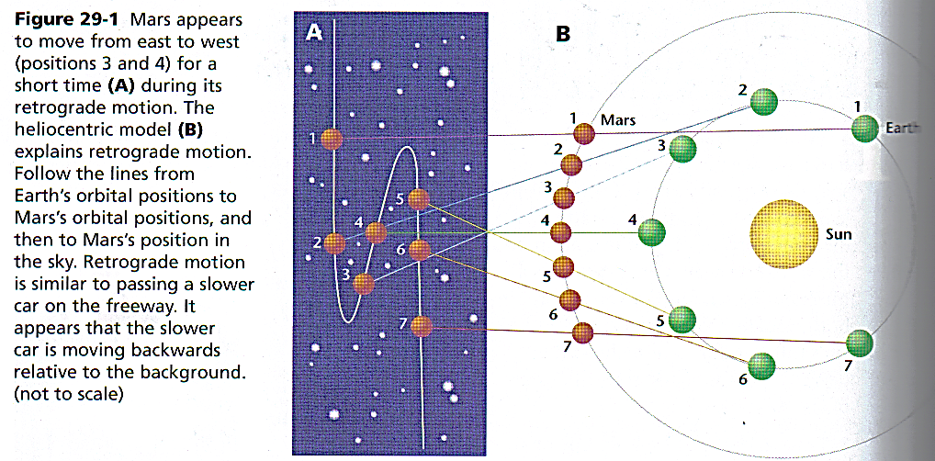

1. **Heliocentric Model** = _________-centered
   1. Suggested by **Copernicus** in 1543
   2. Explained retrograde motion…So **WHY** do we see planets moving “backwards”?
      1. Inner planets move _____________ than outer planets around the sun
      2. Earth will “pass” a slower moving planet
      3. The slower planet temporarily appears to move_____________________
   3. Galileo’s discoveries also support heliocentric
      1. 4 moons orbited ________________ not the Earth
      2. Therefore, Earth ___________________________________of the solar system
2. **Kepler’s 1st Law:** Most planets orbit the Sun in an _____________, NOT a circle
   * 1. Ellipse = Oval that is centered on _______points (__________), not 1 like a circle

* (Focus – singular, _________ – plural)
  + 1. Most planets orbit the Sun in an _____________________ shape
    2. Earth being the exception
       - Earth believed to move between an elliptical orbit and a circular orbit every 100,000 yrs or so.
       - <http://www.youtube.com/watch?v=tw5MvHNw0Co>
    3. Planets orbit while staying centered around _____________points.
    4. The ____________________ is one point
    5. **Orbit is around the “_______________of mass” of the 2 bodies (Sun & planet)**

1. Sun is _________ the center of the orbit, but is 1 of the 2 ________

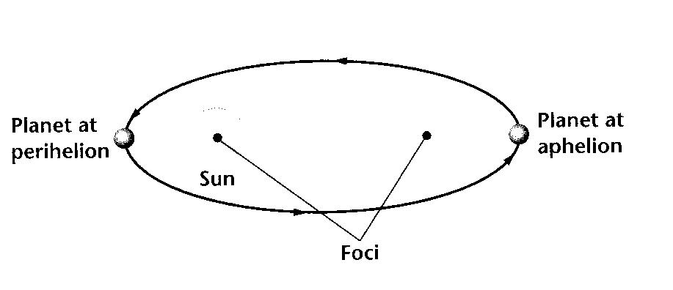 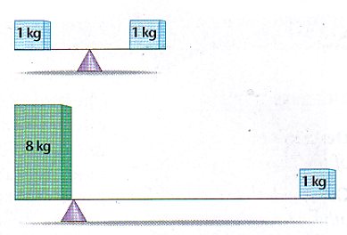

**Eccentricity =** HOW oval-shaped the orbit is, and is based on the ratio of distance between the 2 foci to the

major axis. <http://www.youtube.com/watch?v=BIBz_GQDga0>

* + 1. Planets vary in their distance from the Sun, therefore the distance between focus points is different for each planet
    2. A planet is NOT at a constant distance from the Sun
    3. **1 Astronomical Unit (AU)** = the **average distance** between _____________________
  + 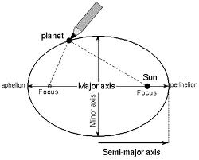Is the unit used for distances between the Sun and planets.

1. **Major axis:** runs __________________________ through both foci.

* Is the ______________________ diameter

1. **Semimajor axis:** _________________ of major axis.
   * Is the planet’s ____________________ distance to the Sun

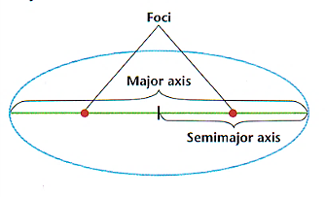

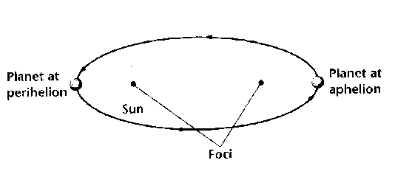

**Eccientricity Mini-Lab Data Table:**

**Eccentricity = _________________________________________**

|  |  |  |  |  |
| --- | --- | --- | --- | --- |
| Distance foci are apart | Length of major axis in cm  (Longest length)  **Use 1 decimal | Equation / Calculation  (Show your work) | Eccentricity Value (Calculation answer) | Describe/Draw Relative Shape of Drawing |
| 2cm |  |  |  |  |
| 9cm |  |  |  |  |
| 0cm  (Just use 1 pin) |  |  |  |  |

**Eccentricity Mini-Lab Questions, Analyze and Conclude:**

1. What do the 2 pins represent?
2. For planets orbiting in our solar system, what is always one of the foci?
3. How does the eccentricity number AND the shape change as:
   1. The distance between the foci (pins) gets larger?
   2. The distance between the foci (pins) gets smaller?
4. What is the eccentricity value of a perfect circle? _____How far apart are the foci of a circle?____

**Eccentricity Notes Continued:**

1. **Eccentricity has a value between ______________**
   * 0 = ________________ (Distance between the 2 foci is _____)
   * 1 = very __________________________

**GRAVITY: Recreating Galileo’s Experiments:**

**Experiment: Testing Gravity’s Influence on Falling Objects**

**Pick 4 objects of different weights from across the room. You can use anything safe to drop. If you want to use anything of the teacher’s, please ask before you grab it.

**Record your object choices in the data table below:

|  |  |  |  |
| --- | --- | --- | --- |
| **Object** | **Trial #1** | **Trial #2** | **Trial #3** |
|  |  |  |  |
|  |  |  |  |
|  |  |  |  |
|  |  |  |  |

**Time for Predictions:**

1. Out of all the objects you selected, what will fall to the ground most quickly?
2. Out of all the objects you selected, what will fall to the ground most slowly?

**Procedure:**

1. Time to test your predictions.
2. Go into the hallway and mark a height on the wall using masking tape. This is your start position from which each object will be dropped.
3. Pick the first 2 objects in your data table and hold them up to the start line.
4. Count to 3 to give the timer time to get the stop watch ready.
5. Drop the objects.
6. Repeat the above steps so both pairs of objects has a total of 3 trials.
7. Grab the next pair of objects, switch jobs, and repeat steps 3-6.

**GRAVITY: Post Lab Questions**:

1. Were your predictions accurate? Why or why not?
2. What relationship did you observe between the speed an object falls towards the Earth and the amount it weighs?
   * Did any object defy this relationship? If so, why do you think this happened?

**Galileo & Gravity:**

1. In the late 16th century early 17th century Galileo was working with gravity.
2. Performed experiments dropping objects off the Tower of Pisa and rolling balls down inclines
3. Gravity accelerates the fall of all objects at the ________________________
4. ________________________ causes lighter objects to fall ____________________

**Sir Isaac Newton & Gravity**

1. 1687 **Newton** published his Law of Universal Gravitation.
   * Also called the inverse square law
2. This theory helped discover Neptune.
   * Watched Uranus’s movements:
     + Gravity of something large was affecting the movements of the planet.

1. Basics of the Inverse Square Law:
   * Any two objects ______________________each other
   * Depends upon their _____________ AND the ___________________ between them.
2. **Inverse Square Law (Summary of Law of Gravity):** 
   * The larger the objects the stronger the force of gravity between them.
   * The farther apart the objects the weaker the force of gravity.

**How Do Scientists Determine Theories for How Our Solar System Formed?**

1. Scientists Examined
   1. Why the planets are so different.
      * + Especially Outer vs. Inner Planets
   2. Asteroids, Meteorites, and Comets.

**Formation of Our Solar System – Section 29.4**

**Collapsing Interstellar Cloud Theory**

**Interstellar Clouds =** Huge clouds of _________ & ___________ in space

1. Made mainly of _________________ and ___________________
2. Forms stars and_______________ when the cloud condenses/collapses due to __________________
3. **These clouds usually look dark because the dust blocks _________________.**
   * Like __________________
   * Stars behind this cloud can’t shine through it.
   * But….Sometimes the light from stars within the cloud causes these interstellar clouds to glow.
4. **Location**
   1. There are many interstellar clouds found within our ___________________________.
   2. Astronomers look for high amounts of gas and dust
5. **Collapsing Interstellar Cloud Theory**
   1. When enough gas and dust is present, scientists think these interstellar clouds condense because of _________________
   2. Can form a star or planet
   3. Cloud begins collapsing slowly.
   4. The smaller it gets the faster it begins to __________________________
   5. This spinning motion with eventually form a ___________ rotating disk with a very dense _____

**Solar Nebula**

1. Scientist believe that one huge interstellar cloud called the _______________ formed the Sun and all the planets.
2. The Sun formed first in the center of this cloud.
   * Fits with why our Sun is the ______________and most ____________thing in our solar system.
3. In the center of the cloud it was the ________________
4. On the edges of the cloud it was the ________________
5. **This difference in temperature as the solar system cooled caused different materials to condense at different distances/regions from the sun**
   1. ______________________ (iron, lead, etc.)
      1. condense at _____________temperatures and
      2. became ___________ close to the Sun
   2. Lighter elements (______________________ etc)
      1. Don’’t condense until the temperature is very ____________.
      2. remained gaseous
      3. didn’t become solid until they were ____________________ from the Sun
   3. **This is why** _________ planets and _________ planets have such ___________ compositions

**Terrestrial Planets**

**What does terrestrial mean? Composed of __________________

1. **Inner Four Planets**
   1. Closest to the Sun
   2. Mercury, Venus, Earth, and Mars
2. **Small (Close to the size of Earth)**
   1. Smaller because the _____________________ captured the majority of materials found here
3. **Solid Surfaces**
   1. Made of Rocks and _________________. AKA __________________planets , because higher mass elements condensed at high temps close to the sun
4. **Few Moons**
   1. ______________________ took all the loose debris

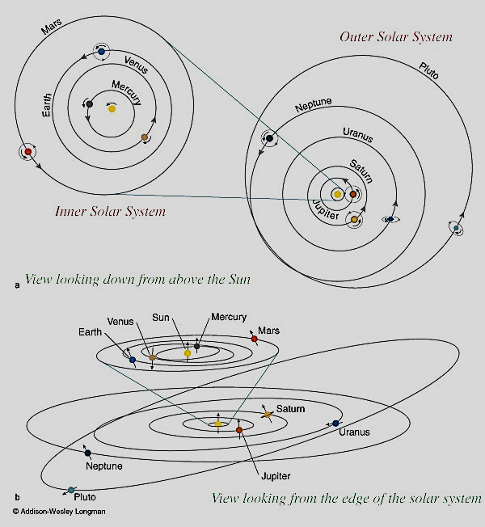

**Gas Giant (Outer) Planets**

1. **Outer four Planets**
   1. Farthest from the Sun
   2. Jupiter, Saturn, Uranus, Neptune
2. **Larger in size & mass**
3. **Lack Solid Surfaces**
   1. Gaseous including ____________________ & ___________________
   2. Very little rock and metal
4. **Many ______________________ (satellites)**
5. **Ring systems**
6. **Belts & Zones: __________ stretched into __________ by __________ rotation of the planet**
   1. Why look “striped”
   2. Clouds made of ____________________, methane (blue) & ammonia (NOT water like on earth)

**DEVELOPMENT & FORMATION OF THE PLANETS**

**Inner Planet Formation**

1. As materials (rock, metal, ice) condense and become solid, they collide and stick together.
2. **Planetesimals** = Space objects (100’s of km in diameter) made by _________________ solid particles
3. **Inner Terrestrial Planets** formed by colliding and sticking _____________________________
   1. Made of very different things, more _________________________
4. **Sun’s ____________________took all the gas and floating debris away from inner planets.**
   1. This is why they are rocky and dense
   2. This is why moons are _____________for inner planets.

**Outer Planet Formation**

1. **The planets formed by a process in which dust and gas gravitationally attracted each other.**
   1. As size increases, gravity increases & pulls even more gas & dust in
   2. Over time this collected and formed larger and larger bodies.
2. **1st planet of the gas to form was________________**
   1. This is why ________________ is the largest.
   2. Had the most materials to build with
3. **Then Saturn, Uranus and Neptune (the rest of the ______________________) formed**
   1. Not as large because _____________ had taken most of the materials; gas, dust, and ice to make itself.
4. **“Leftovers” became ____________________that form along equatorial planes of planets**

**Space Rocks**

**Asteroids** = Leftover pieces of _________________________

1. Asteroids were _______________ planets
2. Asteroids can collide and break apart.
3. **Asteroid Belt** = Planetesimals left behind in a band between __________________________
   1. _______________________ prevented them from merging into a planet

**Meteroid**

* When any space material ____________ Earth’s __________________

**Meteor**

* The _______________________ produced when space material ______________in Earth’s atmosphere.

**Meteorite**

* When a space object _________________Earth

**Meteoroid, Meteor, and Meteorite are all the same pieces of space rock, but the names change depending on location.**

**Comet**

1. Small __________and ______________ bodies with a highly ______________ orbit around the Sun.
2. **Meteor Shower**: Occurs when Earth passes through the **remains** of a comet’s ________________
3. **Most found in 1 of 2 clusters**
   1. Kuiper Belt – close to Pluto (30 – 50 AU) from the Sun
   2. Oort cloud - >100,000 AU from the Sun
4. **Comet Structure (Parts of a comet)**
   1. Icy nucleus = small, ______________________
      1. When it is heated, it releases gas & dust to form the coma & the tail
   2. Coma = _____________________ surrounding nucleus
   3. Tail – always points _________________ from the Sun due to solar_________________

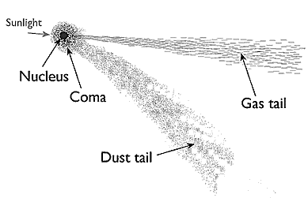 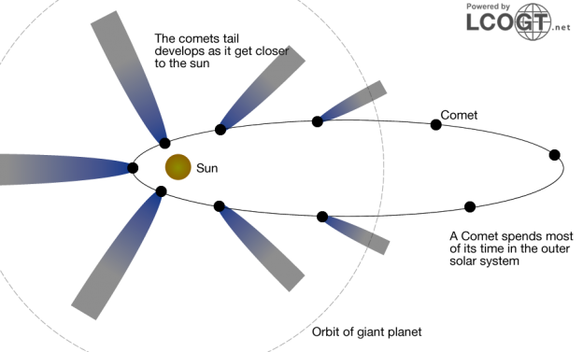

**Impact Theory of Moon Formation**

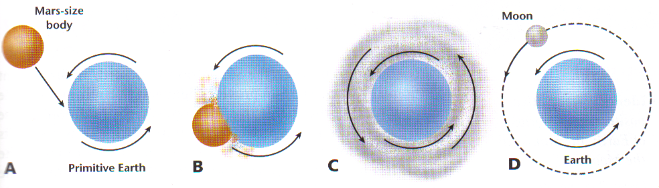

1. Theory states that the Moon formed because of a ___________________ between the Earth & a Mars-sized object
2. Collision expelled material/debris from __________ the Earth & the space object
3. The flying debris combines to form the Moon
4. Positives:
   1. Explains why there are___________ similarities & differences in composition between the Earth & the Moon
   2. Explains why there is ______water on the moon – _____________from the impact would

have__________________________ any water

1. Most commonly __________________ theory
2. Possible cause of crater that became ___________________?

**Moon Topography**

1. **Highlands**: _________________, _______________ in color, ________________
2. **Maria** (“_______”): ___________, ____________________, low elevation, flat _________
3. **Impact craters**: Depressions formed by space object ________________ onto the Moon’s surface
4. **Regolith:** Layers of _______________ matter on Moon’s surface
   1. Very fine regolith has a texture like snow
   2. Thicker in ________________than in _________________
5. **No erosion**
   1. No _________________(no___________ & no flowing _______________)
   2. Impact craters remain _______________________

**How old is the Moon?**

1. How do we know the age of various regions of the Moon?
   * ____________________________________
2. Studies have shown that the Highlands formed ________________ the Maria

**Moon History**

1. Highlands are _______________________ years old
   1. Heavily _____________ during the first 800 million years by flying space objects
   2. Caused surface to be covered with________________,
      1. Regolith = a layer of ___________________ rock caused by impacts
2. Maria are slightly _____________, _________________ years old
   1. Formed by lava filling up huge impact crater holes
      1. ________________ impacts by space objects caused _________ in the larger craters
      2. __________ flowed up through the cracks & filled the _____________ of deep craters
      3. As the liquid lava cooled it created _____________________ maria
   2. Not many space objects have hit since the maria formed, so maria are _____________ with

___________ craters

1. Highlands remain high in elevation because lava _______________________ fill the basins
2. Far Side of the Moon: _____ Maria on the _____side of the Moon
   1. The crust is_____________ on the far side of the moon

the impact cracks weren’t deep enough to reach the lava

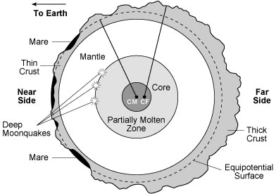

http://ase.tufts.edu/cosmos/pictures/Explore_figs_8/Chapter5/Fig%205_22copy.jpg

**Motions of the Earth**

1. **Rotation**: _______________of the earth around its ________________
   1. Daily motion
   2. Causes __________ & __________, and ___________ & ____________ of the sun
   3. Causes the __________________ of the sun rising in the east & setting in the west
2. **Revolution**: ____________ motion around the___________
   1. Annual Motion
   2. Year = the time to __________________ 1 revolution
   3. **Ecliptic**: _________________ in which the Earth orbits the Sun

**Effects of Earth’s tilt; Seasons**

1. Tilted at _______ compared to the ____________
2. __________ AND _____________are both needed to cause seasons
3. Tilt causes the intensity of the Sun to vary with location
   1. Direct Light = ______________ (more intense)
   2. Indirect Light = _______________
4. Hemisphere tilted TOWARDS the sun;
   1. Has ______________daylight
   2. Is in the _______________ season
   3. The sun appears _______________ in the sky
5. NOTE: Seasons due to TILT (_________________________)

**Solstice:** Is the day when the sun reaches its ________________ distance ____________of the equator

**Solstice: Is** the day when the sun is the greatest distance _____________of the equator

1. **Summer solstice (for N. Hemisphere) i**s when the sun is furthest _______________________
   1. ________________ amount of daylight, ______________ night
   2. Most direct light is at _____ – _____________________
   3. _____________
   4. Arctic circle has _________________
   5. Antarctic has ____________________
2. **Winter solstice** (for N. Hemisphere) is when the sun is the furthest ________________
   1. __________________ amount of daylight, _______________ night
   2. Most direct light is at __________ – _______________________
   3. _________________
   4. Arctic circle has ___________________
   5. Antarctic has __________________

**Equinox**: Sun is _________________ over the ______________________

1. ________________ amount of daylight and night
2. _______________ hemisphere is tilted towards the Sun
3. **Autumnal equinox:** ________________
4. **Vernal** (______________) **equinox**: __________________

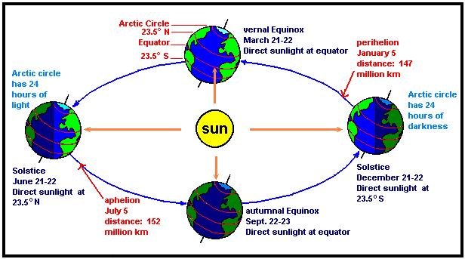

**Motions of the Moon – Synchronous Rotation**

**Synchronous Rotation**:

1. The Moon makes _____revolution (orbit around earth) and ____rotation (on axis) in the________

amount of time

1. So the __________ side of the Moon ___________ faces the Earth
2. We never saw the far side of the moon until space program

**Tides**

1. Moon’s gravity has a _________ effect on the Earth’s tides than the Sun’s due to the moon’s ___
2. High tides occur on the sides of Earth ___________________________ of the moon
3. High tides occur every ____ hours. Low tides also occur every ____ hours
4. Spring tides occur when the earth, sun & moon are _____________________
   1. __________________ tidal range: ______________ high tides & ____________low tides
5. Neap tides occur when the moon is at __________________ to the earth & sun line
   1. ______________ tidal range: _______________ high tides &_______________ low tides

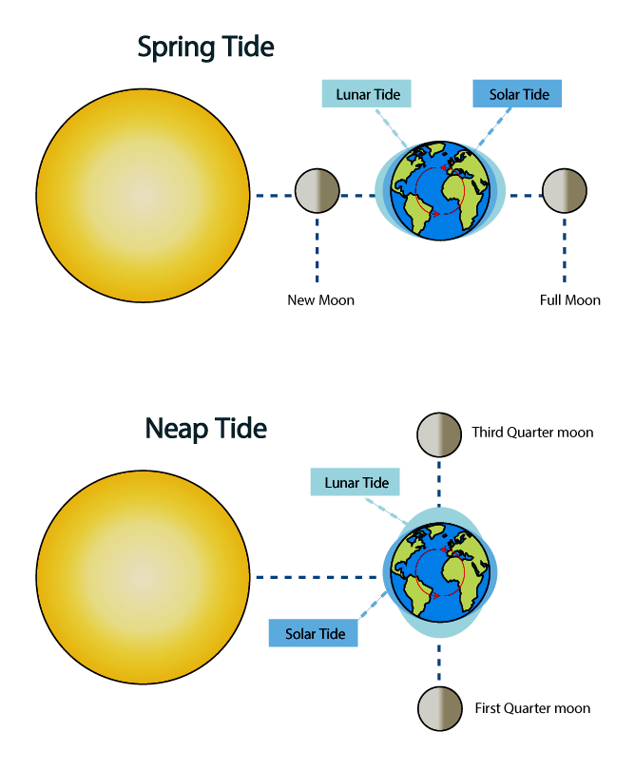

**Questions & Challenges of the Day**

1. Draw the best diagram of our solar system that you can in your notes.  
   Make sure to include labels!
2. What was the problem with the geocentric theory? How did we fix the problem?
3. Compare and Contrast Heliocentric and Geocentric Theory.
4. 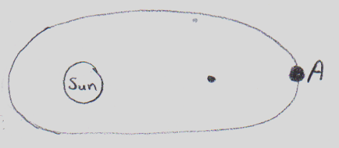Review your knowledge of eccentricity using the diagram to the right.   
   A. Estimate the eccentricity value of the orbit.

B. Explain your estimate.

1. What is retrograde motion?

Who fixed this problem?

1. Understanding Check:   
   Write down as many facts as you can about interstellar clouds without peeking at your notes.
2. What is an interstellar cloud?

What must happen to an interstellar cloud to produce a star or planet?

1. Test your knowledge:   
   Describe what each planet is made of, gas, ice, rock or metal, and why that makes sense.
2. Describe the process that produces terrestrial planets.
3. Describe the process that produces gas giant planets.
4. Use your notes to draw a diagram of a space rocks journey from being classified as an asteroid to a meteorite.

**Miscellaneous Review Questions**

1. List 3 characteristics common to all terrestrial planets
2. List 3 characteristics common to all gas giants
3. Compare and contrast asteroids and comets
4. According to the solar nebular theory, what caused the inner planets to be dense and rocky and the outer planets to be light with H & He?
5. What does an eccentricity of 0.1 tell you?
6. What is retrograde motion?
7. Name the 4 terrestrials
8. What are 2 things that effect gravity?

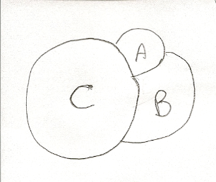**Review #1: 28.2**

1. In the diagram, which crater is
   1. Oldest? How do you know?
   2. Youngest? How do you know?

**Review #2 – Solstices & Equinoxes**

1. Describe an equinox
2. Describe the two solstices
3. Does the distance from the Sun cause the Earth’s seasons? Why or why not?
4. How are the seasons in the northern & southern hemisphere related?
5. Why is the tilt of Earth on its axis important?
6. When the North Pole experiences 24 hours of daylight, what is happening at the South Pole?

**Review #3 –Seasons & Phases**

1. What are the causes of the seasons on Earth?
2. What would our seasons be like if Earth’s axis were not tilted? Explain.
3. If Earth’s axis were tilted 45 degrees, at what latitudes would the sun be directly overhead on the
   1. Summer and winter solstices?
   2. Vernal & autumnal equinoxes?
   3. How would our seasons be different?

**Review #4 – Miscellaneous**

1. What causes day & night?
2. 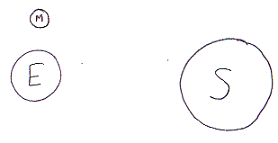How long does earth’s rotation take?
3. What type of tide is shown in the diagram to the right?

What moon phase is occurring?

1. How often does low tide occur?