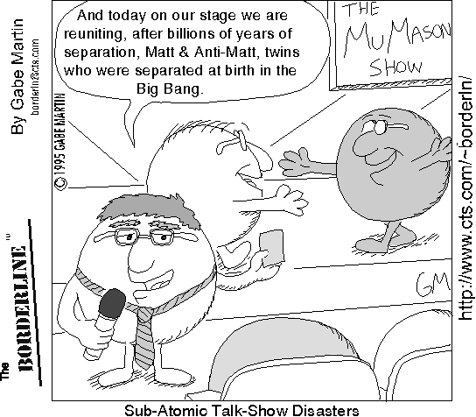
Physical Science
Unit 2
Physical Properties of
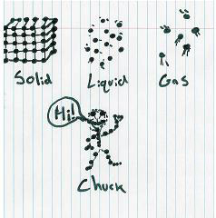
Matter
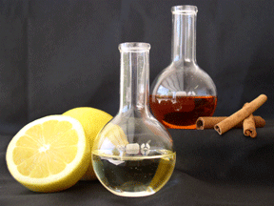

Unit 2- Physical Properties of Matter
Overall objective: Understand and apply knowledge of the structure and properties of matter (Iowa Core Curriculum 2009)

Objectives:
The students will:
- understand the difference between heat and temperature
- be able to understand how the identity of a substance can be found using physical and chemical properties
- understand the molecular movement and energy changes during phase change
- be able to identify and classify matter into three basic groups
- understand how to calculate the density of an object and use it to identify an unknown substance
- investigate the effects of pressure, volume and temperature on the states of matter
Skills:
- interpreting data from a graph
- classifying information into groups
- Analyze data for similarities and differences

Textbook reference pages:
Chapter 2- Section 2 (p.44-48)
Chapter 3- Section 1 (p.70-75), Sections 3+4 (p.83-93)
Chapter 14 – Section 1 (p.472-477)

Prentice Hall: Physical Science
Chapter 14 Section 1 (p.472-477)

- What does “temperature” mean?

- Do the particles move faster in cold chocolate milk or hot cocoa?

- What are the 3 main scales that can be used to measure temperature? Circle the one that scientists use most often.

- What does the amount of thermal energy depend on?

- The ______________ particles an object has at a given ___________________, the ______________ thermal energy it has.

- What does “heat” mean?

- _____________ is thermal energy moving from a ____________ object to a ________________ object.

- What unit is used to measure heat?

How Much Heat Will It Hold?
Objectives
After this activity, students should be able to:
- Define heat capacity.
- Measure the temperature of a material over time.
- Describe the difference between materials with high-heat capacity and low-heat capacity.

Materials List
- 2 thermometers (each group)
- 1 250–300 ml beaker or small jar (each group)
- 1 container to hold small beakers/jars (each group)
- Different material for each group: sand, water, shredded paper, shredded Styrofoam, cloth, or powdered materials
- Hot water (~85°C), enough for each group to fill large jars
- Ice water, enough for each group to fill large jars
- 2 large beakers, cans, dishpans or other containers (for cold and hot water control setup)
- Beakers (or jars with 200 ml level marked)
- Masking tape
- Markers

Jobs
Person #1 - Read the temperature on the thermometer in the material
Person #2 - Read the temperature in the water
Person #3 – Recorder & Timekeeper

Procedure
- Measure 200 ml of your material using a beaker.
- Fill the smaller beaker halfway, place a thermometer into the material and then finish filling the beaker. The material must cover the thermometer bulb or bottom.
- Using masking tape, label your container.
- Measure and record the initial temperatures of the materials and water.
**Recorders, start writing down your data on your worksheet!**
- Place the beaker into the large container of hot water
- Measure and record the temperature of the material and the water bath every minute for 10 minutes. Record the starting temperature at "0" minutes.
- After 10 minutes, empty your beaker.
- Now, repeat the entire activity using ice water instead of hot water (Repeat steps 1-6).
- After you have collected all of your data, make a bar graph showing their material and the highest temperature or the lowest temperature it reached.

Data Collection & Analysis
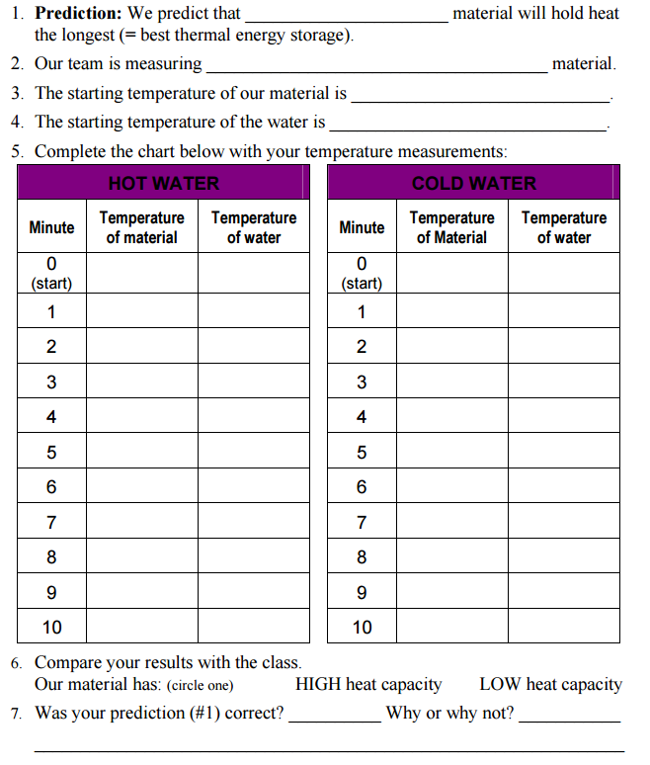

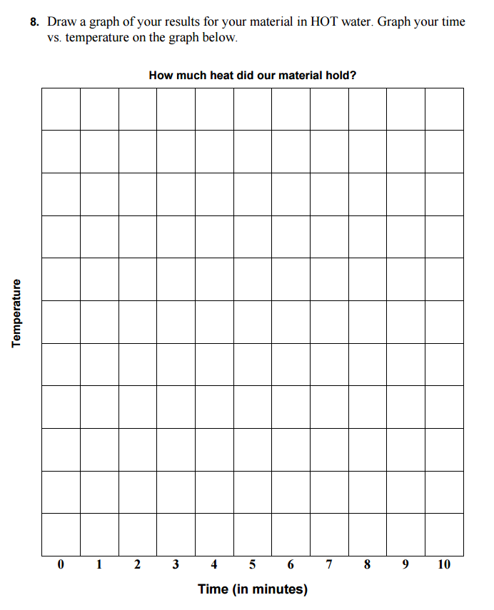

Conclusion Questions
- Compare the results of the different materials tested. Compare graphs. Which materials had the highest heat capacity (stored heat the longest)?

- Also compare the temperature gains (losses) to the teacher's measurement of the hot water and ice water, taken as a control. Discuss the water's heat loss (and gain) to (and from) the air in the room.

- Look back at the prediction you made at the beginning of the experiment. Were you right or wrong? What have you learned? (Hint: What types of materials have a high heat capacity? What types have low?)

- How would an engineer use what the students have learned today?

- Which of the materials that the class measured would an engineer choose for…
  - insulating a home in the winter?

  - to design a good food storage container for soup?

  - to design of a product that you want to heat up quickly?

Prentice Hall: Physical Science
Chapter 3 Section 1 (p.68-75)

1. Complete the outline as you read the section about states of matter.

A. Solid
1. Example:_________________

2. Particle kinetic energy:__________________

3. Particle behavior:____________________

4. Other facts:_______________________________________________

B. Liquid
1. Example:_________________

2. Particle kinetic energy:__________________

3. Particle behavior:____________________

4. Other facts:_______________________________________________

C. Gas
1. Example:_________________

2. Particle kinetic energy:__________________

3. Particle behavior:____________________

4. Other facts:_______________________________________________
Properties of Matter Lab
Name____________________

Everything that has mass and takes up space is called matter. Matter exists in four different states: solid, liquid, gas, and plasma. This paper, your hand, water, and the air you breathe all consist of matter. Even the planets and stars are made of matter.
Scientists use two types of properties to describe matter. Physical properties depend on the nature of the matter. They are observed when there is no change in chemical composition. The physical properties of water describe it as a colorless, nonmagnetic liquid between the temperatures of 0˚C and 100˚C.

Materials

Iron Sample
Copper Sample
Wood Sample
Rubber Sample
Corn Syrup
Copper Nitrate
Water
Vinegar
Iodine Gas
Helium Balloon
CO₂ Balloon
Nitrogen Balloon
Smoke Filled Flask
Magnet
Lamp
Batteries
3 Insulated Copper Wires

Procedure

1. At each station, record the physical properties of each object in your data table.
2. Be sure and be as detailed as possible in your descriptions.
3. For each solid, test its texture, magnetic property and conductivity as demonstrated by your teacher.
4. For each liquid, compare its viscosity (gooiness), and transparency (how well you can see through it).
5. For each gas, compare its transparency.

Physical Properties
Sample | State of Matter | Color | Shape | Magnetic | Conducts Electricity | Viscosity (Gooiness) | Transparency | Ductility (Bendiness)
Iron
Wood
Rubber
Copper
Vinegar
Corn Syrup
Water
Copper Nitrate
Iodine
Carbon Dioxide
Smoke

1. Define physical property _______________________________________________________________

__________________________________________________________________________________________

2. What are two physical properties that iron and copper have in common?

__________________________________________________________________________________________

__________________________________________________________________________________________

3. Do all gases have any similar properties?_______________________________________________

__________________________________________________________________________________________

4. Do all solids have any similar properties?______________________________________________

__________________________________________________________________________________________

5. Do all liquids have any similar properties? ____________________________________________

__________________________________________________________________________________________

6. If we froze the water, what physical properties would change? What would stay the same? __________________________________________________________________________________________

__________________________________________________________________________________________

7. If we boiled the water until it all evaporated, what physical properties would change? What would stay the same? __________________________________________________________________________________________

__________________________________________________________________________________________

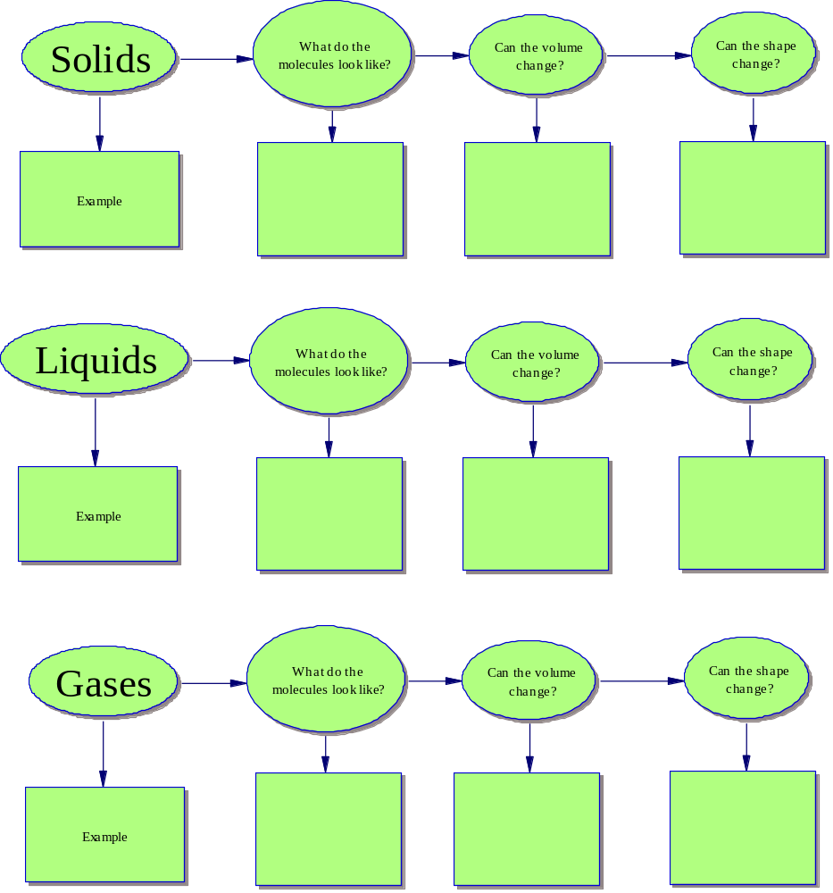
The Great Ice Skating Competition
By, Nick D’Alto

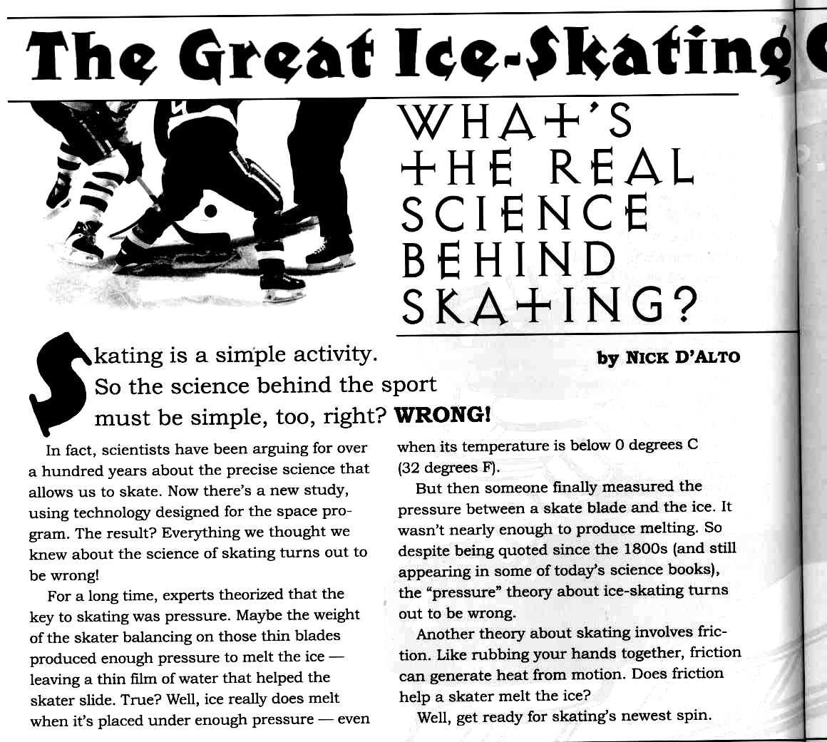
“From Odyssey December 2002”
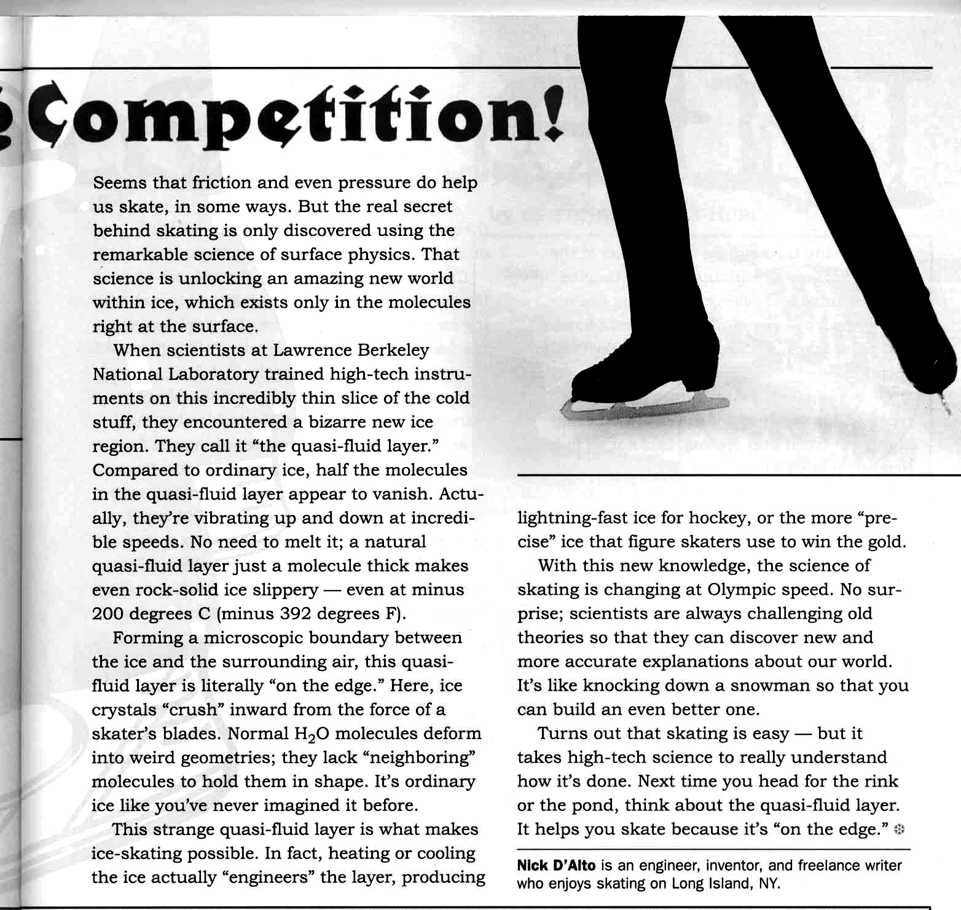

Questions:
1. Why is there such debate over how ice skates work?

2. What do most textbooks and scientists say is the reason why ice skating works?

3. What is the real reason?

4. What does the word ‘quasi’ mean?

5. What happens to the top layer of ice when it becomes a ‘quasi-fluid layer’? Describe what happens to the particles.

6. What is the coldest that the ice can be before you cannot skate anymore?

7. What are three effects that this new understanding of ice skating has had? The article gives you one, and I want you to come up with two new ones on your own.

Directions: Answer the questions and solve the problems. Show your work for each problem and circle your answer. Do not forget to include your units on your answer!

Formula | How to find DENSITY:
mass  density = -----------  volume | 1. Measure the VOLUME and MASS of the sample.  2. Calculate the sample’s DENSITY with the formula.
m
d
v

Water Sample
Mass 1 g
Volume 1 ml

Questions:
1. What is the density of water? ______________

2. In an oil spill, the oil seems to float on top of the water. Does oil or water have the lower density? ___________

3. In an oil spill, is the danger greater to birds and marine mammals than it is to fish and other organisms that live on the ocean bottom? Why?
________________________________________________________________________________________________________________________________

4. How is the density of oil an advantage in the cleanup? ________________________________________________________________________________________________________________________________

5. Corn syrup sinks when poured in water. Does water or corn syrup have the higher density? ____________

6. Why would an oil spill be an even greater disaster if the density of oil were the same as that of corn syrup? ________________________________________________________________
________________________________________________________________________________________________________________________________

Name: _______________
Density Practice Problems

When you solve problems that use an equation in this class, you will need to show the following steps:

- Givens: Each variable in the question with an equal sign. Write a question mark for what you are trying to solve.
- Equation: Write the formula that you will use to solve the problem.
- Substitution: Switch the numbers and variables. Make sure that you include units
- Answer: Write the answer for the unknown with units included.
There will be five points available for each question. You get one point for:
- Correctly identifying the givens.
- Having the correct equation.
- Having the correct substitution.
- Having the correct numerical answer.
m
v
d
- Having the correct unit on the answer.
Volume = L x W x H

Example Problem:
An irregular object with a mass of 18 kg displaces 2.5 L of water when placed in a large overflow container. Calculate the density of the object.
Givens: m = 18 g v = 2.5 mL d = ? g/mL

Equation:  D = m/v | Substitution:  ? g/mL = 18 g/2.5mL | Answer with Units:  7.2 g/mL

1. A block of aluminum has a volume of 15.0 mL and weighs 40.5 g. What is its density?

Givens:

Equation: | Substitution: | Answer with Units:

2. Mercury metal is poured into a graduated cylinder that holds exactly 22.5 mL. The mercury used to fill the cylinder weighs 306.0 g. From this information, calculate the density of mercury.

Givens:

Equation: | Substitution: | Answer with Units:

3. What is the mass of ethyl alcohol that exactly fills a 200.0 mL container? The density of ethyl alcohol is 0.789 g/mL.

Givens:

Equation: | Substitution: | Answer with Units:

4. A rectangular block of copper metal weighs 1896 g. The dimensions of the block are 8.4 cm X 5.5 cm X 4.6 cm. From this data, what is the density of copper?

Givens:

Equation: | Substitution: | Answer with Units:

5. Calculate the density of sulfuric acid if 35.4 mL of the acid weighs 65.14 g.

Givens:

Equation: | Substitution: | Answer with Units:

6. Find the mass of 250.0 mL of benzene. The density of benzene is 0.8765 g/ml

Givens:

Equation: | Substitution: | Answer with Units:

7. Calculate the MASS of a liquid with a density of 3.2 g/mL and a volume of 25 mL.

Givens:

Equation: | Substitution: | Answer with Units:

8. A block of lead has dimensions of 4.5 cm X 5.20 cm X 6.00 cm. The block weighs 1587 g. From this information, calculate the density of lead. (Hint: calculate volume 1st)

Givens:

Equation: | Substitution: | Answer with Units:

Givens:

Equation: | Substitution: | Answer with Units:

9. Calculate the DENSITY of a 500 g retagular block with the following dimensions (measurements): length = 8 cm, width = 6 cm, height = 5 cm. (Hint: calculate volume 1st)

Givens:

Equation: | Substitution: | Answer with Units:

Givens:

Equation: | Substitution: | Answer with Units:

Defy Gravity Using Density!!!

Intro:

George Jetson Superman The Great Gazoo

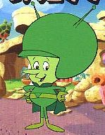

They were all able to defy gravity. Now you too will have this power. You simply need to utilize your knowledge of density to make this possible!!!
Materials:
- • Electric Balance
- • 3 film canisters
- • Large Beaker
- • small objects of various masses (marbles, paper clips, pennies, etc.)
- •ruler
Procedure Part 1:
- 1. Using the materials at your desk, modify three film canisters so that they will float, sink, or remain suspended in the middle of a tub of tap water.
- The first canister should FLOAT on the top of the water.
- The second canister should SINK to the bottom of the water.
- The third canister should remain SUSPENDED (in the middle) in the water.
- 2. Have your teacher check your canisters before you proceed to the next part. Get your teacher’s stamp here:

Procedure Part 2:
- 1. Once you have completed Part 1, use the equipment provided to find the mass and volume of each canister.

- 2. Record the information in Table 1.
3. Calculate the volume of a canister using the formula V=Πr²h
- 3. Calculate the density for each canister using the formula D=M/V

Data Table 1: Mass and Volume of film canisters (Be Sure to use units)
Canister | Mass | Volume
1
2
3

Analysis and Results:

Calculate the densities of canister 1, 2 and 3 below
Canister | Mass (g) | Volume (cm³) | Density (g/cm³)
1

2

3

1. What is the density of the suspended film canister? Why did it not sink or float?

2. If we wanted to make a larger canister be suspended, what would we have to do to the contents of the canister?

3. What is the unit of the density of water?

4. What was the unit of the density for the film canisters?

5. How are we able to compare these? Aren’t these different units?

Density saves the day!!
Colorado Department of Education

Here is the traditional story:
Hiero, king of Syracuse in the third century B.C., gave a jeweler a bar of gold and ordered the jeweler to make it into a crown. When the jeweler delivered the crown to the king, the king measured the mass of the crown and found that the crown had the same mass as the gold he had given the jeweler. Even so, Hiero was suspicious. He believed that the jeweler had cheated him and substituted some less precious metal for the gold. Hiero asked Archimedes, a natural philosopher, to find a way to demonstrate that the crown was not pure gold.
According to legend, Archimedes struggled with the problem for a very long time. Then, one day, as he stepped into a bathtub filled with water, he saw that the water overflowed. He noticed that the amount of water that overflowed the tub was proportional to the amount of his body that was submerged.. He had found the answer and ran from the bathhouse crying, .Eureka!. (.I have found it!.)
Remembering that Archimedes knew nothing of density, let us see if we can figure out how water splashing out of a bath tub led Archimedes to a solution of his problem: testing whether or not the jeweler had cheated the king.
Archimedes Reasoning
Archimedes reasoned that (1) if the gold bar and the crown had the same mass and (2) if both had the same volume, then the crown was pure gold. Archimedes reasoned that the volume of water displaced by the crown should be the same as the volume of water displaced by the bar of gold. However, if the gold bar and the crown were the same mass but had different volumes, then he reasoned the crown was not pure gold, and the jeweler was a fraud.

What Archimedes Measured
 | Mass | Volume
Real Gold | 1000 g | 100 ml
Crown | 1000 g | 50 ml

What Archimedes Assumed
The gold crown should displace the same volume of water as the gold Hiero had given the jeweler.
What Archimedes Found
Archimedes found that the jeweler.s crown displaced more water than the gold block.
Archimedes. Argument (Explanation)
Archimedes reasoned that a gold crown should displace the same volume of water as the as the gold Hiero had given the jeweler. However, if it was not pure gold, but a silver alloy as the king suspected, that would increase the volume of the crown and displace more water. He observed that the jeweler.s crown displaced twice the volume of water displaced by the gold and concluded that the jeweler.s crown was not made from gold.
Thus, Archimedes showed that water displacement was a good method for measuring the volume of irregular objects (as Archimedes certainly was!). An object immersed in water will displace a volume of water equal to the volume of that object.
Questions to Accompany Reading Passage

1) The main idea of this piece of writing is:
a) Hiero was the king of Syracuse in the third century B.C.
b) The gold crown was a fake.
c) Archimedes used water displacement to solve a problem.
d) The mass and the volume of the crown was different than that of gold.

2) Which of these statements could be inferred from the reading?
a) Archimedes liked gold.
b) Archimedes was a king of Syracuse.
c) Archimedes studied science and math.
d) Archimedes was a jeweler and made a crown for the king.

3) After reading the article, a good conclusion would be:
a) Archimedes solved the king.s problem.
b) Water displacement can find the volume of an object.
c) The jeweler.s crown displaced more water than the gold block.
d) The king decided to hire Archimedes.

In your own words, describe how Archimedes knew the king’s crown was not made of solid gold (5 Sentences).

__________________________________________________________________________________________

__________________________________________________________________________________________

__________________________________________________________________________________________

__________________________________________________________________________________________

__________________________________________________________________________________________

While walking by the Mississippi river, I found a rock that looks like gold!! I’m rich, no more teaching… Describe how I would double check to make sure the rock is real gold before I quit my job (4 sentences).
__________________________________________________________________________________________

__________________________________________________________________________________________

__________________________________________________________________________________________

__________________________________________________________________________________________

__________________________________________________________________________________________
Directions: Solve the problems. Show your work and circle your answer. Do not forget to include your units on your answer!

mass = density X vol. | mass  volume = ------------  density
How to find MASS:  1. Measure the sample’s VOLUME.  2. Use a book to find the sample’s DENSITY  3. Use the formula above to calculate the sample’s MASS. | How to find VOLUME:  1. Measure the sample’s MASS.  2. Use a book to find the sample’s DENSITY  3. Use the formula above to calculate the sample’s VOLUME.

Problems:
1. A certain plastic bracelet has density of 0.78g/ml. Would this bracelet float or sink in water? ___________ How do you know?_________________________________________________
_______________________________________________________________________________________

2. If the density of a diamond is 3.5g/ml, what would be the mass of a diamond whose volume is 0.5 ml?
Givens:

Equation: | Substitution: | Answer with Units:

3. Pure gold has a density of 19.32 g/ml. How large (volume) would a piece of gold be if it had a mass of 318.97 g?
Givens:

Equation: | Substitution: | Answer with Units:

4. How many mL would a 55.932 g sample of copper occupy if it has a density of 8.92 g/mL?
Givens:

Equation: | Substitution: | Answer with Units:

5. What is the mass of ethyl alcohol that exactly fills a 200.0 mL container? The density of ethyl alcohol is 0.789 g/mL.
Givens:

Equation: | Substitution: | Answer with Units:

6. Find the mass of 250.0 mL of benzene. The density of benzene is 0.8765 g/mL.
Givens:

Equation: | Substitution: | Answer with Units:

7. What volume of silver metal will have a mass of exactly 2500.0 g. The density of silver is 10.5 g/mL.
Givens:

Equation: | Substitution: | Answer with Units:

8. The density of lead is 11.342 g/mL. What would be the volume of a 200.0 g sample of this metal?
Givens:

Equation: | Substitution: | Answer with Units:

Glencoe Science: Physical Science
Chapter 3 Section 3 (p.83-89)
1. Compare and Contrast the pressure of air added to a balloon and a steel air tank.
**Use the first section on p. 84 to help answer this question**
Balloon
Air Tank

2. Describe the difference, using words, between gasses of high temperatures and low temperatures.
3. What is pressure a measurement of? What are the units for pressure?

4. Draw the difference between a high pressure gas, and a low pressure gas below.
High Pressure Gas
Low Pressure Gas

5. Give an example of an item that you would expect to have a low pressure gas inside.

6. What is Boyle’s Law? (Hint: Look for the bold words on p. 86)

7. What two measurements does Boyle’s Law include?

8. How does Boyle’s Law relate to hot air balloons?
THE HISTORY OF HOT AIR BALLOONING
While reading the article underline the main topic of each paragraph.
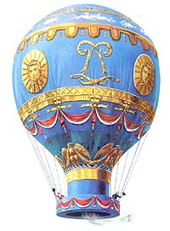
On the 19th of September 1783 Pilatre De Rozier, a scientist, launched the first hot air balloon called 'Aerostat Reveillon'. The passengers were a sheep, a duck and a rooster and the balloon stayed in the air for a grand total of 15 minutes before crashing back to the ground.
The first manned attempt came about 2 months later on the 21st of November, with a balloon made by 2 French brothers, Joseph and Etienne Montgolfier. The balloon was launched from the centre of Paris and flew for a period of 20 minutes. The birth of hot air ballooning!!!
Just 2 years later in 1785 a French balloonist, Jean Pierre Blanchard, and his American co pilot, John Jefferies, became the first to fly across the English Channel. In these early days of ballooning, the English Channel was considered the first step to long distance ballooning so this was a large benchmark in ballooning history.
Unfortunately, this same year Pilatre de Rozier (the world's first balloonist) was killed in his attempt at crossing the channel. His balloon exploded half an hour after takeoff due to the experimental design of using a hydrogen balloon and hot air balloon tied together.
The next major pivotal point in balloon history was on January 7th 1793. Jean Pierre Blanchard became the first to fly a hot air balloon in North America. George Washington was present to see the balloon launch.
Now a large jump in time, of over 100 years: In August of 1932 Swiss scientist Auguste Piccard was the first to achieve a manned flight to the Stratosphere. He reached a height of 52,498 feet, setting the new altitude record. Over the next couple of years, altitude records continued to be set and broken every couple of months - the race was on to see who get reach the highest point.
In 1935 a new altitude record was set and it remained at this level for the next 20 years. The balloon Explorer 2, a gas helium model reached an altitude of 72,395 feet (13.7 miles)! For the first time in history, it was proven that humans could survive in a pressurized chamber at extremely high altitudes. This flight set a milestone for aviation and helped pave the way for future space travel.
The Altitude record was set again in 1960 when Captain Joe Kittinger parachute jumped from a balloon that was at a height of 102,000 feet. The balloon broke the altitude record and Captain Kittinger, the high altitude parachute jump record. He broke the sound barrier with his body!
THE ATLANTIC CHALLENGE
In 1978, the Double Eagle II became the first balloon to cross the Atlantic, another major benchmark in the History of Ballooning. After many unsuccessful attempts this mighty Ocean had finally been cracked. It was a helium filled model, carrying 3 passengers, Ben Abruzzo, Maxie Anderson and Larry Newman. They set a new flight duration time at 137 hours.
THE PACIFIC CHALLENGE
The first Pacific crossing was achieved 3 years later in 1981. The Double Eagle V launched from Japan on November 10th and landed 84 hours later in Mendocino National Forest, California. The 4 pilots set a new distance record at 5,678 miles. 3 years after this, Captain Joe Kittinger flew 3,535 miles on the first solo transatlantic balloon flight, setting yet another record.
In 1987 Richard Branson and Per Lindstrand were the first to cross the Atlantic in a hot air balloon, rather than a helium/gas filled balloon. They flew a distance of 2,900 miles in a record breaking time of 33 hours. At the time, the envelope they used was the largest ever flown, at 2.3 million cubic feet of capacity. A year later, Per Lindstand set yet another record, this time for highest solo flight ever recorded in a hot air balloon - 65,000 feet!
The great team of Richard Branson and Per Lindstrand paired up again in 1991 and became the first to cross the Pacific in a hot air balloon. They travelled 6,700 miles in 47 hours, from Japan to Canada breaking the world distance record, travelling at speeds of up to 245 mph. 4 years later, Steve Fossett became the first to complete the Transpacific balloon route by himself, travelling from Korea and landing in Canada 4 days later.
Finally, in 1999 the first around the world flight was completed by Bertrand Piccard and Brian Jones. Leaving from Switzerland and landing in Africa, they smashed all previous distance records, flying for 19 days, 21 hours and 55 minutes.

Make a timeline below of the accomplishments in ballooning history. Be sure and include at least 8 great accomplishments.

Draw the air molecules inside the balloons below.

Cold Balloon on the Ground Hot Balloon in the Air

If they both have the same volume, which balloon weighs more? How do you know? (**Hint: think about density.)
_______________________________________________________________________________________________________________________________________________________________________________________________________________________________________________________________________________________________________________________________________________________________________

