Physical Science Unit 4- The Atom and Periodic Table Name ___________________
Notes

What is matter?
Definition | Examples

What are the three parts of an atom?

Protons
Location: | Charge: | Mass:

Neutrons
Location: | Charge: | Mass:

Electrons
Location: | Charge: | Mass:

 | Location | Mass | Charge
Protons
Neutrons
Electrons

Element
How do we identify them? | Where is the symbol located on the Periodic Table? | What are the rules for writing the symbol of an element?
1.

2.

Atomic Number
Where is it located on the Periodic Table? | Atomic # tells us the: | Can the atomic number ever change? Why or why not?

Atomic Mass
Where is it located on the Periodic Table? | How do they determine the atomic mass? | How do we change the atomic mass to mass #?

Mass Number (Mass #)
How do you get this number from the Periodic Table? | Formula | Mass # lets us calculate the:

Sample Problems:

Lithium
Atomic Number:
Protons:
Electrons:
Atomic Mass:
Mass Number:
Neutrons:

Sodium
Atomic Number:
Protons:
Electrons:
Atomic Mass:
Mass Number:
Neutrons:

Boron
Atomic Number:
Protons:
Electrons:
Atomic Mass:
Mass Number:
Neutrons:
Which direction does a period go on the periodic table?

What does periodic mean?

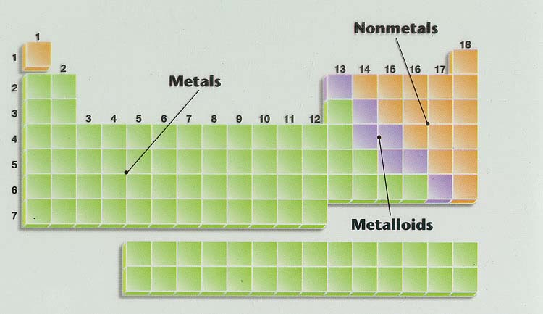

Properties of Metals

Properties of Nonmetals

Properties of Metaloids (Semi-metals)

How was Mendeleev’s original periodic table arranged?

How is the periodic table arranged now?

What are the columns on the periodic table called? How are they organized?
Properties of Alkali Metals

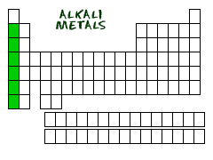
Properties of Alkaline Earth Metals

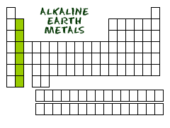

Properties of Transition Metals

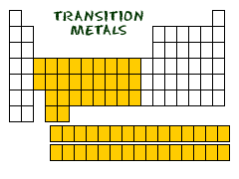

Properties of Halogens

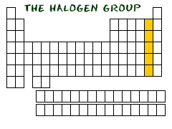

Properties of Noble Gasses

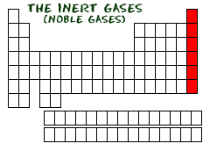

Electron Clouds
How many electrons in the 1st shell?
How many electrons in the 2nd shell?
How many electrons in the 3rd shell?

Sulfur

Aluminum

Why would we use Lewis Dot Structures?

Sample Problems:

O
Caa
Cl

What is the slogan of the octet rule?

What are ions?

Ions
What are negatively charged particles called?
What are positively charged particles called?

Charges
How do you calculate the number of electrons for a positively charged particle?
How do you calculate the number of electrons for a negatively charged particle?

Lithium
Number of valence electrons:
Easier to gain or lose:
How many will it gain or lose:
What charge will it have?

Oxygen
Number of valence electrons:
Easier to gain or lose:
How many will it gain or lose:
What charge will it have?

Name | Symbol | Atomic # | Mass # | Protons | Neutrons | Electrons | Charge
Magnesium - 24 |  |  |  |  |  |  | +2
Sulfur – 33 |  |  |  |  |  |  | -2
Phosphorus - 34 |  |  |  |  |  |  | -3
Examples:

List the rules for atomic tables below:

Name | Symbol | Atomic # | Mass # | Protons | Neutrons | Electrons | Charge
Neon – 20 |  |  |  | 10 |  |  | 0
Iron – 56 |  |  |  |  | 30 | 26 | 0
 | Na |  | 23 |  |  |  | +1
Sulfur – 32 |  | 16 |  |  | 16 |  | -2
Nitrogen – 15 |  |  |  |  |  | 10

