Name___________________________Period________
Lab: Real Evidence of a Subducting Plate
Purpose: Students will:
- Map and construct a 3-D model of actual earthquake data
- Analyze the model to determine what type of pattern (if any) the earthquakes create in the region
- Understand how earthquake data supports the theory of Plate Tectonics
- Compare the behavior of two subducting plates at different convergent boundaries

PreLab Review:
- Latitude:
  - Do latitude lines run: vertically from pole to pole OR horizontally around the earth?
  - What is the reference line for latitude?
  - Compared to that reference line, are the lines labeled as: N & S ? or E & W?

- Longitude:
  - Do longitude lines run: vertically from pole to pole? Or horizontally around the earth?
  - What is the reference line for longitude?
  - Compared to that reference line, are the lines labeled as: N & S ? or E & W?

- Example Calculation: On the other side of this page, review the map and read its information. How far is the Peru-Chile Trench from the East Pacific Rise in kilometers? Show your work. (Note: 1º longitude equals 111 km.)

Diagram:
Sketch the cross-section or side-view of the model. Mark and label the approximate location of the edge of the continent.

Analyze:
- What do you notice about the depth of the focus of the earthquakes as you go further inland from the coast of South America?

- What is the depth of the deepest earthquake in the data Table 1?

- Earthquakes usually do not often occur deeper than that. Why not?

- Using Figure 17-13 on p.455 of your textbook, what type of boundary is present along the west coast of South America?

- What 2 plates are involved at the boundary? Label those 2 plates on your map.

- Explain how the data and model give evidence for that type of boundary. (Hint: what features are present at that type of boundary, and which of those features does the model represent? In your explanation include the position of each of the 2 plates relative to each other.)

- Explain how volcanism is related to this type of boundary.

Going Further: Examine the following 3 diagrams and answer the questions.
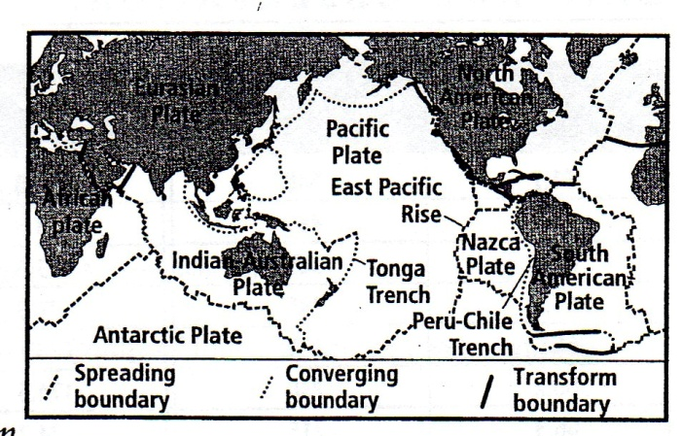
Map Information: The East Pacific Rise is an ocean ridge, running north-south at about 110º where the Pacific Plate meets the Nazca Plate. The wet-flowing material runs into the Austraian Plate at the Tonga Trench, which is north of New Zealand at about 175ºW. East-flowing material meets the South American Plate at the Peru-Chile Trench, at about 65ºW. Assume that the seafloor spreads at the same rate both west and east of the East Pacific Rise.

- Examine the diagram above and read the information next to it. Then write a hypothesis about the relative ages of the East Pacific Rise material at the two convergent boundaries: the Tonga Trench and the Peru-Chile Trench:

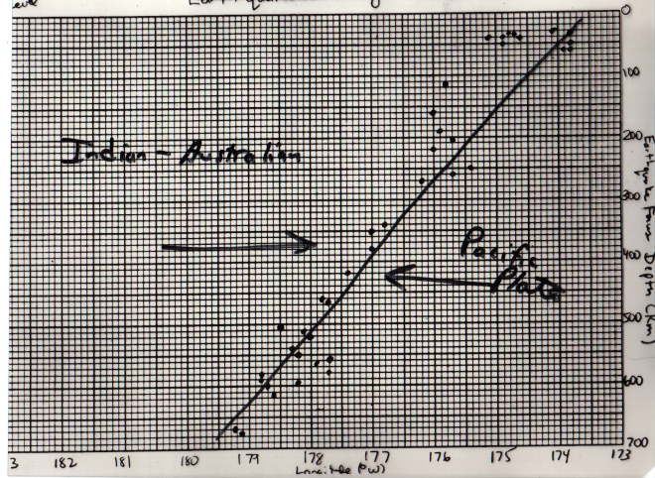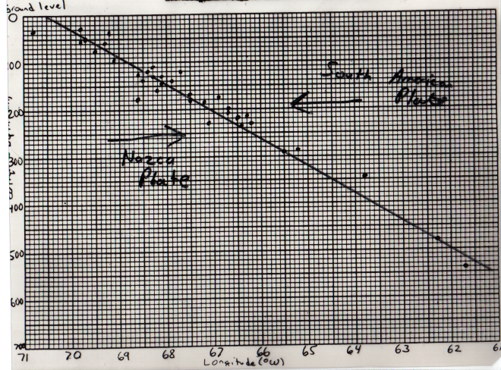
Plate:
Plate:
Plate:
Plate:
Tonga Trench | Peru-Chile Trench

- Looking at the map above or Figure 17-13 on p.455 of your text book, label the 2 plates involved in each of the graphs above.

- Which graph above has the steeper slope, Tonga or Peru-Chile?

- Which do you think has the denser material? Explain what you see in the graph that helped you determine which has the denser material.

- Which has the older material? Explain your choice. (Hint – go back to map to see the location of the two trenches relative to the East Pacific Rise.)

- Explain why the slopes for the two trenches go in opposite directions.

- How far is the Tonga Trench from the East Pacific Rise in kilometers? Show your work. NOTE: 1º longitude equals 111km.
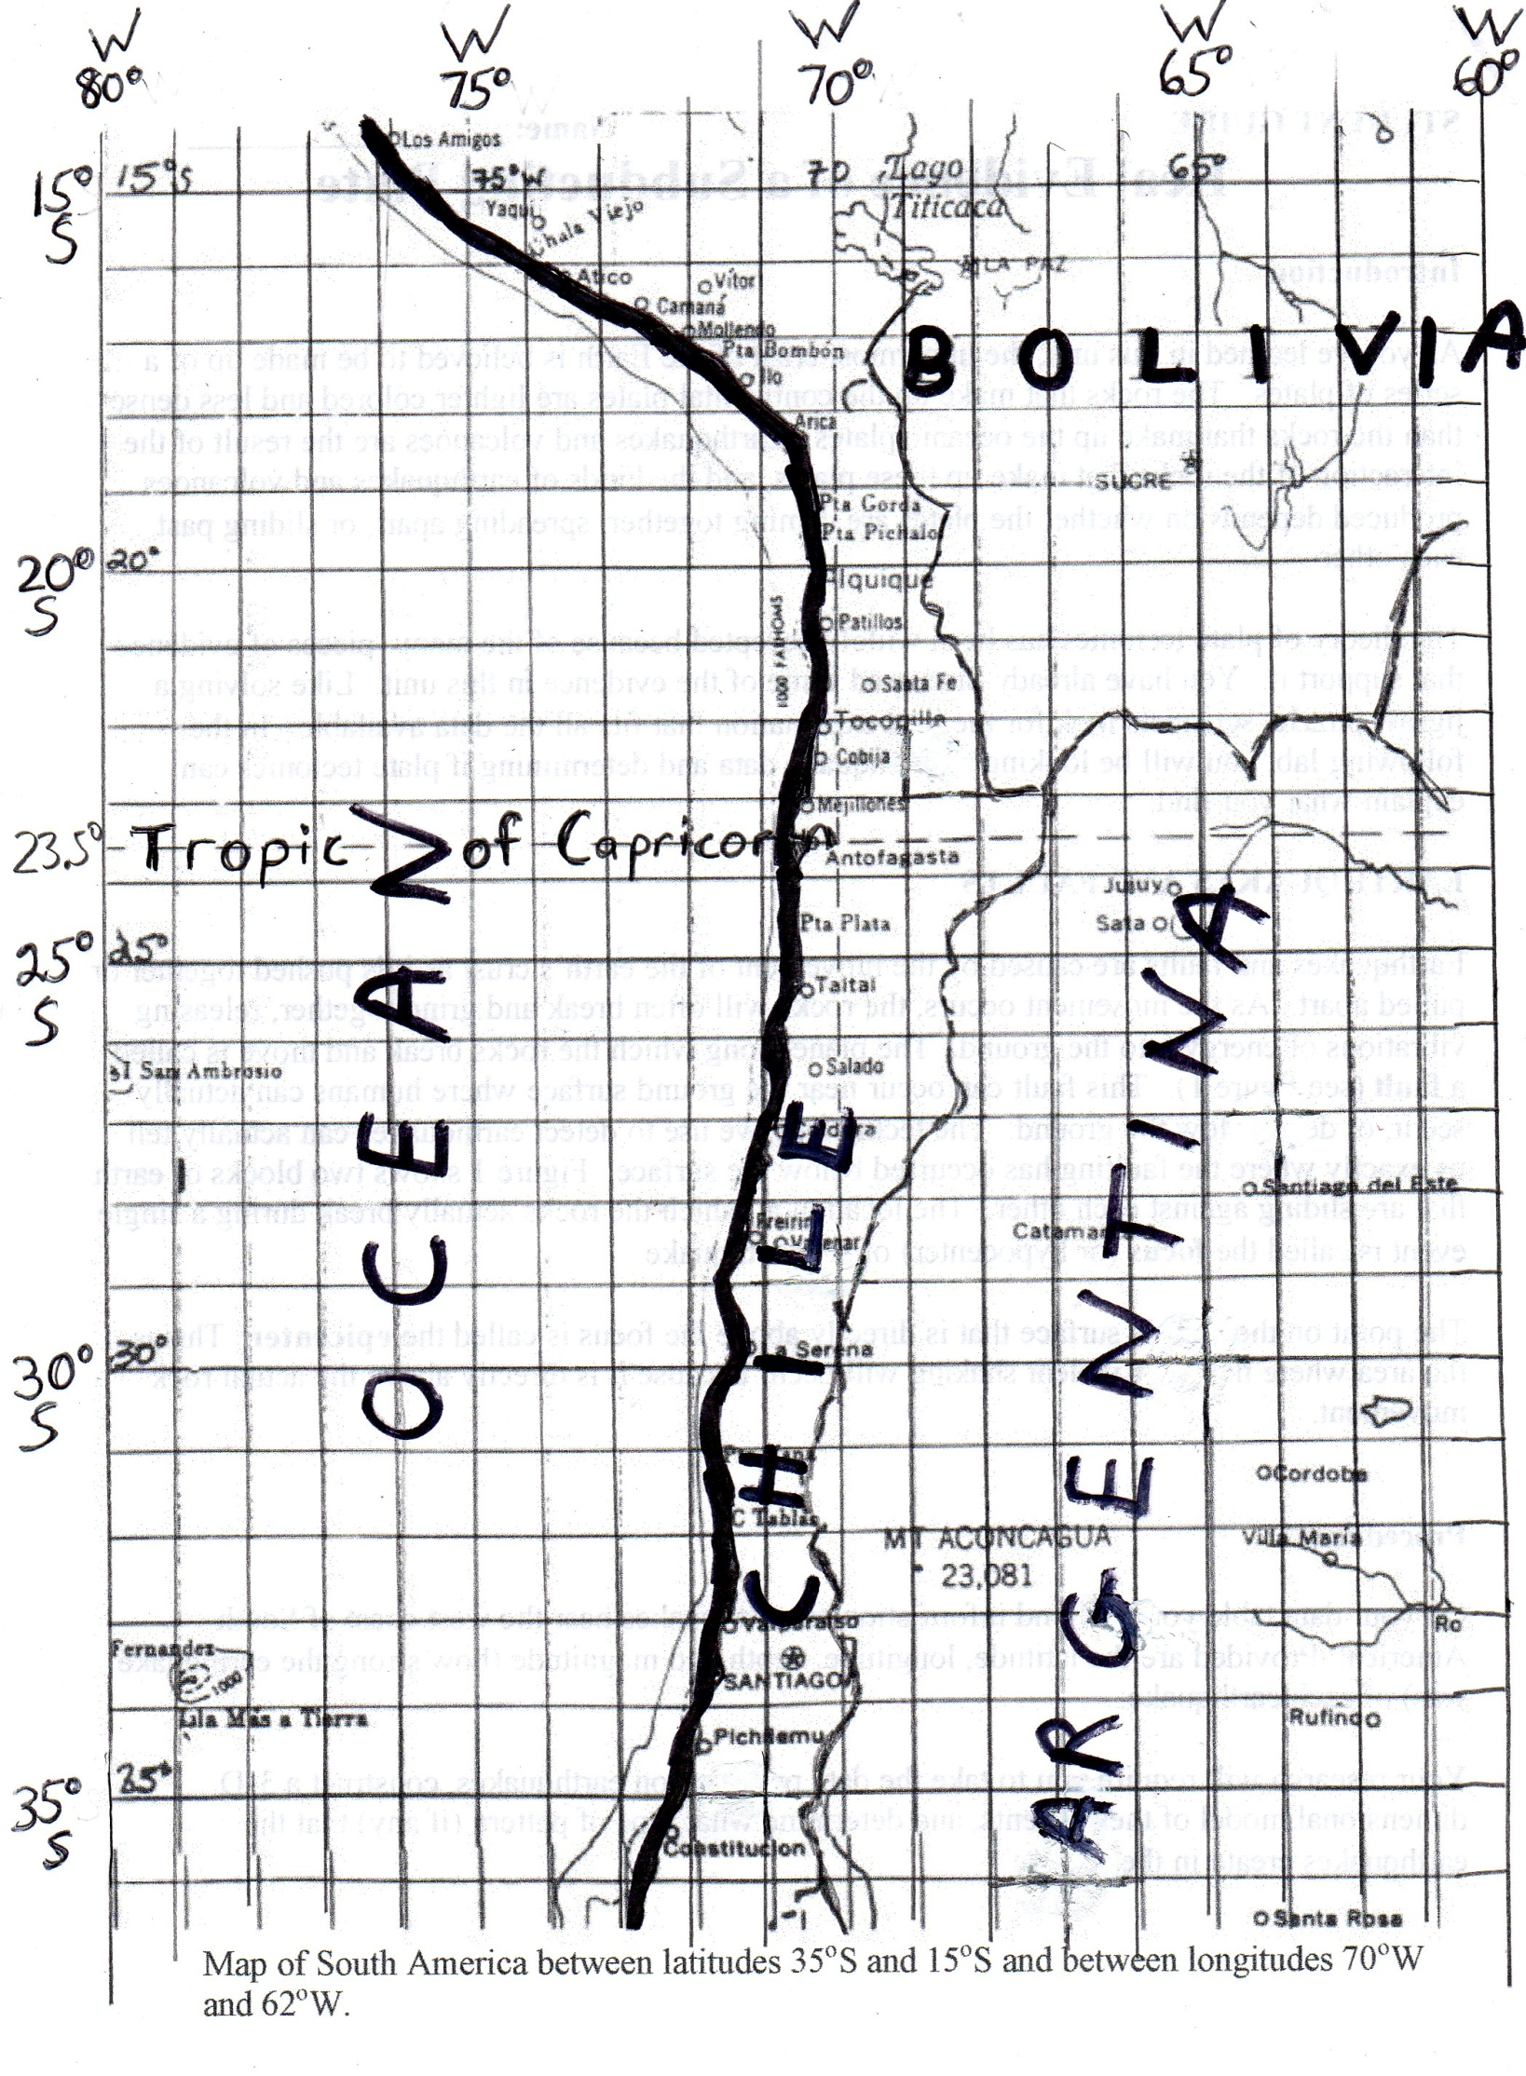
61º
DIRECTION SHEET
Lab: Real Evidence of a Subducting Plate

Purpose: Students will:
- Map and construct a 3-D model of actual earthquake data
- Analyze the model to determine what type of pattern (if any) the earthquakes create in the region
- Understand how earthquake data supports the theory of Plate Tectonics
- Compare the behavior of two subducting plates at different convergent boundaries

Background:

According the theory of Plate Tectonics, the lithosphere is split into a number of plates. Earthquakes and sometimes volcanoes occur at plate boundaries as the plates collide, separate or slide past each other.

The density of rock that makes up a subducting plate is one of the factors that determines how the plate behaves. The greater the density, the faster the plate subducts into the mantle and the steeper the angle of subduction. Older crust is cooler and therefore denser than younger crust, so it subducts faster and at a steeper angle along a subduction zone.

The theory of plate tectonic has been widely accepted because of the many pieces of evidence that support it such as puzzle-like fit of continents, matching rock types, fossils, etc. In the following lab, you will be looking at earthquake data and determining if plate tectonics can explain what you find.

Introduction to Earthquakes:

At plate boundaries, rocks often grind together and break releasing vibrations of energy into the ground – an earthquake. The location deep in the earth at which the rock actually breaks is called the focus of the earthquake. The point on the earth’s surface directly above the focus is called the epicenter. The epicenter is the area where the most violent shaking and damage occurs. The magnitude, or Richter Scale number, tells how much energy was released and how strong the earthquake was.

Materials needed per group or demo:
- 1 large shoebox on side, or 1 12”x12” cardboard elevated 12” off the lab table by placing books under 2 edges
- 22 paper fasteners (brad clips) or push pins or 1 darning needle/dissecting needle (to punch holes in cardboard and to fasten string)
- 22 styrofoam balls or beads of 3 colors, ¾” diameter
- Heavy thread/string
- Rulers
- Scissors
- Colored pencils
- Calculators
- 1 map of appropriate area in South America
- Groups of 2-3 students
Procedure:
- Answer the prelab questions on your data sheet.
- Plot the location of the epicenter (surface point) for each earthquake on the map, using the corresponding colored pencil. Label the location with the Station number.
- Using the depth listed in the data table for each earthquake, “shade” the stations plotted on the map with the appropriate color. Use the color appropriate for the focus depth
  - Yellow (or blue) for shallow foci depth(Less than 70km)
  - Green for intermediate foci depth (70-300km)
  - Red for deep-focus quakes (More than 300km)
- Using a ratio of 3cm = 100km, determine the model depth for each ASSIGNED earthquake focus. Write the model depth for your assigned earthquakes in Data Table #1 below. A couple methods are listed below:
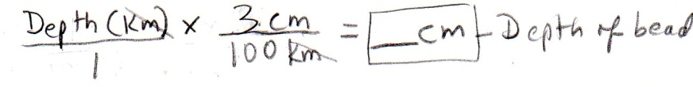

  - Conversion factor equation:
OR
  - Move decimal in depth 2 places to the left & multiply by 3.

- Tape the map to the top of the cardboard. (If a shoe box is used, lay the box on its side so that the opening is on the side. Place the map on the side that is up. The open side of the box is a cross-section view of the earth where you will make a 3-D model showing how deep the earthquake foci are.)
- At each epicenter, punch a hole with the dissecting needle, push pin or scissors to put fastener through.
- Select the appropriate bead color for each assigned earthquake based on the focus depth.
- Tie a string to the bead.
- Wrap the string around the end of the paper fastener, adjusting the string for the proper model length. Then push the ends up through the box and flatten the ends on the map.
