Name____________________________Period____

Chapter 12 Meteorology Review

- Complete the “Characteristics of Air Masses” table:
Symbol | Name | Relative temp | Relative humidity | Example source location (that could affect U.S.weather)
mP
cP
mT
cT

- What are the 2 characteristics we classify air masses by?

- As a cT air mass that formed over Mexico moves north into the United States through New Mexico, Colorado, Nebraska, etc., what would be the major change in the air masses 2 main characteristics? Explain why.

- Define “front”.

- Complete the “Characteristics of Fronts” table:
Type | Relative Steepness  of Front | Type of Clouds | Strength & Length of Storms | Map Symbol  (Color, shape) | Description of Front  Use pictures and/or words  to describe what is happening
Cold Front
Warm Front
Stationary Front | XXXXXXX  XXXXXXX | XXXXXXXX  XXXXXXXX
Occluded Front | XXXXXXX  XXXXXXX | XXXXXXXX  XXXXXXXX

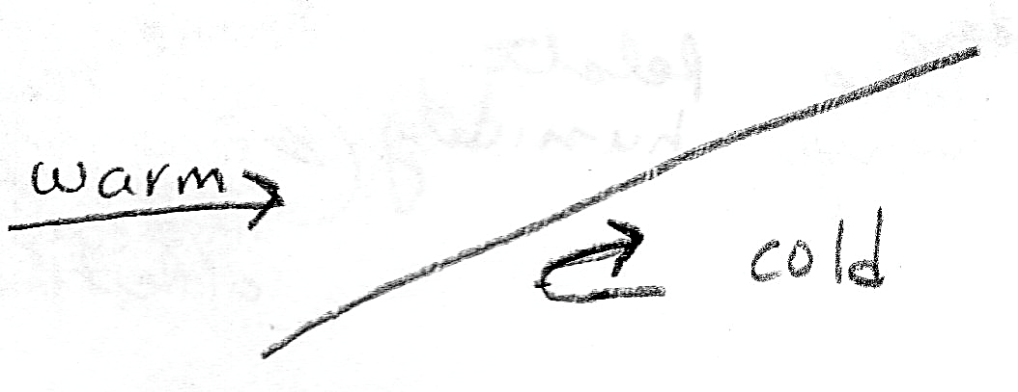
- What type of front is shown in the diagram to the right? How do you know?

- How many air masses are involved in
  - Warm Front?
  - Cold Front?
  - Occluded Front?

- Before the occluded front formed, what were 2 types of fronts were originally present? Explain what caused the occluded front to form.

- Three of the fronts only involve the meeting of a warm and a cool air mass. What determines which of the three front types occurs? Explain.

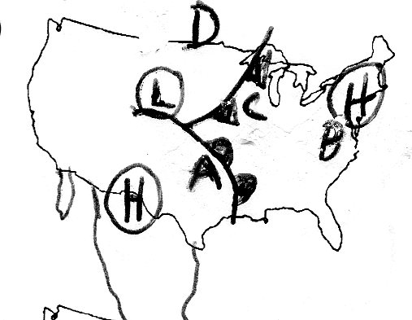

Use the diagram to the right to answer questions # 10-18:

- What type of front is near A in the diagram above?

- What direction is the front near A moving?

- What type of air mass is A likely to be under?

- What type of air mass is D likely to be under?

- Which location (A, B, C, D) is likely to have a steady rain, but not a thunderstorm? Explain your reasoning.

- Which location (A, B, C, D) is likely to have sunny skies? Explain your reasoning.

- Which location (A,B,C,D) is likely to have the highest temperature of 82F? Explain your reasoning.

- Which location (A,B,C,D) is likely to have the lowest temperature of 45F? Explain your reasoning.

- Explain how the weather is likely to change in City C based on conditions evident on the map. Reference things such as:
- Relative temperature before/after
- Direction the wind comes from
- Strength and duration (time) of precipitation
- Types of clouds

- Complete the following table about pressure systems:
System | Does Air Rise or Sink? | Usual weather | Explain WHY that type of weather is found here | Direction of Rotation
Low-Pressure
High-Pressure

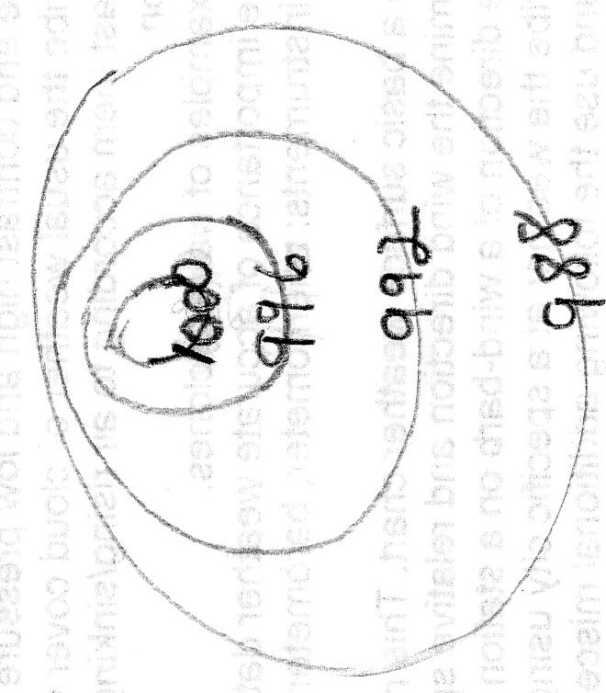
- On the isobar diagram to the right, circle the area with the greatest wind speed. Then explain how you know the wind speed is greatest there.

- Is the center of the isobar diagram a high or low pressure center? Put an H or an L, as appropriate in the center.

- In the isobar diagram, based on the isobar values, draw an arrow showing the direction the wind is blowing.

- Compare and contrast an isotherm and an isobar. (May use a Venn diagram or table if you want). Must include a similarity and for the difference describe both.

