Name__________________________Period ____

REVIEW OUTLINE
Chapter 21 Fossils & Geologic Time
Objectives:

- The Geologic Time Scale
- I understand how Earth’s history is divided into sections of time called the geologic time scale. This means I can:
  - Explain how major changes mark the boundaries between the sections.
  - Discuss the general changes in organisms from the appearance of life on Earth to present day.

- Fossils
- I can describe the characteristics Index Fossils and explain how Index Fossils are used.
- Discuss how fossils can be used to interpret Earth’s past physical and environmental history.

- Dating of Rocks
- I can apply the principles for determining relative age to interpret rock sequences. This means I can:
  - Determine the oldest and youngest layers using the Law of Superposition.
  - Determine the relative age of layers and intrusions.
  - Match rock layers in different areas using Correlation.
- I can apply the principles for determining absolute age using radioactive decay rates and half-lifes.

Geologic Time

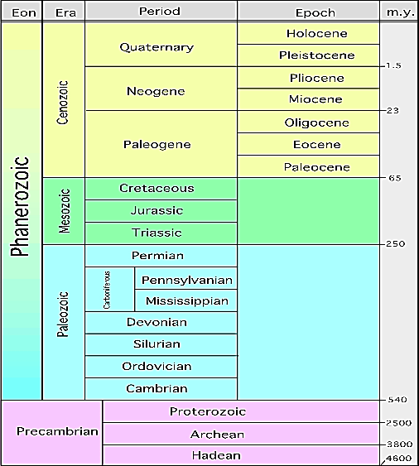
- How is Time Divided?

Remains of Organisms in Rock Record

- Index Fossils

- Trace Fossils

Two Types of Dating

- RELATIVE - Age Dating of Rocks

- Ways to Determine Relative Age
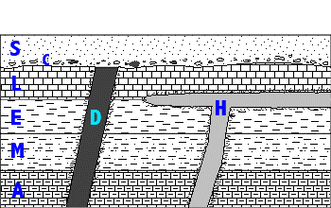

- ABSOLUTE - Age Dating of Rocks

- We use Absolute dating to determine
  - Half-Life

