

Physical Science

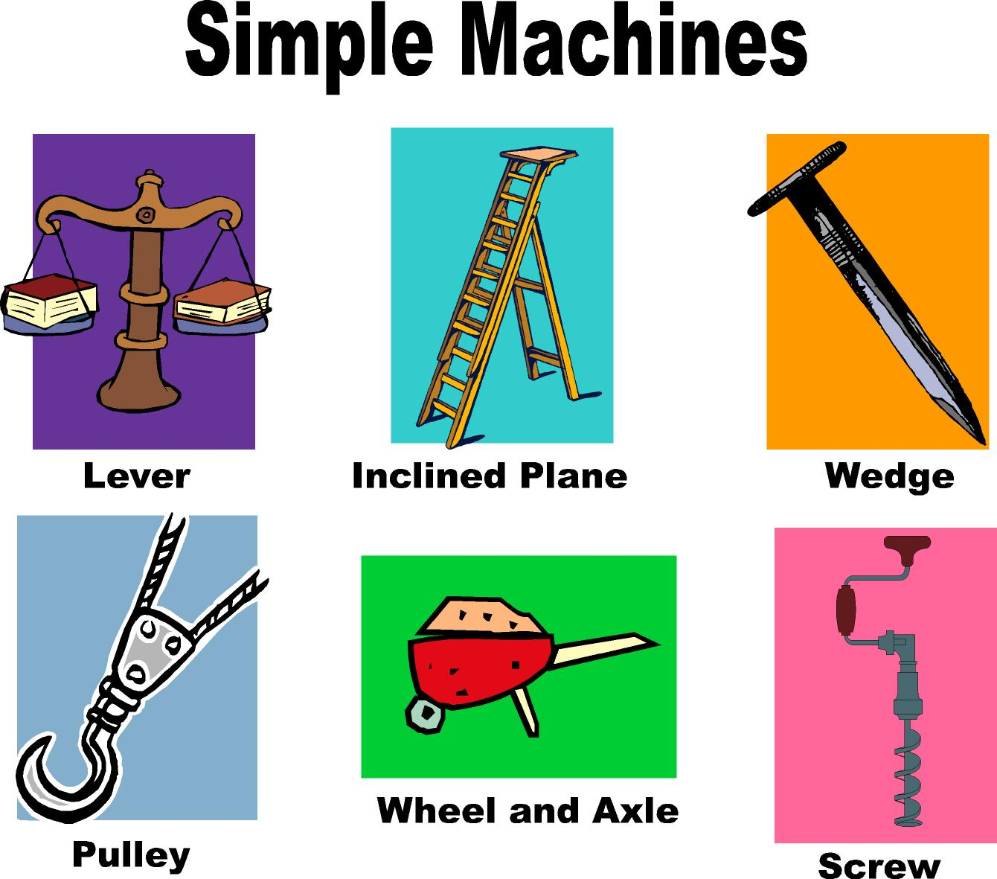

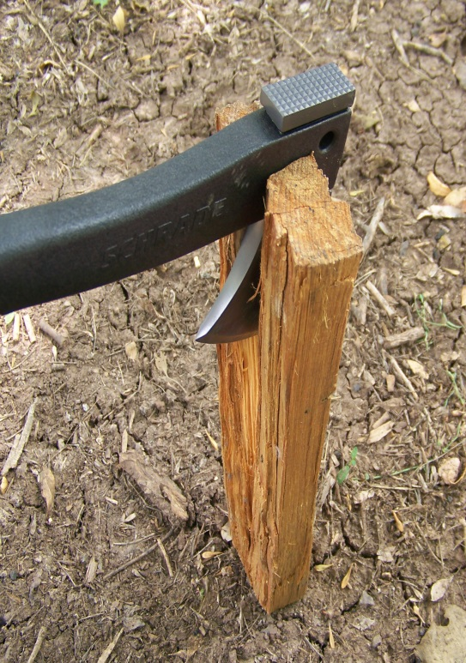

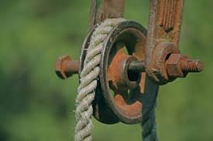 **Unit 11:   
 Simple Machines**

**SIMPLE MACHINES READING GUIDE**

*Directions: Read pages 422 to 433, in your text book, and answer the following questions listed below using complete sentences.*

1. What is a simple Machine?
2. List six different types of simple machines?
3. What affect does an inclined plane have on force of a moving object?
4. Have you ever used an inclined plane? Describe a situation.
5. What is a wedge?
6. How does a wedge’s unique shape classify it as a simple machine?
7. What is ideal mechanical advantage (IMA)?
   1. How does it relate to simple machines?
   2. How does the equation differ when applying it to different machines?
   3. How is IMA measured on a screw?
8. What is a lever?
9. The pivot point on a lever is called what?
10. Describe the three-classes of levers?
    1. First-class lever
    2. Second-class lever
    3. Third-class lever
11. Describe a specific situation where you have used a lever.
12. What is a wheel and axle simple machine?
    1. How does this machine work?
    2. Give an example of this type of machine.
13. What is a pulley?
14. How is force affected by pulleys?
15. What are compound machines?
16. Give an example of a compound machine?

**Bill Nye “Simple Machines”**

*Directions: Answer the following questions as you watch Bill Nye.*

1. Simple machines let us change the _________________________ and _______________________ of force.

2. What simple machine is in a catapult, and how does it work?

__________________________________________________________________________________________________________________________________________________________________________________________________________________________________________

3. What is the fulcrum of a lever?

__________________________________________________________________________________________________________________________________________________________________________________________________________________________________________

4. Which object shot by a catapult do you like best? Why?

________________________________________________________________________________________________________________________________________________________________________________________________________________________________________________________________________________________________________________________

5. How are wheels and levers related?

________________________________________________________________________________________________________________________________________________________________________________________________________________________________________________________________________________________________________________________

6. What parts of a bicycle are simple machines?

________________________________________________________________________________________________________________________________________________________________________________________________________________________________________________________________________________________________________________________

7. How does a ramp make work easier?

________________________________________________________________________________________________________________________________________________________________________________________________________________________________________________________________________________________________________________________

8. Why doesn’t the rope break when a large book is pulled on a ramp?

________________________________________________________________________________________________________________________________________________________________________________________________________________________________________________________________________________________________________________________

9. How is a screw related to a ramp?

________________________________________________________________________________________________________________________________________________________________________________________________________________________________________________________________________________________________________________________

10. What does a pulley do to require less force?

________________________________________________________________________________________________________________________________________________________________________________________________________________________________________________________________________________________________________________________

11. What simple machines can be seen on a sailboat, and what do they do?

________________________________________________________________________________________________________________________________________________________________________________________________________________________________________________________________________________________________________________________

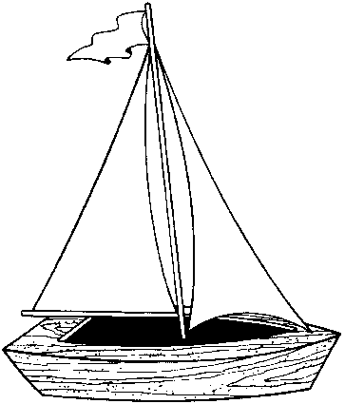

**Simple Machines WebQuest**

*Purpose:* To review simple & compound machines

**Part 1:**

1. Go to this website: <http://edheads.org/activities/simple-machines>
2. Click on the start button

[](javascript:openpopup())

1. A new window will open up. You can bounce between the two windows as necessary.
2. Choose your first activity from THE HOUSE (the second window)
   1. There are four locations in the house: the garage, the bedroom, the bathroom, and the kitchen.

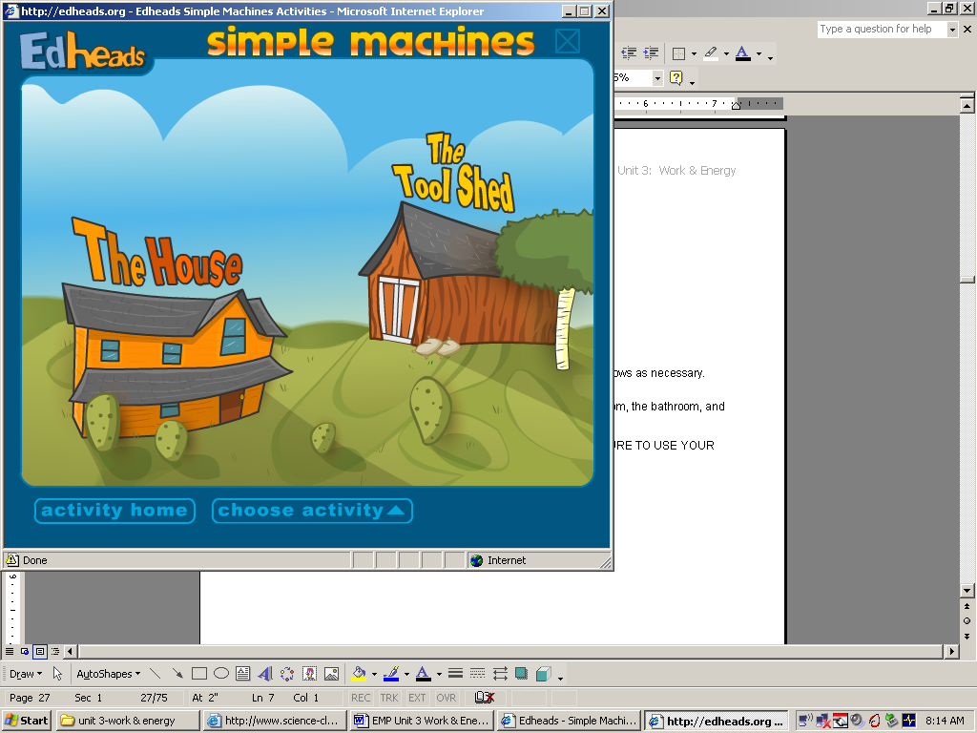

1. Click on each location and do the activity as it is directed. MAKE SURE TO USE YOUR HEADPHONES!!!

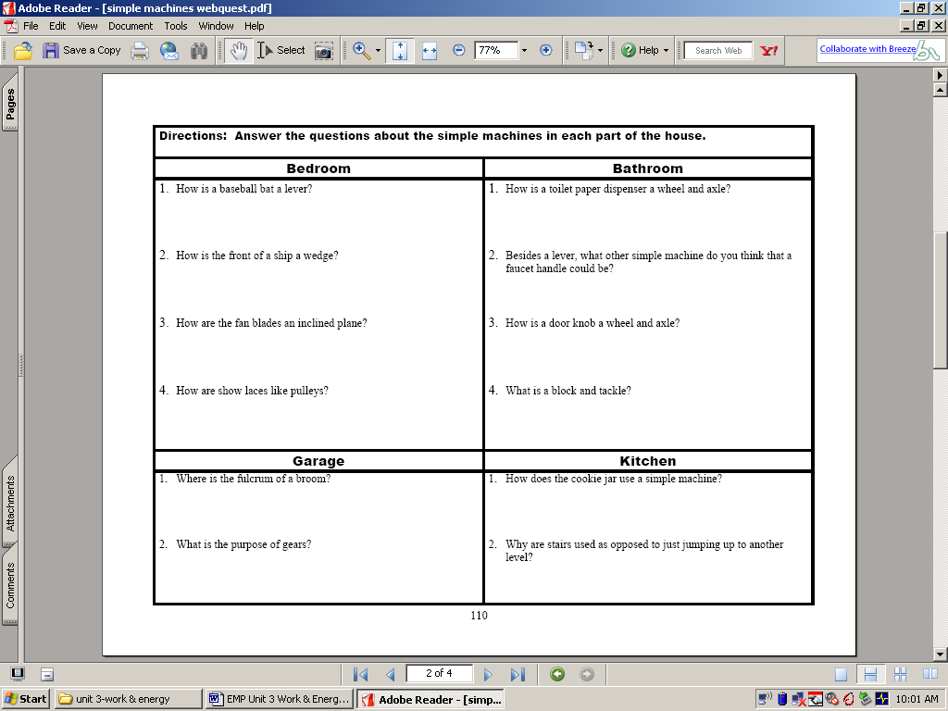

6. Go back to the original screen and click on the TOOLSHED.



1. Following the directions in the intro, click on each compound machine and figure out what simple machines make up the compound machine.
2. List the simple machines found in each compound machine.

|  |  |  |  |
| --- | --- | --- | --- |
| **Wheelbarrow** | **Drill** | **Can Opener** | **Stapler** |

**Part 2**

Go to the following website: <http://edheads.org/activities/odd_machine/index.htm>

Click on the start button and play THE COMPOUND MACHINE GAME

1. What was your final score? __________
2. Where was the plunger? _________________________________________

**Part 3**

Go to the following website: <http://sunshine.chpc.utah.edu/Labs/Machines/>

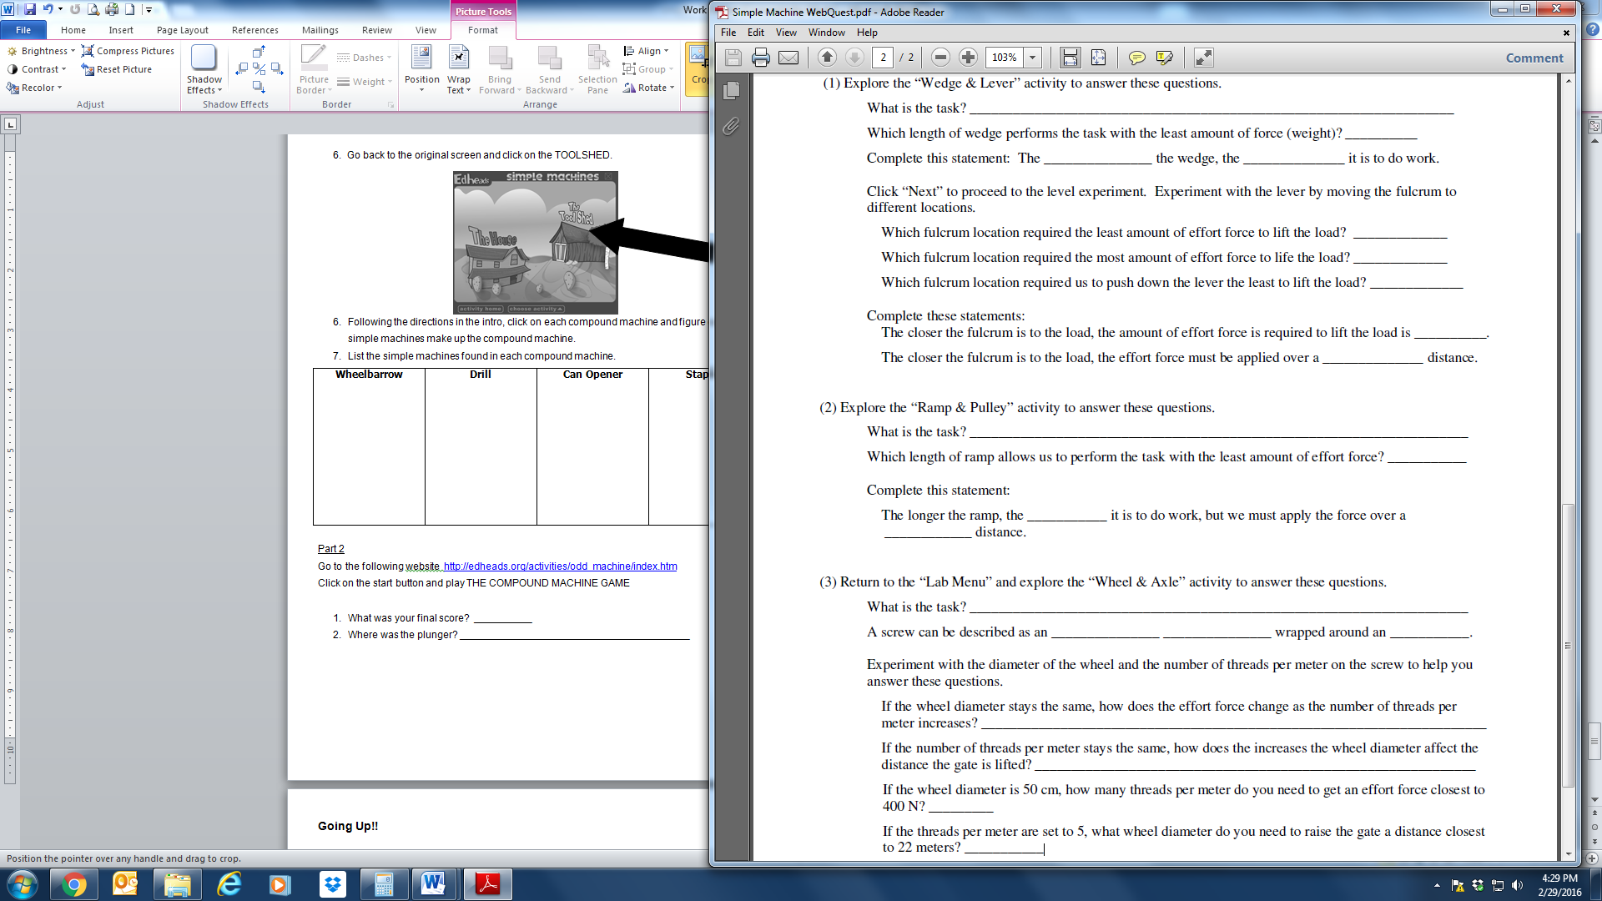

Simple Machines Notes

|  |  |
| --- | --- |
| Simple Machine | Notes taken in your own words. Use summarizing and/or paraphrasing skills. |
| Lever |  |
| Pulley |  |
| Inclined Plane |  |

|  |  |
| --- | --- |
| Simple Machine | Notes taken in your own words. Use summarizing and/or paraphrasing skills. |
| Wedge |  |
| Screw |  |
| Wheel and Axle |  |

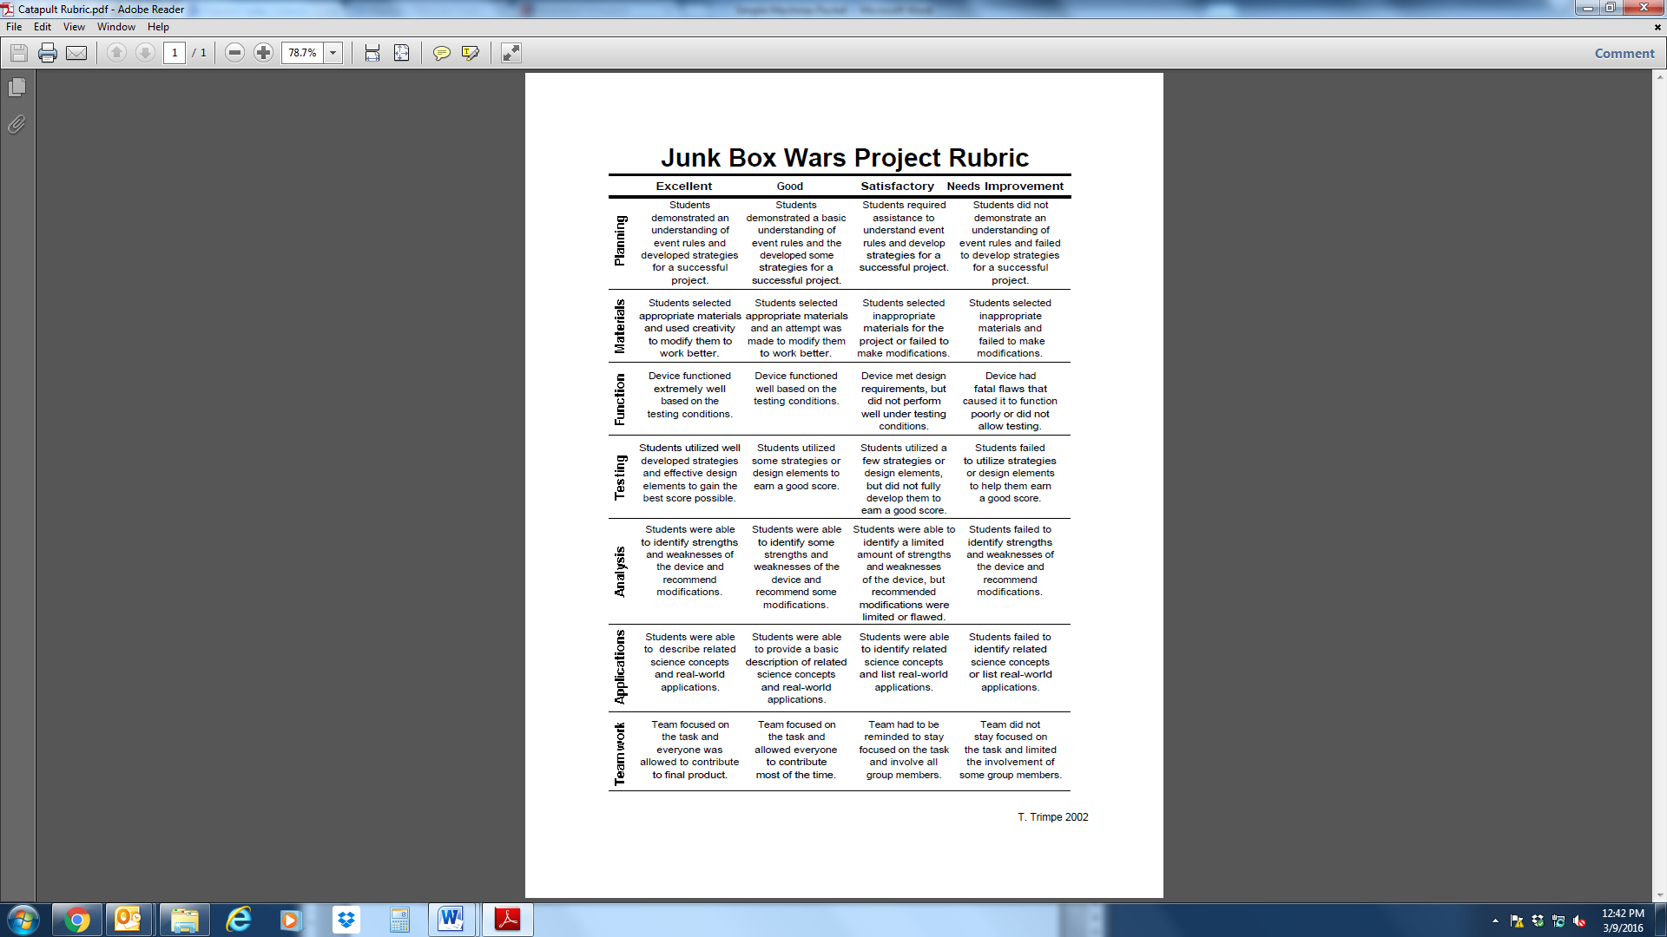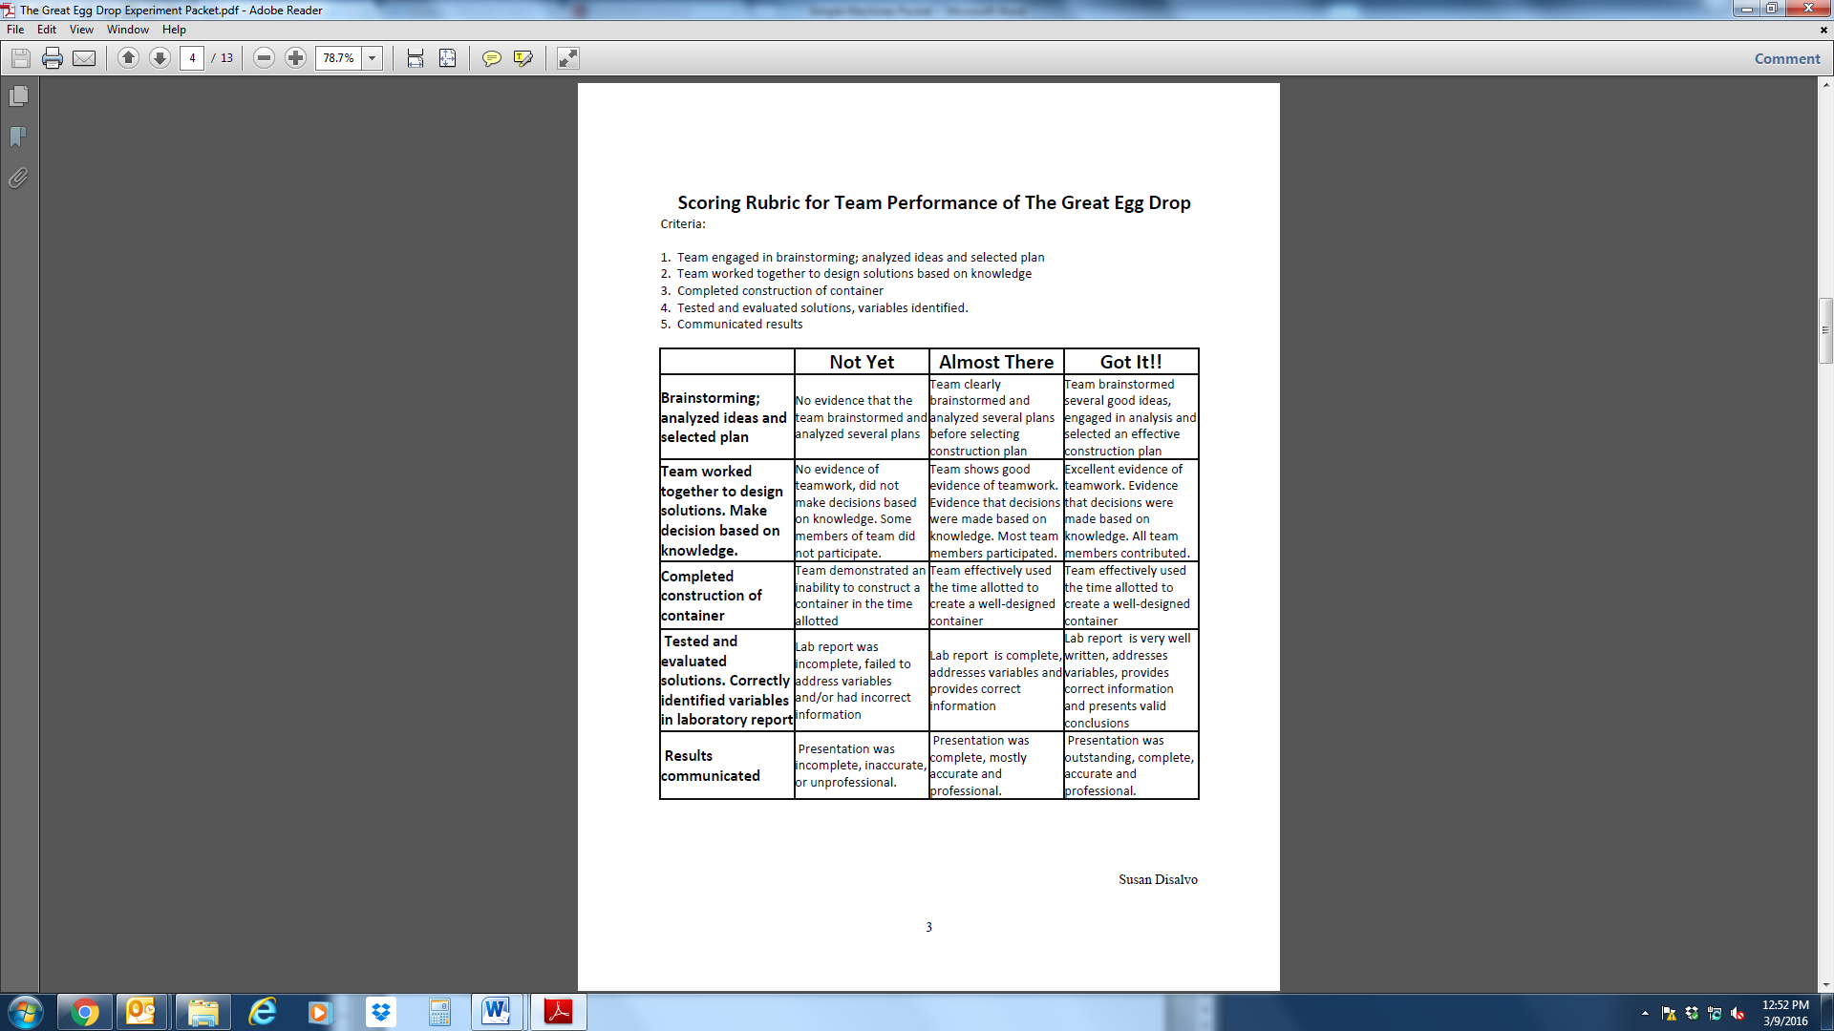

**Catapult**

**Going Up!!**

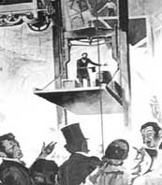 It was May 1854. The World’s Fair was being held in New York City. On display were the newest inventions from many countries. The crowds were amazed by the promise of technology.

A crowd gathered around a tall, dignified man in a top hat. He mounted a platform. As people looked on, the platform was slowly raised by a rope that was wrapped around a motor-driven drum.

When the platform had ascended well above the crowd, another figure standing on a landing above the platform suddenly reached out and slashed the heavy rope by which the platform was suspended. The crowd gasped.

The platform dropped, but only by a few centimeters. Then it came to a stop. “All safe, ladies and gentlemen, all safe!” the man on the platform proclaimed.

The man on the platform was Elisha Otis, and he’d just proudly demonstrated his invention – the safety elevator. His device would become the first public passenger elevator. Just three years after this dramatic demonstration, the first public passenger elevator was put into service at a New York City department store. By 1873, more than 2000 Otis elevators were being used in office buildings, hotels, and department stores.

*An Elevator Fit for a King*

The earliest elevators were little more than lifting platforms. More than 2000 years ago, the Romans described lifting platforms that featured pulleys and rotating drums. The power for these devices was supplied by humans or animals. In 1742, France’s King Louis XV had a private elevator built in his palace at Versailles. It was operated using human power. Servants pulled on ropes to lift and lower the king. Counterweights helped balance the weight of the king as he moved from floor to floor.

[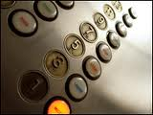](http://www.basement.org/c/images/blog/elevator.gif) These early elevators had a simple design. The car was suspended by a rope or cable that ran over a pulley at the top of the elevator shaft. At the other end of the cable was a counterweight that balanced with the weight of the car plus the average weight of the load the elevator carried. The car and the counterweight were guided between rails to keep from swinging freely.

*Putting on the Brakes*

Beginning in 1830 or so, freight elevators were in common use. But all these elevators, including the one used by King Louis XV, had a big drawback: if the rope from which they were suspended snapped, the elevator went crashing to the ground. There was nothing to cushion or stop its descent.

That’s why Otis’s invention was so important. His safety elevator had something that none of the earlier models did – a brake. If the rope broke, a large spring forced two large latches to lock into ratchets on the guide rails. These latches kept the elevator from falling.

*New Forms of Power*

The earliest passenger elevators were powered by steam engines. As years passed, other power sources were used. Water pressure was tried. The invention of electric-powered elevators, like Otis’s safety device, was an important advance in elevator technology.

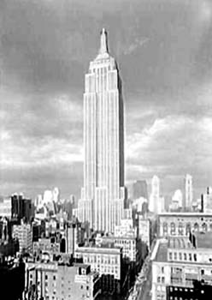 The invention of the electric-powered elevator for passengers had a strong effect on city living. Before it came into use, most buildings were no more than four stories high. People just couldn’t huff and puff their way up any more flights of stairs! The lack of appropriate building materials was another drawback to the growth of tall buildings.

*Changing the Landscape – And People’s Lives*

By the beginning of the 20th century, the word “skyscraper” had entered the English language. Buildings were built taller and taller – and thanks to elevators, people could make their way easily to the top. Additional refinements included self-opening doors, an automatic leveling feature, and faster speeds. Modern elevators travel up to 600 meters a minute.

Today, you can zoom to the top of the Washington Monument or the Empire State Building and back in minutes, thanks to electric-powered elevators. And, thanks to Elisha Otis, you can be assured of a safe trip in both directions.

1. How are pulleys used in elevators?

____________________________________________________________________________________________________________________________________________________________

2. What is the purpose of the counterweight in an elevator?

____________________________________________________________________________________________________________________________________________________________

3. What has been the impact of elevators on building design?

____________________________________________________________________________________________________________________________________________________________