Name__________________________Period____

NOTE OUTLINE: Ch 30-31 Stars & Universe

Objectives

- Describe electromagnetic radiation (EM). This means I can:
  - Describe how the EM is organized and which forms of EM waves are the most and least dangerous.
  - Explain the relationship between wavelength & frequency.
- Classify the types of stars. This means I can:
  - Describe the 3 main characteristics we use to describe stars; color, size, brightness (magnitude & luminosity).
  - Summarize how those 3 main characteristics are interrelated.
- Walk stars through their life cycle and predict how they will die. This means I can:
  - Compare the evolution and death of stars of different masses.
- Define and apply the following vocabulary terms: apparent magnitude, absolute magnitude, luminosity, HR-diagram, main sequence, black hole, planetary nebula, neutron star, protostar, supernova, fusion.
- Explain the Big Bang Theory and how Redshift of light gives evidence for the theory.

What is Astronomy?

- The study of ____________________________________________________________

How can we study it?

- Study things that make it to Earth

  - Meteorites
  - Samples Collected

- Study the ____________________that makes it to Earth

- Study light in space

  - What is the light doing? / What’s releasing light?

What is Light?

- Light = Radiation of the _________________________________spectrum (EM)

  - EM spectrum includes waves of all different ________________ that travel through space, NOT just visible light

  - Energy is used to organize light (EM waves) into categories

  - Types: Radio waves (_____________ dangerous), microwave, infrared, visible light, UV,

X-rays, gamma rays (____________ dangerous)

    - Note – Visible light is the “dividing” line of dangerous vs. non-dangerous forms of EM waves

Video: Electromagnetic Radiation Song https://www.youtube.com/watch?v=bjOGNVH3D4Y
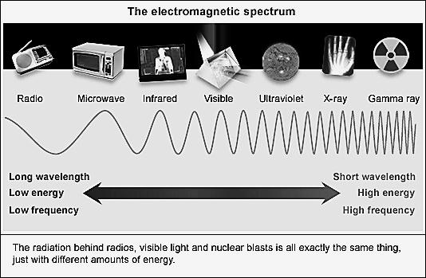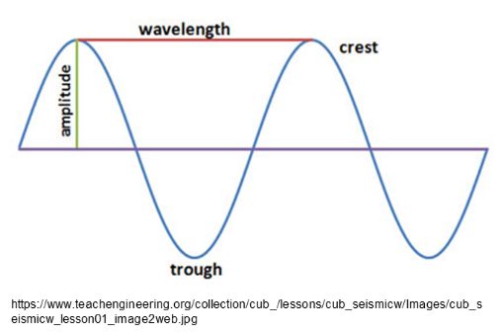

  - Sorted by Wavelength and Frequency

  - Wavelength: The distance until a wave repeats itself

    - Measured from ____________________ or ___________________

    - ____________ wavelengths are more dangerous because they have more energy

  - Frequency: Number of waves in a given time interval.

  - Wavelength & Frequency are ____________________________________________

Chapter 30 Stars

Stars: Examine the HR-Diagram below. Stars - Are they all alike? How do they differ?

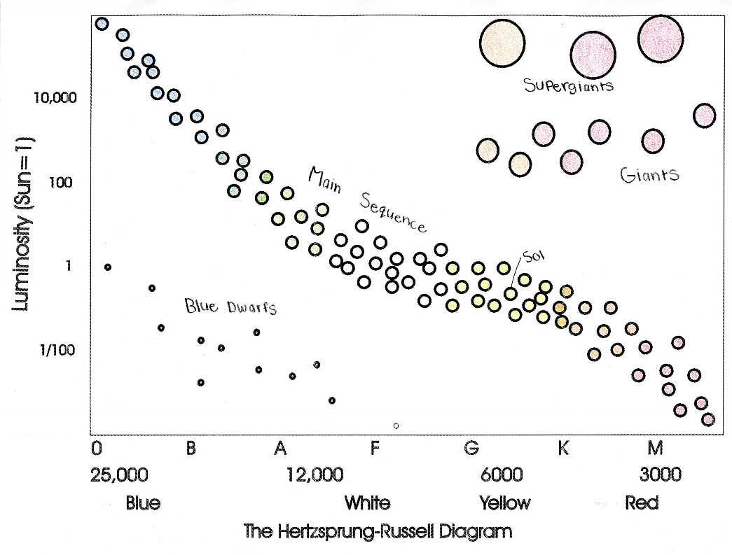

Beginning of a Star Lifecycle

- Interstellar Cloud/___________________

  - Big cloud of __________________________
  - Once enough gas has collected the nebula will condense forming a….

- Protostar: _______________________

  - As the protostar continues to condense it will heat up until it hits Critical Mass and…

- Nuclear fusion begins

  - Now we have a real ________________________ star.

  - Main Sequence = ____________________ as long as fusion occurs & as long as

_____________________________________ available

What is a Star?

  - Star = A cloud of gas, mainly ______________________________ with a core so hot and dense that

that _____________________ can occur.

  - Purpose/Jobs

    - Provide__________________
  - Warms Planet Earth
  - Photosynthesis – base of _________________ which produces _____for breathing

    - Nuclear fusion within stars converts light (low mass) elements (______) into _______________
ones (C, O, Ne, Mg, Si, Fe)

Nuclear Fusion
- Creates new more __________________ elements
  - Without these life would not be able to form

- Will continue in a star until no heavier element can be produced
  - ______________ is the ultimate stopping point

- Helps balance out the force of ___________________ trying to act on stars

- When fusion stops, gravity will win and cause the star to ________________________
  - This is when a star begins to die
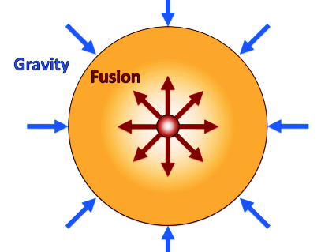
Important Star Qualities

Three Main Characteristics

  - Brightness/Magnitude/Luminosity
  - Light releasing capacity

  - Color
  - Determined by Temperature

  - Size
  - Large - usually blue, hot, bright
  - Small - usually red, cool, dim
  - Determines means of Death

Terms Describing a Star’s Brightness & Energy Output

- Apparent magnitude = How bright the star ___________________

  - What can cause a bright star to look dim? It’s _____________:
Bright star looks dim if it is ________________

  - What can cause a dim star to look bright? It’s ________________________:
Dim star looks bright when it’s ______________

- Absolute magnitude = _______________ brightness based on how bright stars would look if they were ______ the __________________ away.

- Luminosity Measures how much ________________ IS GIVEN OFF.
  - Absolute magnitude & Luminosity closely related
  - Discuss lumens of light bulbs

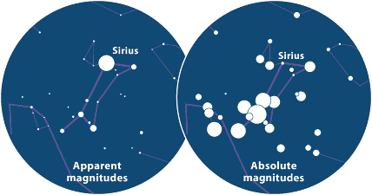

Scales for Magnitude & Luminosity

While Absolute Magnitude is a result of the energy (luminosity) of the stare, magnitude and luminosity have different scales, and they are _______________ proportional.

- Absolute Magnitude:
  - ___________ numbers = BRIGHTER star

- Luminosity:
  - ___________ numbers = BRIGHTER star
Color of Stars

- Stars are identified by their color, which indicates their _________________________.

- They are divided into what are known as spectral classes.

      - These classes are O, B, A, F, G, K, and M.

      - Class O stars are the ______________and are __________ in color.

      - The _______________ stars are identified as class M and are ________ in color.

Star Size

- Determines the length of a star’s life

  - Large Stars = Burn out ____________ because of ___________pressure in core, causing

fusion to occur __________. _________ used up faster.

  - Small Stars = Use fuel more _______________

    - Around for a much _______________time.

- Star size also determines the __________________ a star will take.

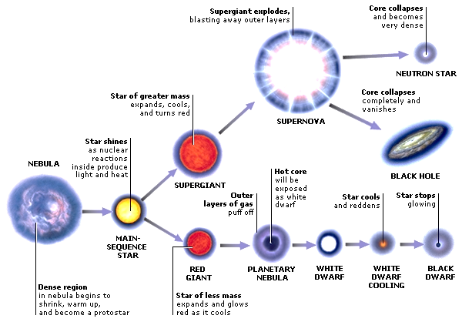

Death of an AVERAGE Size Star
  - Fusion of Hydrogen Stops

    - No longer a ___________________________

  - Red Giant
    - Large star that is reddish or orange in color

    - Reaching sizes of over _______ times the star's original size.

    - Late phase of development in a star's life

    - Hydrogen has been exhausted and ___________ is being fused.
      - This causes the star to collapse, raising the temperature in the core.
      - The outer surface of the star expands and cools, giving it a reddish color.
    - This phase will continue until the star completely runs out of _____ (When Fe made)

    - Each cycle of collapse & expansion leads to next step in fusion sequence.
Examples: H+H He, He +C O, C +O Si, Si + Si Fe

- Planetary Nebula
    - When nuclear ____________ (Fe, iron, made. Fe __________________ in star)

    - Stars blow away their outer layer of ____________________

- White Dwarf
  - Remaining core of the star left behind after the planetary nebulae

    - Present after __________________ has blown away

  - Still very hot so it glows white until it cools off

- Black Dwarf
  - Cooled off ______________of a star

Death of a MASSIVE Star

- Fusion of Hydrogen Stops
  - No longer a main sequence star

- Red Supergiant (Same info as Red Giant – just larger size)

  - Extremely large star that is _______________ or _______________ in color

  - Reaching sizes of over ____________ times the star's original size.
  - Late phase of development in a star's life

  - Hydrogen has been exhausted and ________________ is being fused.
    - This causes the star to collapse, raising the temperature in the core.
    - The outer surface of the star expands and cools, giving it a reddish color.

  - This phase will continue until the star completely runs out of fuel – When ____________ is made. _________ can’t fuse in star.
    - Betelgeuse in Orion is an example of a red supergiant star.
- Supernova

  - Violent explosion –causes fusion to _______________ elements ___________________

  - Ejects most of its mass.

  - Often briefly outshines an entire _________________

  - Fades from view over several weeks or months

Now, ONE of the following 2 steps occurs – EITHER neutron star OR Black Hole

- Neutron Star

    - If the remaining mass of the star is about _______ times that of our Sun, the core is unable to support itself and it will collapse further to become a neutron star.

    - The matter inside is compressed so tightly that its atoms are compacted into a dense shell of ___________________
OR
- Black Hole (The LARGEST stars take this route)

- If the remaining mass of the star is more than about_______ times that of the Sun, it will collapse so completely that it will literally disappear from the universe.

- What is left behind is an intense region of gravity called a __________________

Big Bang – Theory of Universe Formation

According to the theory:

- The entire universe was hot, dense mass, just a __________________ across.

- Approximately _____________ years ago, an unknown type of energy caused a

_____________________________ that caused the universe to __________ from a pebble-size

origin to astronomical size.

- As time passed and matter cooled:

  - Diverse kinds of atoms form (Small atoms _________________ into larger ones)

  - Particles condensed & pulled by ______________ into stars & galaxies.

- Evidence for Theory: Galaxies are moving ___________________ ours at great speed, in all directions, as if propelled by an explosive force (Big Bang)

- Expansion ___________________, but much more slowly now billions of years later.

- Major questions still unanswered; What is the original cause of the Big Bang itself?

  - Answers have been proposed, but none proven.
  - Testing potential answers is a challenge.

Demo – “Stretching Space” POE = Predict, Observe, Explain

- Draw waves as seen on the unstretched elastic bandage:

- Predict & Explain: What will happen to the wave as we stretch the bandage?

- Observe & Explain: What happens as the bandage is stretched? Draw waves as seen on the stretched elastic bandage. Be sure to show any differences from the original unstretched elastic bandage.

- Extend & Explain: If the wavelength had been “yellow” to begin with, would the stretched wavelength become blue or red? Explain using wavelength and the EM Spectrum

Evidence for Expansion of Universe: Red Shift

- Astronomers have discovered that ____ distant galaxies are moving _______________ us.

- The farther away the galaxies are, the _______________ they are moving.

- As the galaxies move away, waves are _____________________ causing:

  - Wavelengths to _____________________

  - _______________ occurs. (______ waves are the ___________ waves in the EM Spectrum.)

- “Red-shift” of light from distant galaxies gives evidence for Big Bang.

Video of Redshift Simulation https://www.stem.org.uk/elibrary/resource/29947/redshift
