Unit 10 – Energy

- What is the Law of Conservation of Energy?

- What does the Law of Conservation of Energy mean for regular devices or objects that use energy?

- Write the three main equations we have used in this unit.

- A 4000 kg car is cruising along the road with a velocity of 20 m/s. What is the KE of the car?
Givens |  | Solving For
Equation | Substitution |  | Answer with Units

- What is the potential energy of a 150 kg man that is 25 m above the floor?
Givens |  | Solving For
Equation | Substitution |  | Answer with Units

- A 0.75 kg bird is flying at a height of 20 m with a speed of 4 m/s.
        - What is its potential energy?
Givens |  | Solving For
Equation | Substitution |  | Answer with Units

        - What is its kinetic energy?
Givens |  | Solving For
Equation | Substitution |  | Answer with Units

        - What is its total energy? (Total E= PE + KE)
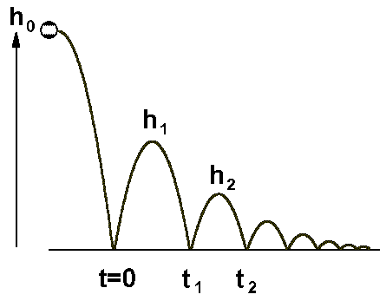

- On the image above, label:
  - The location that has the largest potential energy (use an arrow and write PE)
  - The location that has the largest kinetic energy (use an arrow and write KE)
  - The location where KE and PE are equal (use an arrow and write KE = PE)

