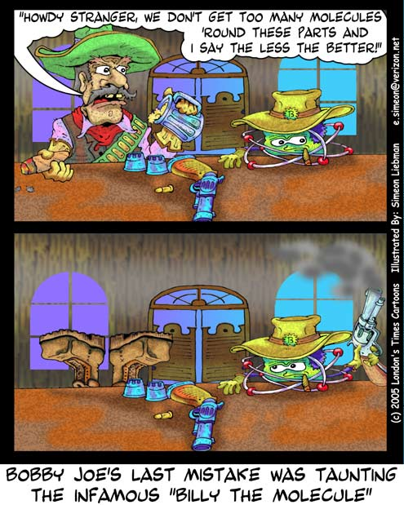**Physical Science**

**Unit 5**

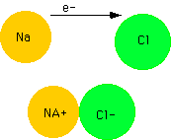**Bonding and Compounds**

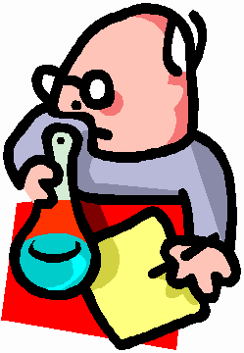





**Types of Bonds – Identification Practice**

1. When atoms share electrons to fill their outermost energy levels, they form ________________________ bonds.

2. When atoms transfer electrons to fill their outermost energy levels, they form ________________________ bonds.

3. Indicate whether the atoms listed below will share electrons or transfer electrons (HINT: when electrons are transferred, both atoms will have complete outermost energy levels. Otherwise, atoms share electrons.)

a. O -- O a. ____________________

b. K -- Cl b. ____________________

c. C -- O c. ____________________

d. H -- F d. ____________________

e. I -- I e. ____________________

f. S -- O -- O f. _____________________

g. Na -- Na -- S g. ____________________

h. Li -- Cl h. ____________________

i. Ca -- Br -- Br i. ____________________

j. N -- N j. ____________________

4. Write IONIC or COVALENT under each substance below to identify the type of bond.

a. Calcium chloride b. Sulfur trioxide

c. Phosphorus pentaflouride d. Sodium iodide

e. Carbon monoxide f. Cesium fluoride

**Ionic Formula Writing Activity**

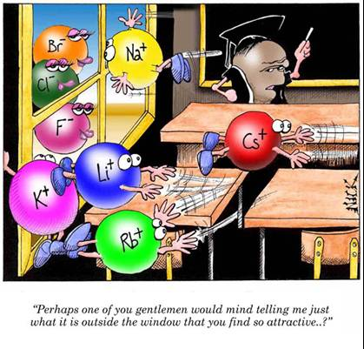An enormous amount of ionic compounds are known to exist today, each having its own unique chemical formula and name. There is no way chemists could possibly test each compound for the weight ratios of the atoms in the compound in order to determine its chemical formula. A systematic method of writing formulas was needed to deal with the vast amount of compounds, without having to do an experiment every time a new compound was discovered. In this activity, you will try to discover the underlying principle used to write formulas for all ionic compounds.

PROCEDURE:

1. Color all the positive ions one color.

2. Color all the negative ions) a different color.

3. Cut out all the positive and negative ion squares carefully (don’t round the corners or cut the squares larger or smaller than they are).

4. Put the two combining substances together, so that the heights of the squares match. Keep adding more of the same squares until the HEIGHTS match! Then, fill in the table and record the formula of the compound.

5. Proceed on the next formula on the data table. Once the data table is complete, answer the questions in the analysis.

|  |  |  |  |  |  |  |  |
| --- | --- | --- | --- | --- | --- | --- | --- |
| **Combining Substances** | **# of Positive ion squares used** | **# of Negative ion squares used** | **The charge on each positive ion** | **The charge on each negative ion** | **The total positive charge** | **The total negative charge** | **Formula** |
| *Aluminum & Bromine* | *1* | *3* | *+3* | *-1* | *+3* | *-3* | *AlBr3* |
| Sodium & Oxygen |  |  |  |  |  |  |  |
| Iron (II) & Sulfide |  |  |  |  |  |  |  |
| Potassium & Sulfate |  |  |  |  |  |  |  |
| Sodium & Nitrate |  |  |  |  |  |  |  |
| Ammonium & Phosphate |  |  |  |  |  |  |  |
| Iron (III) & Chlorine |  |  |  |  |  |  |  |
| Iron (II) & Chlorine |  |  |  |  |  |  |  |
| Ammonium & Sulfide |  |  |  |  |  |  |  |
| Aluminum & Sulfide |  |  |  |  |  |  |  |
| Aluminum & Oxygen |  |  |  |  |  |  |  |
| Iron (III) & Sulfate |  |  |  |  |  |  |  |
| Magnesium & Phosphate |  |  |  |  |  |  |  |
| Iron (III) & Nitrate |  |  |  |  |  |  |  |
| Magnesium & Sulfate |  |  |  |  |  |  |  |
| Sodium & Phosphate |  |  |  |  |  |  |  |
| Ammonium & Sulfide |  |  |  |  |  |  |  |
| Ammonium & Nitrate |  |  |  |  |  |  |  |
| Aluminum & Nitrate |  |  |  |  |  |  |  |

DATA TABLE:

Ionic Bonding

Name: ____________________________

Date: _______________

Hour: _____

# **Information**: Naming Ions

To write an ion, you write the symbol of the atom and put the charge in the upper right corner. Consider the following examples: Al3+, O2-, Mg2+. You should verify that each of the charges is correct.

Positive and negative ions are named differently. Positive ions retain the same name as the parent atom. For example, Al3+ is called the “aluminum ion” and Mg2+ is called the “magnesium ion.” Negative ions are named a little differently. For negative ions, you change the ending of the name to “-ide”. Therefore, O2- is named oxide and P3- is named phosphide.

# **Critical Thinking Questions**

1. Write the symbol (including the charge) and name for each of the ions for each of the following:

a) Ca b) Cl c) N d) K e) S f) B g) P

# **Information**: Ionic Bonding and Formulas

There are two ways in which atoms can “bond” to each other and form a compound. The means of bonding that we will consider now is called ionic bonding, which occurs between a metal and a nonmetal. As you know, opposite charges attract. Ionic bonding is when two ions of opposite charge attract and bond to each other forming an ionic compound. Consider the following examples of formulas for ionic compounds:

* One Na+ (sodium ion) and one Cl- (chloride ion) bond to make NaCl, “sodium chloride.”
* One Mg2+ (magnesium ion) and two F- (fluoride ion) bond to make MgF2, “magnesium fluoride.”
* Three Ca2+ (calcium ion) and two N3- (nitride ion) bond to make Ca3N2, “calcium nitride.”
* One Al3+ (aluminum ion) and one N3- (nitride ion) bond to make AlN, “aluminum nitride.”

The small numbers at the bottom right of each symbol in a formula are called “subscripts”. Subscripts tell us how many of each type of atom are present. For example in the formula Mg3N2 there are three magnesium ions and two nitride ions.

# **Critical Thinking Questions**

1. Consider the formula NaCl in the above example. It tells us that one Na+ ion is bonded to one Cl- ion. What is the overall charge for NaCl? Is it positive, negative, or neutral?
2. Consider MgF2. This formula tells us that one Mg2+ ion bonds with two F- ions. What is the overall charge on MgF2?
3. What is the overall charge on any ionic compound?
4. Why is calcium nitride written like Ca3N2 and not something like CaN2 or Ca2N3? In other words why do exactly three calcium ions bond with exactly two nitride ions?
5. The formula Ca3N2 can never be written as N2Ca3. To find out why, take note of each of the four example formulas given above.
   1. In terms of charge, what do the first ions named all have in common?
   2. In terms of charge, what do the second ions named all have in common?
   3. Now, why can’t Ca3N2 ever be written like N2Ca3?
6. There are two rules to follow when writing formulas for ionic compounds. One has to do with charges (see questions 4 and 5) and the other has to do with which atom to write first and which one to write second (see question 6). What are these two rules?
7. What is wrong with the following formulas?
8. Al2S b) PNa3 c) Mg2S2
9. Write the formula and name for the compound that forms when the following atoms form ionic compounds. The first is done for you.

a) nitrogen and sodium b) barium and sulfur c) magnesium and iodine

Na3N

sodium nitride

d) oxygen and aluminum e) calcium and phosphorus f) sodium and sulfur

1. Given the following compounds, determine the charge on the unknown ion “X”.
2. X2S b) MgX c) X3P2

|  |  |  |  |
| --- | --- | --- | --- |
| Ionic Bonding | | | |
| *1. Solve Out Loud* | *2. Coach and Praise* | | *3. Pass the Paper* |
|  |  | |  |
|  | Partner #1 | | Partner #2 |
|  | Chlorine | | Magnesium |
| Family Name |  | |  |
| Symbol |  | |  |
| Total Electrons |  | |  |
| Valence Electrons |  | |  |
| Lewis Dot Structure |  | |  |
| Electron Shell Diagram |  | |  |
| Likely Ionic Charge |  | |  |
| Ionic Lewis Dot |  | |  |
| Ionic Electron Shell Diagram |  | |  |
| Ionic Valence Electrons |  | |  |
| Metal or Nonmetal |  | |  |
| Negative ion |  | |  |
|  |  | |  |
|  | **MgCl2** | | |
| # of Chlorine Atoms? |  |  | |
| # of Magnesium Atoms? |  |  | |
|  | **5 MgCl2** | | |
| # of Chlorine Atoms? |  |  | |
| # of Magnesium Atoms? |  |  | |

**Chemical Formulas Pairs Check**

*Directions: Write the chemical formula for each word formula listed. Check your partner as they are completing their formula. Praise or coach each other until both partners understand all twenty formulas.*

|  |  |
| --- | --- |
| 1. Sodium Chloride  ______________________________ | 2. Magnesium Oxide  _______________________________ |
| 3. Aluminum Sulfide  ______________________________ | 4. Potassium Oxide  _______________________________ |
| 5. Calcium Chloride  ______________________________ | 6. Lithium Nitride  _______________________________ |
| 7. Lead (II) Oxide  ______________________________ | 8. Iron (III) Flouride  _______________________________ |
| 9. Copper (I) Flouride  ______________________________ | 10. Zinc Oxide  _______________________________ |
| 11. Rubidium Bromide  ______________________________ | 12. Potassium Chloride  _______________________________ |
| 12. Titanium (III) Sulfide  ______________________________ | 13. Calcium Iodide  _______________________________ |
| 14. Lithium Phosphide  ______________________________ | 15. Silver Oxide  _______________________________ |

**Formula Writing for Binary Ionic Compounds**

*Write the formula for the following binary compounds.*

1. sodium bromide ___________________________________________

2. Magnesium oxide ___________________________________________

3. Strontium sulfide ___________________________________________

4. barium nitride ___________________________________________

5. silver chloride ___________________________________________

6. Francium oxide ___________________________________________

7. Lithium bromide ___________________________________________

8. magnesium phosphide ___________________________________________

9. aluminum iodide ___________________________________________

10. calcium oxide ___________________________________________

11. strontium arsenide ___________________________________________

12. Beryllium chloride ___________________________________________

13. Strontium selenide ___________________________________________

14. Barium phosphide ___________________________________________

15. magnesium chloride ___________________________________________

16. Radium oxide ___________________________________________

17. barium iodide ___________________________________________

18. Calcium bromide ___________________________________________

19. Lithium bromide ___________________________________________

20. Cesium sulfide ___________________________________________

**Nomenclature Writing for Binary Ionic Compounds**

*Write the name for the following binary ionic compounds.*

1. CaBr2 ___________________________________________

2. AlCl3 ___________________________________________

3. Zn3N2 ___________________________________________

4. KCl ___________________________________________

5. Na2S ___________________________________________

6. AlN ___________________________________________

7. CsI ___________________________________________

8. Ca3P2 ___________________________________________

9. BaO ___________________________________________

10. BeF2 ___________________________________________

11. FeCl2 ___________________________________________

12. FeCl3 ___________________________________________

13. Ag2O ___________________________________________

14. CuS ___________________________________________

15. CoP ___________________________________________

16. MnBr3 ___________________________________________

17. NiN ___________________________________________

18. ZnF2 ___________________________________________

19. BiP2 ___________________________________________

20. VO2 ___________________________________________

Covalent Bonding

# **Information**: Terminology

Recall that an ionic bond results from the combination of a metal and a nonmetal. A covalent bond is the type of bond between two nonmetals. Covalent bonds are formed by neutral atoms that share electrons rather than by charged ions. When a compound is formed by sharing electrons, the compound is called a molecule or molecular compound. It is important to note that ionic compounds are not called molecules. The largest class of molecules are called organic molecules. Carbon is the distinguishing mark of organic compounds.

# **Critical Thinking Questions**

1. Circle any of the following compounds that would properly be called a “molecule”.

a) H2O b) CO2 c) NaCl d) Mg3P2 e) N2O5

# **Information**: Naming Covalent Compounds

There are several prefixes used to name molecules. The name “carbon oxide” is not sufficient because carbon and oxygen sometimes form CO2 and sometimes CO. Prefixes are necessary to distinguish between them.

|  |  |
| --- | --- |
| Formula | **Name** |
| N2O4 | dinitrogen tetraoxide |
| SF6 | sulfur hexafluoride |
| XeCl5 | xenon pentachloride |
| SO3 | sulfur trioxide |
| CO | carbon monoxide |

# **Critical Thinking Questions**

1. Fill in the table to indicate which prefix is used to represent the numbers. The first one is done for you.

|  |  |
| --- | --- |
| Number | **Prefix** |
| 1 | mono |
| 2 |  |
| 3 |  |
| 4 |  |
| 5 |  |
| 6 |  |

1. Name each of the following molecules using the appropriate prefixes.

a) N2O5 b) CF4

________________________________ _______________________________

c) SCl3 d) SO

________________________________ _______________________________

e) N2O6 f) C2H4

________________________________ _______________________________

g) C4H4 h) C3H5

________________________________ _______________________________

**Covalent Naming Practice**

1. Triphosphorus Pentachloride __________________________________
2. Sulfur Triflouride _______________________________________
3. Silicon Tetrabromide _______________________________________
4. Dinitrogen Octabromide ______________________________________
5. Pentacarbon decahydride ______________________________________
6. Tricarbon hexahydride ________________________________________
7. Heptasilicon Monoiodide ______________________________________
8. Phosphorus dioxide _________________________________________
9. Tetracarbon pentaflouride _______________________________________
10. Sulfur dihydride _______________________________________________

**Covalent Formula Writing**

1. C6H10 _____________________________________________________________
2. P3O7 ______________________________________________________________
3. NCl2 ______________________________________________________________
4. Si4H9 _____________________________________________________________
5. C2F5 ______________________________________________________________
6. S7H2 _____________________________________________________________________________________________
7. PBr8 _____________________________________________________________________________________________
8. N4Se5 ____________________________________________________________________________________________
9. C6H6 _____________________________________________________________________________________________
10. P4Br9 _____________________________________________________________________________________________

**Compound Naming Race**

Be the first team in the room to correctly get all the names on this sheet right. When you have finished the first ten problems, bring them up to the teacher to be checked. Once these have been checked, move to the second ten. Once all forty problems have been solved, you’re the winner!

1) copper (II) oxide __________________

2) sodium sulfide __________________

3) lithium oxide __________________

4) carbon dioxide __________________

5) aluminum sulfide __________________

6) magnesium oxide __________________

7) iron (III) phosphide __________________

8) vanadium (V) phosphide __________________

9) sodium chloride __________________

10) xenon tetrafluoride __________________

11) beryllium nitride __________________

12) nickel (III) sulfide __________________

13) potassium oxide __________________

14) silver bromide __________________

15) zinc phosphide __________________

16) diphosphorus pentasulfide __________________

17) nickel (II) selenide __________________

18) boron trichloride __________________

19) lead (IV) nitride __________________

20) nitrogen dioxide __________________

21) lithium arsenide __________________

22) chromium (VI) sulfite __________________

23) calcium bromide __________________

24) sulfur trioxide __________________

25) copper (II) oxide __________________

26) platinum (IV) phosphide __________________

27) carbon dioxide __________________

28) silver nitride __________________

29) diarsenic pentoxide __________________

30) nickel (III) cyanide __________________

31) vanadium (IV) phosphide __________________

32) silver sulfide __________________

33) cobalt (III) sulfide __________________

34) silicon tetraoxide __________________

35) copper (II) nitride __________________

36) phosphorus pentafluoride __________________

37) zinc nitride __________________

38) manganese (VII) nitride __________________

39) tellurium hexabromide __________________

40) sodium nitride __________________