PROCEDURE PAGE
Wavelength and Frequency Relationship for Visible Light
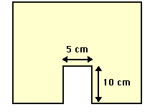

Materials:
- Pre-cut manila folder, as shown at right
- metric stick
- 4 books
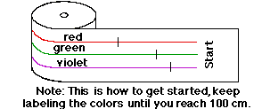
- Timer
- Calculators
- Pipe cleaner
- 1 Pre-Colored Strip, as shown at right
Procedure:

- Tape a pipe cleaner to the START end – to pull the strip.

- Materials Manager: Manila Folder & Paper Feed Set-Up:
  - Stand the manila folder cut out on the table supporting it with the four books (2 in front of the folder on each side of the cut-out and 2 in the back of the folder).
  - Feed the START end of the paper through the narrow space between the manila folder and the two back books until "Start" appears in the middle of the opening in the manila folder cut-out.
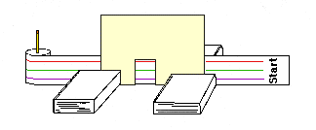
- Recorder should now be prepared with the Data Table.

- Determining Frequency:
  - Time Keeper should call "start" and begin timing which begins the following steps.
  - Mechanic slowly pulls the tape through the cut-out. Try to pull the tape at about the same speed for every trial!
  - Reader calls out the appropriate color every time a mark passes through the cut-out. When the “End” appears, the Reader should tell the Time Keeper to stop timing.
  - Recorder should tally the colors in the appropriate box on the data table every time a color is called out by the Reader.

- Make a "trial run" to eliminate error and then repeat the procedure an additional 3 times.

- Measure the distance between the vertical marks on each color line.
  - A different student should do each line; Red, Green, Violet (Purple).
  - These marks represent the different wavelengths of the different colors of light. Record measurements in the bottom line of the Calculate Frequency Table on your data sheet.

(NOTE: The true wavelengths are actually measured in terms of angstroms. An angstrom is 10⁻⁸ cm or 0.00000001 cm. Red has a wavelength of 7800-6220 angstroms, green has a wavelength of 5770-4920 angstroms and violet has a wavelength of 4550-3900 angstroms. However, in this lab, the simple relationship among the visible light waves will be what is important.)
Name________________________Period_____

Lab: Wavelength and Frequency Relationship for Visible Light
DATA SHEET

Purpose
Students will discover and verify the relationship between Wavelength and Frequency of the Electromagnetic Spectrum.

Pre-Lab Questions:
- What type of energy here has the longest wavelength?

- What type of energy has the shortest wavelength?

- What is the definition of wavelength? (Use p.748 if needed)

- What is the definition of frequency? (Use p.748 if needed)

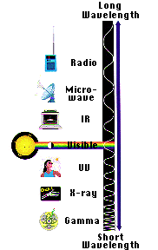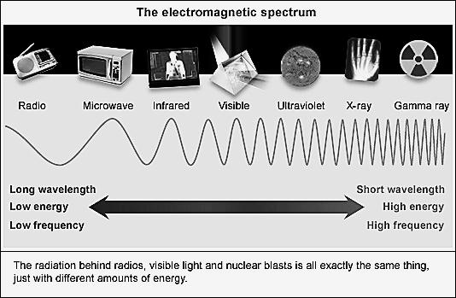
Wavelength

Data Table
 | Trial 1 | Trial 2 | Trial 3 | Average
 | # Marks | # Marks | # Marks | # Marks
Red
Green
Violet
Time (s) from Start of Tape until End |  |  |  | Average time (s)

Calculate Frequency:
Line Color | Example  “Color A” | Red | Green | Violet
Average # Marks | 27
Average # Seconds | 20
Frequency  Calculation  (Waves/second) | 27  20
Frequency | 1.4 waves/sec
Wavelength (cm) | XX

Post Lab Questions:
- What do the dark vertical marks on each colored line represent?
- Which color has the shortest wavelength? ____________ Which has the longest wavelength? _____________
- Which color has the highest frequency? ____________ Which color has the lowest frequency? _____________
- Compare the wavelengths and frequencies of the three waves. Write about any patterns you notice in their relationship.

- Compare the wavelength of red light to wavelength of the green:

- Order the colors (red, green, and violet) from highest frequency to lowest frequency.

